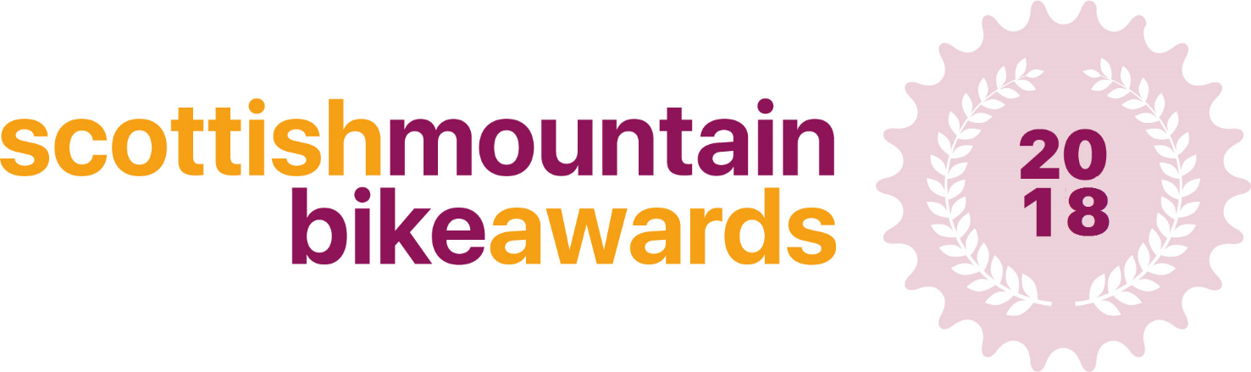
MTB Community Project of the Year Application

This form is designed to capture details of your mountain bike community project, for consideration to become the Scottish MTB Community Project of the Year 2018.
The winner of the award will be announced at the Scottish Mountain Bike Awards on the evening of Friday 23rd November at the Scottish Mountain Bike Conference 2018, in Aviemore - with the winners having their award presented to them on the night.
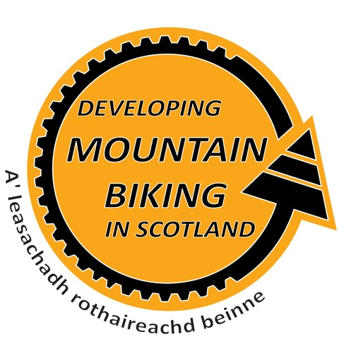
This category recognises the amazing work and impact that communities across Scotland are doing. We anticipate applications from trail advocacy groups, trail management groups, volunteer groups, participation programmes and more.

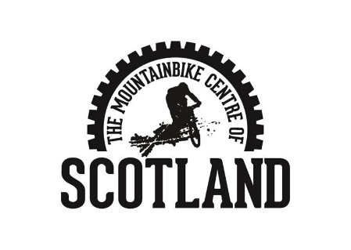
We are looking for community projects who have approached an issue or problem in a unique way and used innovations (thinking differently about the problem) to improve what they do.

Please fill in the answers to the following questions, providing as much detail as possible – there is no limit on how much you can write.

When sending your application to us, please include at least 1 photo related to your project or a video if possible!

Thank you

Contact Details:

Full Name:

Community Organisation Name:

Address:

Telephone: |  | Mobile:

Email:

Aims of the Project:

Background to the project What are the foundations of the project? Where and how did it begin?

Innovations

What have you done which you think is different from other projects? What did you do and how did you do it? Who did you involve? (Departments/ Community groups/ Clubs/ Agencies/ Parents/ Leisure centres/ Volunteers etc)

Results

What were the outcomes/results of your innovative ideas? (How many people benefit from your project? How do they benefit?)

What one features of your project would you highlight as a particular success or unique aspect?

Future Innovations & Development

How do you plan to innovate in the future?

Additional Information

Is there anything else you’d like to tell us about your project?

Guidance notes and eligibility criteria.

The Participation and Development awards will recognise local clubs and communities who encourage and develop mountain biking in their area. We are looking for the most innovative way these clubs and communities have developed MTB in their area this year. These awards will be judged by a panel of experts who will judge each application individually.

- When sending your application to us, please include at least 1 high resolution photo related to your service/product!
- Your business must be registered in Scotland in order to apply for these awards.
- You must provide a service/product which is mountain bike related in order to apply.
Send your completed application to:
mtb@napier.ac.uk
Deadline for applications: Thursday 12th October

Please call 01721 722172 or email mtb@napier.ac.uk if you require any further information.

Timeline
Awards open for applications 25th September
Deadline for applications 12th October – 12 midnight
Judging – 13th October – 4th November
Shortlist Announced – 9th November

