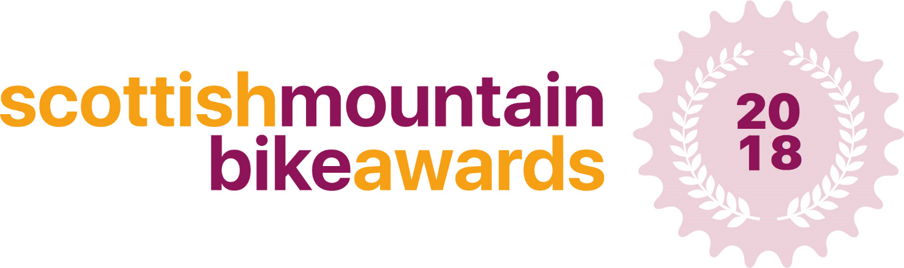

Scottish Mountain Bike Local Hero of the Year Application
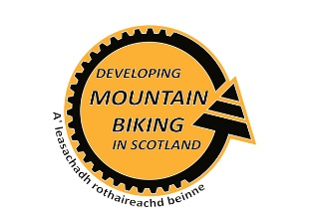
This award will celebrate and recognise a local hero nominated by someone in their community. We are looking for the local hero who has made the most impact to their local MTB community
Nominate the person in your community, whom you believe contributes more to the local MTB scene than anyone else. Without whom things just wouldn't happen. The nominations will then be reviewed by an independent panel, with a shortlist announced on the 9th November and the winner announced at the Scottish Mountain Bike Awards on Friday 23rd November

Please fill in the answers to the following questions, providing as much detail as possible – there is no limit on how much you can write.

Thank you

Your Contact Details:

Full Name:

Address:

Telephone: |  | Mobile:

Email:

Local Hero Contact Details:

Full Name:

Address:

Telephone: |  | Mobile:

Email:

Actions

What did/do they do for the local MTB community that makes them your local hero?

Results

Describe the difference that they have made to your local MTB community? (eg. What things would not exist without their contribution?)

What one action by your hero illustrates their dedication to the local MTB community?

Additional Information

Is there anything else you’d like to tell us about your local hero?

Guidance notes and eligibility criteria.

This award will celebrate and recognise a local hero nominated by someone in their community. We are looking for the local hero who has made the most impact to their local MTB community. This award will be judged by a panel of experts who will judge each application individually.

- When sending your application to us, please include at least 1 high resolution photo of your local hero
- Your local hero must reside in Scotland in order to be nominated for this award.
Send your completed application to:
mtb@napier.ac.uk
Deadline for applications: Thursday 12th October

Please call 01721 722172 or email mtb@napier.ac.uk if you require any further information.

Timeline
Awards open for applications 25th September
Deadline for applications 12th October – 12 midnight
Judging – 13th October – 4th November
Shortlist Announced – 9th November

