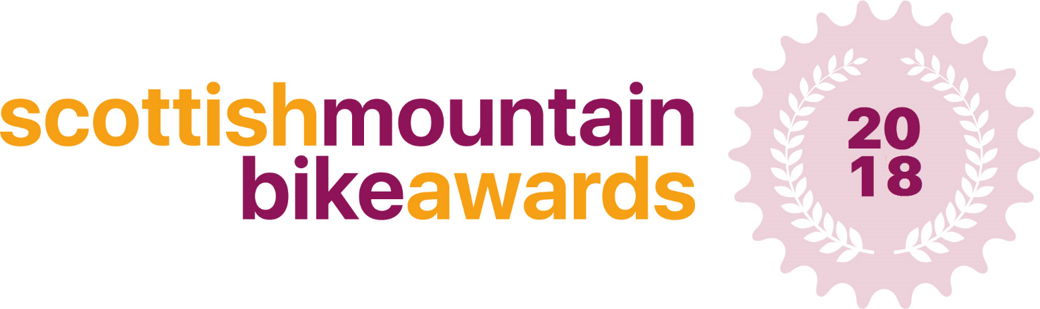

Best Scottish Business Collaboration
Application 2018

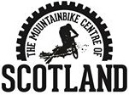
This form is designed to capture details of your business’s collaboration with a Scottish University or other Scottish company, for consideration to become the best Scottish Business Collaboration 2018, announced at the Scottish Mountain Bike Awards on the evening of Friday 23rd November at the Scottish Mountain Bike Conference 2018, in Aviemore - with the winners having their award presented to them on the night.

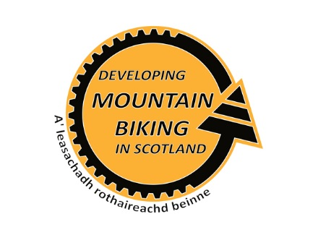
Please fill in the answers to the following questions, providing as much detail as possible – there is no limit on how much you can write.

Thank you

Company Contact Details:

Full Name:

Company Name:

Address:

Telephone: |  | Mobile:

Email:

Collaborating Company Contact Details:

Full Name:

Company Name:

Address:

Telephone: |  | Mobile:

Email:

Project Details:

Project Description:

Actions

Please describe how the academic collaboration benefited your product?

Results

At what stage of development are you now with your product? Awards won? Crowdfunding success? Product launches? Academic evidence of product performance?

What one feature of the academic collaboration would you highlight as a particular success or unique aspect? Ground breaking technology/research, evidence of product success etc.

Future Development

How do you plan to develop the product in 2019 and beyond?
Do you have any further academic collaborations planned?

Additional Information

Is there anything else you’d like to tell us about your product or company?

Biography

Please write a brief summary of your company and product below:
This will be used on the Mountain Bike Centre of Scotland website to highlight shortlisted companies.

Guidance notes and eligibility criteria.

The aim of this award is to highlight current innovation in ‘Scottish Cycling Products’ by showcasing companies who are innovation in design, idea or method. Each category will be judged by a panel of independent business experts who will judge each application on its own merits.

- When sending your application to us, please include at least 1 high resolution photo related to your service/product!
- Your business must be registered in Scotland in order to apply for these awards.
- You must provide a service/product which is mountain bike related in order to apply.
Send your completed application to:
mtb@napier.ac.uk
Deadline for applications: 12th October

Please call 01721 722172 or email mtb@napier.ac.uk if you require any further information.

Timeline
Awards open for applications 7th September
Deadline for applications 12th October – 12 midnight
Judging – 13th October – 4th November
Shortlisted Entries Announced – 9th November

