

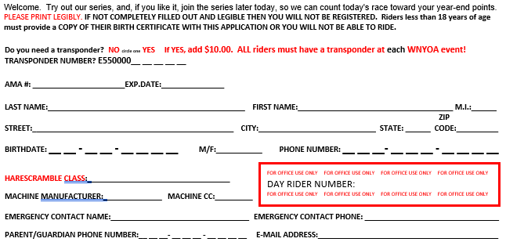



**MINI BIKE CLASSES # SEQUENCE OTHER INFO**   
Super Mini (14-15) 1-85 79-112cc 2-Stroke

75-150cc 4-Stroke

Wheelbase max 52”, min 48”

Super Mini (12-13) 200-285 Rear wheel Max 16”, Min 14”

Front wheel Max 19”

85 (12-15) 300-385 66-85cc

85 (7-11) 400-485 Wheelbase Max 51”

Rear Wheel Max 14” Min 12”

Front Wheel Max 17”

65cc (10-11) 500-585 51-65cc 2-stroke

59-112cc 4-stroke LTD

65cc (7-9) 600-685 Max wheelbase 45”

Rear Max 14”

Front Min 10”

Girls (13-15) 700-785 51-112cc 2-Stroke

51-150cc 4-Stroke

Max Wheelbase 52”

Max rear 16”, front 19”

4-Stroke (12-15) 800-885 75-150cc 4-Stroke

4-Stroke (7-11) 800-885 Air Cooled ONLY

Girls (7-12) 900-985 51-112cc 2-Stroke

75-150cc 4-Stroke

**BIKE CLASSES # SEQUENCE OTHER INFO**

AA 1-85 16+ AA

AA 35+ 100-185 35+ AA

250 A 200-285 201-250cc

OPEN A 300-385 251cc-open

125-200 A 400-485 125-200cc

VET A (30+) 500-585 30+ A

SR A (40+) 600-685 40+ A

SUPER SR A (50+) 700-785 50+ A

250 B 800-885 201-250cc

OPEN B 900-985 251cc-open

125-200 B 1000-1085 125-200cc

VET B (30+) 1100-1185 30+ B

SR B (40+) 1200-1285 40+ B

SUPER SR B (50+) 1300-1385 50+ B

WOMEN 1400-1485 minimum 19” front wheel

250 C+ (22+) 1500-1585 201-250cc

250 C1 (17-21) 1600-1699 201-250cc

250 C2 (12-16) 1700-1799 201-250cc

OPEN C 1800-1885 251cc-open

125-200 C+ (16+) 1900-1985 125-200cc

125-200 C (12-15) 2000-2085 125-200cc

SCHOOLBOY 1 (12-16) 2100-2185 86-125cc 2-STROKE, 75-150CC 4-STROKE

MIN FRONT WHEEL 19”& MIN REAR 16”

SCHOOLBOY 2 (14-16) 2200-2285 122-250cc, MIN wheelbase 53”

NO MINICYCLES OR SUPER MINI

VET C (30+) 2300-2385 30+ C

SR C (40+) 2400-2485 40+ C

SUPER SR C (50+) 2500-2585 50+ C

MASTERS (60+) 2600-2685 60+

VINTAGE 2700-2785 OPEN, 1990 AND OLDER MACHINES

\*\***Must be 12 to race up to a 250cc**\*\*

\*\*\***Must be 14 to race 251cc and above** ***

Mini Bike Start Time: 8:00am

Bike Start Time: 11:15 am

am

**PEEWEE BIKE CLASSES # SEQUENCE OTHER INFO**

SR Pee Wee 8 1-85 50cc automatic

SR Pee Wee 7 200-285 50cc automatic

SR 4-Stk Pee Wee 7-8 300-385 50cc multi-speed

SR Pee Wee 6 400-485 50cc automatic

JR Pee Wee 5 500-585 50cc automatic

JR Pee Wee 4 600-685 50cc automatic

JR 4-Stk Pee Wee 4-6 700-785 50cc multi-speed

Peewee Girls (4-8) 800-885 50cc

Trail Rider (8-9) Air Cooled 900-885 70cc-90cc

PW Bike Start: 9:30am

**ANY ELECTRIC MOTORCYCLES MUST USE THE COMPETITION WAIVER ON PG. 23 OF THE NYOA RULES TO ENTER A CLASS**

I hereby release and agree to hold harmless the American Motorcycle Association, American All Terrain Vehicle Association, New York Off-Road Association, the promoters, the owners: leases of the premises, the participants, and the officers, directors, representatives, agents and employees of all of them, of any form of liability, loss, claims and demands that may occur from any loss, damage or injury (including death) to my person or property, in any way resulting from, or arising in connection with any NYOA event, and whether arising while engaged in competition or in practice or preparation therefore, or while upon, entering or departing from said premises, from any cause whatsoever. I know the risk and danger to myself and property while upon said premises or while participating or assisting in any NYOA event, so voluntarily and in reliance, upon my own judgment and ability, and I thereby assume all risks for loss, damage or injury (including death) to myself and my property from any cause whatsoever. I have read and understand the above release from liability. Also, by signing this application, I agree to hold myself and my family accountable to the 2022 Sportsmanship Pledge, which is available in the rule book. I remember this is a family event. **Riders less than 18 years of age must provide a COPY OF THEIR BIRTH CERTIFICATE WITH THIS APPLICATION.**

