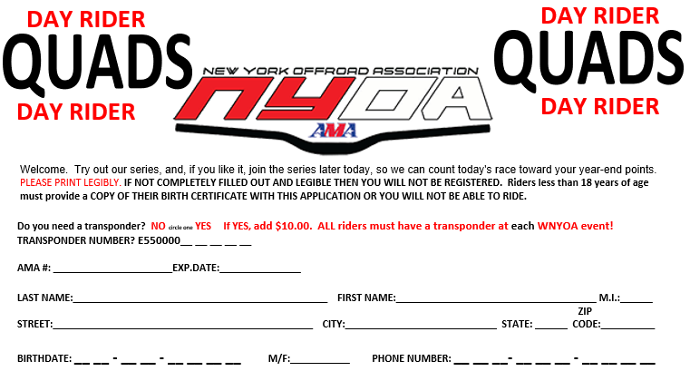

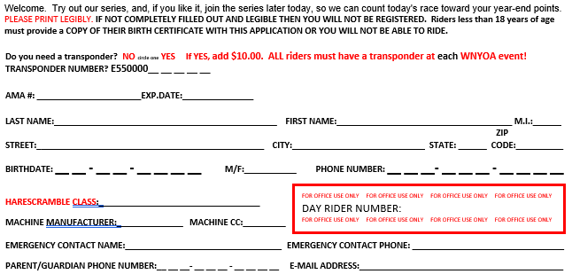

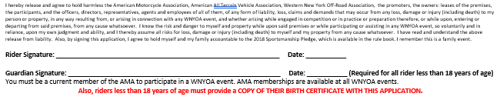

**QUAD CLASSES # SEQUENCE OTHER INFO**

AA/AA2 1-99

JUNIOR A (22+) 200-299

COLLEGE A (16-21) 300-399

VET A (30+) 400-499

SENIOR A (40+) 500-599

JUNIOR B (22+) 600-699

COLLEGE B2 (16-18) 700-799

COLLEGE B1(19-21) 800-899

VET B (30+) 900-999

4X4 1000-1099

WOMEN (13+) 1100-1199

TEEN (13-15) 1200-1299 91cc-200cc 2-stk/91cc-300cc 4-stk

TEEN (14-15) * 1200-1299 91-300cc 2-stk/301-400cc 4-stk

JUNIOR C (22-24) 1300-1399

JUNIOR C (25+) 1300-1399

COLLEGE C1 (16-18) 1400-1499

COLLEGE C2(19-21) 1500-1599

UTILITY (FAST RACER MAY BE PROMOTED TO 4X4) 1600-1699

FIRST YEAR C (16+) 1700-1799

SENIOR B (40+) 1800-1899

SUPER SR B (50+) 1900-1999

VET C (30+) 2000-2099

TEEN NOVICE 1 (13-15) 2100-2199 91-200cc 2-Stroke, 91-300cc 4-Stroke

No Apex Allowed

TEEN NOVICE 2 (14-15) * 2200-2299 91-300cc 2-STK/301-400cc 4-STK

TEEN GIRLS (13-15) 2300-3099 SAME RULES AS TEEN 900 LINE

WOMEN NOVICE 13+ 2400-2499

Teen Girls 13-15 can race in the Women line’s,they must use same machine

as allowed in Teen Girls line

**\* Hybrids NOT allowed in these classes only\***

\*\***Must be 16 to race a 450cc**\*\* \*\*\***Must be 14 to race a 400cc** ***

I hereby release and agree to hold harmless the American Motorcycle Association, American All Terrain Vehicle Association, New York Off-Road Association, the promoters, the owners: leases of the premises, the participants, and the officers, directors, representatives, agents and employees of all of them, of any form of liability, loss, claims and demands that may occur from any loss, damage or injury (including death) to my person or property, in any way resulting from, or arising in connection with any NYOA event, and whether arising while engaged in competition or in practice or preparation therefore, or while upon, entering or departing from said premises, from any cause whatsoever. I know the risk and danger to myself and property while upon said premises or while participating or assisting in any NYOA event, so voluntarily and in reliance, upon my own judgment and ability, and I thereby assume all risks for loss, damage or injury (including death) to myself and my property from any cause whatsoever. I have read and understand the above release from liability. Also, by signing this application, I agree to hold myself and my family accountable to the 2022 Sportsmanship Pledge, which is available in the rule book. I remember this is a family event. **Riders less than 18 years of age must provide a COPY OF THEIR BIRTH CERTIFICATE WITH THIS APPLICATION.**

**MINI QUAD CLASSES SEQUENCE # OTHER INFO**

Open* (12-15) 1-99 71-105cc 2-stk, 71-150cc 4-stk

Girls Open* (12-15) 200-299 71-105cc 2- stk, 71-150cc 4-stk

125 Open (12-15) 300-399 71-90cc- 2-stk LIM, 71-125cc 4-stk open

90cc /125cc* (8-12) 400-499 71-90cc 2-stk, 71-125cc 4-stk

70cc OPEN (8-11) 500-599 70 cc

Girls Open (8-12) 600-699 70-90cc 2- stk, 70-125cc 4-stk

No Aftermarket Frames

90cc LIMITED (8-11) 700-799 71-90cc 2- stk, 71-125cc 4-stk

NO Production Hybrids Allowed

No Aftermarket Frames

Apex with CR85 engines not allowed

90cc SPORT LIM (8-15) 800-899 71-90cc 2- stk, 71-125cc 4- stk

Fully Automatic machines ONLY (no shifter)

No aftermarket frames

All Non-Shifting quads are permitted except: DRR, no APEX, no Cobra machines

90cc BEG LIM (8-15) 900-999 71-90cc 2 stk, 71-125cc 4 stk

No Production Hybrids Allowed

Maximum width 45”

No aftermarket frames

Apex with CR85 engines not allowed

Competitors must be 1st year racers, having never raced prior to this season

**\* Hybrid allowed in class\***

Quad Start Time: 2:30 pm

Mini Quad Start Time: 9:30am

**Open ATV** – Open ATV’s are to use the stock Frame (frames may be Gusset) must use Engine cases that the ATV came with from the manufacturer. Modified stock engine cases allowed. All other components are allowed to be changed.

**(Sport) Limited ATV** – Must be a stock machine. The following items may be changed from stock: standard race equipment such as tires (no tire balls), wheels, complete exhaust systems, sprockets, gearing, clutch, twist throttle, handlebars (no open ends), grips, handle bar pads, front bumper, rear grab bar, air filter and jetting. Fenders may be trimmed, but NO other modifications are allowed INCLUDING to the engine, frame (except for gusseting), ignition, CDI box, suspension, carburetors, and complete air box (air box & lid may only have nonperformance gaining changes such as a cover or duct tape installed).

PeeWee Quad Start Time: 8:00am

**PEEWEE QUAD CLASSES # SEQUENCE OTHER INFO**

50cc Open (6-9) 1- 99Modifications are allowed

Modified stock engines

No aftermarket frames

50cc ATV’s that do not fit the limitations of the 50cc Limited Class

50cc Perf Lim (4-9) 200-299 50cc

No aftermarket frames

90cc STOCK (8-9) 300-399 51-90cc 4 Stroke ONLY

50cc Open Girls (4-9) 400-499Modifications are allowed

Modified stock engines

No aftermarket frames

50cc ATV’s that do not fit the limitations of the 50cc Limited Class

50 LIM Girls (4-9) 500-59950cc

No aftermarket frames

Girls 400 & 500 lines will start together unless more than 3 in each class

90cc STOCK (6-7) 600-699 51-90cc 4 Stroke ONLY

50cc Sport Lim (6-9) 700-799 **NO Kymko, DRR, Apex, Cobra**

50cc Sport Lim (4-5) 800-899 **NO Kymko, DRR, Apex, Cobra**

**Max width 42"**