WNYOA Scholarship
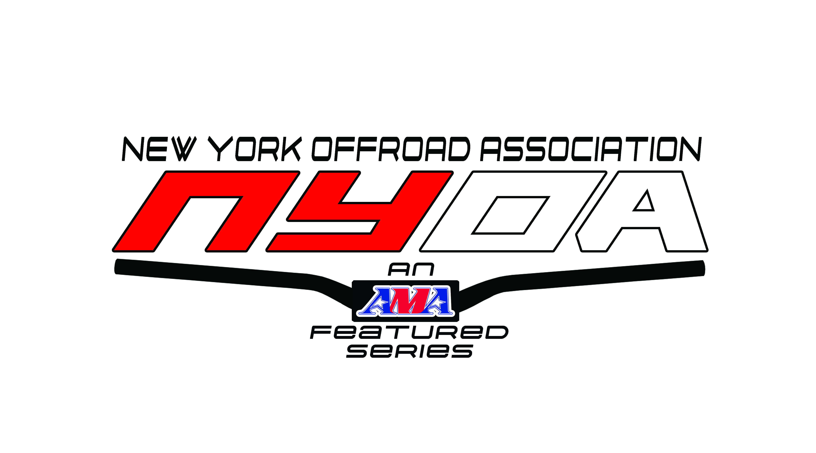

Eligibility Requirements:
❖ A. Applicants must be a high school senior during this scholastic year, enrolling full time in a United States College/institution/trade or technical school for a 2 or 4-year program for the following scholastic year.
Or
❖ B. Must have been a college student during this scholastic year, continuing as a full-time student in a United States College/institution/trade or technical school for a 2 or 4-year program for thefollowing scholastic year.
❖ Must have been a NYOA series member for the past season (2 of 3 NYOA seasons) who has participated in at least 50% of events and has volunteered as a worker this season (2 of the past 3 seasons.)
❖ Proof of Enrollment as a student in your post-secondary institution or Trade school.
❖ Current School Transcript and/or (ACT scores or SAT scores)
Please include the following with your application:
❖ Two Letters of Recommendation from people of your choice. Below are some ideas of people who might be able to recommend you for this award.
➢ Letter from the promoter of the race you worked
➢ Personal reference
➢ Teacher or school administrator
➢ Coach
➢ Club leader/president

❖ Essay: Please include with your application an essay of approximately 1000 words. Use some of the ideas below to help form a topic related to your life and riding. You may create your own topic along these lines if you so choose.
➢ Many people outside of our race community do not understand why we race and it is viewed as hazardous. What are some positive ways that racing has influenced your life?
➢ The biggest hurdle I ever overcame was…
➢ How has riding/racing helped form you into the person you are striving to be?
➢ Some riders talk about their race family, how has the riding community become important to you? Does the term “race family” mean something special to you.

Selection Process:
❖ Deadline: December 15th of this year
➢ Email your application to
WNYOAraceScholarship@gmail.com

❖ Awards given: NYOA will award a minimum of two scholarships. Selection of winners will be by the scholarship committee. Additional awards may be offered, this will also be determined by the scholarship committee.

❖ Recipients will be chosen December31, of this year. Recipients are encouraged to attend and will be recognized at the NYOA Banquet. Awards will be sent directly to the students College/University/Trade or Technical school for the Spring semester.

WNYOA Scholarship Application
Name ________________________________________________________________________
Parents Name ______________________________________________________________________
Address ____________________________________________________________________________
Email Address _______________________________________________________________________
Primary Phone __________________________ Alternate Phone ______________________________
Birthdate/Age _______________________________________________________________________
Current School _______________________________________________________________________
School Address _______________________________________________________________________
Guidance Counselor _____________________________ Phone________________________________
What is your current GPA and your school grading scale? i.e. 4.0
_____________________________________________________________________________________
What is your high school class rank and size (i.e.112/260) if applicable?
____________________________________________________________________________________
Are you currently a WNYOA member and what class are you in?
_____________________________________________________________________________________

How many years have you been a NYOA member and have you attended at least 50% of WNYOA events during the past 2 of 3 years?
_____________________________________________________________________________________

What was the best riding class ranking you ever had?
_____________________________________________________________________________________

Do you participate in any other off-road series? If so, please list…
_____________________________________________________________________________________
_____________________________________________________________________________________

What post-secondary institution do you plan to attend in 2023- 2024 and class will you be? Freshman, sophomore, first year second year….
_____________________________________________________________________________________

Is this a United States College/University or a trade/technical institution?
_____________________________________________________________________________________

What is your parents adjusted annual gross income? Circle one:
• Greater than $100,000.00
• $75,001.00 to $100,000.00
• $50,001.00 to $75,000.00
• $25,001.00 to $50,000.00
• Less than $ 25,000.00

Total number of Dependents: ___________
(includes parents and all children under 22 years)
How many family members in your household will be in college next year? _______________
What is your expected family contribution from FAFSA next year? ________________
Parents initials for financial info: _________________

What degree or certificate will you pursue? What profession do you hope to enter upon completion of your degree or certificate program and why? ______________________________________________
_____________________________________________________________________________________
_____________________________________________________________________________________
_____________________________________________________________________________________
_____________________________________________________________________________________
_____________________________________________________________________________________
_____________________________________________________________________________________
_____________________________________________________________________________________
_____________________________________________________________________________________
_____________________________________________________________________________________
_____________________________________________________________________________________
_____________________________________________________________________________________
_____________________________________________________________________________________
_____________________________________________________________________________________
_____________________________________________________________________________________
_____________________________________________________________________________________
_____________________________________________________________________________________
_____________________________________________________________________________________
_____________________________________________________________________________________
_____________________________________________________________________________________
_____________________________________________________________________________________
_____________________________________________________________________________________
_____________________________________________________________________________________
_____________________________________________________________________________________
_____________________________________________________________________________________
_____________________________________________________________________________________
_____________________________________________________________________________________
_____________________________________________________________________________________
_____________________________________________________________________________________

What extracurricular, community, or other public service activities are you involved in outside of our NYOA community? __________________________________________________________________
_____________________________________________________________________________________
_____________________________________________________________________________________
_____________________________________________________________________________________
_____________________________________________________________________________________
_____________________________________________________________________________________
_____________________________________________________________________________________
_____________________________________________________________________________________
_____________________________________________________________________________________
_____________________________________________________________________________________
_____________________________________________________________________________________
_____________________________________________________________________________________
_____________________________________________________________________________________
_____________________________________________________________________________________
_____________________________________________________________________________________
_____________________________________________________________________________________
_____________________________________________________________________________________

What NYOA events have you worked in the past and what was your job? _____________________
_____________________________________________________________________________________
_____________________________________________________________________________________
_____________________________________________________________________________________
_____________________________________________________________________________________
_____________________________________________________________________________________
_____________________________________________________________________________________
_____________________________________________________________________________________
Feel free to attach any other information that you feel would strengthen your application

