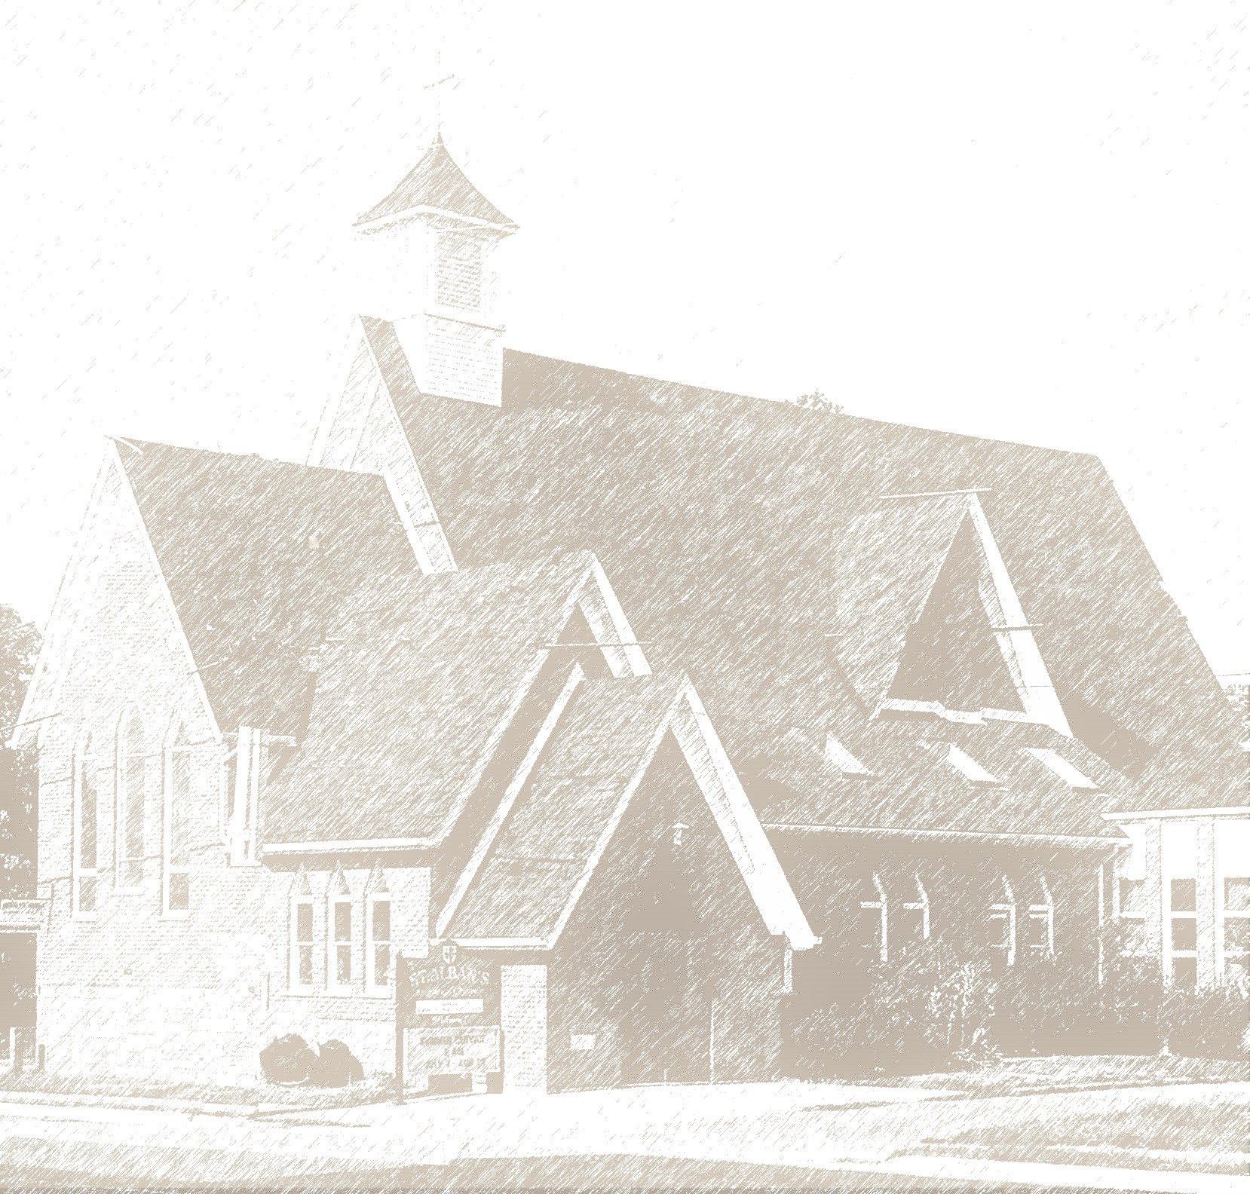
St. Alban’s, Beamsville
Pre-Authorized Giving Form

Giving Made Easy

Please return or mail to
4341 Ontario Street, Beamsville, Ontario, L0R 1B0

At St. Alban’s, Beamsville, we represent a community of family and friends with a shared vision and mission. Together we live out our core values in the world.

On this shared path, we pool our resources gladly. We chip in with the work required and stand ready to give a hand as we’re able. We also accept a hand of support when it is needed. By pitching in together with our time, talents and treasure, we grow as individuals spiritually as we seek to act justly and loving with all our resources that God has provided.

Pre-Authorized Giving not only helps our church community plan its annual budget, it also means our church can plan its ministries. It enables us to move from budget talk to conversations on ministry, outreach, activism, prayer, and caring for one another. It means we can focus more on why we exist as a community of believers rather than how we’re going to support our ministries and the work of the church.

Thank you for your support of the ministries of St. Alban’s.

You make a difference.

(con’t)

Easy Giving through Pre-Authorized Giving

St. Alban’s, Beamsville.

Business Number:

New* Increase Decrease Change Banking* Cancel

Name(S) ______________________________________________________________________________________________________________________
Address ________________________________________________________________________________________________________
City _________________________________________________ Postal Code _____________________________________________
Phone ______________________________________________ Email ___________________________________________________

* For New or Changed Banking, please provide a void cheque OR complete the table below:

Cheque Number  not required |  |  |  | Transit (Branch) Number |  |  |  |  |  | Financial Institution Number |  |  |  | Designation Number |  |  |  |  |  |  |  | Account Number

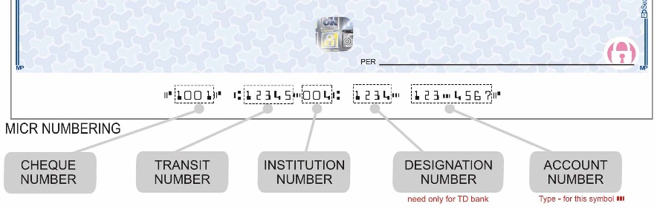

Payments can be taken on any numerical day of the month, i.e., 1st, 15th, 22nd, etc.

I/we hereby authorize you to debit my/our account each month on the _______________________ (1st, 12th, 23rd, etc.) in the amount of $ ______________ payable to the Diocese of Niagara on behalf of the St. Alban’s, Beamsville.** Your treatment of each payment shall be the same as if I/we had personally issued a cheque authorizing you to pay as indicated and to debit my/our account accordingly.

IMPORTANT: This authorization may be canceled upon written notice. Please note that the Church Office must receive any change by the 15th of the month for it to take effect the following month.

Signature (1) ________________________________________________________________________ Date ____________________________

Signature (2) ________________________________________________________________________ Date ____________________________

**The Diocese of Niagara remits Pre-Authorized Giving donations back to St. Alban’s, Beamsville. Please contact the church office at 905-563-4518 with any questions or to make any changes.

