Check out our new online

blood donor program at

www.yourwebsitehere.com

Lorem ipsum dolor sit amet, consectetuer adipiscing elit, sed diam nonummy nibh euismod tincidunt ut laoreet dolore magna aliquam erat volutpat. Ut wisi enim ad minim veniam, quis nostrud exerci tation ullamcorper suscipit dolor in hendrerit in vulputate velit esse molestie consequat.

Working Together for Better Healthcare

Support Our Annual

Blood Drive Event

Medical

CLINIC

Lorem ipsum dolor sit amet, consectetuer adipiscing elit, sed diam nonummy nibh euismod tincidunt ut laoreet dolore magna aliquam erat volutpat.

Nevada County’s 1st Annual

Senior Health & Resource Fair

**Free**

**Admission**

F

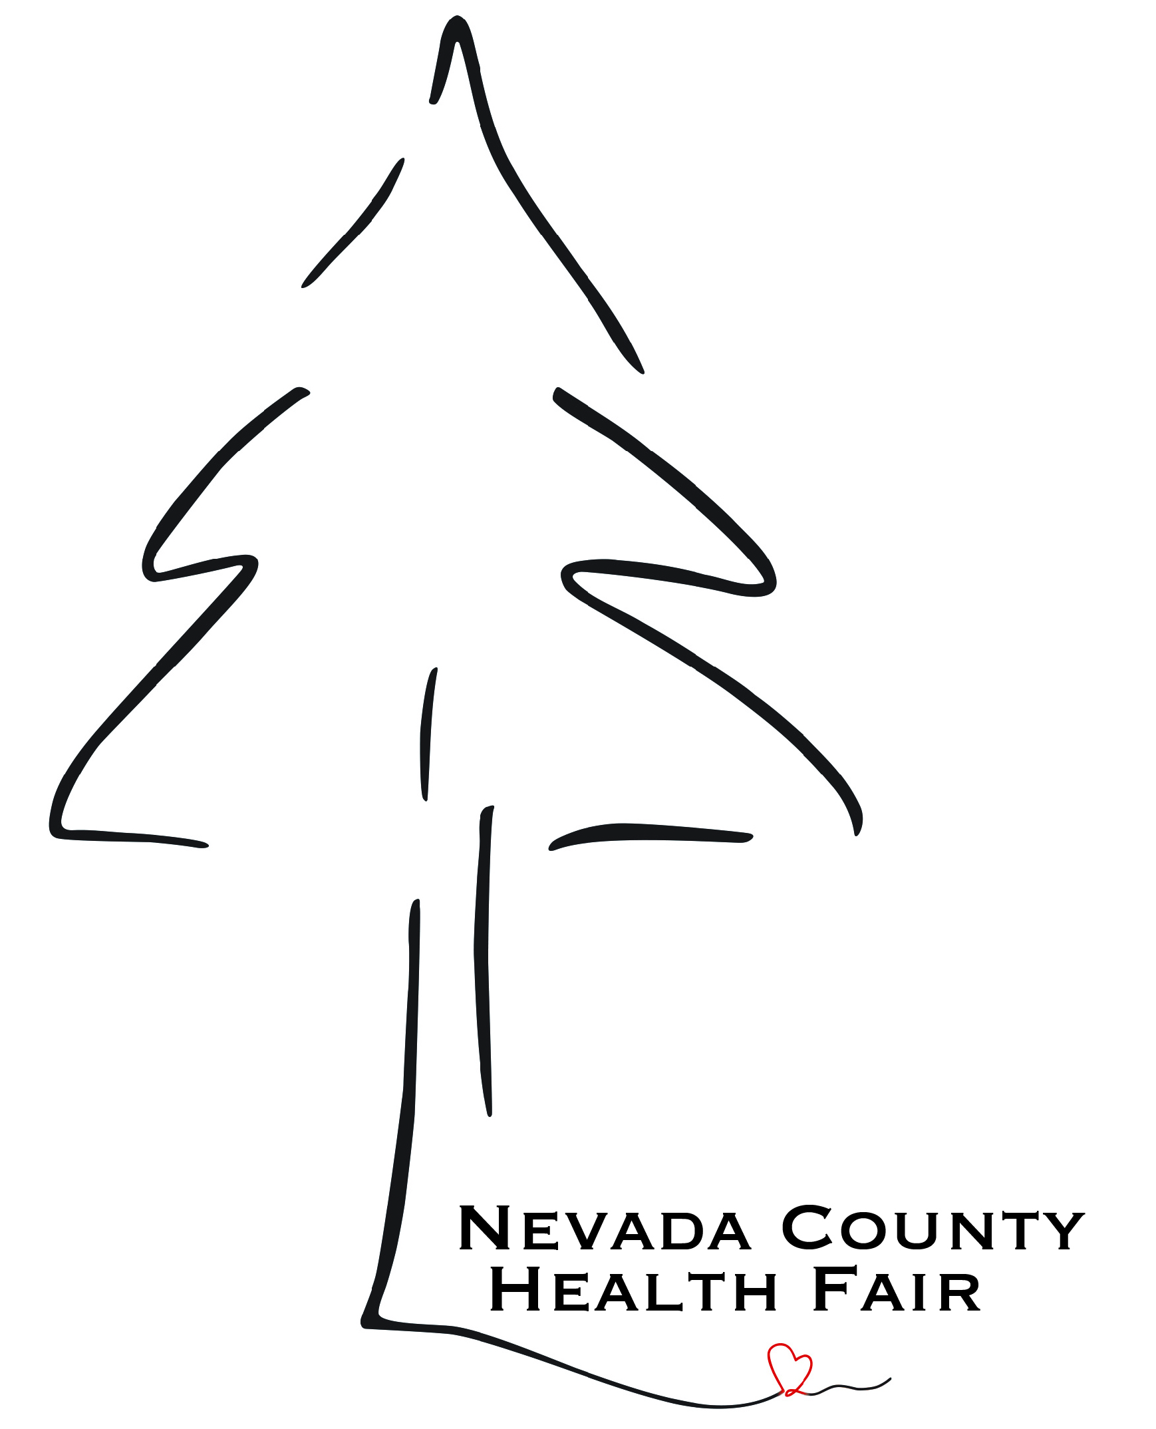

**MONDAY**

**25TH**

**APRIL**

5432 Any Street West

Townsville, ST 54321

**Free Health Screenings**

* **Flu Shots**
* **Blood Pressure Check**
* **Audiologist**

**Resource and Service Vendors**

* **Health Care Professionals**
* **Senior Agencies**
* **Adult with Disability Services**
* **County Emergency Service**

**For More Information Call:**

**Register at:**

**Event Sponsors:**

**ECPC**

**Nevada County**

**FREED**

**Amor Senior Care**

**Eskaton**



**October 4th, 2023**

**10am - 2pm**

**Gold Miner’s Inn**

**121 Bank St.**

**Grass Valley**

**BE A**

**HERO**

**GIVE**

**BLOOD**

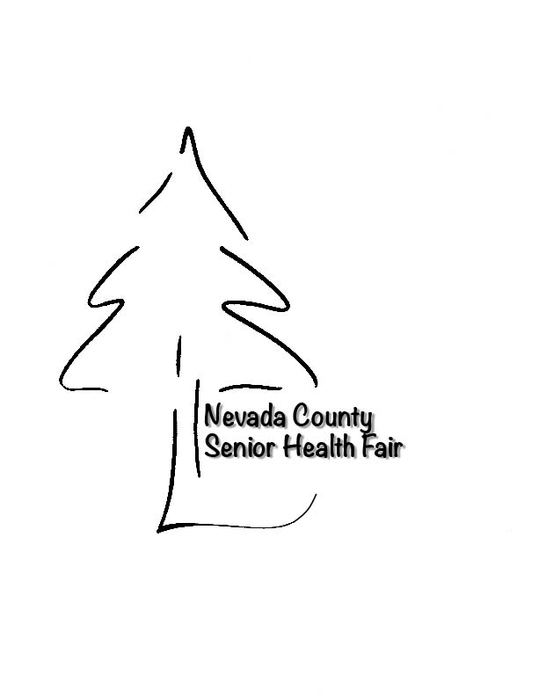**2-5pm**