Working Together for Better Healthcare

**Nevada County’s**

**2nd Annual Health Fair**

**Free**

**Admission**

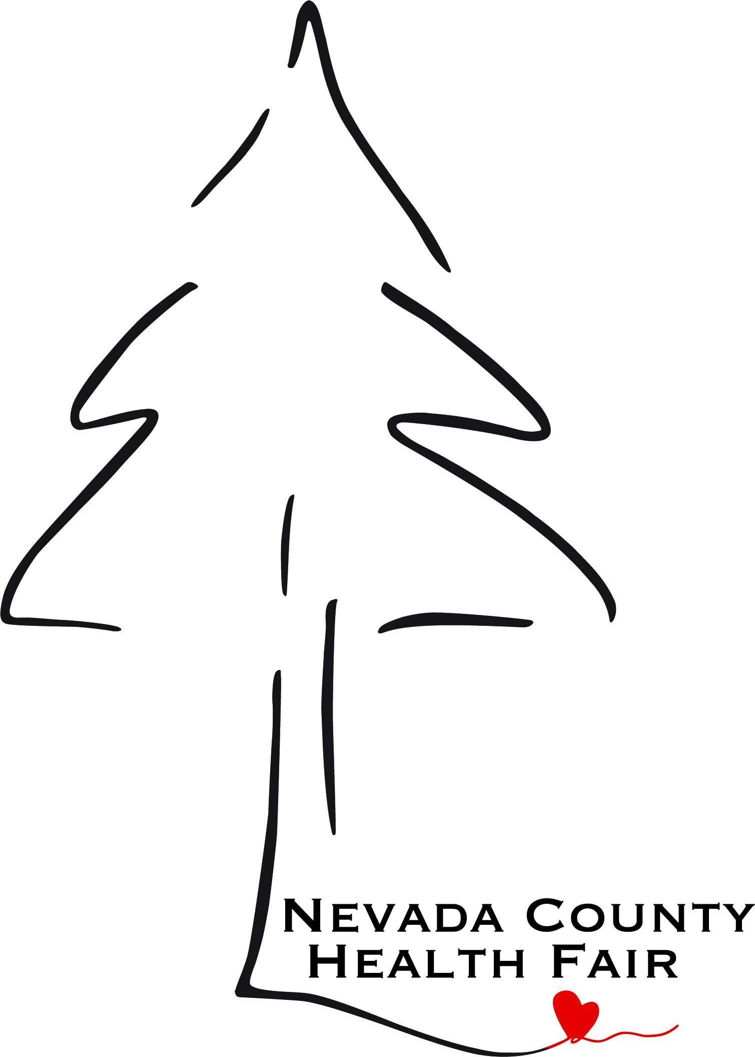

**MONDAY**

**25TH**

**APRIL**

5432 Any Street West

Townsville, ST 54321



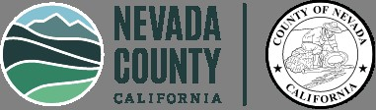

 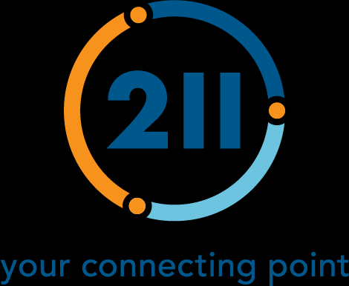

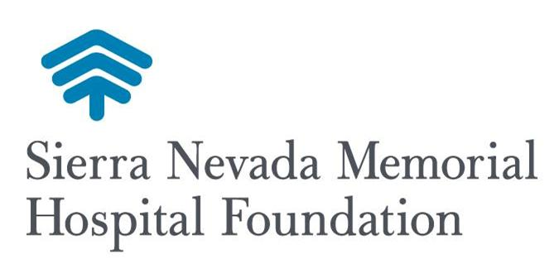

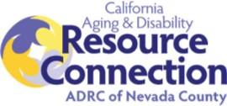

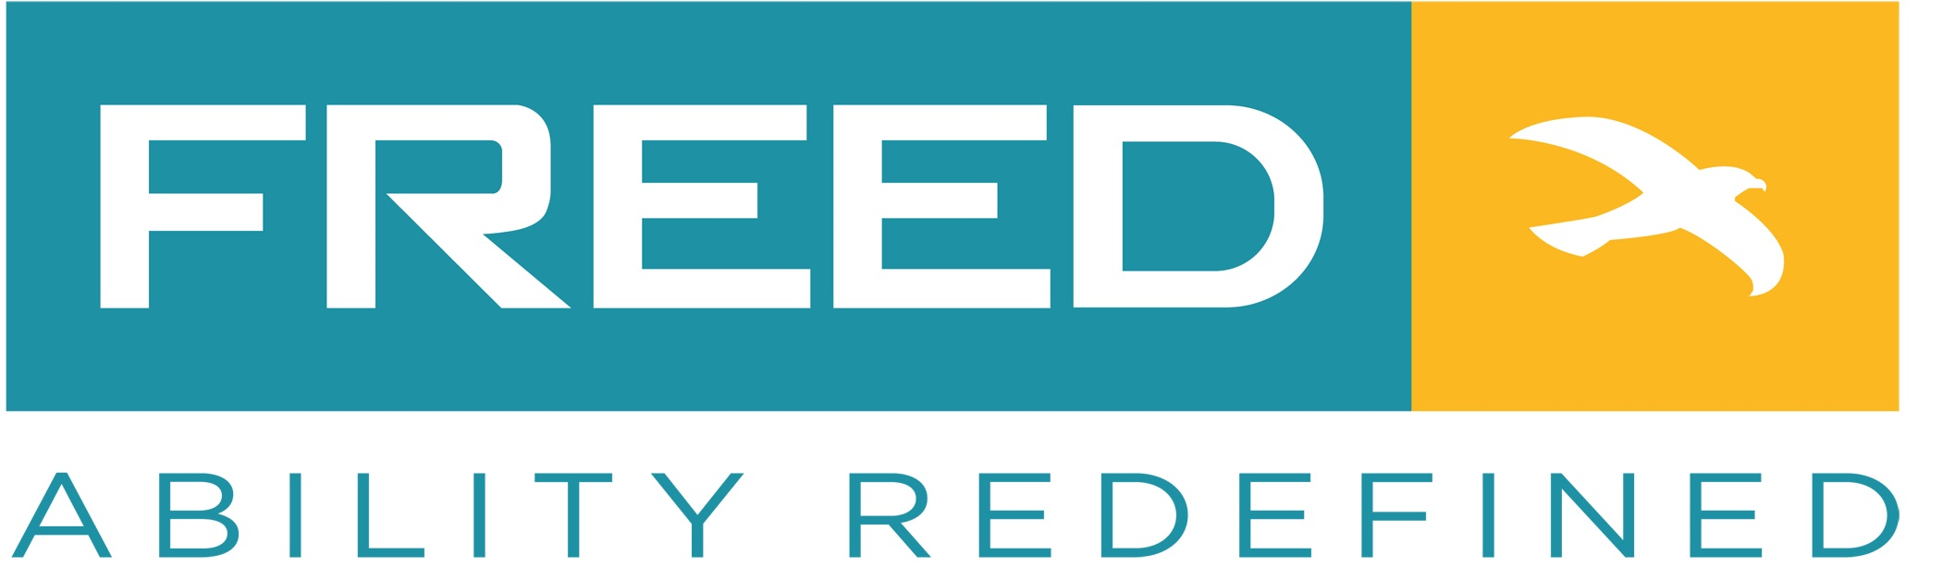



**Dokimos**

**Pharmacy**

**Sponsors**

**For Older Adults & People with Disabilities**

**40 Local Resource Providers including Nevada County Adult & Senior Programs, FREED, Hospital services,**

**Non-Profit & Businesses that provide services and resources for older adults and more….**

**Health Screenings**

* **Flu vaccinations**
* **Audiologist**
* **Blood Pressure Check**
* **Balance Evaluation**

**Call 211 to register for vaccinations after Sept 1st**

**Nev. Co. Connects rides will be free to this event!**

**Raffle Prizes!!! Snacks!!!**

**October 9th**

**2024**

**10am - 2pm**

**Gold Miner’s Inn**

**121 Bank St.**

**Grass Valley**



**BE A**

**HERO**

**GIVE**

**BLOOD**