Working Together for Better Healthcare

Nevada County’s
3rd Annual Senior Health Fair

Free
Admission

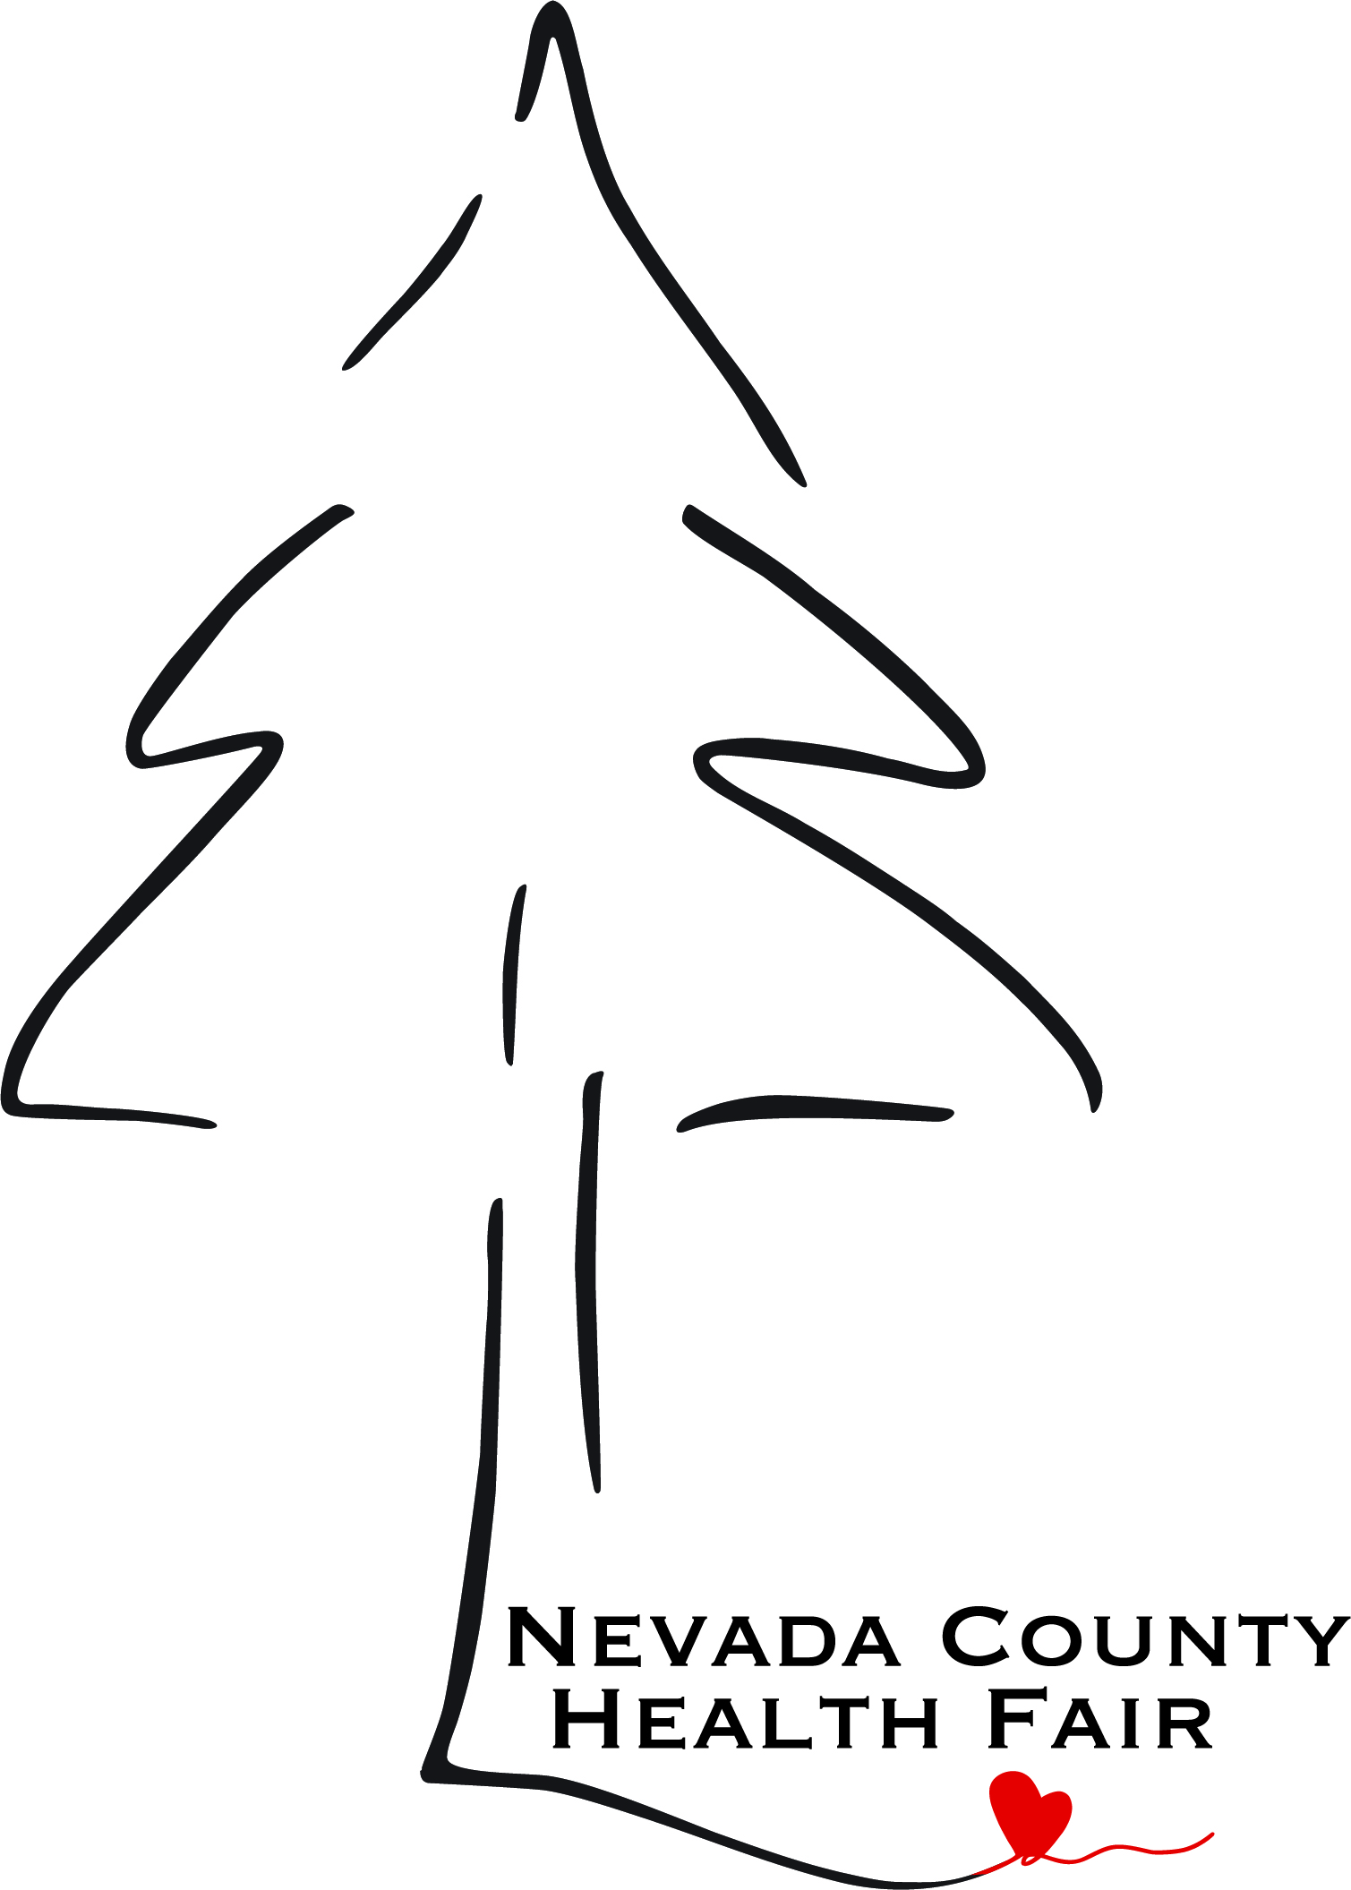
MONDAY
25TH
APRIL
5432 Any Street West
Townsville, ST 54321
October 14th
2026

10am - 2pm

Gold Miner’s Inn
121 Bank St.
Grass Valley

For Older Adults & People with Disabilities

40 Local Resource Providers including Nevada County Adult & Senior Programs, FREED, Hospital services,
Non-Profit & Businesses that provide services and resources for older adults and more….

Health Screenings
- Flu vaccinations
- Audiologist
- Blood Pressure Check
- Balance Evaluation

COVID vaccinations available if you pre-register with Dokimo’s by calling: 530-470-8854

Nev. Co. Connects rides will be free to this event!
Raffle Prizes!!! Snacks!!!



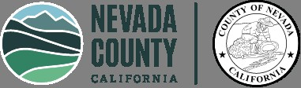

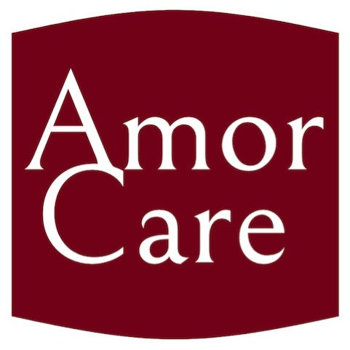

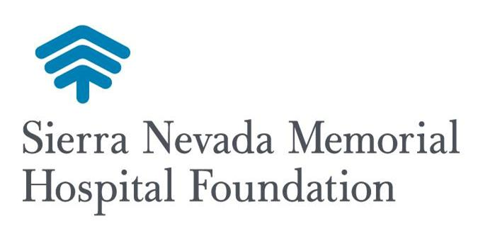

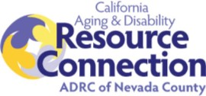

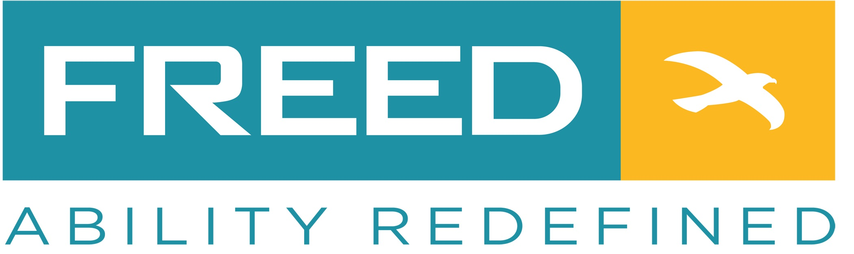

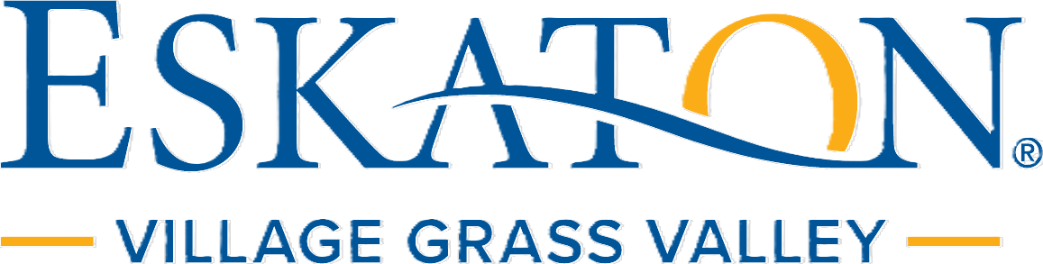

Sponsors
BE A
HERO
GIVE
BLOOD

