Valley Academy Public Board Meeting Agenda

May 12, 2015 at 6:00pm

539 N 870 W, Hurricane, UT 84737

1. Work session of the Board (6:00- 7:00pm)

a. SEI training (Karlene Young- 1st grade teacher)

b. Closed session (if needed)

c. Discussion regarding Gary G. Kuhlmann & Associates, P.C.’s contract

d. Discussion regarding 2015-16 budget and upcoming finance meeting.

2. Welcome and open regular session (7:05pm)

3. Pledge of Allegiance and Mission Statement: (7:05-7:10)

4. Approval of minutes from 4/9/15 meeting

The mission of Valley Academy is to provide a superior, character building academic program enhanced by integrated training in fine and performing arts, and a technologically advanced curriculum; *in a* ***S****ocial* ***E****motional* ***L****earning environment that promotes responsible freedom.*

5. How well are the school’s finances being managed? (7:10-7:25)

a. Business Manager’s monthly report

b. Discussion and possible action on updated contract with Gary G. Kuhlmann & Associates

P.C., for legal services.

c. Discussion and possible action on any purchase orders over $1,000. (Piano Gallery, lunch room tables, Voyager writing program, Star Math and Reading assessments)

6. How well are students achieving the outcomes for which the school was chartered? (7:25-7:50)

a. Mr. Dunkley’s monthly report

7. How well is the Board performing its responsibilities? (7:50-8:20)

a. Board Training/Charter Review

b. Any reports from committees

i. Accountability Committee

ii. Growth Committee

c. Discussion and action on addition of two new board members.

d. Discussion to create a resolution changing the bylaws to state that a majority of members equals a quorum.

8. Public Comment (8:20-8:30)

a. PTO report

b. Any other public comment

Please plan ahead for your comments to be 3 minutes or less. Due to open meeting regulations, please be aware that the board will not be able to *formally* discuss or take action on items brought up in this meeting’s public comment period.

9. Next meeting *proposed* for June 11, 2015

Valley Academy Public Board Meeting Minutes

May 12, 2015 at 6:00pm

539 N 870 W, Hurricane, UT 84737

In attendance: Lane Blackmore, Alisha Terry-Martin, Kevin Dunkley, Thayne Smith, David Hinton, Miranda Kloos, Karlene Young.

Work meeting started at 6:00pm

Karlene Young- teaches 1st grade this year giving a presentation on SEI in her classroom. Praise the positive instead of pointing out the negative. Marvin and Jesse lessons used in the classroom. (Games are available for this also that go with the assemblies) Kids are given the opportunity to stand and say what they appreciate about classmates. Teacher notices kids that aren’t mentioned so every child receives praise. Prevention Dimensions- character education curriculum K-6. Music goes with this. SEI is used in class every day. “Song of the month”. Steve James- possible assembly?

No closed session needed.

Attorney is not here for discussion on contract. Item will be placed on June agenda.

Budget discussion: Karlene Young gives an overview of a proposed drama budget for next year. Kevin Dunkley and Barbara Merrill have helped write the Beverly Taylor Sorensen grant. If we get this, it pays for 40% of drama teacher’s salary plus benefits. This year the state has appropriated more money. Last year 69 schools got the grant. This year 220 schools have applied and the legislature has doubled the funding. Teachers at the school will need to attend drama/music classes in order to maintain grant funding.

Finance Committee meeting- May 28th at noon for full budget discussion. Everyone should attend, if possible, because the budget will need to be voted on at the June meeting.

Playground discussion. A grant is being written to help pay for half of a new playground. A discount of 50% is given with the grant, then a payment system will pay for the rest. Lane is willing to donate equipment and labor to get the playground installed. Can we afford a payment? Playground can be placed outside the west fence and the fence moved. This could be done before school opens in the fall. Discussion to continue in the budget meeting.

Discussion of needing more presence in the community. We need a person in charge of marketing and promotion....maybe someone that is paid. The growth committee will look into this and maybe find a volunteer.

Elementary students (4th grade) turned in essays to the Sons of Utah pioneers. Valley turned in the most by double than any other school.

Motion to adjourn work session by Alisha. All members in favor. 7:00

Regular meeting opened at 7:05pm

Additional in attendance: Peggy Childs, Shawna Iverson, Barbara Merrill, Natalie Metzger, Charlotte Potter, Amy Mackay.

Recognition of two new board members, Miranda Kloos and David Hinton, officially voted by the board.

David led the pledge

Miranda read mission statement

David made a motion to accept the minutes as written. All in favor.

Thayne’s report- Valley Academy’s enrollment is good compared to other schools that Red Apple assists with financing. Oct 1 count was 413 and today’s count is 406.

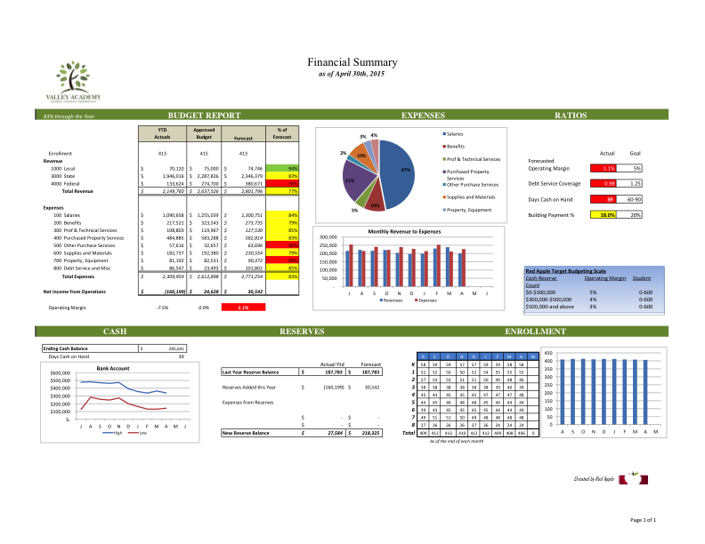

Purchase orders more than $1,000:

* Step up to writing- purchase request for next year. Helps teachers with lesson plans.
* Pianos come from REAP grant. Most of the grant $ was spent on the Journey’s reading program.
* Go Math program and Star Reading program.
* Replacing lunch tables with lunch funds.
* Step up to Writing, Character Education, and Autism items.
* All items are in the budget. Motion by David to approve the above items per purchase order policy. All members in favor.

Miranda made a motion to table the discussion on the contract with Gary Kuhlmann and associates. All members in favor.

Kevin’s monthly report:

* Sharing 1st grade student work, “If I were President”.
* Kids are finishing up SAGE this week. Most are showing significant growth. Future of SAGE test is uncertain, but our school did a great job this year.
* $200,000 in grant money still coming.
* Library specialist- Barbara Merrill moving from 2nd grade.
* Lyndy Butler hired for piano and guitar as electives. She is on board with SEI and wants to get kids on stage. Doing an assembly for the school on Friday. Kevin says the room available for kids before and after school to practice and details are still being worked out for instruments.
* Discussion of 8th grade. Comments made from audience that kids are moving to the middle school to follow their friends, students may feel 8th grade is not challenging enough, our SPED resources are stretched thin, teachers need to be highly qualified for 7th and 8th grade, teachers comment that the kids might be bored of the same classroom. Teachers are telling students that we are dropping 8th grade. What other options do we have to keep 8th grade and improve it? Removing 8th grade will require an amendment to our charter. A work session will be required to get more information on this subject before a decision is made- maybe a special work session prior to the next board meeting. Staff requests to make the decision soon.
* Kevin reports that next year’s calendar is still being worked on. Unsure if we will mirror the districts minimum days or not.

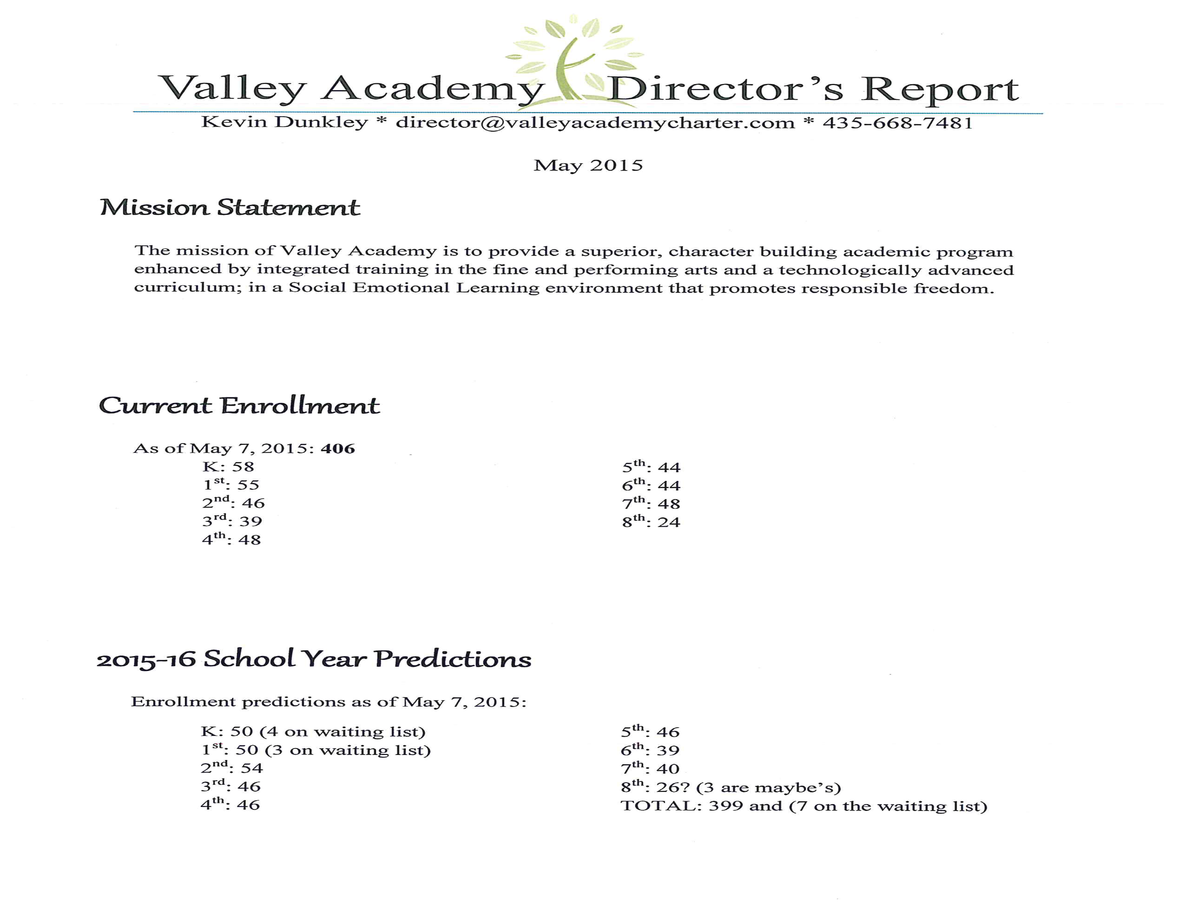

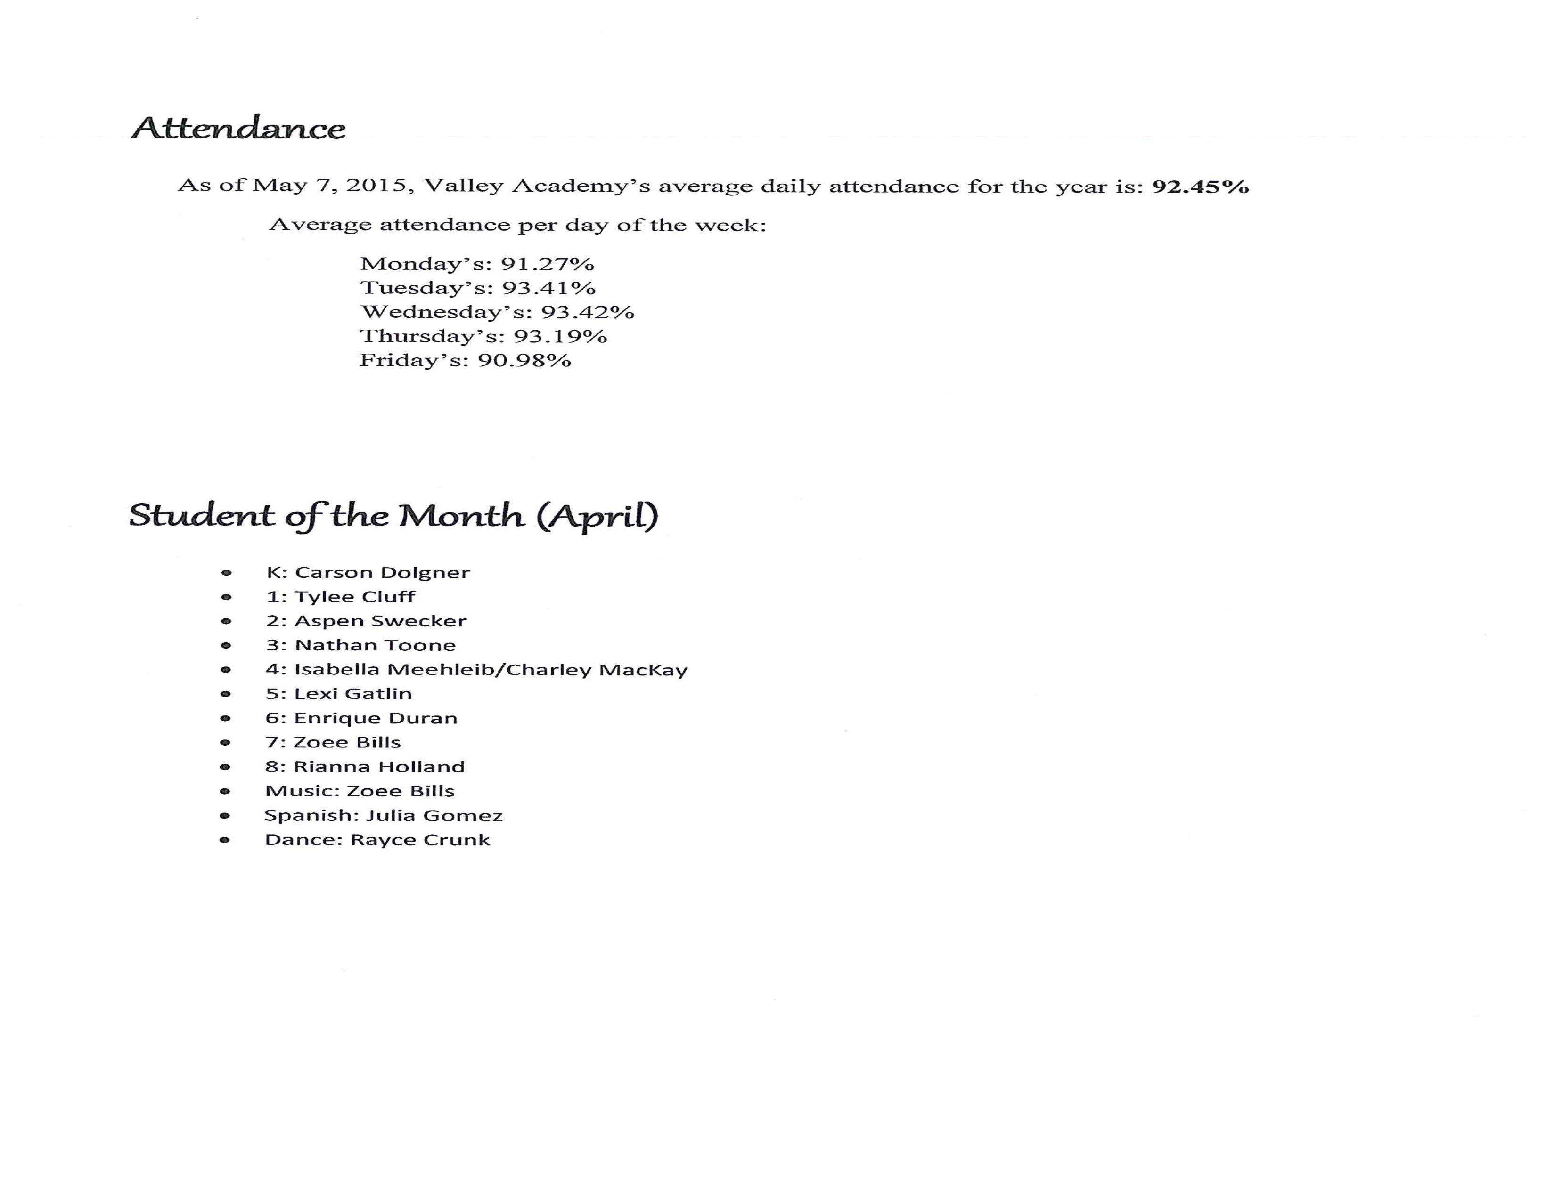

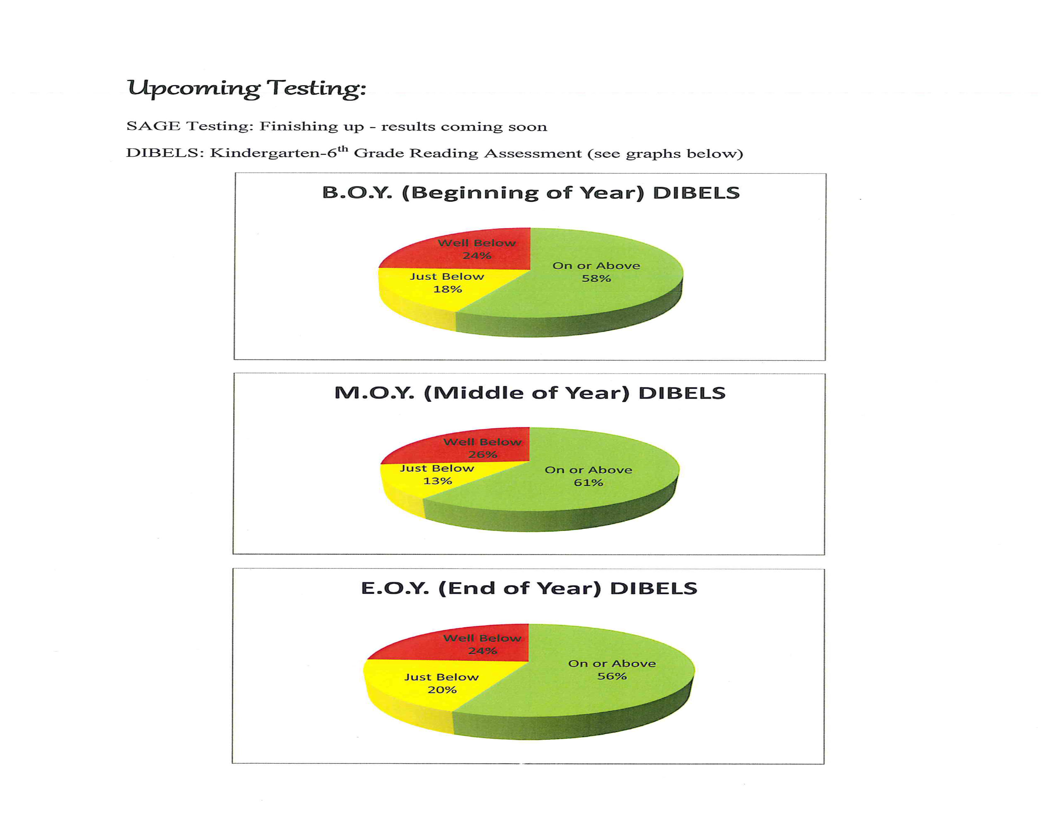

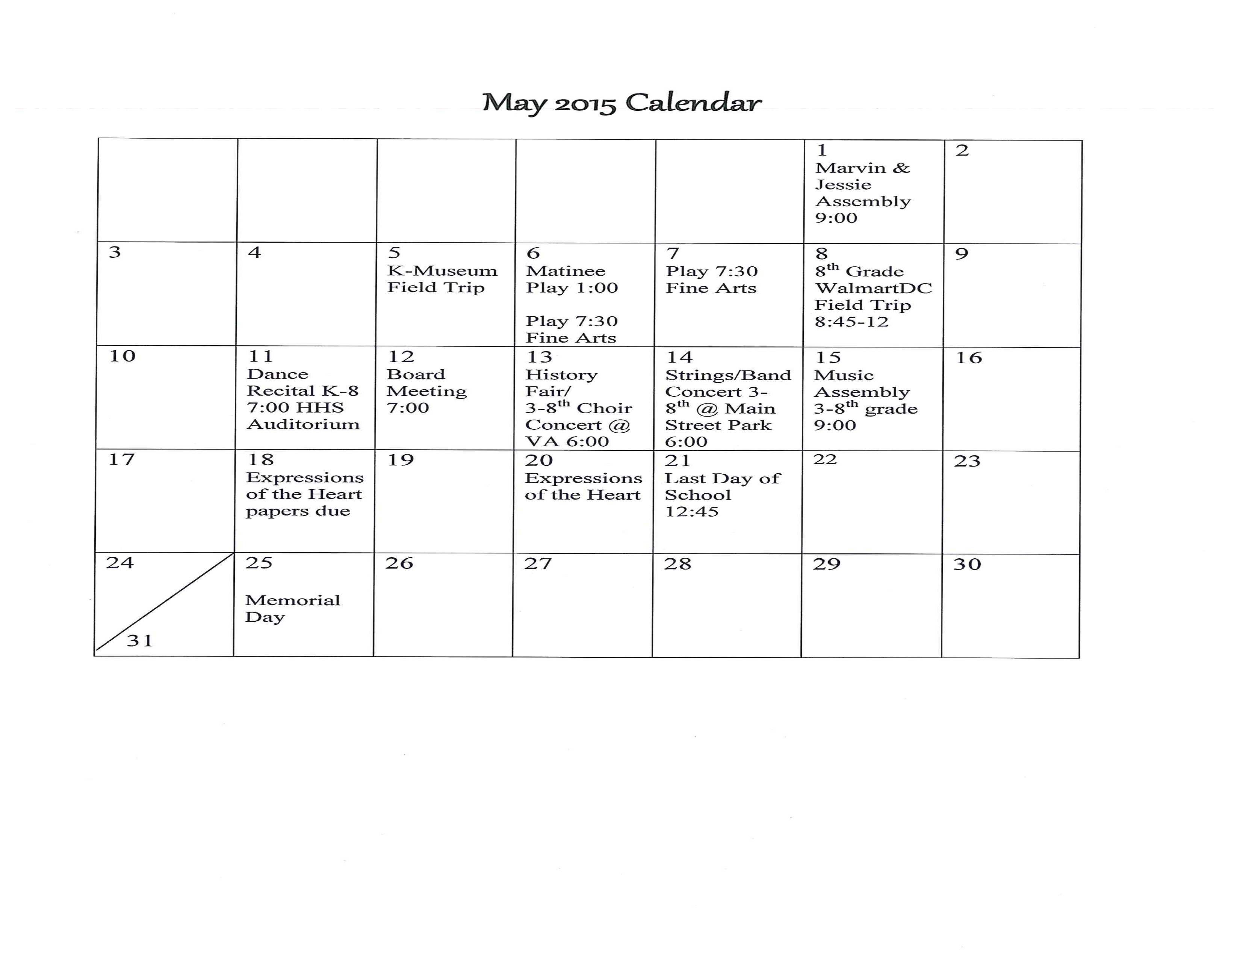

Accountability Committee will meet after this meeting, so nothing to report this time.

Growth committee report. This committee will meet monthly.

Growth Committee Notes- April 23, 2015

In attendance: board members, school director, teachers, parents.

Committee purpose and goals agreed upon:

* improve current enrollment
* explore alternative funding
* discuss high school plan
* transparency and the reality of what’s happening at the school
* improvement of school culture
* staying true to the charter
* growth that is financially sound and responsible

Discussion started with high school planning. The group was interested in a blended model that would allow for online learning, in-school guidance, and in-school electives (especially the arts). Concerns about the older kids mixing with the younger kids...to be addressed with building planning. The group agreed that a high school is eventually where we want to go, but strengthening the elementary and middle school that we currently have is top priority.

Discussion shifted to what we do well and what we need to improve on. Everyone agreed that the school is only getting better each year as we learn and grow.

What is going well:

* Summer school (improve on the good foundation and offer more intensive “summer camps” for arts and technology)
* Our school garden and livestock
* K- 3 reading and math programs
* Breakfast and Lunch
* Busses
* Awesome teachers- teachers now want to come here from the district
* Full day Kindergarten (with the option of ½ day)

What we need to improve:

* Getting the word out about the great things that are happening here (FB, Instagram, Twitter) *Someone needs to be in charge of this. We can offer rewards for sharing. We also need to be aware of those who don’t want their kids pictures on social media.
* Classes for parents on what SEI is....most people still don’t know.
* Be out in the community performing.... a lot! Get our arts programs well known.
* Invite the community in to our school more- take advantage of the experts that live in our area to teach intensive classes, workshops, and assemblies.
* Participate in all the local parades, festivals, etc. Be a presence. Flyers, shirts, etc. Have a booth at Peach Days and at the WC fair until we have a wait list and we’re well known. There are still people who don’t know we are here or don’t know we are a free public school.
* Connect with local businesses for sponsorship.
* We need a playground for the older kids. This is the number 1 thing lower grades hear complaints about. 2nd grade team is currently working on a project with grants to help pay for ½ of a new playground. They have also found a company that will take payments. We need to be competitive in the lower grades...this is the first step.
* Reach out to homeschool kids. There needs to be a solid plan in place for doing online work at home, but allowing them to come to us for electives (mostly arts). *Someone needs to be in charge of this.
* Make more school logo clothing available (hoodies and spirit shirts)
* School should be fun.
* Programs available before and after school (boys and girls club?)
* Strengthen our arts programs in all grades
* Put testimonials on our social media and website
* Create a video that showcases our programs, teachers, and students....to play in the local theaters and at our booth in festivals. This is apparently already in progress, but needs some follow up.

There was some discussion about 8th grade....low numbers (20 are staying) and high SPED requirements (50%). Trying to figure out the schedule for next year has been difficult so far because of these two issues. Several parents and teachers state that they are taking their kids to the middle school for 8th grade because they don’t want their kids to have to be in 3 different schools in 3 years. This will be an ongoing discussion.

Motion to table resolution to bylaws. All members in favor.

PTO report: provided treat for 5th grade maturation packets, provided water for Arbor Day, Box Top party for Kandis White’s class, Lins check for grocery points, playground funding towards grant, teacher appreciation (door decorating, snacks, massages, VA tumblers, lavender essential oil, dry erase marker set, water dispenser for the faculty room), last day of school activity soccer game (kids vs teachers), stencils on the back parking lot, tetherballs. Future of the PTO is uncertain due to lack of volunteers. We hope to have better news soon.

No public comment requested.

Motion to adjourn by David. All in favor. 8:42pm