Valley Academy Public Board Meeting Agenda
September 19, 2013 at 6:00pm
539 N 870 W, Hurricane, UT 84737

1. Work session 6:00-7:00
a. Closed session to discuss insurance contract negotiations 6:00-6:30
b. Open session for any other discussion 6:30-7:00

2. Welcome and open regular meeting 7:00pm

3. Approval of meeting minutes from our 8/20/2013 Board Meeting

4. Mission Statement:

The mission of Valley Academy is to provide a superior, character building academic program enhanced by integrated training in fine and performing arts, and a technologically advanced curriculum; in a Social Emotional Learning environment that promotes responsible freedom.

a. Update on State Charter Board request to update mission statement.

5. Board Appreciation:

6. How well are students achieving the outcomes for which the school was chartered?
a. Mr. Dunkley’s monthly report
b. Introduction of new staff members

7. How well are the school’s finances being managed?
a. Mr. Stringham’s monthly report
b. Mr. Monson’s monthly report

8. How well is the Board performing it’s responsibilities?
a. Board Training/Charter Review
b. Any reports from committees

9. Public Comment
a. PTO monthly report
b. Any other public comment
Please plan ahead for your comments to be 3 minutes or less. Due to open meeting regulations, please be aware that the board will not be able to formally discuss or take action on items brought up in this meeting’s public comment period.

10. Next meeting scheduled for October 17th, 2013

11. Adjourn
Valley Academy Public Board Meeting Minutes
September 19, 2013 at 6:00pm
539 N 870 W, Hurricane, UT 84737

In attendance: Allan Kaplan, David Bowles, Doug Beecher, Derek Lewis, Lane Blackmore, Alisha Terry-Martin, Dave Monson, Kevin Dunkley, Ben Ruesch, Tonya Heyder, Tonya Crunk.

6:00pm- work session

***Closed session for the purpose of contract negotiation***

Lane turned time to Dave Monson who had requested a closed session to discuss our insurance contracts. Dave says that Spectra Management, who is currently servicing our insurance contracts for the school have had numerous customer service related problems and additional costs. Ed Woodd signed this contract with Spectra last year. Our normal bill per month is $10-12,000. Last month was over $20,000 and Dave was unable to quickly get any answers or help because Dawn was still the administrator for the account. He has since been able to get a credit on the account. Due to poor customer service, Dave is suggesting a change in the company that services our insurance programs and also adding a life insurance policy in order to make our program more competitive with surrounding schools and more attractive to our teachers. Adding life insurance will cost the school $226 per month total to cover all our full-time employees, which is around $2,000 per year. Employees will be able to purchase additional life insurance for a small amount.

Dave introduced Mountain West, a local company who is offering a contract to service our insurance accounts. They are aware of what is being offered by WCSD because they service those accounts as well. They are interested in educating our employees on insurance plans, HSA, and financial planning. WCSD pays 100% benefits. We currently offer 80/20. Adding life insurance will help us be more competitive. Mountain West says switching our plan to their company will not cost us any more than we are paying now.

The quote from Mountain West is the only quote. Because this is a large budget item, it will need to be added to the normal agenda for the next meeting. The Board would like to see a comparison and cost breakdown prior to the next regular board meeting in order to make sure we are complying with our policy and State procurement rules.

Derek made a motion to move into open session

***Open session***

Meeting moved into multi-purpose room for remainder of work meeting.

Discussion of policy on firearms on campus. Our current student/parent handbook has a zero tolerance statement on weapons. Dave and Kevin and revisiting policies and handbooks, updating what was written last year.

Technology night was last night from 5-7pm. Was supposed to start with a 20min presentation by Skywire, but they were late, so the group was split up into 8 break-out groups and visited classrooms around the school, showcasing our technology and the online programs we are utilizing. Around 200 people attended. Two iPods were donated and two drawings were held to give them away to attendees.

7:00pm- Regular meeting opened by Lane

Additional attendees: Scott Smith, Darin Larsen, Amber Larsen, Nick Hasenwinkle, Brandon Howe, Charlotte Potter, Rebecca Hall, Brenda Hall.

Doug made a motion to accept the 8/20/13 and 9/16/13 meeting minutes as written. All members in favor.

Mission statement read by Doug. We asked about the process to add to our mission statement, which usually requires an amendment request to the State Charter Board. Marlies said that she will be able to make an approval like that sometime in the next several months so we won’t need to travel to SLC and make a formal application.

Amber Larsen was nominated for Board Appreciation because she came in as a long-term substitute when we had a teacher quit 2 days before school started. She did an excellent job with our 7th and 8th grade language arts classes. She stayed for nearly a month while we looked for a permanent teacher. The students loved her and we appreciate her service!

Mr. Dunkley’s monthly report: Introduced new faculty members, Brandon Howe who is teaching 7/8th grade Language Arts. Also Nick Hasenwinkle who is teaching 7/8th grade Science. Kevin says we searched for teachers who fit well with our philosophy and these two teachers have already made great contributions and have excellent ideas for the year.

We got the implementation grant, which was just over $100,000. This allowed us to get more laptops and iPads for the students as well as desktop computers for each of the staff. This grant was also for instruments and music.

Our enrollment is currently 414. We currently have 53% of our students reporting eligible for free and reduced lunch. Daily attendance is over 95%, which is much better than last year. Even Fridays are over 95%.

The Board would like to see families that leave the school given a survey so we know why students are leaving. This will help us to improve. Survey should ask if they would like contact if the situation they left for changes.

Kevin showed a document from the USOE that spoke of best practices. Valley Academy is following nearly all the best practices. The Board asks that we share this with our families.

Kevin is working on setting up a better testing environment in the extra classroom space for this year. It will be able to better utilize our technology and be a quiet space.

There are hanging wires in the hallway to showcase student art without damaging the walls with tape. Our students are participating in poetry contests. Our online programs are able to give feedback to the teacher and parents on how much time is being spent practicing and which areas are being practiced.

The DIBELS test has been purchased for all grades this year. It is required for K-3 by the State of Utah, but all our students will be tested for our own baseline this year.

Brandon Howe was asked to tell about his new elective program called “Attic”. This will be an arts elective that has many components such as photography, poetry, etc. We will hear more about it as it grows.

Mr. Howe and Hasenwinkle spoke about teaching our 7th and 8th grade students to be leaders and set themselves apart from the elementary so they can prepare for their high school experience.

Mr. Stringham’s monthly report: Read by Dave Monson.

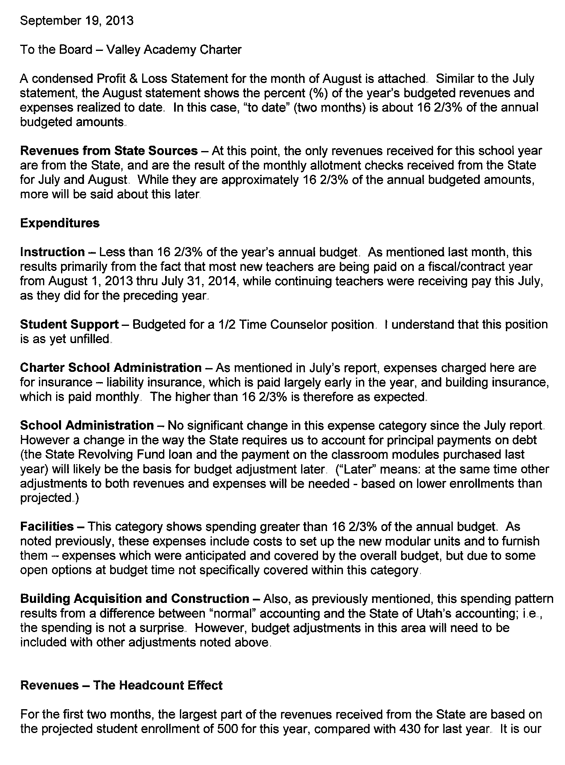

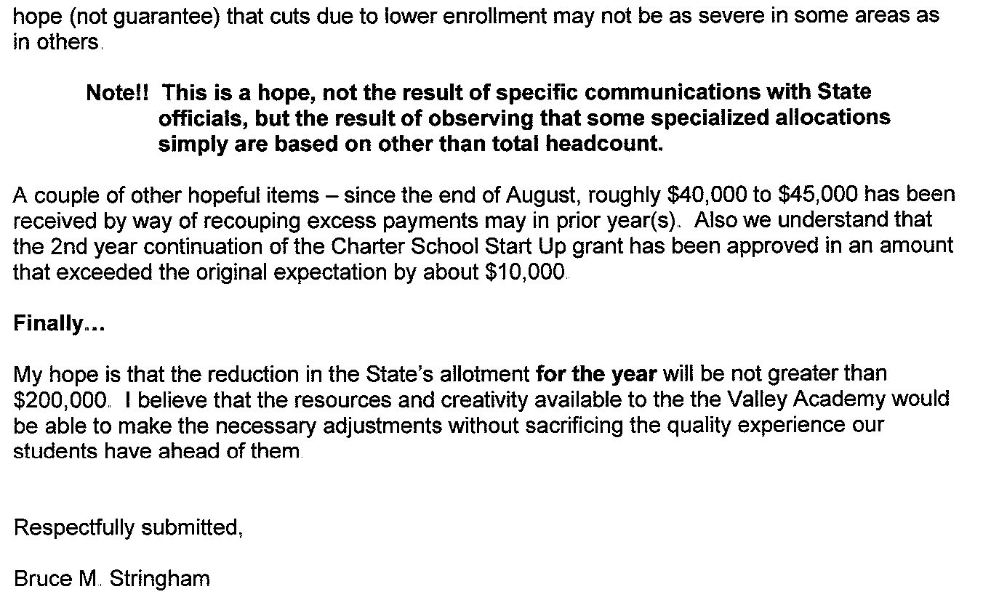
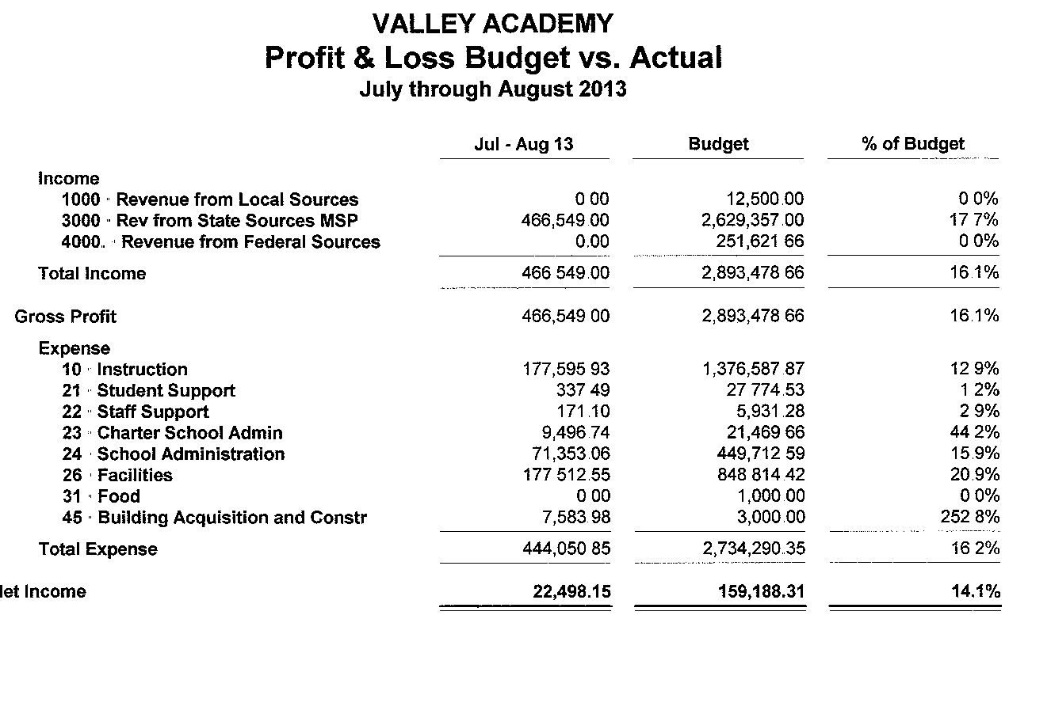

Mr. Monson’s monthly report: Dave reported a possible change in insurance coverage. This will be reported on again at the next regular board meeting. The proposal will add life insurance to what is currently offered to full time staff members.

Dave reported that an offer had been made to a PT counselor and was pending her background check.

Positions still open: internal staff developer, IT technician, Special Education director, Special Education teacher.

Work is continuing on policies and handbooks.

The Director, Business Manager, and HR Director met with Karl Wilson –USOE Director for Title I and IIa programsfor initial and recurrent UCA budgettraining here at Valley on September 11, 2013.
Keturah Lance and Dave Monson attended UTRex training that was held in Salt Lake City on August 21, 2013. Additional two-hour webinar training with UTRex took place on September 17, 2013 that includes changes to reporting accredited students.
SkyWire continues to provide training to all Faculty members using school technology in the classroom.

Lane requests moving Board training to next meeting due to time.

Doug reports that the Accountability Committee will meet on 9/24/13 at 6pm. The reason for the meeting change was that Kevin was attending meetings in SLC to gather information on school grading. The committee wanted this information for its meeting.

Lane reports that he attended a State Trust Lands meeting. He learned that State Trust Lands greatly effect school funding in Utah and that much of our State lands are locked up. Other states that have greater school funding are those that have allowed use of their state lands. There is a State Trust Lands Board meeting in St. George at the Hampton Inn on River Road, 9/25 at 6-8pm and 9/26 at 9am.

Charlotte Potter reports on PTO activities: PTO has approximately $7,000 and has been asked for funds for several projects. They request that people will come to them with proposals and funds needed for consideration. The $7,000 total is broken into different projects right now, like drama and playground, etc. The penny wars fundraiser has raised $460 this week. PTO led a Patriot Day activity where classes wrote letters and drew pictures for police, fire, armed services- Charlotte delivered these to agencies around the valley and had a great experience. There is a school dance tomorrow for 7th and 8th grades. Pizza day is successful every Thursday- about 45 pizzas each time. Celebrating Homecoming week in Hurricane with a Spirit Week for our school. Doughraiser at Dominos will be held during this week. Red Ribbon week will be celebrated with a walk to school day.

We are currently working on school lunch. WCSD has informed us that they will not be serving us, but we have a couple other options. We are in process of setting up our own account with the State Nutrition office for free and reduced lunch. We have met with DRMC for the possibility of vending meals from them. This will be a great partnership because of the focus on healthy meals. We will most likely need to hire one person for this and offer a benefit of free meals for lunchroom volunteers. We hope to have this up and running by October 1.

No public comment.

Next regular public meeting will be October 10th, moved due to school break.

Derek made a motion to adjourn. All members in favor. Meeting ended at 8:55pm

