Valley Academy Public Board Meeting Agenda
November 21, 2013 at 6:00pm
539 N 870 W, Hurricane, UT 84737

1. Work Session of the Board 6:00-7:00pm
a. Communication of School Activities
b. Discussion of forming a committee for school growth and grants

2. Welcome and open regular Board meeting 7:00pm

3. Approval of minutes from 10/10/13 meeting

4. Mission Statement:
The mission of Valley Academy is to provide a superior, character building academic program enhanced by integrated training in fine and performing arts, and a technologically advanced curriculum; in a Social Emotional Learning environment that promotes responsible freedom.

5. Board Appreciation

6. How well are students achieving the outcomes for which the school was chartered?
a. Mr. Dunkley’s monthly report
b. Introduction of new staff members

7. How well are the school’s finances being managed?
a. Mr. Stringham’s monthly report
b. Mr. Monson’s monthly report

8. How well is the Board performing its responsibilities?
a. Board Training/Charter Review
b. Any reports from committees
c. Discussion and possible approval of School Climate Survey and Director’s Semi-Yearly Evaluation (recommended by Accountability Committee)

9. Public Comment
a. PTO report
b. Any other public comment
Please plan ahead for your comments to be 3 minutes or less. Due to open meeting regulations, please be aware that the board will not be able to formally discuss or take action on items brought up in this meeting’s public comment period.

10. Next meeting scheduled for December 19, 2013
11. Adjourn
Valley Academy Public Board Meeting Minutes
November 21, 2013 at 6:00pm
539 N 870 W, Hurricane, UT 84737

In attendance: Lane Blackmore, Alisha Terry-Martin, Derek Lewis, Tonya Heyder, Jimmy Ashley, Scott Smith, Dave Monson, Kevin Dunkley, Gary Kuhlmann, Ben Ruesch.

Lane opened the work meeting at 6:00pm

Discussion of how we can make sure everyone is better notified and aware of activities and good things going on at the school. Sometimes the word gets out to some people and not others. The Board doesn’t need to know every tiny little detail, but would like to be more aware of the activities going on so we can attend, support, and share the good news. Kevin and Dave will discuss a possible calendar format where all activities are added to the website. It would then be everyone’s individual responsibility to check the calendar. They will let the Board know what they decide to do. Also, the Board should be on the email list for messages that go out to the whole school population.

Discussion of creating a committee for school growth. Kevin says that there is a PR committee that was meeting weekly up until the Oct 1 count. Administration is working on growing our enrollment to be full at the end of the school year. Planning for summer programs to keep students here and interested in staying for the next year. Working on getting a bus. The school has a need for a bus to help with enrollment and also reducing the costs of renting buses for field trips. Kevin will report back on what he find out about liability and insurance costs, as well as maintenance. Marlies told Kevin that most charter schools who have buses own the bus instead of having the PTO own it, like Vista currently does. We also want to work on the public’s perception of our enrollment being full and a wait list of 2 years. This is a rumor that is going around…we need some better PR to let families know we still have spaces currently open.

Discussion of possible refinance of the building. Kevin has talked to Ziggler, a company that helps churches and schools with building financing. We would like to hear more detailed information about how Vista’s experience was with their recent refinance. Marlies gave information that many schools are able to refinance or Bond in year 3. Joel Wright helps charter schools with bonding in the State. A better interest rate will help us save thousands of dollars per month that we can use toward education instead of rent. We need to create a plan before we invite Highmark to discuss a contract/lease negotiation. We would like to ask Trent Seegmiller to participate in this discussion with us. Gary Kuhlmann will also review our lease agreement with Highmark so we are aware of what our legal options are. Kevin will set up a Thursday evening meeting with representatives from Vista and Ziggler, Trent, and Gary. Enough notice needs to be given for us to properly post the meeting.
Question of the $500,000 that was unresolved in the construction process with Bouma and Highmark. Highmark was able to demonstrate that the money was paid to Bouma, but Bouma was not willing to show where the extra money went. They had originally agreed with us not to have a profit of greater than a certain amount. When asked about violations of the lease agreement, they explain it with they did what they needed to do to get the building open on time.

Question: what we are paying Kuhlmann and Assoc. for retainer. $500 per month for up to 4 hours per month.

Question: are teachers/school staff looking for grants and do they have any incentive to do so? Kevin says that Mrs. Metzger and Mrs. Bowler are attending a grantwriting workshop. School staff have applied for and gotten a couple of grants for the school this year. Who else can we get to help us write grants? Contact: Charity Smith (previous Board candidate), Shirlayne Quayle, Tom Kuhlmann, Adam Heyder. Look into Eccles Grant, Gates Foundation, Wal-Mart local and DC grants. Our goal is to become a school that is in a strong position to be eligible for gants. Grants.gov has 405 educational grants currently listed. Nickelby foundation for school improvement. Jimmy is aware of a grant available through Wal-Mart for the Bio Dome we have been planning. We will get a group together and include the PTO’s wellness committee to get a plan and application in place for that.

Question of how we are handling Board Appreciation: in the future, discuss nominees at the work meeting and award at the next scheduled meeting. If possible, get the person who nominated to come speak as to why they chose the person. Encourage students, parents, teachers to make nominations. Add a certificate signed by Board Chair and Administrator. Add picture and why nominated on website to give people ideas on what is appropriate to nominate for. We don’t mind sorting through students nominations who want to say their friend is a good friend, but want to encourage nomination for something that was beneficial to the school.

Work meeting adjourned at 6:57pm

Lane opened the regularly scheduled Board meeting at 7:05pm

Additional in attendance: Brenda Hall, Tonya Crunk, Charlotte Potter, Megan Gatlin.

Jimmy made a motion to accept the minutes of our 10/10/13 meeting as written. All members in favor.

Alisha read the mission statement.

Board Appreciation: Megan Gatlin was nominated for appreciation by the Board because of her dedication to the school. Megan is a Valley Academy founder. She donated countless hours to marketing and recruitment before we opened the school, and also was a big part of creating our mission and vision statements. Megan is now part of our 6th grade team, stepping in to fill a vacancy mid-year. She has taken on the challenge well, and her students are happy to have her.

Mr. Dunkley’s monthly report:
- The Stewart Family has been doing PE classes at the school and would like to be more involved with fitness and nutrition.
- Looking for a school nurse who will be able to work just a few hours per month, mostly with IEP’s.
- Draft of Attendance Policy was handed out. This can be re-visited at the December Board Meeting.
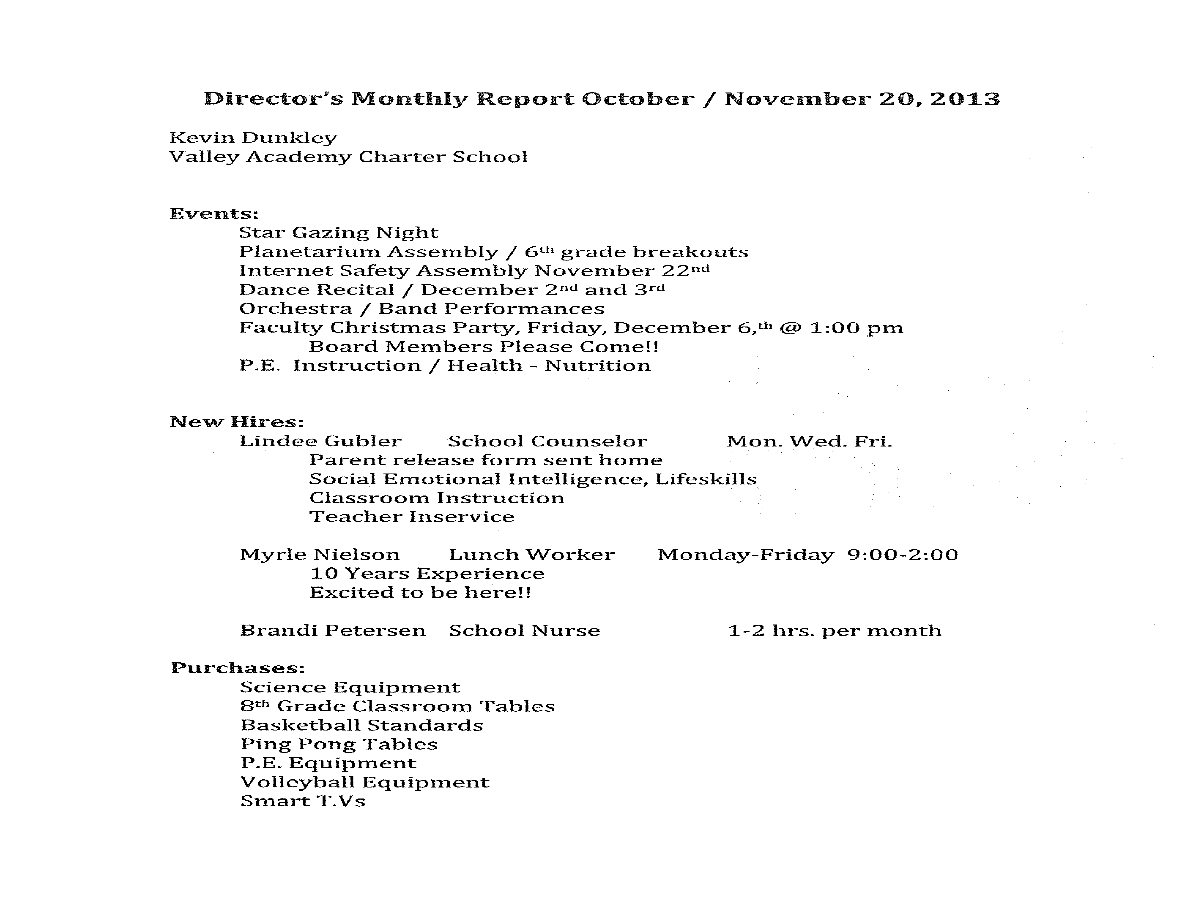
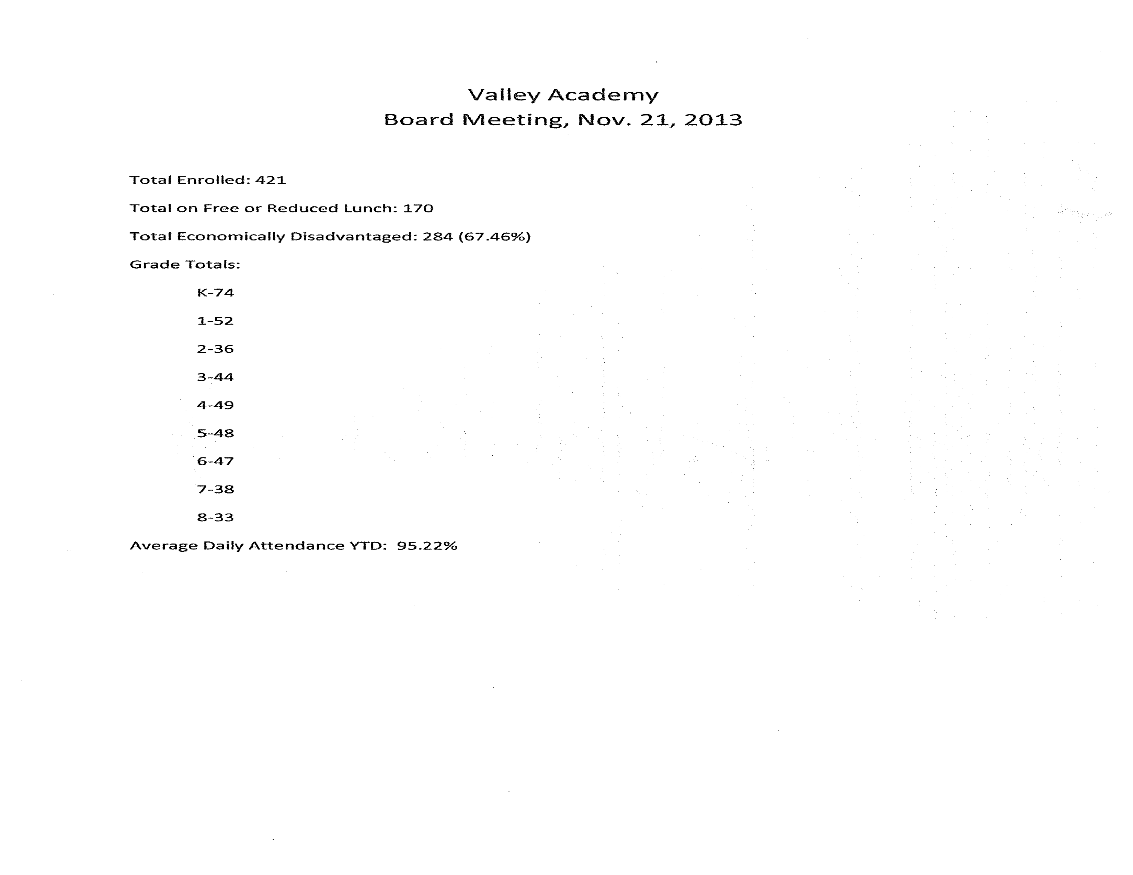

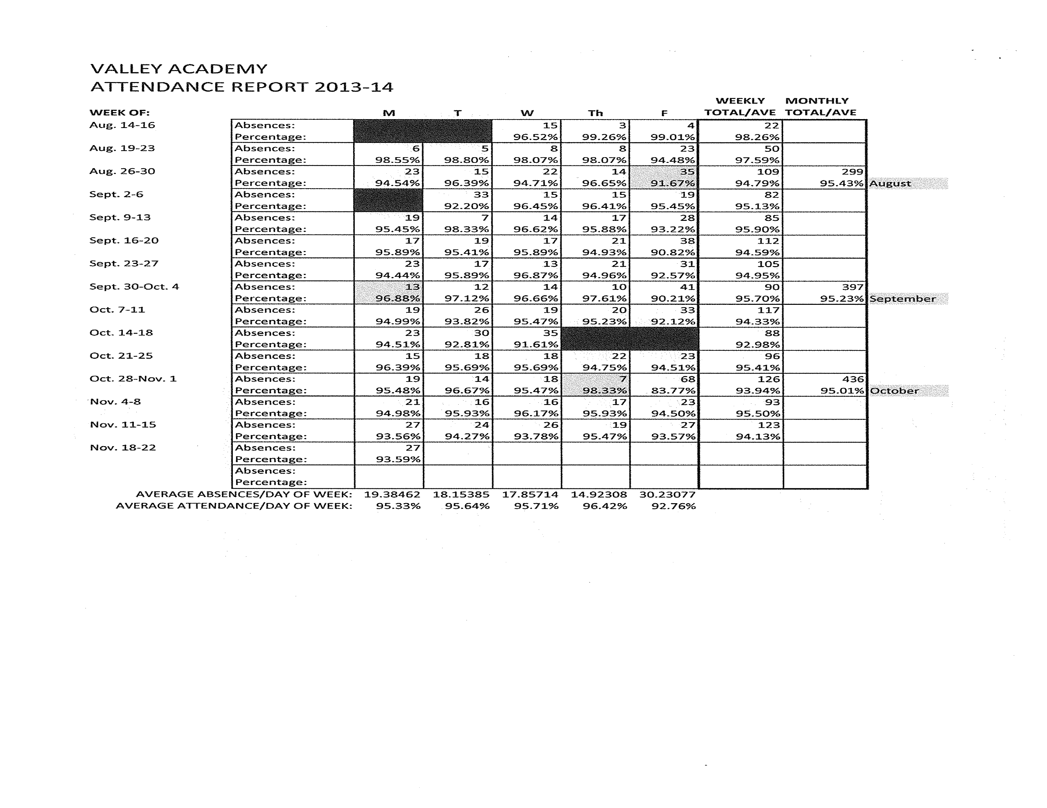

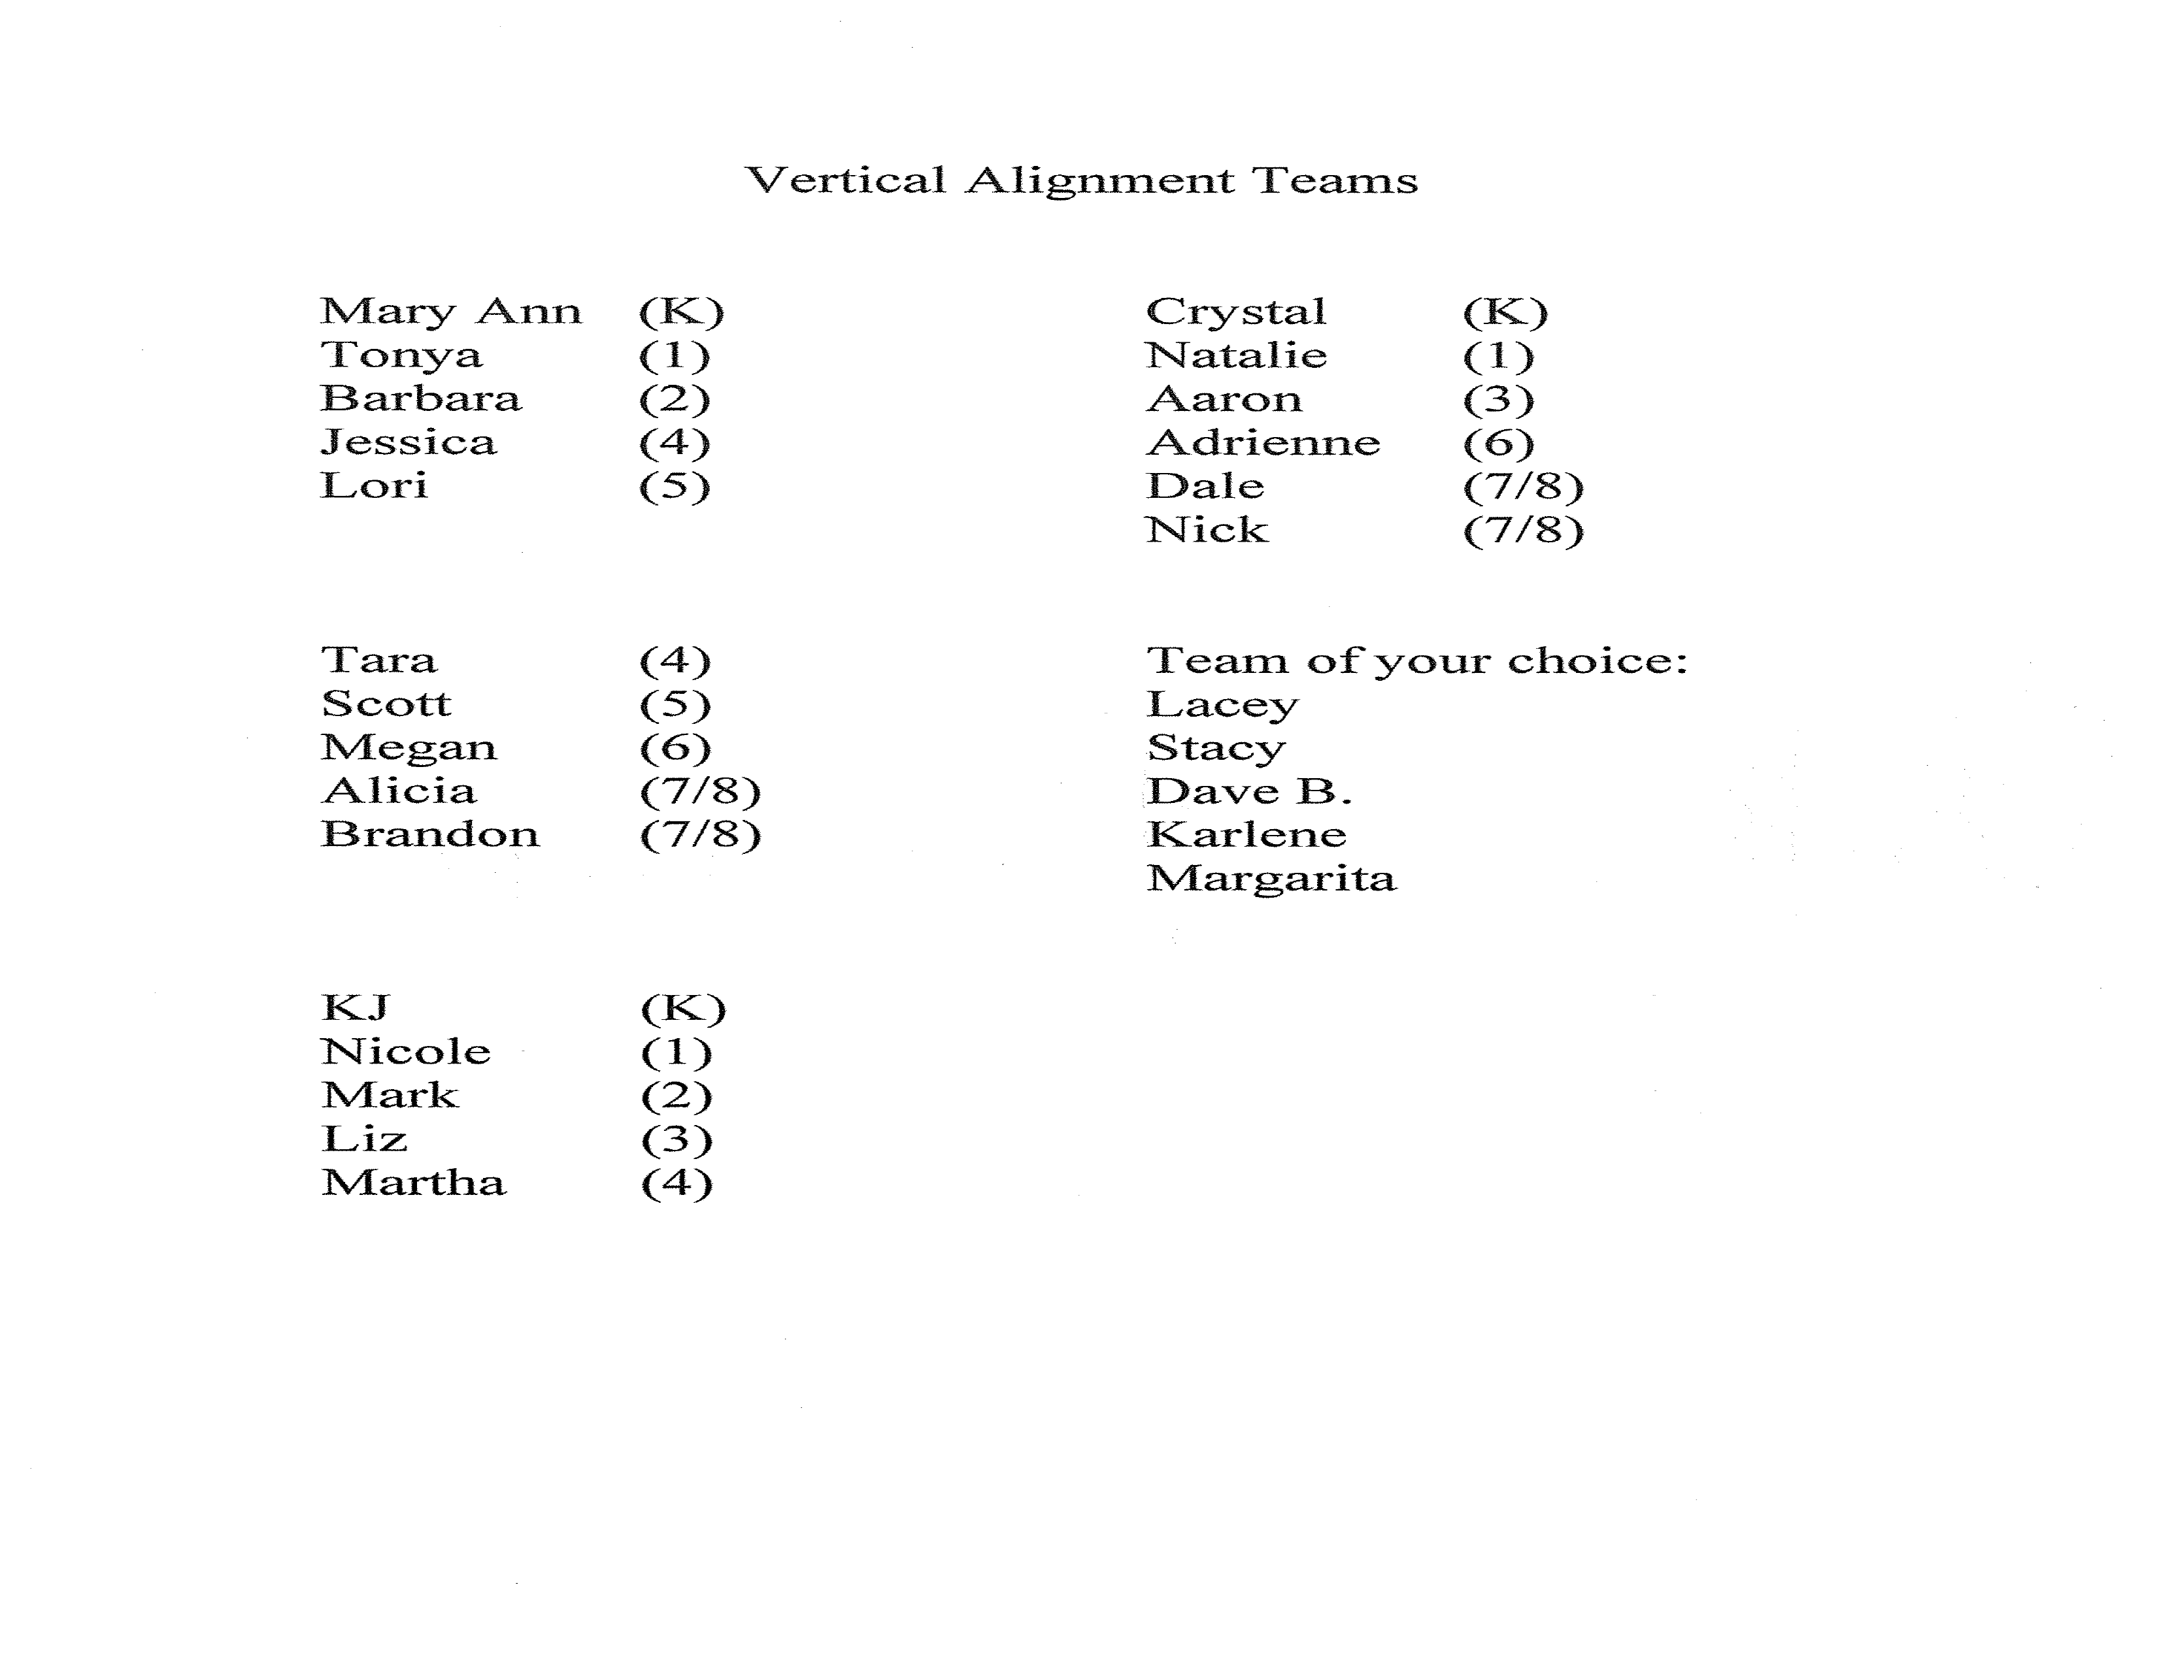

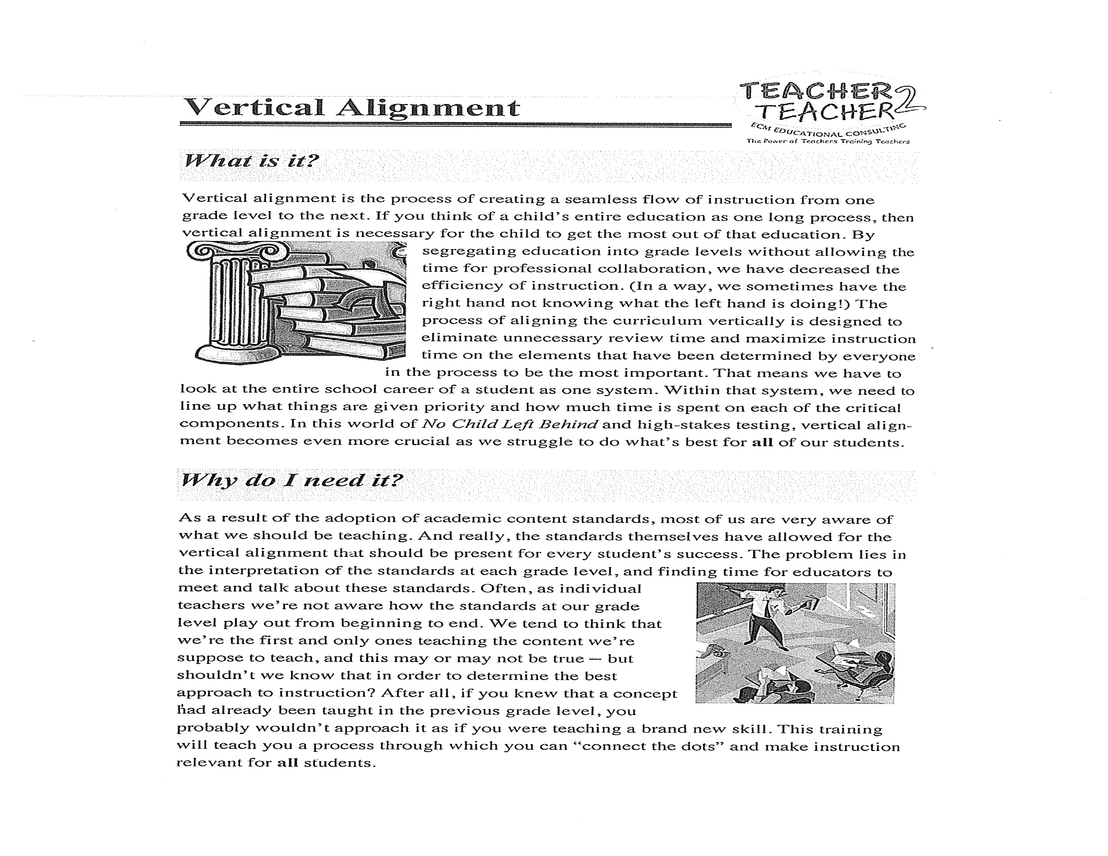
Mr. Stringham’s Monthly Report:

This month’s report will provide an update to last month’s report which focused on the budget status, expectations for the year-end outcome, and possible actions to be taken to reduce or minimize the projected shortfall. So far, I am aware of the following:

Changes from last month:

1. The $2,000 monthly note payment on the modular units acquired last year is being suspended for the remainder of this fiscal year. While the interest will continue to accrue at the rate of 9% and will need to be paid later (about $4,400), the reduction in current cash outflow will be $16,000 ($2,000 x 8 months).

2. While I am not aware of any reductions in staffing (one of the options previously discussed), the filling of the 1/2 time position of Counselor – not at the beginning of the year, but later, together with the exclusion of some benefits previously anticipated for the position) means about $7,000 less expense for that position than projected.

The current year cash savings from these two items totals $23,000. This savings, separate from any other changes, would reduce our projected deficit from $159,000 to about $136,000 – obviously encouraging, but not yet as great an improvement as hoped for.

Status of State monthly allotments:

From our contacts with the State regarding adjustment of the monthly allotment checks, we have been told that the reduction in revenues, based on the difference between our projected student headcount of 500 and the actual audited October headcount of 419, will be spread over the remaining months of the school year, beginning with our November 30 allotment check. Therefore, if our calculation of annual reduction of (about) $320,000, we will expect a monthly reduction in allotment of about $40,000 (8 monthly checks remaining in this year). This means that allotment checks (State funds portion) that have typically been in the area of about $218,000 will be closer to $178,000.

As the reductions in funding take place over a period of months, this means that in the interim we may perceive the Academy’s bank balance of $578,000 (as of October 31st) to be a bottomless source of cash. My hope is that additional means may yet be applied to further reduce the remaining shortfall that is still awaiting at year’s end.

For now, my best conservative estimate of our cash balance at year-end is calculated as follows: Cash Balance at June 30, 2013 $413,623
Projected cash loss for 2014 (136,000)
Projected Balance at June 30, 2014 $277,623

$277,000 is not a substantial cushion, considering that the monthly state allotments are received at the end of each month after expenses have already been paid. In addition, the
temporary adjustments made for this year will result in additional deferred costs to be covered in the following year.

Other Funding:

As discussed last month, our projections of other (Federal and/or Federal-State) revenues have not been changed, however their realization depends on applying for 2014 allocations as was done in 2013. In the absence of a trained specialist in the areas of Special Education that are the subjects of much of this funding, I believe it is important to acknowledge the efforts of our Human Resources / Purchasing Director, David Monson, who has stepped far outside his own specialized job areas to prepare and submit year 2014 applications for such funding. If successful, and we believe it will be, these applications will account for about $135,000 in funding otherwise lost to the Academy, which funding is already included in previous budget projections.

Finally

Although no financial statements as of October 31, 2013 are provided with this analysis, such statements are available upon request. Although the October 31 Statement of Income shows a fair excess of income over expense to date ($152,000), the information above should indicate that this is a very temporary number, not to be used as a basis for any year-end projection.

Although I am available to cover necessary business matters and expect to continue the same, due to health reasons with which many of you are familiar, it is advisable that I not attend the Board meeting in person. However, I can be available by telephone at that time, as you decide.

Mr. Monson’s Monthly Report:

Benefit Programs –
1. Discussions regarding ObamaCare with our broker and the effects of these upcoming benefits for other ‘qualifying’ employees beginning January 1, 2014.

2. Regence BCBS offering to renew plan by January will increase by eight (8) percent. Other healthcare providers such as Select Health and Altius cannot match BCBS ‘new’ proposed premium increases. Most health care providers are looking at increases of >.20% if Valley Academy switches providers.

3. Open enrollment with BCBS will occur in December to meet the new Healthcare Act.

Professional Development –
1. No Report

Policies and Procedures –
1. Continue to work on policies and procedures to include employee handbook. Employee Handbook will be presented to the Governing Board for review during December’s Board meeting.

Training –
1. SkyWire (Classroom Smart) service/support contract under review. Valley Academy looking at other viable options to fit and/or meet the schools demands for service and support with a limited budget ($1,665.00 per/month).

Purchasing/Budget –
1. Administration has completed (with the assistance of teachers) ‘new’ goals for the 2013-14 Special Education budget year through the Utah Consolidated Application (UCA) process. These goals are:
a. Improve Literacy
b. Improve Math Skills of Students
c. Improve/Enhance Reading Skills of Students
d. At-Risk/Accelerated Interventions

2. UCA Special Ed. budget now submitted to USOE for review and approval.

3. Do to the Federal Sequestered budget; all schools are impacted by a five percent decrease in Special Education budget. (around $17,000)

New Programs –
1. November 11, 2013, Valley Academy officially offered the State sponsored free/reduce lunch to those qualifying families. This includes providing lunch on half-day Fridays.

2. The lunch rates have increased from $1.75 to $2.10 per/student (full pay students) and $3.00 per/adult. The average revenue per week has been $950.00. Valley Academy anticipates this will increase as more families become aware of the free/reduce program. A letter was sent to all families.

3. Valley Academy awarded a $5,000 grant to support the lunch program. Special thanks to Cory Martin for helping Valley earn this grant.

4. Myrle Nielson, who brings five years of experience, has accepted the position as Food Service Coordinator. Jill Cotton has accepted the position as a Food Service Worker.

Question about moving the registered agent to our legal counsel’s office. Gary will talk to Trent about this. We will add this to our next agenda for official vote of the Board.

Board Training/Charter Review: The Board was asked to review pages 38-44 of the charter, which is the Organizational Structure section. Also a reminder to complete the State Charter Board required online training: GBOT13. Lane reminded the Board of free training with Dr. Brian Carpenter that is being provided free of charge by Highmark. A short educational video was shown by Rita Pierson.

Reports from Committees: The Accountability Committee met last week and discussed the Vertical Alignment teams that Kevin presented in his report. School goals and accountability is being done this way, and we’ll hear more about it as the teams get together and gather data. The Accountability Committee also put together the School Climate Survey and Director Evaluation for presentation and approval by the Board. By charter, these surveys are to be sent out in December and May of each year. After approved, they will be sent to the stakeholders on December 16- January 8. The results will be compiled by the Accountability Committee at their January meeting and presented to the Board at our January meeting. Quick review of the surveys. Revisions suggested. Not all of the Board was able to review these prior to the meeting, so they will be given a week to send in additional suggestions for final approval.

No public comment.

PTO report by Charlotte Potter: All classes now have room mothers, the dance activities being held by the 6/7/8th grade team have been well-attended and profitable. Veteran’s Day invited Veterans into the school, but would like to have a bigger plan for next year. Book Fair was successful, but the PTO ended up losing money on it overall. They will be looking at other school’s book fairs for ideas for next year. PTO is selling Dixie Direct books and has earned good money so far- would like to sell the rest of the books (around 200 left). Last BoxTops blitz brought in around $300. The PTO now has their bylaws complete and provisional 501c3 status. PTO will be decorating the Christmas tree at the Hurricane City Office as well as one for the Tree Festival at the Hurricane Community Center. A food drive is planned for the holidays. Organized carpool will no longer be run by the PTO- no volunteers for this since the mom who was running it is now ready to have her baby. PTO is working on creating a web-page to post meetings, minutes, etc. Question on wether spirit shirts would be allowed. Kevin would like to see it as a reward for good attendance.

Jimmy made a motion to adjourn. All members in favor.

8:40pm

