Valley Academy Public Board Meeting Agenda
November 13, 2012 at 7pm
539 N 870 W, Hurricane, UT

7:00pm-
- Welcome and call to order
- Review and approval of minutes from 10/16/2012 public meeting
- Read mission statement:
The mission of Valley Academy is to provide a superior, character building academic program enhanced by integrated training in the fine and performing arts and a technologically advanced curriculum.
- Board Appreciation
- How well are students are achieving the outcomes for which the school was chartered?
  - Director’s monthly report (Mr. Woodd)
    - Follow up on building rental
- How well are the school’s finances being managed?
  - Business Manager’s monthly report
- How well is the Board performing its responsibilities?
  - Charter Review
  - Board Development Topic
  - State Trust Lands Committee
  - Follow up on items from previous meetings
    - Amendment to Mandatory Reporting Policy
- Reports from Committees
  - Accountability Committee (Liz)
    - SEI training
  - Land and Building (Lane)
  - Legal (Trent)
    - Follow up on RFP for legal council
  - PTO (Shani)
- Public Comment: Members of the public wishing to participate in public comment must sign in with the Board secretary prior to the start of the meeting. Please keep comments to 2 minutes or less. The Board will not formally discuss public comments during this meeting. Board Members and School Administrators will be available to answer questions following the meeting.
- Time and place for next meeting: December 18, 2012. 7pm in the Board room at Valley Academy.
- Adjourn
Valley Academy Public Board Meeting Notes
November 13, 2012 at 7pm

In attendance: Alisha Terry-Martin, Ed Woodd, Mike Killeen, Liz Goddard, Doug Beecher, Lane Blackmore, Bruce Stringham, Trent Seegmiller, Keturah Lance, Kelly Faucett, Cory Martin. Excused: Tonya Heyder, Derek Lewis.

- Welcome and call to order. 7pm
- Lane made a motion to approve minutes as printed from our 10/16/2012 pubic meeting. All members in favor.
- Mission statement read by Doug Beecher
- Board Appreciation: Shawn Hadley, parent, was nominated and selected by the board for recognition of her great efforts on the PTO serving many hours coordinating room mothers and the classroom Halloween parties and parade. Many thanks to Shawn.
- Director’s Monthly report:
Personnel: Most of you are aware that Dawn Martin has left us and returned to New York to live with her immediate family. We are happy to announce Bruce Stringham has taken over responsibility for accounting, financial compliance, benefits and payroll. Bruce comes to us with a wealth of experience in the field and has attended a training in Salt Lake Ben Klepper has been assigned to purchasing and Dawn’s other duties have been assigned to existing staff. Although we miss Dawn and she has provided tremendous service to us, there is a silver lining. We will now be able to hire a part-time counselor which we need in order to be compliant with the state middle school requirements. We will advertise and hire for the position to start second semester.
Adopting a Growth Model: Discussion on the way we will grow our grade levels and the timeframe for this. There are many options. Lane made a motion for a committee to be formed for discussion and recommendation to the board on this topic. All members in favor. Members of the committee will be Lane, Alisha, Ed, and Mike. Ed will ask for two parent participants to join this committee.
New Personnel: David Booth has been hired as a part-time teacher in special education. Jessica Billings had her baby and Megan Gatlin has taken over as long-term substitute. Magarita Castro has taken over the strings program as a long term substitute. We will advertise for a full-time replacement for strings and encourage Maragrita to apply for the position. Several parents have volunteered to be on the hiring committee. Andrew Docksteader has been hired as a part-time custodian. Kristy Strattford has been hired as paraprofessional in special education.
Pre-Accreditation Visit: Robert Stillwell, from AdvancED, our accrediting agency made his pre-accreditation visit Thursday, Nov. 8. Mike and I met with him and discussed our plans and areas of needed improvement. We informed him that our plan was to apply for accreditation next school year once we had some student achievement data under our belt. He agreed that was a good idea and left saying he was impressed with the school. Mike and I will now undertake the process of addressing the compliance issues required to attain our 5 year accreditation.
Social Emotional Inventory (SEI): As most of you know, social/emotional learning is a central part of our curriculum in all grades. During our pre-service training, all faculty members took the SEI and felt it was beneficial. There has been a great deal of discussion about the potential benefit for board members to take the SEI as well to gain greater insight not only of themselves, but also of what our students are learning. The SEI provides each individual a snapshot in time regarding their perceptions of their emotional intelligence. Once the SEI has been taken online, the individual is provided a 1 hour debriefing session with a trained professional.
FAMILY/PARENTING CLASSES: Beginning in February, the Department of Human Services, Juvenile Justice Services division will be offering family/parenting classes at Valley for Hurricane families (schedule attached). The classes last ten weeks and involve in-depth training for families on how to effectively communicate, deal with difficult issues and celebrate meals together. We are very fortunate to host these classes and have them available for our families.
FERPA/PPRA: We have just received the new FERPA/PPRA requirements from the federal government (attached) and have posted them to our website.

VALLEY ACADEMY
ATTENDANCE REPORT 2012-13
WEEK OF: |  | M | T | W | Th | F | WEEKLY  TOTAL/AVE | MONTHLY  TOTAL/AVE
Aug. 15-17 | Absences: |  |  | 2 | 9 | 8 | 19
 | Percentage: |  |  | 99.54% | 97.93% | 98.17% | 98.55%
Aug. 20-24 | Absences: | 21 | 29 | 23 | 42 | 51 | 166
 | Percentage: | 95.18% | 93.35% | 94.72% | 90.39% | 88.33% | 92.39%
Aug. 27-31 | Absences: | 36 | 39 | 23 | 34 | 37 | 169 | 354
 | Percentage: | 91.78% | 91.10% | 94.76% | 92.26% | 91.57% | 92.29% | 94.41%
Sept. 4-7 | Absences: |  | 28 | 28 | 20 | 22 | 98
 | Percentage: |  | 93.62% | 93.61% | 95.43% | 94.99% | 94.41%
Sept. 10-14 | Absences: | 31 | 28 | 24 | 24 | 39 | 146
 | Percentage: | 92.94% | 93.61% | 94.53% | 94.53% | 91.12% | 93.35%
Sept. 17-21 | Absences: | 30 | 14 | 13 | 27 | 37 | 121
 | Percentage: | 93.20% | 96.80% | 97.02% | 93.81% | 91.51% | 94.47%
Sept. 24-28 | Absences: | 20 | 19 | 19 | 17 | 38 | 113 | 365
 | Percentage: | 95.40% | 95.18% | 95.18% | 96.12% | 91.36% | 94.65% | 94.14%
Oct. 1-5 | Absences: | 25 | 26 | 13 | 14 | 24 | 102
 | Percentage: | 94.29% | 93.18% | 97.02% | 96.79% | 94.50% | 95.16%
Oct. 8-12 | Absences: | 20 | 15 | 18 | 22 | 29 | 104
 | Percentage: | 95.37% | 96.53% | 96.05% | 94.88% | 93.27% | 95.22%
Oct. 15-17 | Absences: | 20 | 8 | 17 |  |  | 45
 | Percentage: | 95.59% | 98.15% | 96.06% |  |  | 96.60%
Oct. 22-26 | Absences: | 24 | 20 | 12 | 16 | 30 | 102
 | Percentage: | 94.44% | 94.91% | 97.22% | 96.28% | 93.04% | 95.18%
Oct. 29-Nov. 2 | Absences: | 23 | 8 | 9 | 25 | 37 | 102 | 393
 | Percentage: | 94.63% | 98.13% | 97.90% | 93.93% | 91.33% | 95.18% | 95.47%
Nov. 5-9 | Absences: | 31 | 18 | 15 | 14 |  | 78
 | Percentage: | 92.77% | 95.79% | 96.50% | 96.72% |  | 95.45%
- Discussed incentives to reward students with no tardies.
- Reported on the scooter accident which happened Friday, November 9, 2012. Student was taken to hospital by ambulance, is now back in school.
- Follow up on Mr. Woodd creating a rental agreement for parties to use the school outside of school hours, board action from October meeting. Mr. Woodd states he has not done it yet.
6. Business manager’s monthly report:
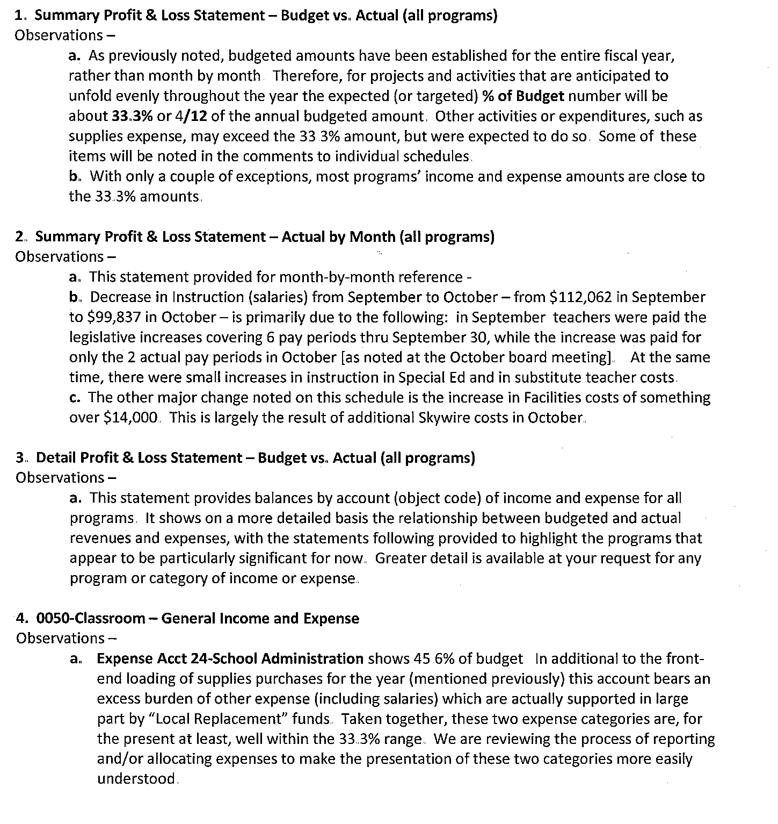
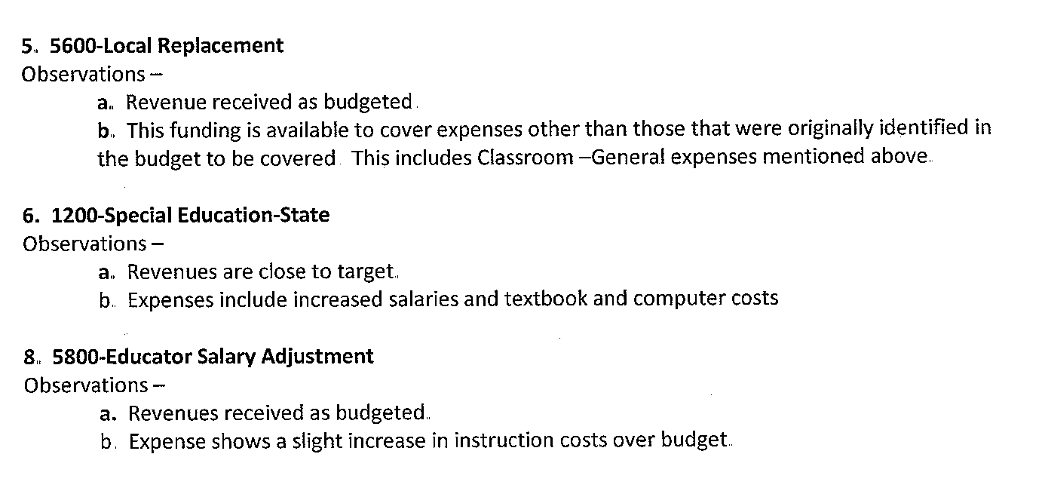
  - Should be currently at 33.3% in budget. Most programs are on target.
  - Presented Squire & Co. financial statement for Audit. Lane made a motion to authorize signing the financial report. Accepted by all. Lane signed. Bruce will return acceptance to Squire.
  - First installment payment to Highmark will be noted that it is only a good faith payment. Total price has still not been confirmed, but is still being worked on with the Highmark staff and Bouma. Lane is heading this up and keeping track. The board is appreciative of all Lane’s efforts in assuring we are informed of what we are paying for.
7. a. Charter Review: Reviewed the goals in Valley Academy’s charter contract with the State Charter Board. It seems all goals are being met so far. Alisha will send Doug and Bruce a copy of the financial goals to make sure they are being met.
b. Board Development Topic: Podcast by Dr. Brian Carpenter, “Annual Check-ups: Not just for your doctor”.
c. State Lands Trust Committee: We decided at last month’s meeting to request State Lands money for hiring staff for literacy enhancement. We will need someone to write the request. There are two videos they are requiring us to watch. We will watch them prior to our meeting next month.
d. Follow up on 9/28/12 meeting, board action creating a committee to revise our mandatory reporting policy. It was determined that the committee had not yet had a chance to meet and some of the members of the committee were not present. Lane made a motion to table this discussion until our next meeting. All members in favor.
8. Reports from committees
a. Accountability Committee (hereafter called the School Improvement and Support Committee):
i. Liz reported that the committee met this past week for the first time. The committee consists of 2 board members, 2 members of school administration, 2 school teachers, and 1 parent.
ii. The upcoming formal Director evaluation was asked to be looked at by the committee. Recommendations were made for the evaluation. Our current evaluation form will be used and broken into sections, given to groups according to relevance. This will be typed into Survey Monkey in order to make compiling the results easier. For this survey, Board and Teachers will be surveyed.
b. Land and Building: Lane reported that he is still working with Highmark and Bouma to confirm the total price of our lease. We have begun making payments on the modular units. The Washington County School District is not ready to take our offer on the strip of land between our two properties, so the offer will be withdrawn for now. This will reduce our debt to Highmark as it was budgeted into the modular note.
c. Legal: Trent reported that he has an RFP put together for legal council. This will be put on the website and will necessitate forming a committee to go through the applicants. The goal would be to have the RFP out to the public by November 30, 2012. Trent also stated that we need to be careful about representing the school with our official name and logo and not letting ourselves get lax about freelancing and calling ourselves by anything other than our name.

9. No public comment.
10. Next board meeting will be held on December 18, 2012 at 7pm, here in the board room.
11. Lane made a motion to adjourn the meeting. All members in favor.

