Valley Academy Public Board Meeting Agenda
December 11, 2012 at 7pm
539 N 870 W, Hurricane, UT
- Welcome and call to order (7:00)
- Review and approval of minutes from 11/13/2012 public meeting (7:05)
- Read mission statement:
The mission of Valley Academy is to provide a superior, character building academic program enhanced by integrated training in the fine and performing arts and a technologically advanced curriculum.
- Board Appreciation (7:10-7:15)
- Discussion with UEN/Skywire (7:15-7:30)
- How well are students are achieving the outcomes for which the school was chartered? (7:30-7:50)
  - Director’s monthly report (Mr. Woodd)
    - Follow up on before/after school building rental
    - UCA presentation
- How well are the school’s finances being managed? (7:50-8:15)
  - Business Manager’s monthly report
- How well is the Board performing its responsibilities? (8:15-8:30)
  - Charter Review
  - Board Development Topic
  - State Trust Lands Committee
  - Follow up on items from previous meetings
    - Amendment to Mandatory Reporting Policy
- Reports from Committees (8:30-8:45)
  - Accountability Committee (Liz)
  - Land and Building (Lane)
  - Legal (Trent)
    - Follow up on RFP for legal council
  - Growth committee report (Alisha)
  - PTO (Shani)
- Public Comment: Members of the public wishing to participate in public comment must sign in with the Board secretary prior to the start of the meeting. Please keep comments to 2 minutes or less. The Board will not formally discuss public comments during this meeting. Board Members and School Administrators will be available to answer questions following the meeting.
- Time and place for next meeting: January 15, 2012. 7pm in the Board room at Valley Academy.
- Adjourn

Valley Academy Board Meeting Notes
December 11, 2012
539 N. 870 W., Hurricane, UT 84737

In attendance: Alisha Terry-Martin, Liz Goddard, Lane Blackmore, Tonya Heyder, Trent Seegmiller, Ed Woodd, Mike Killeen, Ben Klepper, Keturah Lance, Cory Martin, Bruce Stringham, Ray Timothy (UEN), Aden Kay and family.

Pre-meeting: watched the State Trust Lands movies as required for the application process
- Meeting called to order by Alisha at 7:00pm
- Lane made a motion to approve 11/13/2012 Board Meeting minutes. Accepted by all.
- Mission statement read by Tonya Heyder.
- Board Appreciation awarded to Aden Kay, 5th grade student in Mr. Smith’s class. Aden is continually asking where he can be of help. He is frequently found helping in the lunch room without having to be asked and has offered to help in many other areas of the school. Aden was caught by Mr. Martin one day attempting to set up the lunch room before anyone knew he had done it. Mr. Martin said that the lunch room was set up perfectly that day! Many thanks to Aden for his great attitude, service to the school, and example to his fellow students! The board would also like to recognize Jessica Billings and Mark Zwahlen, two of our excellent teachers who have recently had new babies born to their homes.
- UEN/ Skywire Discussion regarding Internet connectivity agreement
  - Lane made a motion to accept Option #1 which was offered in letter sent from UEN. Accepted by all.
- Director’s Report
  - Survey Monkey done on Kindergarten and 7th grade asking who will be returning to Valley Academy next year for 1st and 8th grade. Report was favorable, showing that we have interest in K and 7th graders continuing with us next year. Mr. Woodd reports that the official lottery for 2013-2014 school year will be held the last week of March 2013. Teachers will be polled to see if they plan to return next year in Jan/Feb 2013.
  - UCA-Utah Consolidated Application-Mike
    - Grant applications for federal funding. $128,000 possibility for school. Mike reports that we have 16% SPED students in the school.
  - Jada Stout is our first winner of attendance award. Attendance on Fridays is the biggest struggle. Mondays is the second biggest.
  - Check will be made this week for bonding of Bruce for Treasurer. Cost to the school $350/year. Bonding of the treasurer (business manager) is required for charter schools.
  - Discussion of school facilities rental agreement and policy. Lane made a motion to approve policy. All members in favor. Lane made a motion to approve the facilities use agreement. All members in favor. More detail will be added to the agreement as needed. It may also need to be condensed into a 1 page format.
  - Ed will provide a formal report to the board in January of progress on our goals as stated in our charter contract.
  - Special Education State Audit: The Special Education Department was audited by the State (documentation attached). The audit found that our special education department is providing the needed assessments, providing necessary staff training, and consistent with Child Find requirements. The department was commended for Dr. Killeen’s experience and the quality of instruction being provided by the department. The files reviewed during the audit were found to be out of compliance. Although we received most of the 30 plus files from the school district late and out of compliance, the audit gives no quarter. Dr. Killeen and Sondra Monson are to be commended for their hard work and have given assurances that all the files will be brought in to compliance in the short term.

423 Enrolled as of Dec. 7, 2012

Current Class Sizes (see below):
Kindergarten:
- Johnson-25
- Mecham-25
- Karen-jane-25
- TOTAL: 75
1st Grade:
- Simmons-18
- Crunk-22
- TOTAL: 40
2nd Grade:
- Merrell-26
- Zwahlen-21
- TOTAL: 47
3rd Grade:
- Varga-23
- Bowler-23
- Freiberg-9
- TOTAL: 55

4th Grade:
- Freiberg-11
- Dunkley-23
- Billings-24
- TOTAL: 58
5th Grade:
- Isom-24
- Smith-24
- TOTAL: 48
6th Grade:
- Jacobs-25
- Starks-26
- TOTAL: 51
7th Grade:
- Mackey-25
- Monson-24
- TOTAL: 49
7. Business Manager’s Monthly Report: 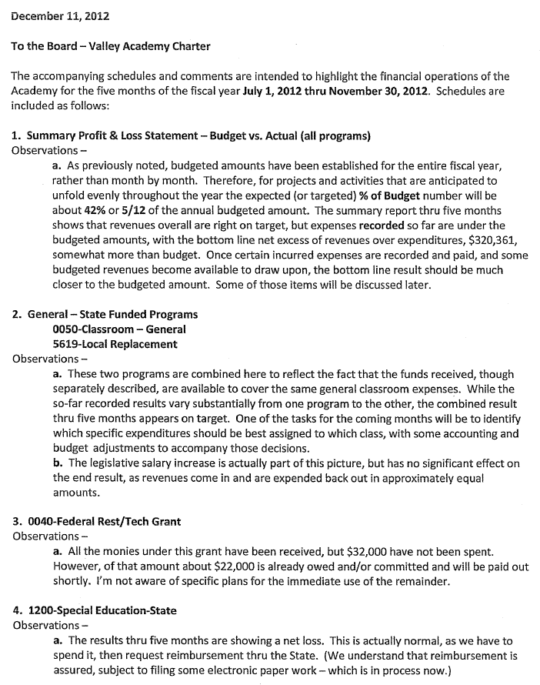

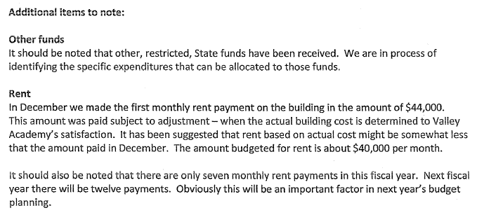

8. How well is the Board performing its responsibilities?
a. The board review its bylaws for this month’s charter review
b. Board Development topic- listened to the last podcast 12 of 12 from Dr. Brian Carpenter on the role of board and administration.
c. State Land Trust Committee: Liz has discussed this with her school improvement committee. Liz, Mrs. Bowler (teacher), Mike, and Ed will be writing the plan for this. Due date is early March 2013. Follow up in February.
d. Follow up on mandatory reporting policy- item tabled from last meeting. Liz states that policy is clear and made a motion to disband the committee that was created to amend this policy. All in favor.

9. Reports from committees:
a. School improvement and support: Liz reports that:
- School Facebook page has been turned over to the PTO
- School website is being updated daily by Ben. It looks great!
- Due to Facebook and website functionality, a newsletter may not be necessary, but the board would like to get emails that the parents are getting to stay better informed about the great things that are happening daily at the school.
- Six Seconds survey available to board members. This would allow board members to have a better understanding of how this is working in the school. An outside evaluator would come to go over the results with board members. Lane made a motion to approve Six Seconds training/survey to be sent to all board members. All members in favor.
- Contacted Vista and GWA- they are currently not utilizing an “Accountability Committee”, so there was not a lot to compare. Other schools willing to help and offer advice. Valley Academy will continue with our School improvement and support committee as recommended by the SCB and set a good example to the others by being ahead of the curve. Many thanks to Liz and her committee for what they have already done!
- Needs a scribe for meetings
- Director’s evaluation has been transcribed over to survey monkey and sent out to staff, teachers, and board members. Due date of December 21, 2012. Liz will compile the results and report back at our January meeting. This will be a closed session. Mr. Woodd asks if he will be able to see the evaluation prior to the report in the board meeting. This is possible and should be no problem.
- Fire drills are happening each month and are getting better each time
- As required by charter contract: the committee reports that 100% of classrooms are implementing a character development program, implementing fine and performing arts programs, and regularly utilizing technology in the curriculum.
- The Six Seconds climate survey will be administered this month to parents, students, staff, and board members.
- Strategic planning was done in March. This will be review once per year.
- Our goal is to be accredited within 3 years. Mr. Woodd has asked for board participation. He will advise when help is needed, and what is needed.
- Reported on current school activities.
- Suggestion that teachers be invited to board meetings to report on what is happening in the school and in their class. All members in favor.
b. Land and Building: Lane reports that he has found all receipts matching except for one area that he is currently working on with Highmark.
c. Legal: Trent reports that the RFP is complete and will be advertised for legal services. Deadline will be December 31st, 2012. Ben will put this on the website and we will notify others that would be interested. To be revisited at our January meeting.
d. Growth committee: Met on 11/28. Recommendation to the board is that we grow one grade each year until 12th grade. Ed and Mike will write the amendment that will be presented to the SCB. The goal is to have the plan ready by April 2013. Help is still needed with financials and marketing. Suggestion for possibly using Hurricane Fine Arts building for next year for older grades as well as adding more portable space. 3 additional classrooms will be needed for next year. Mike asked for the list of K-12 charters in Utah. Alisha will send that by email.
10. No public comment
11. Next meeting January 15, 2013.
12. Lane made motion to adjourn. All members in favor.

