Bernese Mountain Dog Club of Alaska
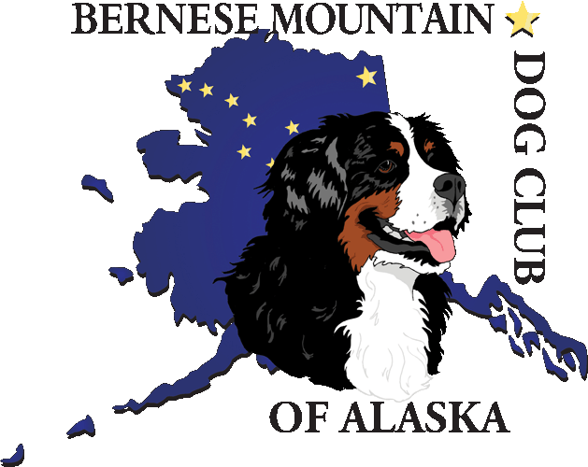

Application For Membership

Application date/1st reading:_________________________
2nd reading date:_______________ Approved:__________
Amount paid:$________ Check #:________

Name:__________________________________________________________________

Address:________________________________________________________________
City: _________________________ State: ___________ Zip: ___________________

Phone: (Home)_______________________ (Work)___________________________________

Email:________________________________________________________________________

Occupation:____________________________________________________________________

Type of Membership:
Regular: $20______ Family: $30______ Junior: $10______ Associate: $15______

- Do you own a Bernese Mountain Dog (BMD)? If so, how many?
What are their names?

- When did you get your first BMD?

- How would you describe youself as a BMD owner? (Check all that apply)
____Pet/Companion ____Obedience
____ Breeder ____Breeder/Exhibitor (owner/handler)
____Drafting ____Therapy Work
____Other______________________________________________________________________

- Does your dog(s) hold any titles?

- Why are you interested in joining this club?

- Do you belong to any other dog clubs? If yes, please list.

- Have you ever had your membership terminated or suspended from the American Kennel Club or any other dog club? Please explain.

page 1 of 2
page 2 of 2 for membership applicant:_____________________________________________

- How can you contribute to this club?

- Please list any activities that you would like to participate in, or have the club host. For example, grooming, drafting, conformation, obedience, education, Berner walks, parties, etc.

- Are you a member of the Bernese Mountain Dog Club of America?

Please obtain two sponsors for your membership. Sponsors need to be in good standing with the Bernese Mountain Dog Club of Alaska. ***Sponsor not needed for associate membership***

_______________________________ ___________________________ ____________
Sponsor’s printed name Sponsor’s signature Date

_______________________________ ___________________________ ____________
Sponsor’s printed name Sponsor’s signature Date

In applying for membership to this club, I agree to comply with the bylaws and constitution of the Bernese Mountain Dog Club of Alaska and the rules of the American Kennel Club.

________________________________________________ __________________
Applicant signature(s) Date

Note, we share our membership list on a club roster among the members.

