ECB Clubmark Accreditation Scheme 2022

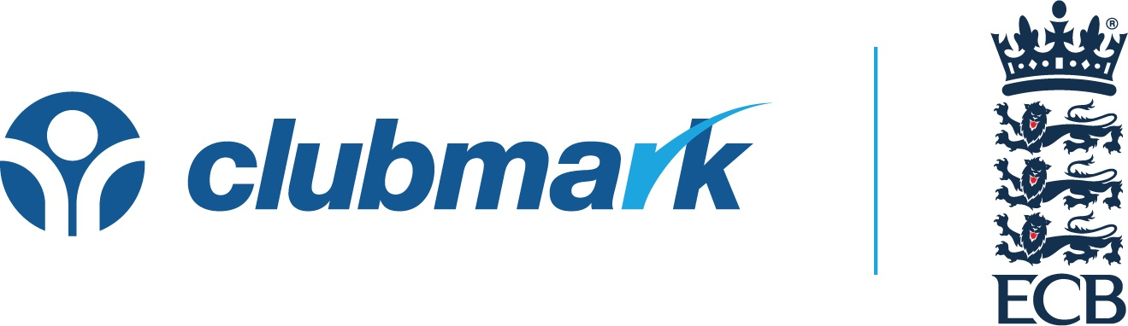

Club User Guide
Introduction

Clubmark remains a key component of helping clubs raise standards in the recreational game and is used by many leagues as an entry requirement and the Home Office as part of requirements for the managed migration process. The historic 3 year accreditation cycle has been a victim of the pandemic, so there have been some amendments made and we will continue to review to ensure it remains fit for purpose and value add for the clubs going through the process.

Strategic Direction

Given the 3 year accreditation cycle has been broken and the Sport England withdrawal from the programme, going forward we can make the scheme whatever we want it to be. For 2022 we want to build on the introduction of SHMS in 2021 given the importance of safeguarding and build on this by reviewing key governance related documents as well.

Another key difference in 2022 relates to timescales. We will ask all clubs to upload relevant evidence by 30th June which will then be reviewed, and any technical remediation can be completed ahead of the end of the season. This resolves clubs submitting last minute, not getting accredited and not having time to resolve. It also means leagues are clear at the end of the season who are accredited and can plan accordingly for the following season.

Process

- You can now access your 2022 Clubmark files and add the required evidence. Instructions on how to load evidence can be found on the Clubmark section of the online portal.
- The Clubmark scheme is run centrally by the ECB but is managed locally via the County Boards. Your local County Board will let you know of the operational timescales they are working to. All documents will need to be added to the portal by 30th June 2022 or any earlier date specified to you by your local County Board.
- You will be allocated a Club Support Officer by your local board, who will assist you with the process and conduct a site visit if that is necessary
- The 2022 criteria is below for you to familiarise yourself with. You will see there are a number of mandatory evidence requirements to be loaded on the portal.
- Your club will also need access to the Safe Hands Management System and ensure that all individuals who need a DBS have one and are registered on the system.
- Other blank templates such as model constitutions and templates can be found under the “Resources” section of the Club Portal. We are currently refreshing a number of these, together with adding new resources, so please keep checking this section of the portal.
- If you are currently not accredited then you will receive a site visit from your local County Board to review your practices on a junior training night.
- If you don’t have access to the Club Portal then please e-mail clubmark@ecb.co.uk detailing club name, your e-mail address and your position within the club
- Upon review of your online file you may be asked to undertake some remediation activity. You will not have your accreditation confirmed until that is done. All remediation will need to be completed before 31st August 2022.

Best Practice

- Start reviewing your documentation as soon as you can and ensure it meets the criteria before you load onto the portal.
- The earlier you start the process, the easier it will be for you. Where clubs have left loading documents to near local deadlines, the more difficult it has been to achieve re-accreditation.
- Ensure your coaches and other relevant officials are up to date with all qualifications and added to the Safe Hands Management System. This should be done ahead of the season starting as vetting needs to take place before someone takes up a role. The biggest area of non compliance in 2021 was open age team captains so ensure they are vetted as checks to information on play-cricket will be undertaken
- If you employ the services of an outside coaching company for junior training, you still have the responsibility of ensuring all coaching, safeguarding and first aid qualifications are up to date for coaches undertaking sessions at your club.
- Review your constitution to make sure membership is “open” and that it adopts the relevant ECB policies. If your club has any clauses relating to proposers and seconders for membership or has a committee vote on membership, then this means the constitution is not open and will need amending. There is an updated club constitution in the “Resources” section which cover off all these points.
- Ensure your meeting minutes are all up to date.
- Share the work involved with your re-accreditation around your club, by adding relevant colleagues to the portal. You can do this by clicking on your name in the top right-hand corner, clicking on “Admin” and then clicking on “My Colleagues”.
- Add Clubmark as a standing agenda item to your committee meetings.
- Try and load documents onto the portal ahead of the season starting so your Club Support Officer can review these ASAP.
- Discuss a timetable with your Club Support Officer for the process during the year to ensure the re-accreditation happens in a timely manner.

Criteria

Criteria | Evidence (* - Mandatory Upload)
We have a club development plan in place which we review annually to ensure it meets the wants and needs of our club members. The plan highlights our short, medium and long term aspirations and is shared with our members. | - Club development plan*
We have governing documents in place which detail how the club is run and includes as a minimum an open (non discriminatory) constitution which includes "Safe Hands" and ECB Anti-Discrimination Code of Conduct adoption, together with a separate Club Safeguarding Policy Statement. | - Open non-discriminatory constitution*  - Copy of AGM/EGM minutes when current constitution adopted*  - Club safeguarding policy statement*
We are aware of risks that may impact on our Club. Our activities, premises and coaches are insured using public liability insurance to a minimum value of £5 million and employers liability insurance to £10 million. | - Insurance schedule and/or central ECB scheme confirmation*
We practice good financial management and manage our finances through a dedicated club bank account which requires 2 independent signatures for payments. We also prepare annual accounts which are made available to members. | - Copy bank statement*  - Annual accounts*
Our governing committee –  - Consists of at least 3 people who are unrelated and not co-habiting.  - Includes the Club Safeguarding Officer  - Is subject to regular election.  - Meets at least 4 times a year with decision making recorded.  - Holds an Annual General Meeting open to members  - Recognises and records any conflicts of interest.  - Proactively recruit new committee members considering skills needed and diversity. | - Committee structure chart*  - Copies of at least 4 committee meeting minutes within the last 12 months*  - Latest AGM minutes (to be within last 12 months)*
We have adopted & implemented the ECB "Safe Hands" Policy, ensuring all members are aware of safeguarding procedures. This includes but is not restricted to:  - Appointing a Club Safeguarding Officer (s) who is ECB Vetted, has attended a Sports Coach UK Safeguarding and Protecting Children workshop and the ECB Safe Hands Workshop for Club Welfare Officers.  - Ensuring Coaches and other relevant personnel whose roles include responsibilities relating to working with children are ECB vetted (including an enhanced DBS check), | - Compliant status on Safe Hands Management System

Questions

For any questions contact your local County Board representative.

