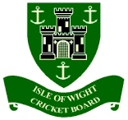
ISLE OF WIGHT CRICKET BOARD
Ltd

ANNUAL GENERAL MEETING
Monday 20th December 2021
7.00pm @ Newclose CCG

  - Apologies for absence

  - Minutes of the 2020 AGM

  - Matters Arising from the previous minutes

  - Annual Management Report by the Chairman

  - Distribution of IWCB Annual Accounts for the year ending 30th September 2021

  - Appointment of Auditor

  - Election of Directors

  - Brief statement on ECB commitment to Equality, Diversity & Inclusivity

  - Date of the next AGM

