CAMPOUT PLANNER

Patrol: __________________________

Date: ___________________________

Campout: _______________________

Grubmaster: _____________________
SHOPPING LIST
have | need
Paper towels |
Aluminum Foil |
Salt |
Matches |
Fuel/charcoal |

GROCERY LIST
Quant. Item
______ _______________________
______ _______________________
______ _______________________
______ _______________________
______ _______________________
______ _______________________
______ _______________________
______ _______________________
______ _______________________
______ _______________________
______ _______________________
______ _______________________
______ _______________________
______ _______________________
______ _______________________
______ _______________________
______ _______________________
______ _______________________
______ _______________________
______ _______________________
______ _______________________

Name | Attn | Pd. | Init.
1
2
3
4
5
6
7
8
9

Saturday
Breakfast

Drink
Notes

Lunch

Drink
Notes

Dinner

Drink
Notes

Sunday
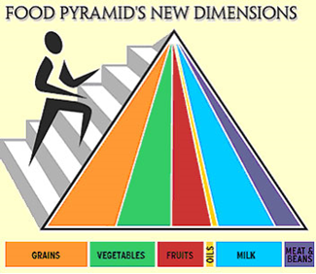
Breakfast

Drink
Notes

SM Signature:________________________
Person buying food is responsible for the food/ice/cooler for the duration of the campout.

PATROL CAMPOUT DUTY ROSTER

Patrol Name: ______________________________________ Date: ____________________

SETUP FRIDAY
Patrol Box
Water
Other -

BREAKFAST SATURDAY
Head Cook
Assistant Cook
Clean-Up

LUNCH
Cooking
Assistant Cook
Clean-Up

DINNER
Cooking
Assistant Cook
Clean-Up

BREAKFAST SUNDAY
Cooking
Assistant Cook
Clean-Up

PACKING
Patrol Box
Water Jugs
Other -

OTHER DUTIES
1.
2.
3.
4.

