Twitti School, Oct 5-25, 2017
By Sandy Gordon, Fredericton, NB

A three-week stay at Twitti School seems like a whirlwind visit. I stayed in “Canada Room”, a former classroom in the home of Lydia Maonde, who, with her deceased husband, Simon, started Twitti a bit over 20 years ago. Being adjacent to the school, I woke up every morning to the wonderful sound of (many) children's voices arriving at school between 6 & 7 a.m.
My welcome on my first Monday was the main event of the weekly assembly, on the lawn in front of the library & admin building. With the Canadian flag flying just below the Zambian one, and me as the focus of 500 people's attention (475 students + teachers & staff), and songs written to welcome me, with my name in the lyrics, the experience was overwhelming. But by 7:30 everyone was in class and I went for breakfast. Up so early became one of many adjustments I made to life in Zambia.
Several events scattered throughout the 3 weeks added to an exciting schedule. No school on the National Day of Prayer or on Independence Day. One day was a trip to visit Namwala boarding school in Southern Province. And one day was the unforgettable Grade 4 trip to the airport where all 44 students had their turn flying in a 6-seater plane normally used to transport medical and religious personnel to remote areas of the country. The children were not told they would fly before arriving at the airport, and I wondered whether their parents would even believe them when they got home, it was so far removed from all of their wildest expectations.
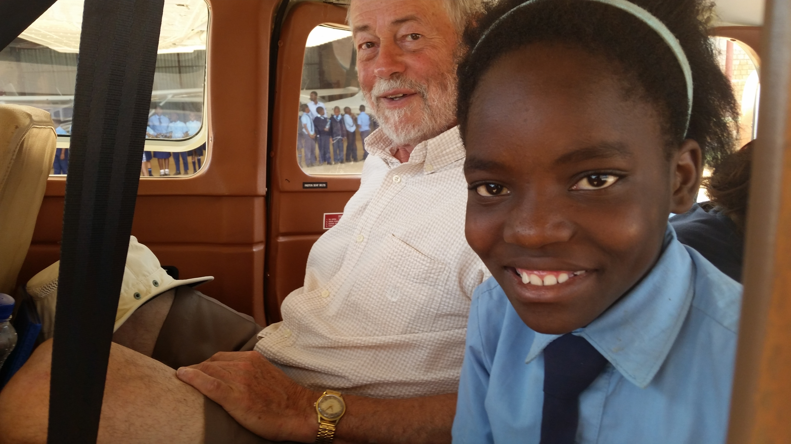

Sandy about to fly with his sponsored child Doreen, Grade 4

My days at school, apart from the above 4 days of no school, were occupied with interviewing sponsored children, conversations with leaving students (grade 7 & 9) on what I call “life issues”, reading with one of my & my wife's sponsored children, and many conversations with children, in class and during breaks, about life in Canada. I even was invited to review with the teachers' committee the up-coming progress evaluations (exams) to be given to all grades.
The trip to Namwala Secondary School for a prospective student to have a look was arduous. Although much of the road is good smooth hard surface, about 70 km had continuous deep holes causing everyone to come to almost a complete stop every 10 or 20 meters. It's a main highway between South Africa and countries north of Zambia so there are many very large transport trucks. At one point, as we were coming home in the dark, three trucks were jammed abreast causing passenger vehicles like ours to drive on the side of the road through residents' front yards and over ruts worse than in a normal farmer's field. However, I was told the road used to be much worse. Road improvement is evident in much of the area; it's to be hoped this section gets it next. Leaving Twitti at 4:45 a.m. and getting back at 10 p.m. made for a long day, to say the least. The temperature that day was definitely in the high 30s, and of course almost no cars have AC, including the one we were driving.
We were all favourably impressed with Namwala School, although it didn't have the shiny bright atmosphere and careful maintenance of Twitti.

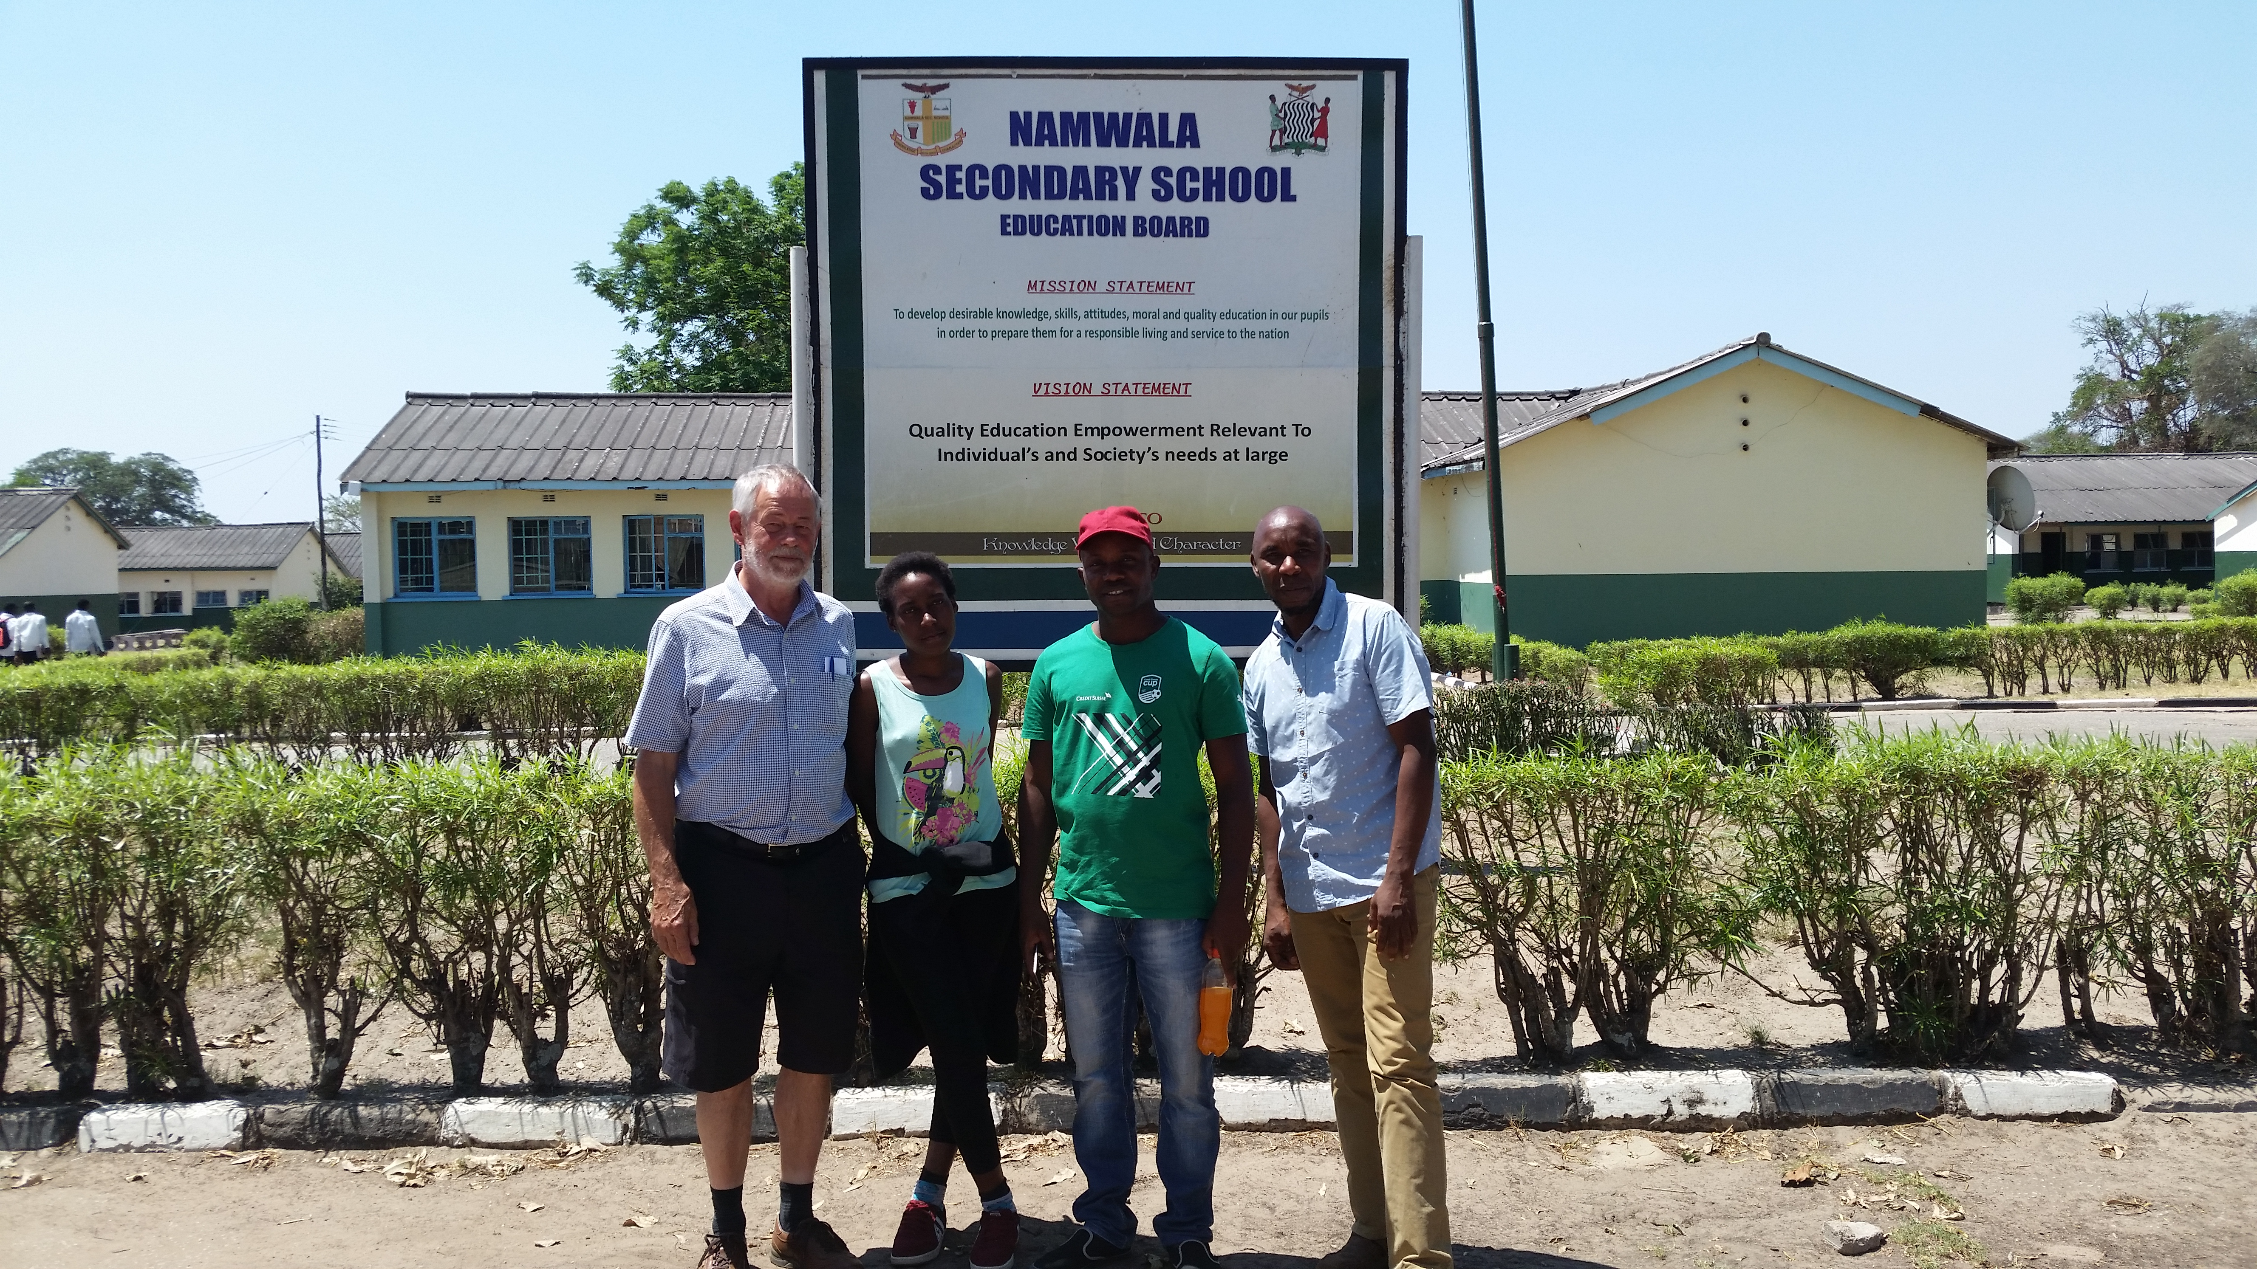
Sandy, Toko, her brother Michael, and Arthur at Namwala Secondary

Many times my Zambian friends reminded me that President Lungu encourages all citizens to remember that Zambia is officially a Christian country. That is thought to be one reason it is the only sub-Saharan country not to have had an armed conflict since independence from colonial powers in the 1960s. Certainly religious maxims, thoughts and admonitions seem to be continually on most people's minds, and there is no hesitation to inquire about the position of visitors like myself on such personal matters.
Attending church with the mother & baby sister of our sponsored child (12 yr old Doreen) met my fondest hope with the spontaneous singing in beautiful harmony of the whole congregation. I was initially surprised to clearly hear singing from another church very close by. After church I discovered there are 5 churches on a piece of land about the size of two house lots in Canada. Churches less known in Canada abound: Jehovah's Witnesses, Seventh Day Adventists, Mormons, Pentecostal, as well as ones better known in Canada: Anglican, Catholic, Presbyterian. It is unbelievable to Zambians that church buildings in Canada and Europe are being sold for everything from recreation centres to law offices, certainly not the case in Zambia.

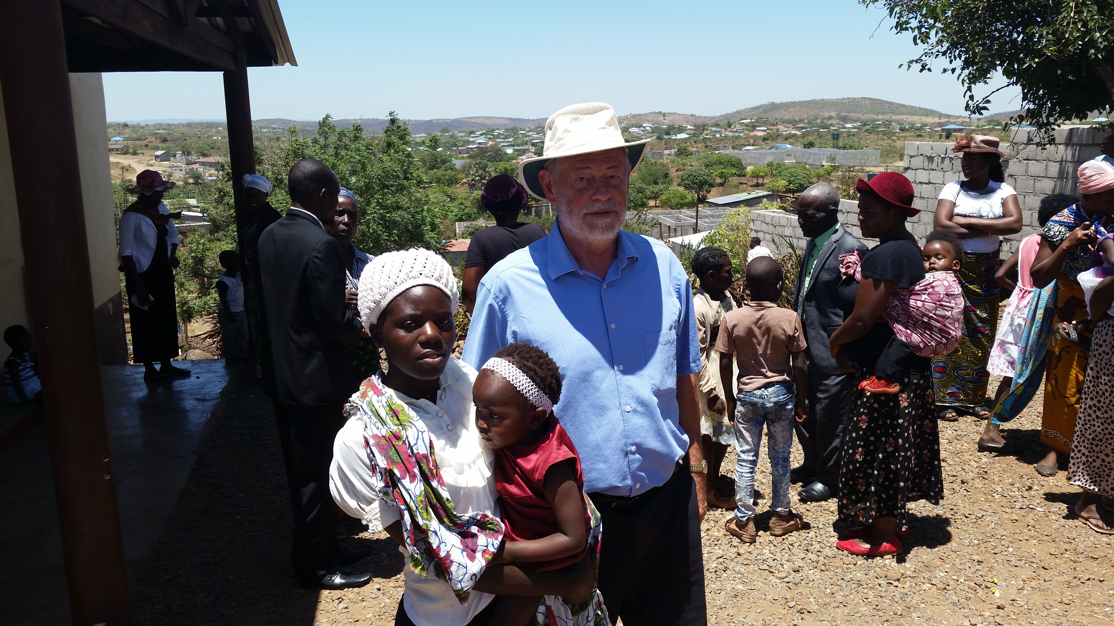
Sandy attended church with Doreen’s Mom and baby sister

As a social worker, it seemed appropriate for me to spend time with leaving students (Grade 7 & 9) talking about their departure and what the future holds. Some widely shared questions and opinions of these young people impressed me with how different the world these young people live in is from the one we assume our youth enjoy. They all identified early pregnancy as the mostly likely obstacle to finishing a reasonable level of education (Grade 12 or beyond). This of course led to conversations about respect for girls and women. And that conversation highlighted a social issue Zambia is confronted with: gender inequality and the expectation of physical violence done to women. Hearing 12 year old girls say that disagreeing with a boyfriend means having to break up or be beaten was shocking to say the least. Discussions about sexuality and male-female relations were reminiscent of how it was in my youth in the 50s, but with the added dynamic of the widespread poverty of a developing country.
I was given to understand that the Zambian Ministry of Education has a policy of schools talking to students starting in Grade 4 about HIV-AIDS, safe sex, etc, with graphic printed material available. However, it seems that it will be quite a while before current attitudes about such issues will allow the goals of such a national policy to be reached.
Grade 9 Girls and Teacher Musowe (centre)
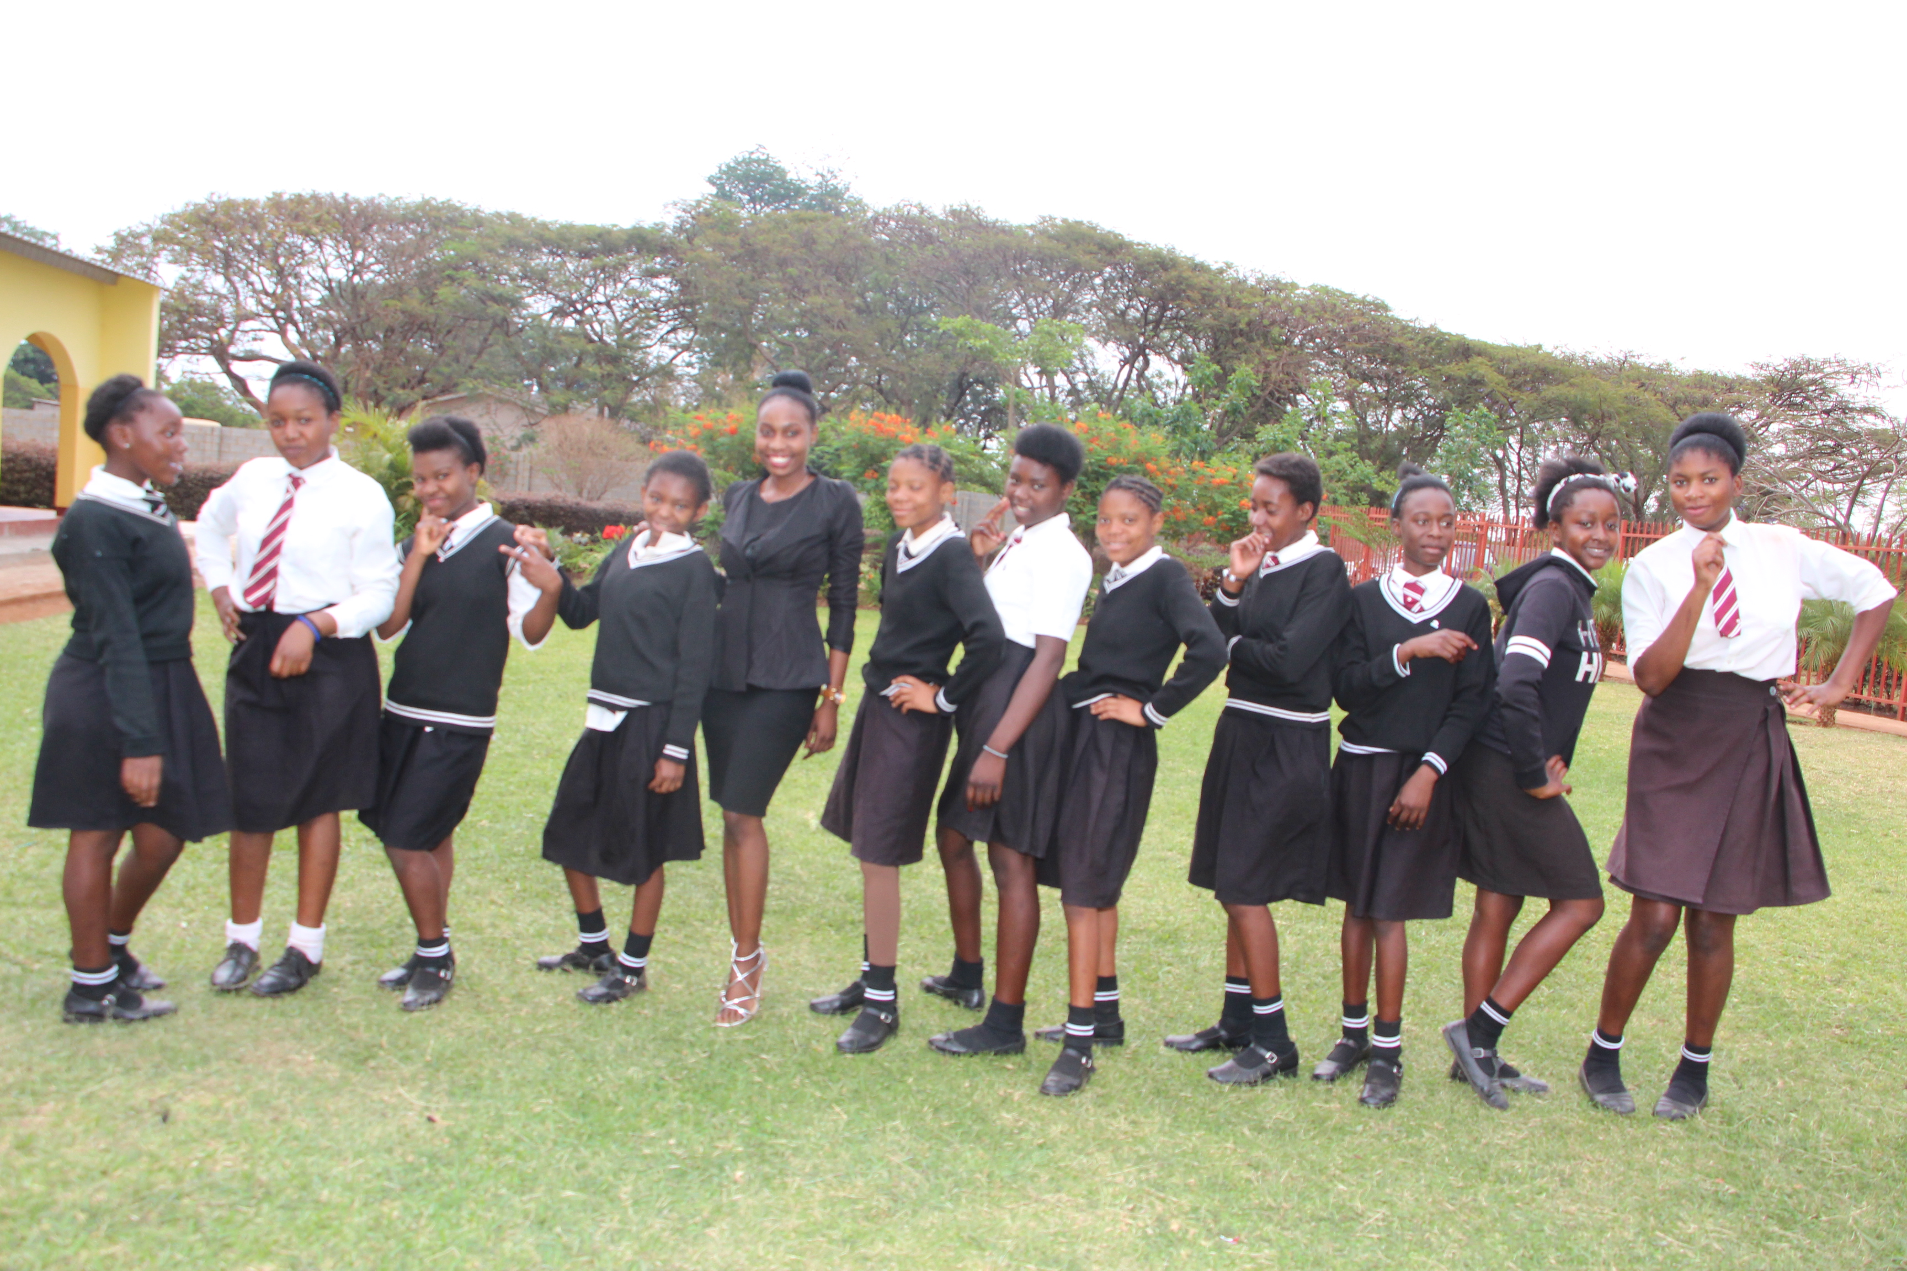

Who would have thought that Scottish bagpipes would be such a significant component of everyone's experience of my 3 weeks at Twitti? As soon as I told Director Arthur I had brought my pipes with me, he exclaimed with tremendous enthusiasm that I'd be playing for all the children at Monday morning's assembly. So I had a long blow, marching all of them around the school property to drop them off at their classrooms. But when I succeeded in teaching about 50 (maybe more) from Grade 4 & 6 to do the Virginia Reel (a Scottish/North American square dance) I was constantly being asked by students, “When are we going to do the dance again?” In 59 years of playing for that dance, I have never seen more enthusiasm for it, or as much fun doing it, by both boys & girls.
If what Twitti children get from Canadians' visits is a broadening of their horizons, they will remember this one well, as will I.

Sandy discusses music with the staff choir director

Arthur Maonde, school Director, and his mother, Lydia Maonde, both told me how positive it is for Twitti students to have Canadian visitors. As I said in my parting speech to them (all 475 at a special assembly the morning I left), whatever benefit knowing me was to them, it was 10 times more than that to me. The spontaneous expressions of happiness and excitement by body movements and dance, and also song, make a tremendous impact on a (relatively) reserved Western like me. I guess one could say it's a wonderful exchange, between people from very different circumstances: 7 year olds to over 70 year olds, people from wealthy countries to people who sometimes don't know if they will have food for tomorrow, from summer temperatures of 40 degrees to winter ones of minus 30, the contrasts are countless.
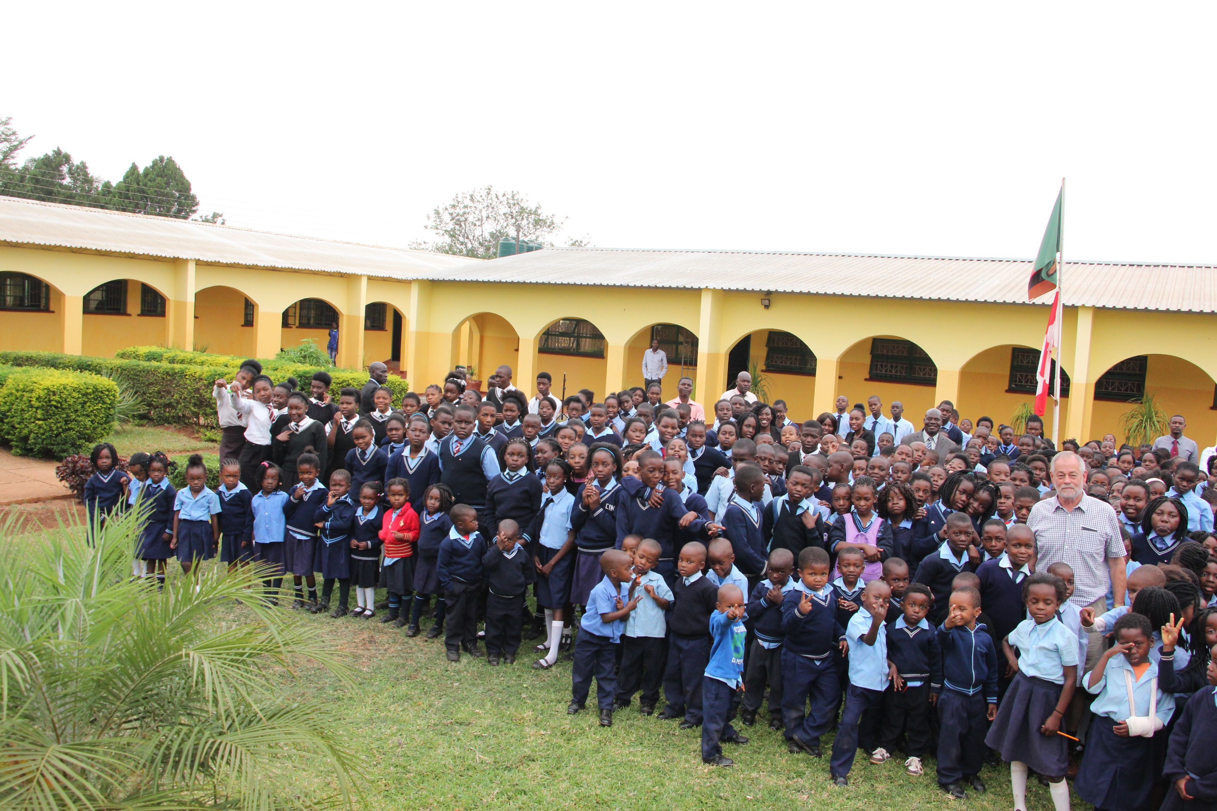
Twitti pupils say Good-bye to their visitor from Canada

