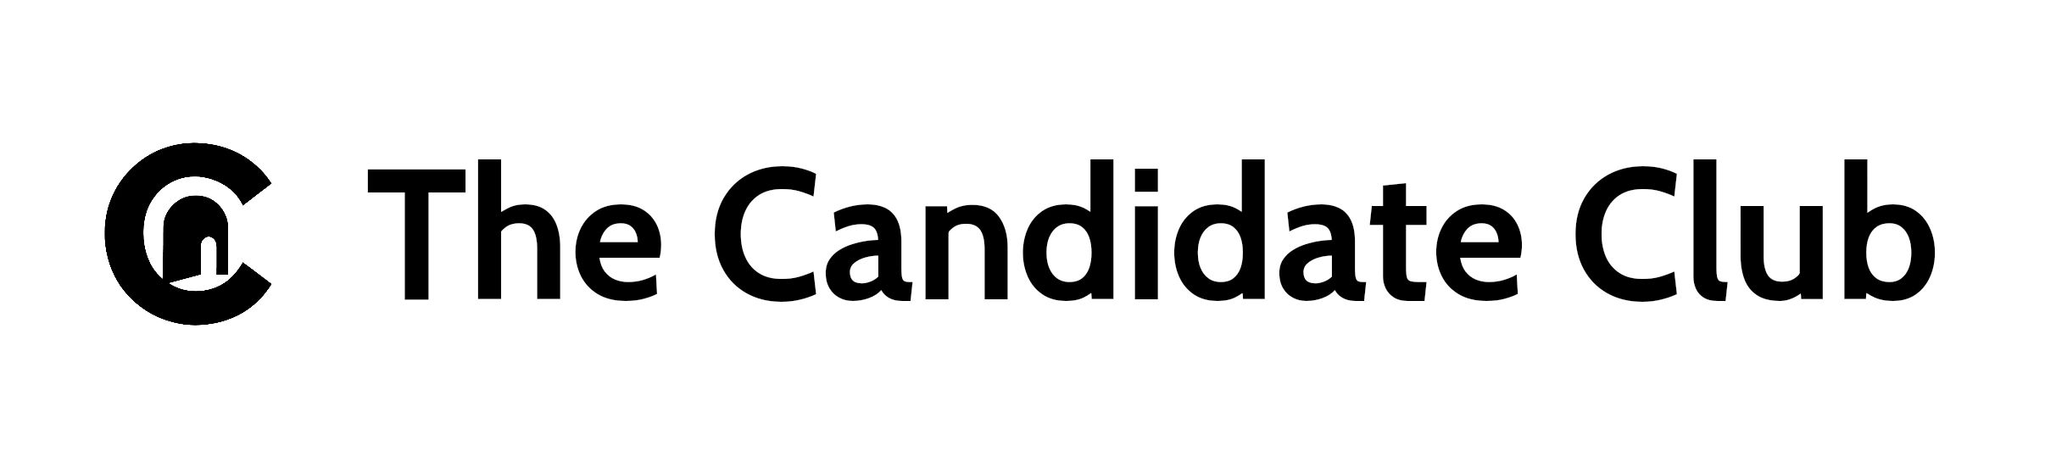
🏭 Employer Pilot Overview

The Candidate Club (Dalor C²) Credential-first hiring for skilled trades

🔧 What We Do
Dalor C² replaces résumé-based filtering with credential-first matching. Our platform helps manufacturers hire qualified talent based on verified skills—not formatting or guesswork.
🚀 How the Pilot Works
- Structured Job Listings: You provide role requirements and preferred credentials
- Candidate Matching: We surface candidates with verified credentials and skill alignment
- Swipe-to-Match Interface: You engage only when match scores meet your criteria
- Bias-Reducing Filters: Credential alignment comes first—no résumé screening required
- Impact Tracking: We document hiring outcomes, credential gaps, and retention signals
🎯 Pilot Goals
- Reduce hiring friction for skilled roles
- Improve visibility for credentialed candidates
- Align with national workforce development efforts
- Build data-driven dashboards for hiring outcomes
🛠️ Ideal Roles for Pilot
- Machinists
- Welders
- CNC Operators
- Maintenance Techs
- Fabricators
💬 What You’ll Get
- Access to credential-matched candidates
- Employer dashboard with match scores
- Support with onboarding and job structuring
- Visibility in our impact reporting and partner network
📬 Ready to Join?
→ [Join the Employer Pilot] Or contact us at support@thecandidateclub.net

