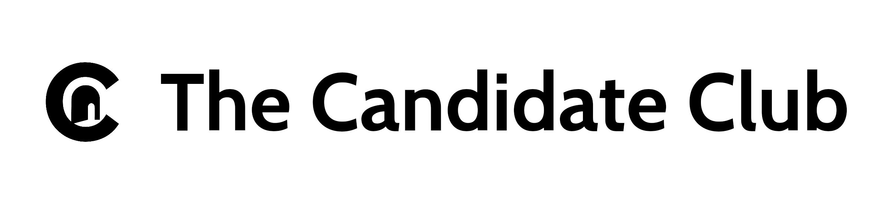
📄 Case for Support

The Candidate Club (Dalor C²) Building a résumé-free, credential-first future of work

🧭 Our Mission
The Candidate Club is transforming hiring by replacing résumé-based filtering with credential-first matching. We help skilled candidates showcase verified capabilities and help employers hire with confidence—starting with manufacturing roles like machinists, welders, and operators.
🛠️ Our Model
Dalor C² is a career platform that uses structured profiles, credential tagging, and swipe-to-match logic to connect candidates and employers.
- No résumés. Candidates are matched based on verified skills, not formatting.
- Credential-first. We integrate with Credential Engine and training providers to make credential data actionable.
- Bias-reducing. Employers engage only after credential alignment is confirmed.
- Impact-driven. We track match scores, hiring outcomes, and upskilling referrals.
💸 Why We Need Funding
Your support helps us build the infrastructure for equitable hiring. We are seeking funding to:
- Onboard 1,000+ credentialed candidates
- Launch 5 regional employer pilots
- Integrate 3 credentialing bodies
- Build dashboards to track hiring outcomes
- Sponsor upskilling for candidates with credential gaps
🎯 How You Can Help
- Donate to fund platform development and candidate onboarding
- Sponsor a pilot or credential integration
- Partner with us to scale impact across industries
📬 Contact
Erica Carpenter, Founder
https://thecandidateclub.net
support@thecandidateclub.net

