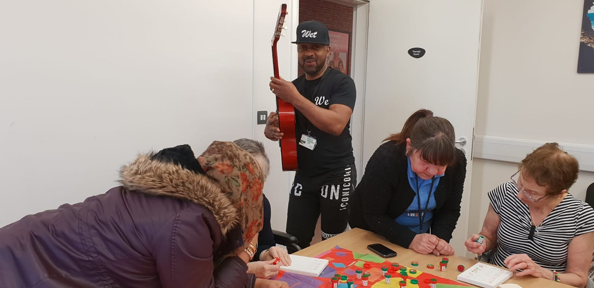

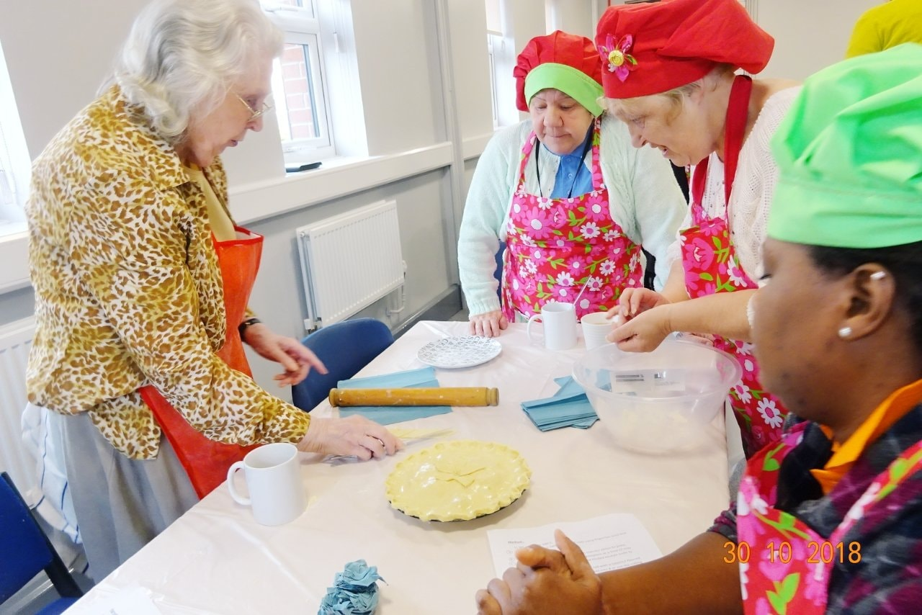

** ANNUAL REPORT 2018 - 2019**

**www.widowsempowerment.com**

**Registered Charity 1171317**

Contents

**INTRODUCTION Annual Report October 2018 - September 2019** 3

**The Widows Empowerment Trust Vision** 4

**OUR STRATEGY** 4

**OUR VISION:** 4

**OUR MISSION:** 4

**OUR AIM** 4

**OUR VALUES** 4

**OBJECTIVES:** 5

**THERESE ADAM’S TESTIMONIAL** 5

**THANK YOU NOTE FROM TRUSTEE BOARD MEMBER** 6

**THANK YOU NOTE FROM FOUNDER/CEO** 6

**PROVIDING A SUPPORTIVE ENVIRONMENT** 6

**ACHIEVEMENT AND PERFORMANCE** 7

**SOCIAL OUTINGS** 11

**NEVER TOO OLD TO PLAY** 12

**MONTHLY COOK ‘N’ TASTE SESSIONS** 13

**BEFRIENDING SERVICES** 14

**REVIEW** 15

**CASE STUDY** 15

**VOLUNTEERS** 16

**FINANCIAL REVIEW** 17

**Strategic Plan for 2019** 18

**RISK REVIEW** 18

**Independent examiner's report to the trustees of The Widows Empowerment Trust** 19

**Statement of Financial Activities for the Year Ended 30 September 2019** 20

**ACCOUNTING POLICIES** 22

# **INTRODUCTION Annual Report October 2018 - September 2019**

**The Widows Empowerment Trust Report of the Trustees for the Year Ended 30 September 2019**

**The Objects of the CIO**

For the public benefit, relief and support of widows, widowers and others in need due to bereavement in UK and Nigeria, who are socially excluded, with a specific focus on minorities in the UK and Nigeria, in particular but not exclusively by the provision of grants, counselling, practical workshop, training and information. This will provide them with the opportunity to live again after the trauma of experiencing a loved one’s death and help them to integrate into society.

The trustees present their report with the financial statements of the charity for the year ended 30 September 2019. The trustees have adopted the provisions of Accounting and Reporting by Charities: Statement of Recommended Practice applicable to charities preparing their accounts in accordance with the Financial Reporting Standard applicable in the UK and Republic of Ireland (FRS 102) (effective 1 January 2015).

# **The Widows Empowerment Trust Vision**

The Widows Empowerment Trust was born out of compassion and empathy for widows. it was officially adopted as a Registered Charity on the 25th January 2017. Trust was founded by Mrs Oyovwe Agatha Kigho and three board members of the trustees and Chief Executive Office.

# **OUR STRATEGY**

Linking our vision to our plan

# **OUR VISION:**

Helping widows to restore hope in their lives.

# **OUR MISSION:**

To bringing back smile, happiness, warmth and intrinsic value in widows.

# **OUR AIM**

* To support and to provide relief for women and others in need due to bereavement- Reduce the level of social Isolation facing widows.
* To work with other organisations to meet the needs of widows.
* To continue to develop the skills of our volunteers and stronger community.
* To reduce loneliness and Isolation facing widows.
* To reduce the level of mental health facing widows.
* To improve health and well- being.
* To challenge the stigma facing widows.
* To bring back lost hope

# **OUR VALUES**

Empathy, compassion, value, integrity, equality, empowerment:

Empathy: we put ourselves in widow's shoe! We support empathy in widows

Compassion: we support our clients to restore hope and we empathise with our clients feeling in their journey of grieving.

Value: We champion the interest of our clients to be able to socialise, we appreciate their participation and value diversity.

Integrity: We provide our clients with high quality practical and emotional support and treat our volunteers, clients with respect

Equality: our clients are treated the same regardless of culture, race, disability, nationality, colour, faith, ethnicity, and belief.

Empowerment: We work tirelessly to empower widows to recover their dreams and we take pride in our professionalism and aim to provide the best support to promote social inclusion in the lives of widows.

# **OBJECTIVES:**

* To offer a supportive environment where widows can talk freely in the company of others in the same position such as Education and Training.
* To provide a social environment which includes wide variety of events/party to suit all taste such as valentine's day, Mother’s Day, and Christmas party.
* We offer befriending/ home visit.
* Meal out/ day out trip
* Pampering session (Spa)
* Delivery practical workshop such as Art and Craft
* Sign posting to the relevant Agencies
* Food parcels
* Engaging Volunteers

# **THERESE ADAM’S TESTIMONIAL**

*“I’m a client of WET, my soulmate John was taken to paradise last year. I’m so happy to be supported by the trust, positive and cheerful engaging with others. The super volunteers are so special, befrienders, delivery and drop off help! My days would be so sad without WET. My experience with WET has been a wonderful help and support in my grieving journey. This trust is a game changer in the field of grief and loneliness!”*

# **THANK YOU NOTE FROM TRUSTEE BOARD MEMBER**

**STEPHANIE ROBERTS**

*I would like to say a huge thank you for all the effort and support provided by our volunteers. They have shown true dedication, compassion and have given all that they can in order fundraise, provide befriending services and help with Admin/Finance duties for The Widows Empowerment Trust. With the help of our volunteers we have been able to reach 142 service users this year.*

*Exceptionally proud of the work carried out by The Widows Empowerment Trust.*

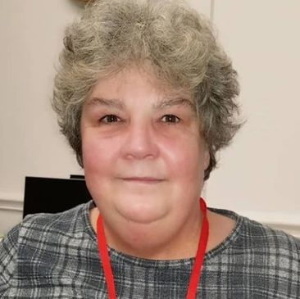

# **THANK YOU NOTE FROM FOUNDER/CEO**

**OYOVWE KIGHO**

*We have helped tackle loneliness and become socially inclusive for 142 service users last year. When our service users reach out to The Widows Empowerment Trust, they are looking for support and are in a situation where they need to be around others who have suffered the loss of a partner.*

*Our service users feel alienated from society and they cannot relate to others who are still carrying on with their lives, they often socially isolate themselves because they feel there is no one out there that can relate to their sadness. The mental health services in the UK are overstretched and there are often long waiting lists. The Widows Empowerment Trust was set-up to bridge that gap, to let the service users know that they are not alone in their grief and we provided a safe environment for them to relate to others who have suffered the same sense of loss. This has only been possible with the great dedication of our staff and volunteers. Lastly, my gratitude to our funders, donors and supporters, none of this would have been possible without you.*



# **PROVIDING A SUPPORTIVE ENVIRONMENT**

The Widows Empowerment Trust understands the deep pain that one suffers as a result of becoming a widow or widower, their sense of loss is so immense that they stop being social and end up isolating themselves for long periods of time, which have long-term negative impact on their mental wellbeing. Our service users are mostly referred to us from external agencies or they reach out to us to find out how we can support them through their grieving journey. Some times our service users are not even able to their own basic needs.

It is estimated that 29% widows are lonely and isolated which could lead to poor health and mental issue. Widows living in the UK, sometimes struggle to have their voice heard by the mainstream government system.

The result is that widows can become some of the most marginalised group in society yet are often those in in greatest need. Whether in terms of financial help, physical or mental health, or emotional or practical adjustments in their lives (Women National Commission).

The staff and volunteers at The Widows Empowerment Trust are extremely dedicated to providing support for the service users so that our service users do not have to go through the journey of grief alone.

The Widows Empowerment Trust has reached out to 142 service users this year.

Our services were reviewed in August 2018, when we conducted a research and interviewed 27 widows in our community and wider communities to ask what other services, they felt that they would benefit from. We found that befriending/home visit, meals out/day trip and celebrating key dates is another way to help tackle loneliness & social isolation facing widows.

In order to provide such essential services our volunteers helped us fundraise by ‘Bag Packing’ once or twice a month from superstores like Asda, Tesco, Morrison’s & Sainsburys.

Gender access to our service is an important issue for us. In light of our research, we identified widowers and others in need of support due to bereavement are facing loneliness and Isolation. We endeavour to include our services for the widowers.

However, the impact of our work goes far beyond those we help directly and include volunteers both young and elderly in our community and Students from the University of Manchester.

# **ACHIEVEMENT AND PERFORMANCE**

**PAMPERING SESSIONS**

Presently we promote health and wellbeing by supporting widows on 1:1 or a group visits to Spa where they use the jacuzzi, steamer and sauna. This helps to build their confidence, self-esteem and encourage social inclusion. We supported 12 women with pampering session. Looking after oneself becomes the least important and when one suffers from such a huge trauma like this.

We try to encourage and empower our service users that to take time out for themselves and that it is perfectly ok to take care of themselves whilst on their grieving journey. Once again, we try to empower them to take care of their own mental wellbeing, which can help through the deep emotional loss that they feel.

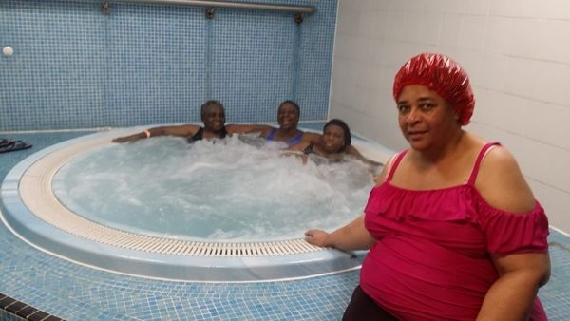

**ARTS & CRAFT CLASSES**

Education and Training sessions such as sewing, knitting and crochet session: This workshop is being run by workshop facilitators. The session is twice in a week, where service users learn how to create their own fabric designs.

We provide our service users with the fabric material and sewing tools such as sewing machines, needles, pins, thread, tapes etc. They also learn how to use their hands to sew and amend clothes, which has enabled them to identify their potential.

Twenty widows access the workshop, eleven widows were able to learn from the scratch how to use the sewing machine and also to sew using needle & thread to make an embroidery. Nine widows were able to build and develop and utilise the skills that they had forgotten they had. Just providing this safe space for widows has a positive effect on their mental wellbeing as they are able to meet others on the same grieving journey and can express what they feel without being judged, as well as learning new skills.

**ART/MUSIC THERPAY FOR DEMENTIA CLIENTS**

In addition, we have every Thursdays a dedicated arts & crafts classes for our older services users up to ten members attend, who suffer from Dementia. We engage in music therapy during these sessions as it helps to calm their minds and promote a sense of mental wellbeing. We also do karaoke during these sessions to encourage fun and laughter to help ease the burdens of their illness and their grieving process, which they experience often as some often relive the pain of being told that their life partner has passed away as they have no memory of being told that before.

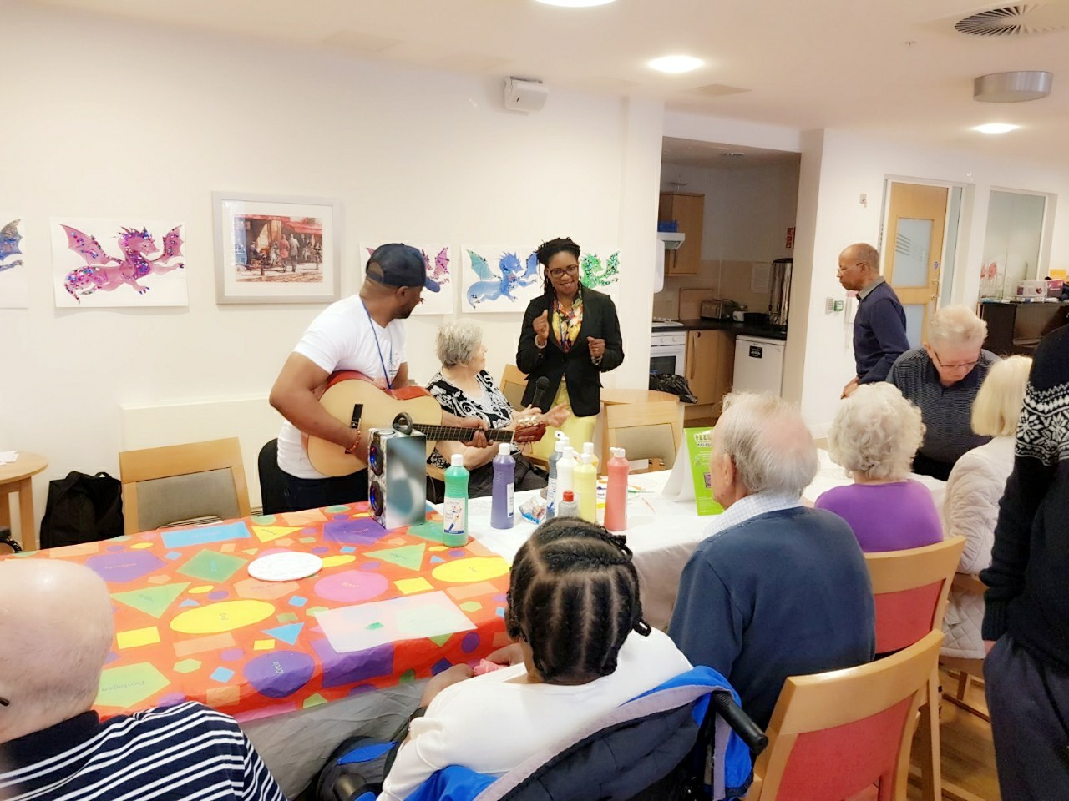

**CELEBRATION DAYS**

We celebrate key dates such as Valentine's day, Mother's Day, Easter and Christmas. During these times the bereaved missed their loved ones more than they would on any other day. We felt that it is important to empower our service users to be able to try and turn these days into something that they can smile about and reminisce fondly of their partner. We present our service users with flowers & gifts and we celebrate together with the family.

This year on Valentine’s day, we visited the Manchester Royal Children’s Hospital with our service users. We decided on this with the agreement of our service users as they felt that they would like to do something and give back to the community which made our service users feel great. We donated toys to children who were staying at the Manchester Royal Children’s Hospital. Manchester News came along with us to film our donation as part of community coverage that they do.

*“Hospitalised children, widows & orphans etc, are easily forgotten on Valentine’s day*” quote from one of our service users.

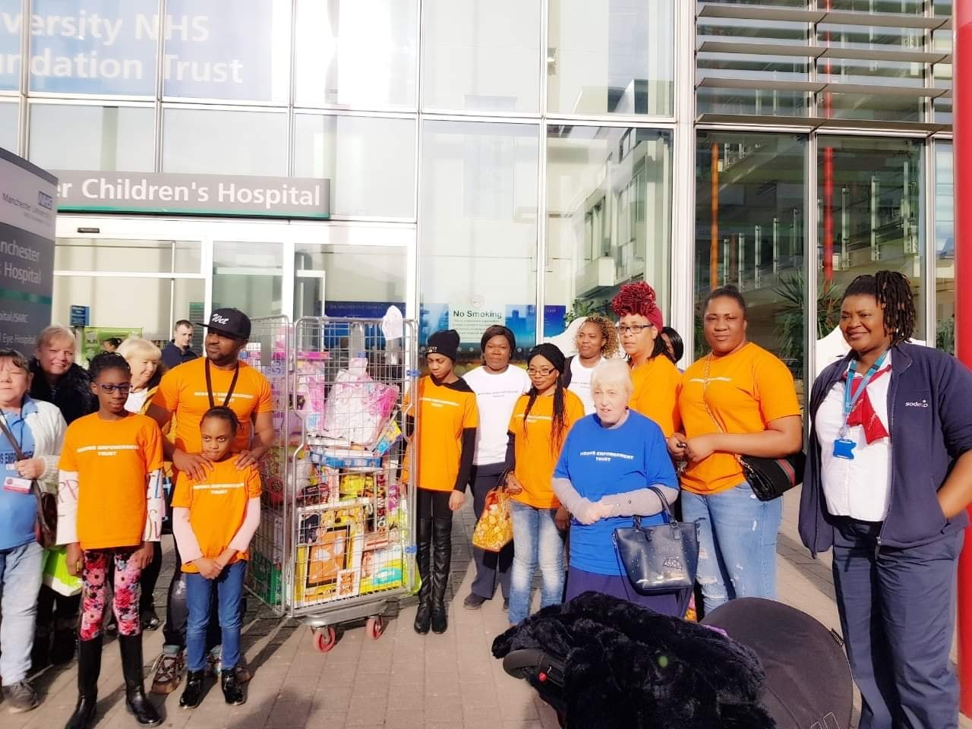

Mother’s Day, is the time when widows really do miss their spouse the most. Every year we visit our widows and present them with flowers, gifts including cash, cards and spend time with them. In addition, this year we provided a lavish meal for our beneficiaries, catered for and held at our office complex. We put on line dancing entertainment for our beneficiaries. Again, this is all done with the view of providing a positive atmosphere with others who are facing a similar situation and are able to relate to each other in terms of their grieving journey.

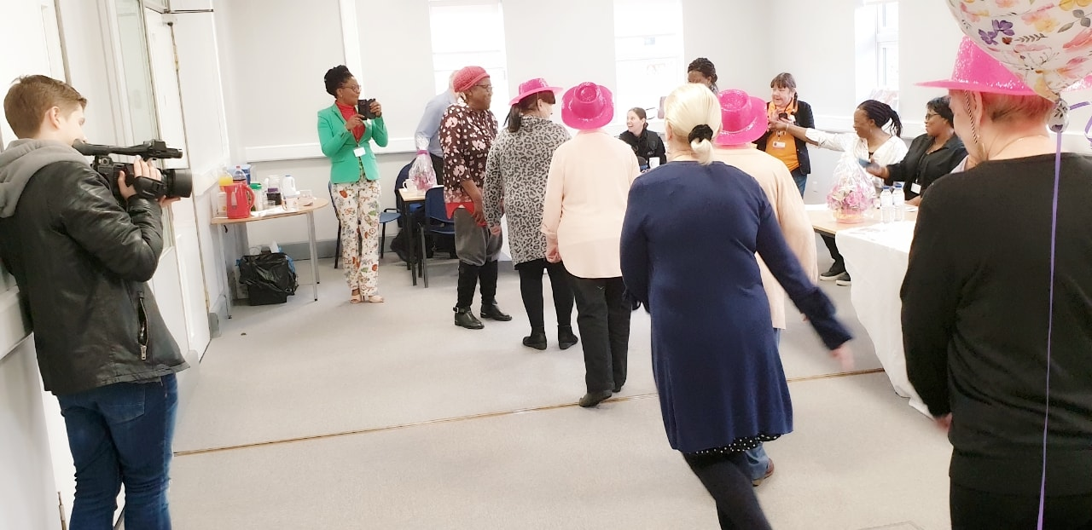

Christmas time can often exacerbate the feelings of loneliness that the widowed community feel. In order to help our beneficiaries through this challenging time of the year we have a Christmas party for our beneficiaries and present them with Christmas gifts so that it eases the pain often felt during this time of the year.

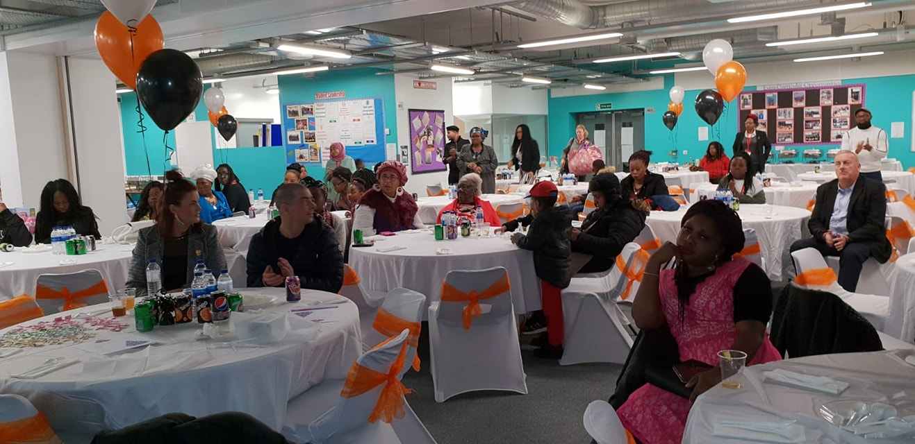

# **SOCIAL OUTINGS**

When someone loses a life partner, they also lose their social circle, they often withdraw from social activities. We recognise their loss and the fact that they feel alone in what they are going through.

* In the last year we have set-up two group meal days with our service users socialising in an environment with others who also share the similar experience of losing a life partner.

We provided these days out to promote their mental wellbeing and bring about a sense of positivity to their lives. In doing so our service users feel uplifted and are given a renewed strength to be able to navigate through their grieving journey.

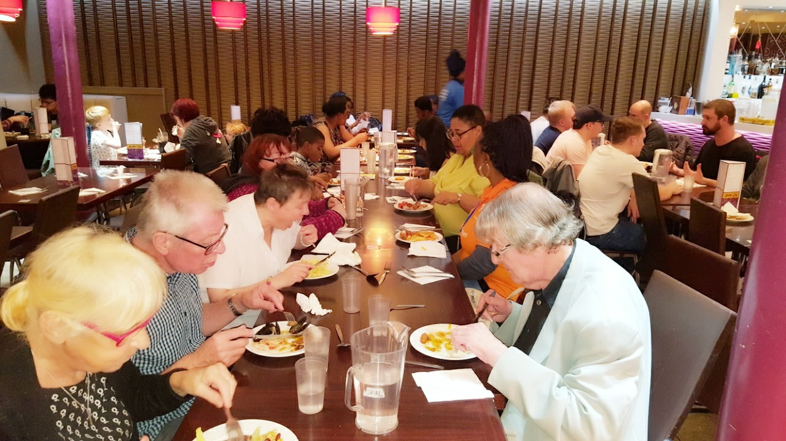

# **NEVER TOO OLD TO PLAY**

This year in August 2019, we were part of an initiative with Each Step Blackley Care home, where we provide volunteers 15-19-year olds through the National Citizen service to take part in a 4-week activity with the residents of this care home who have been widowed. We were delighted to be part of this partnership as it highlighted how important it is to have intergenerational community care as it does lift spirts of our service users and the members of the care home. Through these activities our volunteers felt that they had so much to learn from service users of the care home, they were very much interested in their life experiences and felt that they had gained an insight into perhaps what the future could hold for them. Not only did our volunteers gain community care experience they were left feeling inspired by the lives that our service users at the care home had lived. Our service users also benefitted from this 4-week partnership as they felt that they were able to impart their knowledge on to the younger generation. Our service users also felt that they were being listened to and quite enjoyed the company of the younger generation and the activities that they were involved in.

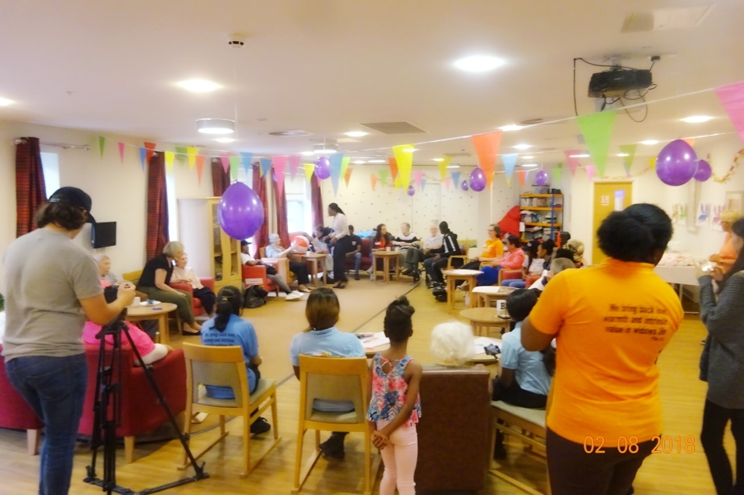

# **MONTHLY COOK ‘N’ TASTE SESSIONS**

This year we introduced once a month Cook ‘N’ Taste Sessions that are accessed by 10-15 beneficiaries. This initiative was taken to ensure that we have a diverse portfolio of services to offer our beneficiaries for them to become more socially involved in an environment where they feel safe and with others who ae on a similar grieving journey as themselves. This session is always fully booked and our services users enjoy cooking together in each other’s company. This is just one more step taken to eliminate loneliness that is felt within the widowed community.

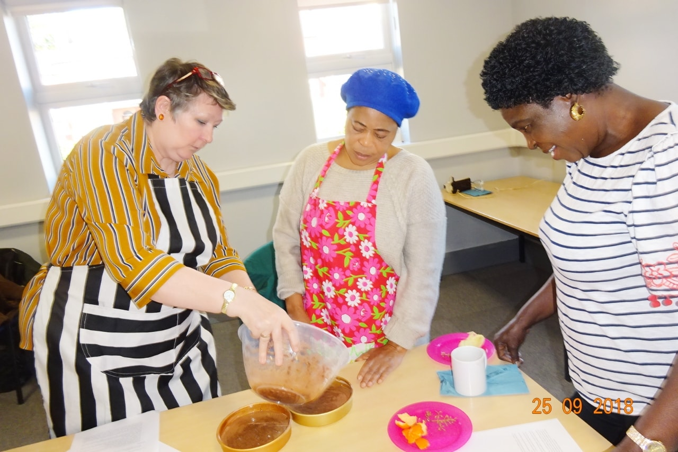

# **BEFRIENDING SERVICES**

Last year our volunteers visited 50 in their homes to offer a befriending service. Our volunteers provided support by listening to our service users with empathy. Our volunteers played chess, let the service users play music, go for walks or have a cup of tea and even assist to them to medical appointments. By offering our befriending service we give our service users time to engage socially, especially for those who have become socially isolated.

Our befriending visits are something that they look forward to and very much enjoy as it prevents them from being alone and isolated. Our service users need space to be able to speak about their grief and are often let down by the mental health services as they are already quite stretched and the likes of our organisation gives them that chance to talk to promote their own mental wellbeing.

To ensure that The Widows Empowerment Trust is accessible to those who need us, we have become community partners with Cruse Bereavement Manchester, NHS Navigator and housing association, other professional agencies and other community organisations.

We reach out to bereavement support groups on social media and to ensure we are diverse we also send literature to BME community groups throughout the UK.

We have expanded our befriending service to cover new areas in Greater Manchester including Stockport and Trafford Boroughs.

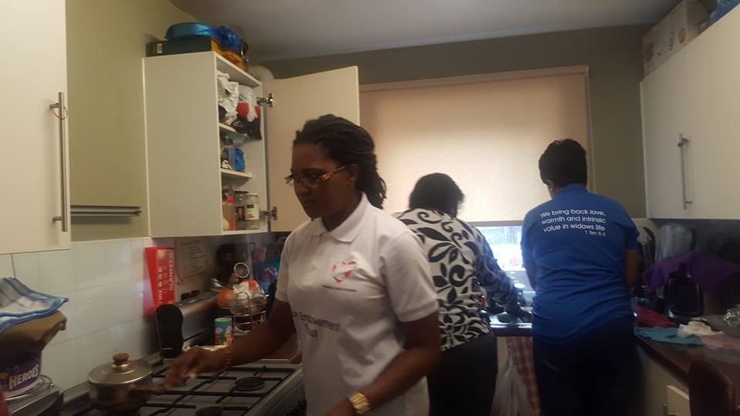

# **REVIEW**

Assessment of the activities that were carried out were measured by carrying out a baseline assessment before and after each project, using our questionnaire and interview process. Reviewing and evaluating our activities time to time enabled us to track our progress and achievement at the end

of each project. Also, we encouraged our service users with their feedback after every activity. Some areas of our work, for example the Rebuilding life project which was funded by the Big lottery, Eric Robin fund, We love MCR and Forever Manchester, we were able to use the fund to help one of our service users called Gift,

# **CASE STUDY**

Mrs Jon, was referred to us due to her detioriating mental health. She was showing signs of confusion induced by stress due to her bereavement and was displaying signs of very low self-esteem. Mrs Jon started to attend our weekly craft sessions and felt empowered by developing new skills that allowed her to contribute towards making craft items that we sell in order to fund these classes. Mrs Jon she now taken on a leading role as a volunteer for our organisation in the workshop where she instructs and leads the class for newcomers.

Testimonial by Dennis – widower who attends our weekly craft sessions

‘*I really enjoy the crafts workshop on Tuesdays. I have made new friends there which has helped me to cope with my grief. It gives me something to look forward to each week. And I feel a real sense of achievement knowing that I am contributing to make the charity sustainable by making crafts to sell.’*

# **VOLUNTEERS**

We have provided 827 volunteering opportunities for students of Manchester University and young people by being part of the CHALLENEGE run by the National Citizen service. The volunteers have supported The Widows Empowerment Trust to raise fund and awareness about our services.

We have also joined in partnership with the Job centre plus, where we provide regular 2x admin volunteering vacancies for job seekers.

The Widows Empowerment Trust continued to raise awareness of the difficulties faced by widows such as loneliness and isolation. The Widows Empowerment Trust also, encouraged the widows to volunteer to help them to combat their own loneliness.

Our volunteers are the backbone of The Widows Empowerment Trust, without them giving up their own personal free time we will not be able to support our service users as effectively as we do right now.

• We have a bank of 1114 volunteers

The Widows Empowerment Trust endeavours to reward our volunteers by ensuring that they are learning new working skills that will help them to develop themselves further in future careers.

We provide the option of learning

* Admin
* accounting,
* fund writing and
* community care skills.

We have a partnership with University of Manchester for student placements. Last year with the help of our volunteers we were able to carry out.

* 35 fundraising activities before the March 2020 lockdown and
* we had 50 volunteers help with the fundraising.
* Our volunteers have learned the skills of communicating with the public and gaining confidence in their ability to converse with others, which in turn builds their confidence in a work like environment.
* Last year we provided 16 student placements, who also worked as volunteers gaining office administration skills as well as finance skills.
* By providing these placements we are establishing ourselves as Trust that gives back to society by arming the volunteer students with employability skills to help them gain future employment.

As an organisation we are committed to providing training to our volunteers who want to excel within the community services sector. Last year we provided befriending training to

* 85 volunteers, who carried out befriending home visits as well as telephone befriending services.
* Our volunteers will use the skills learned in their future employment within the community care sector.

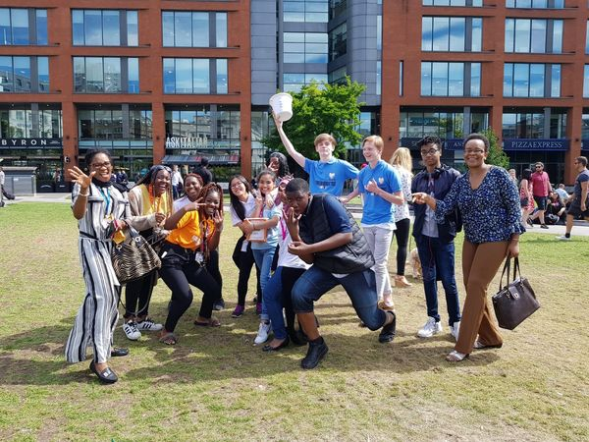

# **FINANCIAL REVIEW**

Without key stores such as Asda, Tesco and Morrison's who allowed us to come to the stores to fundraise money through bag packing, it would have been difficult to provide our befriending/home visit, pampering and meal out for thirty of our clients. From April to September we raised money from bag packing and donations from compassionate family and friends. Thanks to our fundraisers and supporters Without the support of key businesses like Asda, Tesco, Morrison and Sainsburys we will not have been able to provide support to widows and we rely on the ongoing support of our many fundraisers, who contribute their time, skills, commitment and passion.

We are very grateful especially to Manchester University volunteers who are able to give back to the community by raising funds for The Widows Empowerment Trust

**OUR SUPPORTERS**

Our Service is free at any time, we rely on donations, grants and trusts to fund our work. Our fundraising has really been a great opportunity for us to generate income, to reach out to many supporters, widows, and raise our profile. We are very pleased and would like to thank Northward Housing for their generous support, by providing their facilities for free to run our workshop. We would like to thank all the generous donors, individuals, organisations, key businesses, partners, volunteers, who supported our vision –

Big lottery

Forever Manchester

We love MCR

Eric Robin fund

# **Strategic Plan for 2019**

In support of our strategic priorities The Widows Empowerment Trust are striving to put in place

* Reliable and effective volunteer/ staff to continue with the befriending visits and telephone befriending services.
* Monetary and a secure financial base by applying for further grants
* Introduce Smart technology to be able to work more effectively
* More partnership and stronger network, especially in the field of volunteers and to be able to provide workable skills to our volunteers that they are able to use in their future careers.
* Reach out to more widows and widowers by raising awareness of our services to other relevant agencies who are able to recommend our services as a form of supporting our clients through their grieving journey.
* Raising awareness of our services nationally by being actively present on social media and also seeking coverage in the media to highlight our story and how we help within the community.
* Be able to secure funding for paid staff role to ensure the efficiency of the organisation

# **RISK REVIEW**

The Trustee have the responsibility to monitor and control the risk of the charity. With every activity we do, we consider the risk involved. Identifying existing controls and any mitigating actions such as the liability insurance and procedures which help to reduce the risk whilst managing how to monitor and maintain an efficient use of resources. The fundamental risk factor is the imbalance between the resource available to The Widows Empowerment and the unmet need of the widows. The most difficult part is the pressure on key personal who have limited support and scope to delegate with Succession risk. Our resources are therefore planned effectively to mitigate any risk.

The trustees' annual report was approved on 20 June 2019 and signed on behalf of the board of

trustees by:

Mrs Veronica Keke

Trustee

# **Independent examiner's report to the trustees of The Widows Empowerment Trust**

I report to the charity trustees on my examination of the accounts of The Widows Empowerment Trust (the Trust) for the year ended 30 September 2019.

**Responsibilities and basis of report**

As the charity trustees of the Trust you are responsible for the preparation of the accounts in accordance with the requirements of the Charities Act 2011 ('the Act').

I report in respect of my examination of the Trust's accounts carried out under section 145 of the Act and in carrying out my examination I have followed all applicable Directions given by the Charity Commission under section 145(5)(b) of the Act.

**Independent examiner's statement**

I have completed my examination. I confirm that no material matters have come to my attention in connection with the examination giving me cause to believe that in any material respect:

1. accounting records were not kept in respect of the Trust as required by section 130 of the Act; or
2. the accounts do not accord with those records; or
3. the accounts do not comply with the applicable requirements concerning the form and content of accounts set out in the Charities (Accounts and Reports) Regulations 2008 other than any requirement that the accounts give a true and fair view which is not a matter considered as part of an independent examination.

I have no concerns and have come across no other matters in connection with the examination to which attention should be drawn in this report in order to enable a proper understanding of the accounts to be reached.

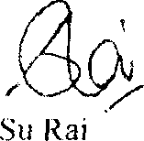

BA Hons, FCA, DChA

RaiseChartered Accountants 10th Floor

3 Hardman Street Spinningfields Manchester

M3 3HF

30/03/2020

Date: .............................................

# **Statement of Financial Activities for the Year Ended 30 September 2019**

|  |  |  |  |  |  |
| --- | --- | --- | --- | --- | --- |
|  |  | Unrestricted fund | Restricted fund | 30.9.19  Total funds | 30.9.18  Total funds |
| Notes | £ | £ | £ | £ |
| **INCOME AND ENDOWMENTS FROM**  Donations and legacies |  | 16,309 | 21,927 | 38,236 | 14,069 |
| **EXPENDITURE ON** |  |  |  |  |  |
| **Charitable activities**  Travel and subsistence |  |  |  |  |  |
| Volunteer expenses |  | 4,854 | 4,071 | 8,925 | 5,727 |
| Gifts to widows |  | 2,373 | 430 | 2,803 | 3,384 |
| Purchases |  | 2,141 | 27 | 2,168 | 1,802 |
|  |  | 651 | 2,572 | 3,223 | 12,902 |
| Advertising Facilitators |  | 1,971 | 429 | 2,400 | 900 |
| Fundraising and events |  | - | - | - | 2,700 |
| Office expenses |  | 895 | 4,660 | 5,555 | 2,519 |
|  |  | 775 | - | 775 | 409 |
| Rent of hall Sundry expenses |  | 1,338 | 2,000 | 3,338 | 1,958 |
|  |  | - | - | - | 110 |
| Meals out |  | - | - | - | 866 |
| Support costs Insurance |  | - | - | - | 298 |
|  |  | 385 | - | 385 | - |
| Telephone  Legal and professional fees |  | 730 | - | 730 | - |
|  |  | 364 | - | 364 | - |
| Memberships |  | 101 | - | 101 | - |
| Training |  | - | 860 | 860 | - |
| **Total** |  | 16,578 | 15,049 | 31,627 | 33,575 |
| **NET INCOME/(EXPENDITURE)** |  | (269) | 6,878 | 6,609 | (19,506 ) |

|  |  |  |  |  |  |
| --- | --- | --- | --- | --- | --- |
|  |  | Unrestricted fund | Restricted fund | 30.9.19  Total funds | 30.9.18  Total funds |
| **RECONCILIATION OF FUNDS** | Notes | £ | £ | £ | £ |
| **Total funds brought forward** |  | (8,693) | 293 | (8,400) | 11,106 |
| **TOTAL FUNDS CARRIED FORWARD** |  | (8,962) | 7,171 | (1,791) | (8,400) |

|  |  |  |  |  |  |
| --- | --- | --- | --- | --- | --- |
|  | Unrestricted  fund | Restricted  fund |  | Total  funds | Total  funds |
| Notes £ | £ |  | £ | £ |
| **FIXED ASSETS**  Tangible assets | 4 630 | 625 |  | 1,255 | 1,587 |
| **CURRENT ASSETS**  Cash in hand | 663 | 6,546 |  | 7,209 | 1,995 |
| **CREDITORS**  Amounts falling due within one year | 5 (10,255 ) | - |  | (10,255 ) | (11,982 ) |
| **NET CURRENT ASSETS/(LIABILITIES)** | (9,592) | 6,546 |  | (3,046) | (9,987) |
| **TOTAL ASSETS LESS CURRENT LIABILITIES** | (8,962) | 7,171 |  | (1,791) | (8,400) |
| **NET ASSETS/(LIABILITIES)** | (8,962) | 7,171 |  | (1,791) | (8,400) |
| **FUNDS**  Unrestricted funds | 6 |  |  | (8,962) | (8,803) |
| Restricted funds |  |  |  | 7,171 | 403 |
| **TOTAL FUNDS** |  |  |  | (1,791) | (8,400) |

The financial statements were approved by the Board of Trustees and authorised for issue on............................................. and were signed on its behalf by:

.............................................

Stephanie Roberts – Trustee

# **ACCOUNTING POLICIES**

**Basis of preparing the financial statements**

The financial statements of the charity, which is a public benefit entity under FRS 102, have been prepared in accordance with the Charities SORP (FRS 102) 'Accounting and Reporting by Charities: Statement of Recommended Practice applicable to charities preparing their accounts in accordance with the Financial Reporting Standard applicable in the UK and Republic of Ireland (FRS 102) (effective 1 January 2015)', Financial Reporting Standard 102 'The Financial Reporting Standard applicable in the UK and Republic of Ireland' and the Charities Act 2011. The financial statements have been prepared under the historical cost convention.

**Income**

All income is recognised in the Statement of Financial Activities once the charity has entitlement to the funds, it is probable that the income will be received and the amount can be measured reliably.

**Expenditure**

Liabilities are recognised as expenditure as soon as there is a legal or constructive obligation committing the charity to that expenditure, it is probable that a transfer of economic benefits will be required in settlement and the amount of the obligation can be measured reliably. Expenditure is accounted for on an accruals basis and has been classified under headings that aggregate all cost related to the category. Where costs cannot be directly attributed to particular headings, they have been allocated to activities on a basis consistent with the use of resources.

**Tangible fixed assets**

Depreciation is provided at the following annual rates in order to write off each asset over its estimated useful life.

**Taxation**

The charity is exempt from tax on its charitable activities.

**TRUSTEES' REMUNERATION AND BENEFITS**

There were no trustees' remuneration or other benefits for the year ended 30 September 2019 nor for the year ended 30 September 2018.

**Trustees' expenses**

There were no trustees' expenses paid for the year ended 30 September 2019 nor for the year ended 30 September 2018.

**COMPARATIVES FOR THE STATEMENT OF FINANCIAL ACTIVITIES**

**INCOME AND ENDOWMENTS FROM**  Unrestricted Restricted Total

fund fund funds

£ £ £

Donations and legacies 11,079 2,990 14,069

**EXPENDITURE ON**

**Charitable activities**

**Travel and subsistence** 4,077 1,650 5,727

Volunteer expenses

Gifts to widows

2,127 1,257 3,384

Purchases

1,776 26 1,802

7,467 5,435 12,902





**MOVEMENT IN FUNDS - continued**

**Comparative net movement in funds, included in the above are as follows:**

Incoming Resources Movement

resources expended in funds

|  |  |  |  |  |  |  |
| --- | --- | --- | --- | --- | --- | --- |
|  | £ | | £ £ | | | |
| **Unrestricted funds**  General fund | 11,079 | | (20,612 ) (9,533) | | | |
| **Restricted funds**  Restricted funds |  | |  | | | |
|  | 2,990 | | (12,963 ) | | (9,973) | |
| **TOTAL FUNDS** | 14,069 | | (33,575 ) | | (19,506 ) | |
| A current year 12 months and prior year 12 months combined position is as follows: |  | |  | |  | |
|  | At | | Net movement | | At | |
| 1.10.17 | | | in funds | 30.9.19 | | |
| £ | | | £ | £ | | |
| **Unrestricted funds**  General fund | | 730 | (9,802) | | | (9,072) |
| **Restricted funds**  Restricted funds | |  |  | | |  |
| 10,376 | | | (3,095) | | | 7,281 |
| **TOTAL FUNDS** 11,106 | | | (12,897 ) | | | (1,791) |

A current year 12 months and prior year 12 months combined position is as follows:

|  |  |  |  |
| --- | --- | --- | --- |
|  | Incoming  resources | Resources  expended | Movement  in funds |
| £ | £ | £ |
| **Unrestricted funds**  General fund | 27,388 | (37,190 ) | (9,802) |
| **Restricted funds**  Restricted funds |  |  |  |
|  | 24,917 | (28,012 ) | (3,095) |
| **TOTAL FUNDS** | 52,305 | (65,202 ) | (12,897 ) |



RELATED PARTY DISCLOSURES

There were no related party transactions for the year ended 30 September 2019.

RESTRICTED FUNDS

Tesco bag for life - To purchase arts and crafts, refreshments and support the Christmas party. Manchester City Council - To go towards volunteer travel.

Manchester Wellbeing - To purchase arts and crafts, spread awareness and go towards volunteers travel. Big lottery - To purchase new computers, for training, contribution towards rent and session work.

Tesco bag for life 2 - To go towards the session work. Asda Foundation - To go towards the Christmas party. Duch of Lancaster - To go towards session work.

Manchester Wellbeing 2 - To go towards travel. Northward Housing - To fund speakers.

