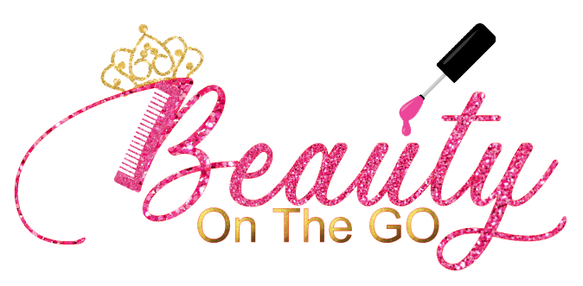
Beauty On The Go Waiver and Release Form:
Please notify a member of Beauty On The Go if your child has any allergies. Our skin products are for sensitive skin and extremely safe for children, but please make our staff aware of any allergies so that we can prepare accordingly.
____I understand the nature of the spa services to be rendered to my child, and that the services provided are of my child’s best interest. I understand the services of the children’s salon and spa and am aware of the prices as well as the nature of the services.
____ I agree that my child and I will hold harmless Beauty On The Go and its staff for personal injuries or property damage, arising out of or related to unintentional or negligent conduct of the service provider, and hereby waive all claims, suits, losses, or related causes of action arising from such conduct for damages, including, but not limited to, such claims that may result from injury, digestion or allergic reactions during, or arising in any way from, the spa services.

_____We stand by our products and guarantee all functions within its intended use. By accepting our services, you agree to release from all liability whatsoever including, but not limited to spa products, mani/pedi products, soaps, accessories, etc. manufactured or provided by vendor.
____ I am aware that all products are non-consumable and are not intended to be eaten or digested unless otherwise stated and if consumed, products may be hazardous and could result in serious bodily injury, death, or damage. As with all skin care products we adhere to the guidelines and regulation set forth by the FDA. We do; however, recommend that you conduct small skin tests prior to use.
____In signing this Waiver of Claims and Liability Agreement, I affirm that I have read this Agreement in its entirety and that I understand the nature of the spa services that will be provided to my child. I also affirm that my questions regarding these spa services have been answered to my satisfaction.
___I hereby waive, release, discharge, and covenant not to sue, indemnify and hold harmless Beauty On The Go, its owners, directors, administrators, agents, volunteers, operators, its officers and employees, the sponsors, and the venue of the event in any incident resulting to loss, liability, damage or damages, claims, causes of action whether in whole or in part, the negligence by which may be incurred.
___I assume the inherent and other risks that may result to harm, injury, illness, loss, or death during my participation in any activities of the event.
___I hereby sign this form freely, unconditionally, and without inducement or consideration of any nature as an affirmation and consent to the contents of this form by which I will be legally bound.
____I assume all responsibility for every child/person participating in services in my group.
____Agree _____ Disagree to have my child’s photos taken or used for any marketing, advertising, or promotional items.

Signature:______________________ Date:____________________

