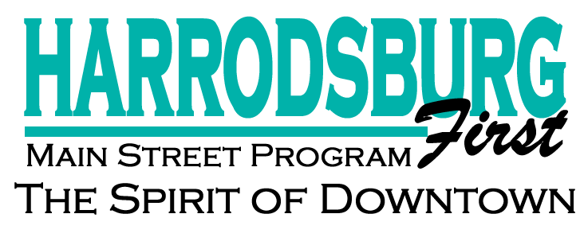

December 18, 2018

Dear Downtown Business Owner,
Each year, Harrodsburg First is required to collect statistics that measure our downtown district’s growth and vibrancy.
The statistics are compiled and totals sent to the Kentucky Heritage Council and the National Main Street Center. The success of this effort is part of our annual certification process, with certification dependent on our ability to submit accurate statistics.
Attached is the 2018 Reinvestment Survey form. Please complete this and return to Harrodsburg First no later than December 22, 2018.
No individual information is ever shared. All data is compiled and added together with a grand total sent to the state and national Main Street centers. Everything you share is kept in the strictest of confidence.
Should you wish to discuss this survey, do not hesitate to call me at 734-6811 or 859-583-2631.

Kindest Regards,

Julie Wagner, Executive Director
Harrodsburg First Mian Street Program

ANNUAL DOWNTOWN HARRODSBURG INVESTMENT STATISTICS

NAME OF BUSINESS: Click or tap here to enter text.
EMAIL: Click or tap here to enter text.
CONTACT #: Click or tap here to enter text.

EMPLOYMENT NUMBERS:
# FULLTIME EMPLOYEES Click or tap here to enter text.
# PARTTIME EMPLOYEES Click or tap here to enter text.

INVESTMENT FIGURES:
Roughly calculate the investment you have made into your business in 2018:
$ Click or tap here to enter text. New Inventory, Equipment and/or merchandise
$ Click or tap here to enter text. Building improvements and repairs

OCCUPANCY INFORMATION:
☐RENT
☐MORTGAGE/OWN
MONTLHY RENT OR MORTGAGE PAYMENT $ Click or tap here to enter text.

PLEASE COMPLETE AND EMAIL THIS FORM TO:
DOWNTOWNHARRODSBURG@GMAIL.COM

