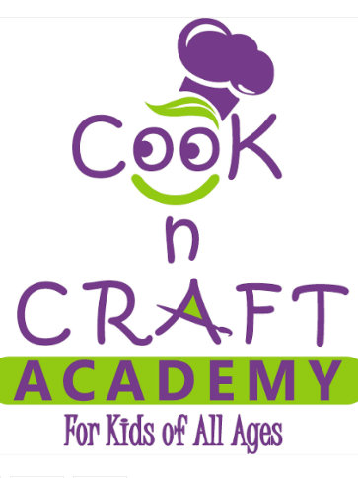
In consideration of being permitted by Cook n Craft Academy to participate in a cooking class and/or craft class, I hereby waive, release and discharge any and all claims for damages or personal injury, death, or property damage which I may have or which may hereafter accrue as a result of my participation in said activity. This release is intended to discharge, in advance, Cook n Craft Academy, its officers, directors, members and managers, and all other members of its cooking school staff whether contracted or employed, from and against any and all liability arising out of or connected to in any way with any participation in said activity. I understand that the activity that I am participating in may be of a hazardous nature and/or include physical and/or strenuous activity, that serious accidents occasionally occur during the said activity; and that participants in the said activity can occasionally sustain personal injuries as a consequence thereof. Knowing the risks involved, nevertheless, I have voluntarily applied to participate in said activity, and I hereby agree to assume any and all risks of injury or death and to release and hold harmless Cook n Craft Academy its officers, directors, members and managers, and all other members of its cooking school staff whether contracted or employed, who might otherwise be liable to me. I further understand and agree that this waiver, release and assumption of risks is to be binding on my heirs and assigns. I hereby grant Cook n Craft Academy all rights and consent to copyright, use, re‐use, publish or re‐publish, copy, exhibit or distribute all photographs and/or video of myself to be used for Cook n Craft Academy’s website, social media, and any educational, training or promotional electronic or printed material without restriction as to frequency or duration of usage and without compensation. By signing this waiver, I acknowledge that I have carefully read this Hold Harmless Agreement, Waiver and Release and fully understand its contents. I am aware that this is a release of liability and a contract between myself and Cook n Craft Academy and any staff member of cooking class whether contracted or employed.

Name (print)__________________________________________________________

Signature_____________________________________________________________

Address:_______________________________________________________________

Phone number___________________________________________________________

Email__________________________________________________________________

Emergency contact number__________________________________________________

