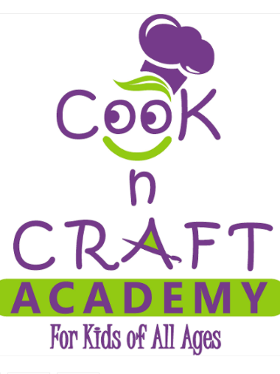

ASSUMPTION OF RISK, RELEASE OF LIABILITY & WAIVER SPROUTS COOKING’S PERMISSION TO USE IMAGE By signing this Assumption of Risk, Release of Liability and Waiver, I represent that it is my desire and intent that my child_________________________participate in the activities of Cook n Craft Academy specifically including cooking and or crafting class(es). I also represent that I have the authority to enter into this agreement on behalf of my Child as the Child’s parent or legal guardian. I acknowledge that the participation of my Child in Cook n Craft Academy which includes participating in activities related to preparing and eating food, and/or making crafts involves known and unknown risks, including the risk of physical injury, death and other damage. On behalf of my Child, I expressly and voluntarily assume any and all risks associated with participation in Cook and Craft Academy and eating any food prepared there. I understand that there are risks inherent in cooking and eating the food prepared, and crafting including but not limited to, slips, falls, cuts, burns, choking, food allergy reactions and other accidents and injuries that may arise from the activity of crafting, cooking and eating the food prepared in class. In consideration for my Child being permitted to attend and participate in Cook n Craft Academy and any and all of the activities that are or might be associated with Cook n Craft Academy on my Child’s behalf, I release and further agree to indemnify, defend and hold harmless Cook n Craft Academy, including its members, managers, officers, owners, employees, agents, contractors, representatives, volunteers, interns, and insurers, from any and all claims, demands, actions, causes of action, lawsuits, expenses or losses (including attorney fees) whatsoever that could be brought by me, my Child or a third party acting on behalf of my Child or me for acts or omissions related in any way to, or arising out of, Cook n Craft Academy classes and the preparation of food in that class for consumption. I understand that at any classes, events or activities of Cook n Craft Academy my Child may be photographed, filmed or otherwise have our activities recorded by Cook n Craft Academy, its employees, agents or contractors. In further consideration for my Child being permitted to attend and participate in Cook n Craft Academy class(es), I agree to allow the voice, image and likeness of my Child to be recorded and reproduced by photo, video, film, tape or any other media, including any electronic or digital media, and that such content may be used and reproduced for any legitimate purpose by Cook n Craft Academy or its assigns. I agree that Cook n Craft Academy shall own all copyrights in such content. I hereby waive any and all rights to royalties, commissions or other compensation, and any and all rights of publicity or privacy, that my Child may have, now or in the future, related to the use or exploitation of such content described above by Cook n Craft Academy.. I understand that this is the entire agreement between Cook and Craft academy, their agents or employees, and me, and that it cannot be modified or changed in any way by the representations or statements of any employee, agent, volunteer or intern of Cook n Craft Academy. I agree that this Agreement shall be governed and interpreted under Tennessee law. I acknowledge that I have read and understand this document, which affects my Child’s and my legal rights, and I am signing it on behalf of the Child, as well as his/her heirs and assigns, who will be bound by all its terms. By signing this form, I agree to the above waiver (continued on next page)

Name of Participant___________________________________________Age_________

Parent or Legal Guardian’s Signature___________________________________________

Emergency contact number__________________________________________________________

Email_____________________________________________________________________________

