**ONE STOP FENCE AND GATE SHOP – CUSTOMER ENQUIRY FORM**

Customer Name: Click here to enter text.

Telephone number: Click here to enter text.

Address (including postcode): Click here to enter text.

**Please use a separate form if you require multiple quotes.**

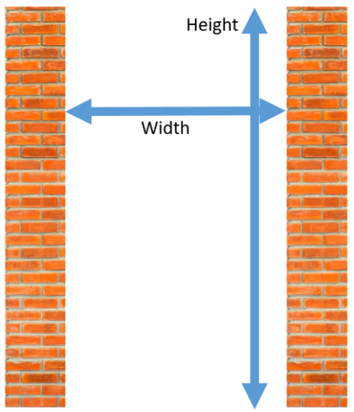**STEP ONE –** Please let us know if you require a gate or a fence and the dimensions of your space or gap. Please check the relevant box.

Fence

Gate

Please provide us with the **WIDTH** of the space and

**HEIGHT** required for your fence or gate in millimetres.

**WIDTH:** Click here to enter text. mm

**HEIGHT:** Click here to enter text. mm

**STEP 2 –** Insert or attach photos of your space or gap.

   

**Step 3 –** Choose the design of your fence or gate (please check the relevant option)

Fence Gate

Slatted Wood (1) 3 panel bi fold (1) 4 panel bi fold (1)

Solid Wood (2) Single gate (2)

TBC (3) Double gate (3)

**Step 4 –** Choose the material of your fence or gate (please check one option)

Fence Gate

Green (1) Metal Composite (1)

Light Brown (2) Wooden Composite (2)

Dark Brown (3) Wood (3)

Additional information and extras:

Please let us know of any further preferences or any information that you think will assist us with your quote such as XXXXXXXXXXXXXXXXXXXXXXXXXXXXXXXXXXXXXXXXXXXXXXXXXXX>

Click here to enter text.

Important information - Please read:

Blah, blah, blah…..

Please check this box to show you have read and understood this information.