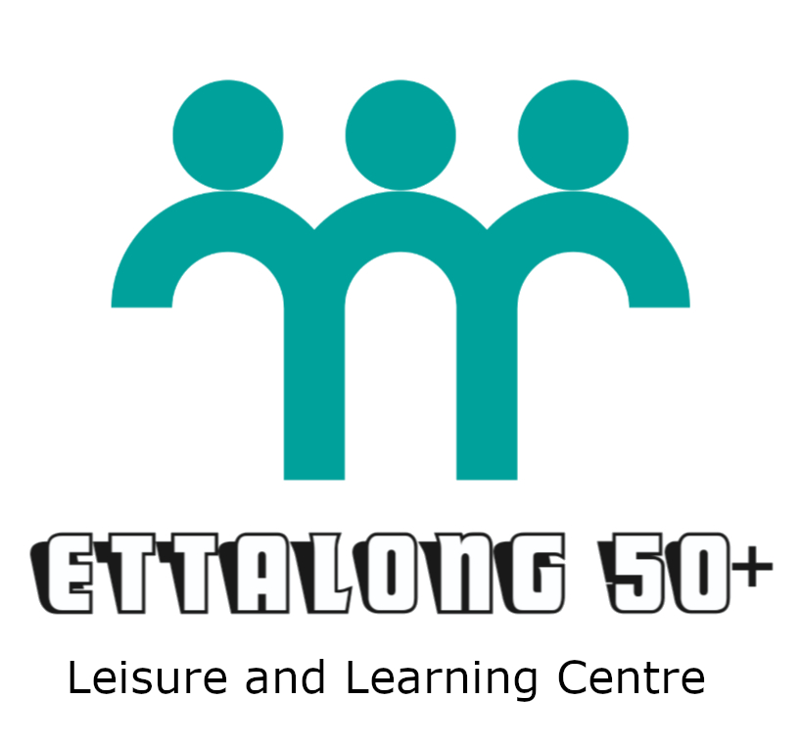
Activity Program and Fees
Phone: 02 4342 1034 Open: Mon-Fri 8:30am to 3pm
Cnr Broken Bay Road and Karingi Street, Ettalong NSW 2257 Email: ettalong50plus@gmail.com
MONDAY | TIME | FEE
Table Tennis | 9:00am – 11:00am | $3
Chess | 9:00am - 11:30am | $3
Rummyking | 9:00am – 12:00pm | $3
Ukelele | 9:00am – 11:00am | $3
Computers/Technology | 11:00am – 1:00pm | $3
Mahjong | 12:30pm – 3:30pm | $3
Gentle Yoga Contact: 0481 511 434 | 11:15am – 12:15pm | $10
Active 50+ Fitness Contact: 0424 347 578 | 1:00pm – 2:00pm | $10
Chair Yoga Contact: 0412 415 879 | 2:30pm – 3:30pm | $10
Clubbercise Contact: 0424 176 411 | 6:15pm – 7:15pm | $15
TUESDAY | TIME | FEE
Indoor Bowls | 9:30am – 11:30am | $3
Dancing | 9:00am – 11:30am | $3
Euchre | 9:00am – 11:30am | $3
Handicraft | 9:30am – 11:30am | $3
Darts | 12:00pm – 2:30pm | $3
Cards (500 / Hand & Foot) | 12:00pm – 3:30pm | $3
Recorder Group | 12:45pm – 1:00pm (Beginners)  1:30pm – 2:15pm (Continuers) | $3
Computers/Technology | 11:00am – 1:00pm | $3
Tai Chi | 2:30pm – 3:30pm | $3
Shake it Off Dance Fitness Contact: 0401 951 698 | 6:30pm – 7:30pm | $15
WEDNESDAY | TIME | FEE
Table Tennis | 9:00am – 12:00pm | $3
Leatherwork | 9:00am – 12:00pm | $3
Patchwork | 12:30pm – 3:30pm | $3
Bridge | 12:00pm – 3:30pm | $3
Scrabble | 12:00pm – 3:30pm | $3
Active & Healthy Contact: 0404 944 342 | 1:00pm – 2:00pm | $15
THURSDAY | TIME | FEE
Indoor Bowls | 9:30am – 11:30am | $3
Dancing | 9:00am – 11:30am | $3
Create and Chat | 9:30am – 11:30am | $3
Mahjong | 12:00pm – 3:30pm | $3
Rummiking | 9:00am - 11:45am | $3
Table Tennis | 1:30pm – 3:30pm | $3
Active 50+ Fitness Contact: 0424 347 578 | 12:00pm – 1:00pm | $10
Gentle Yoga Contact: 0481 511 434 | 4:15pm – 5:15pm | $10
FRIDAY | TIME | FEE
Indoor Bowls | 9:00am – 11:30am | $3
Painting | 9:30am – 12:00pm | $3
Bridge | 12:00pm – 3:00pm | $3
Choir | 12:30pm – 2:30pm | $3
Line Dancing (PH) Contact: 0409 150 518 | 9:30am – 11:30am | $8
SUNDAY | TIME | FEE
Coastal Bootscooters Contact: 0409 150 518 | 12:00pm – 4:00pm | $8

