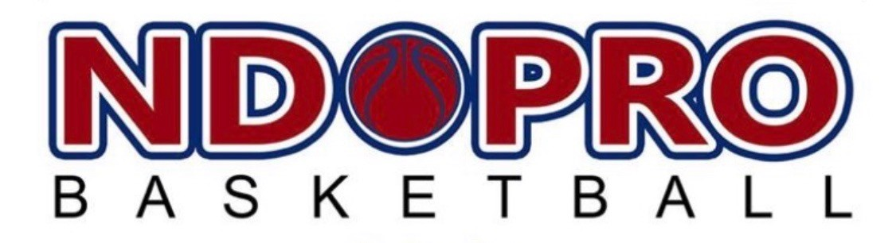

2023 NDPRO REGIONAL CHAMPIONSHIP

COLLEGE/AAU/HIGH SCHOOL

Tournament June 2023
When: Saturday/Sunday - June 24-25, 2023 (Friday the 23rd if needed after 4pm)
Where: Concordia College, Moorhead, MN
Cost: $375 - - 4 game guarantee (college level is 3 games)
Levels
College Level - V - Juniors and Seniors
College Level - JV - Freshman and Sophomores
17U - Varsity A – Schools of 500 or more
16U - Varsity B- Schools less than 500
15U - JV A – Schools of 500 or more
14U - JV B – Schools less than 500
13U - Middle School A – Grades 7-8
12U - Middle School B - 6th grade

Team Name: ________________________
Level: ____________________
Email: ___________________________________________________________________________
Mailing Address: ________________________________ City: _____________State: ___ Zip: _____
Contact: _______________________________________Phone Number: _____________________

Send your team name, team level, mailing and email address and payment to:
NDPRO
PO Box 10036
Fargo, ND 58106
ndproaau@gmail.com

