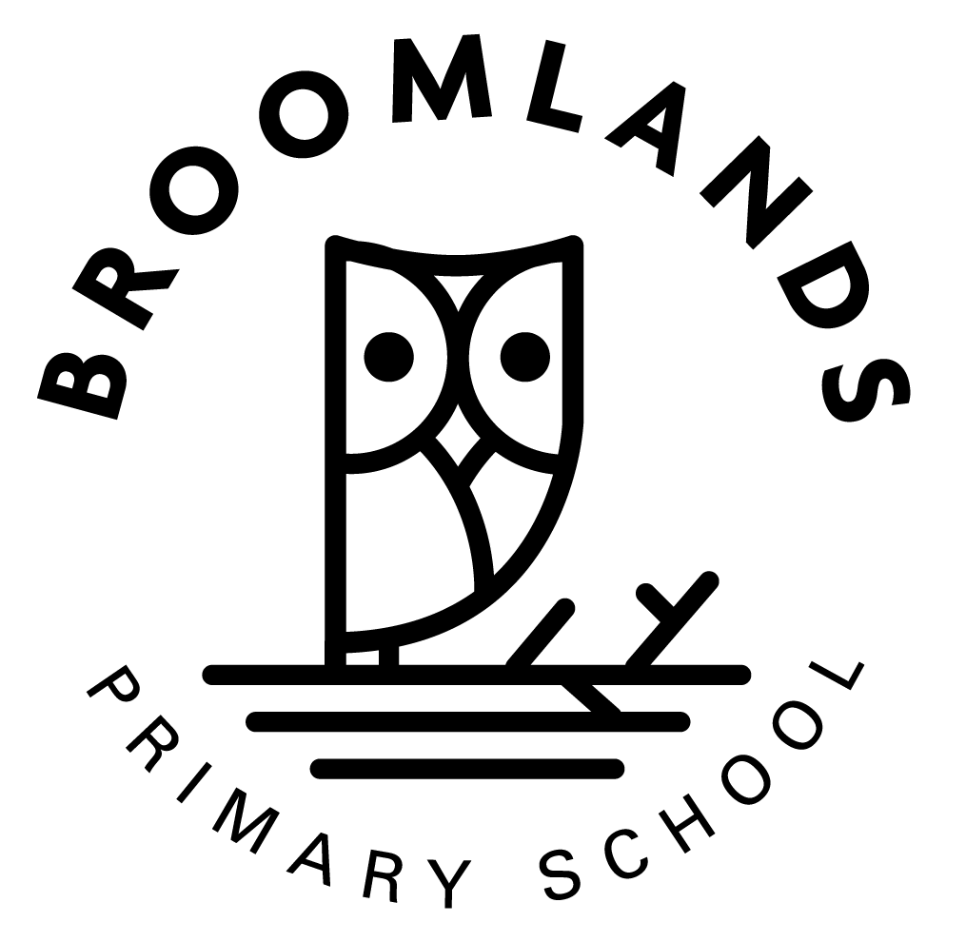 | BROOMLANDS PRIMARY SCHOOL  SCHOOL SESSION ARRANGEMENTS  AUGUST 2022 – JUNE 2023

School term dates for Session 2022-23

Autumn term
- Monday 15 Aug 2022 - Staff resume, In-service day
- Tuesday 16 Aug 2022 – In-service day
- Wednesday 17 Aug 2022 - Pupils resume
- Friday 7 Oct 2022 - Last day of term for pupils and staff, mid term holiday
- Monday 17 Oct 2022 - Staff resume, In-service day
- Tuesday 18 Oct 2022 - Pupils resume
- Monday 28 Nov 2022 - St Andrew's Day holiday, school closed
- Tuesday 29 Nov 2022 – casual holiday
- Thursday 22 Dec 2022 - Last day of term for pupils and staff

Winter term
- Monday 9 Jan 2023 - All resume
- Friday 10 Feb 2023 - Last day of term for pupils, February holiday
- Monday 13 Feb 2023 – casual holiday
- Monday 20 Feb 2023 – In-service day
- Tuesday 21st Feb 2023 - All resume
- Friday 31 Mar 2023 - Last day of term for pupils and staff

Summer term
- Monday 17 Apr 2023 - All resume
- Monday 1 May 2023 - May Day holiday, school closed
- Tuesday 2 May 2023 - Staff resume, In-service day
- Wednesday 3 May 2023 - Pupils resume
- Thursday 29 June 2023 - Last day of term for pupils and staff

Casual holidays
Each learning community allocates two casual holidays for pupils and staff which are usually aligned to their local festivals.

Cheviot
- Tuesday 29th November 2022
- Monday 13th February 2023

