2 Year Old

Funding Information

September 2018

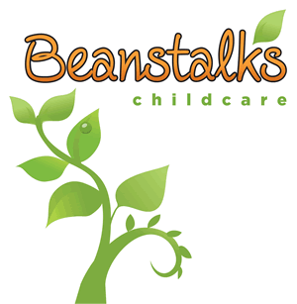

**2 year old eligibility criteria**

For your child to be eligible you must meet one of the criteria in the table below. Details of the evidence you will need to provide are also listed:

|  |  |
| --- | --- |
| **Criteria** | **Evidence** |
| Families in receipt of one or more of the following benefits or tax credits:   * Income Support * Income-based Jobseeker's Allowance * Income-related Employment Support Allowance * Universal Credit, where your household has a combined annual work income of less than £15,400 after tax * The guarantee element of the State Pension Credit * Child Tax Credit, where your household annual income is less than £16,190 before tax * Working Tax Credit, where your household annual income is less than £16,190 before tax | We will use the information you provide on the application form to check your eligibility using an online government database.  We may contact you if further information or evidence is required. |
| Asylum seekers receiving support under Part 6 of the Immigration and Asylum Act 1999. | National Asylum Seeker Service (NASS) Reference Number |
| Children who are looked after by the local authority or who have left care through special guardianship, adoption or residence order. | Confirmation from your Social Worker. |
| Children who are the subject of a Child Protection Plan. | Confirmation from your Social Worker. |
| Children who have an Education, Health and Care (EHC) plan. | Confirmation from your EHC lead professional. |
| Disabled children who receive Disability Living Allowance (DLA). | Copy of your benefit letter confirming you are in receipt of DLA for your child. |

If you think you may be eligible, based on the criteria provided above, please visit the following site to apply directly for your 2 year old funding with the council.

<https://www.trafford.gov.uk/residents/children-and-families/early-education/secure/2-year-old-funding-declaration.aspx>

Please then forward your confirmation email to [beanstalks@hotmail.co.uk](mailto:beanstalks@hotmail.co.uk) or [Saskia.beanstalks@gmail.com](mailto:Saskia.beanstalks@gmail.com)

Alternatively, you may have been posted information directly from Trafford telling you that you ARE entitled to the funding for 2 year olds. In this case, fill in and return the form they have sent to you, then wait a few days and call them on 0161-912-1053 for confirmation of receipt. Once you have done this you can inform us and we can call on your behalf as the provider of choice and check that everything is in place for your child to start their Pre-School journey!

If you have any further questions or queries, please contact our designated funding officers directly on 0161-291-0545.

Saskia Nield and Emma Riley are happy to assist you with any of your funding needs.