IT TAKES TWO, INC 2020-2021

Tools for Success Scholarship Application
Please type and print.

Personal Information (Student)
Name
Street Address
City ST ZIP Code
DOB
Cell Phone
E-Mail Address
Parent’s Name, Phone & E-Mail
Parent’s Full Address
Student’s Gender | - Male  - Female
Ethnic Background | - African American  - Asian/Pacific Islander  - White  - American Indian  - Hispanic/Latino  - Other

Educational Background
Name of Current School:

City & State:

Year/Grade in School (as of today’s date):

Current GPA (out of 4.0):

Name of School for 2020-2021 School Year:

City & State:

Extra-Curricular Activities (You may type and attach to the application)

List academic and/or athletic activities.

Honors, Awards, and Achievements: (You may type and attach to the application.)

List any honors and other recognitions you have received.

Essay Questions (Grades 4 & Up)
The following essays are grade specific. Please select the appropriate essay according to your current 2019-2020 grade/academic level. For example, if you graduate(d) in the Spring of 2020 and attending college in the fall, you will complete the “Grades 9-12” essay question. Limit your typed response to 250-300 words for grades four through eight and 400-500 words for grades nine through college. Format the document with one-inch margins (top, bottom, right and left). Include a cover page reflecting your name, grade level, and date of submission.

Grades 4 & 5
Who is your hero and why? What makes him/her a good leader? What do you think it takes to be a good leader?

Grades 6-8
As a youth, what has been the toughest obstacle you have faced and overcome? What did you learn from the experience?

Grades 9-12
What are your professional goals and aspirations? How do you plan to achieve these goals? How will you overcome the obstacles that may arise?

College Students
What are your professional goals and aspirations? How will this scholarship impact your ability to achieve these goals?

INCOME VERIFICATION

*Using your W-2 or 2019 filed tax return, please confirm that your gross income for 2019 meets the financial eligibility requirements in the following statement.

Scholarship income requirements mirror those of the federal free and reduced meals program guidelines (below). IT TAKES TWO, INC will use the same guidelines in determining scholarship eligibility.

I, ________________________________________ (your name) parent/guardian of ______________________________________ (your child’s name) certify that my gross income for 2019 meets the income requirement as outlined in the below table.
**Proof of income will be verified after receipt of your application if your child is selected for an award. Please do not provide any financial information with this application.**

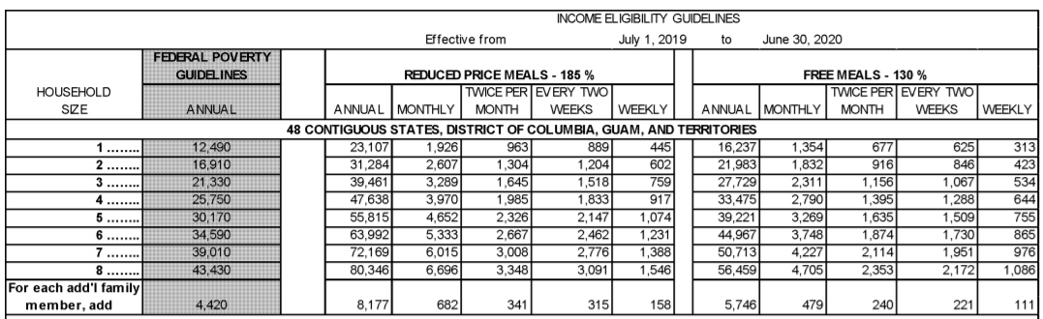

Source: USDA (March 2019) https://www.govinfo.gov/content/pkg/FR-2019-03-20/pdf/2019-05183.pdf

Agreement and Signature

As a condition of acceptance as a scholarship recipient from IT TAKES TWO, INC, I, the undersigned, agree that the information provided is correct and factual to the best of my knowledge.
Name (printed/typed)
*Signature & Date
Parent or Guardian Signature (if a minor, under 18 years old)

*Electronic signature is acceptable and may type the date.

IT TAKES TWO, INC will announce the winning recipient(s) across multiple media sources.

IT TAKES TWO, INC MEDIA RELEASE FORM

I, _____________________________________, give my permission for IT TAKES TWO, INC to video tape, audio tape, and interview me and/or my child, for my/his image likeness or comments to be used in print, internet, television, and radio, for any program evaluation, publicity, or media purpose’s in support of IT TAKES TWO, INC’s programs, workshops, and events.

I do hereby waive any right to inspect or approve the finished photographs or published material that may be used in conjunction with them now or in the future, what that use is known to me or unknown, and I waive any right to royalties or other compensation arising from or related to the use of the photograph or other media.

I understand that there will be no financial or other remuneration for published media.

I also understand that IT TAKES TWO, INC is not responsible for any liability incurred because of my participation in any media recording, photographs, or published material.

I, _____________________________________, do not give my permission for IT TAKES TWO, INC to photograph, video tape, audio tape, and interview me or my child, and for my/his image likeness or comments to be used in print, internet, television, and radio, for any program evaluation, publicity, or media purpose’s in support IT TAKES TWO, INC’s programs, workshops, and events. I understand that it is my responsibility to ensure that my photograph nor that of my child is not taken as he/she participates in any program, workshop, or event(s).

Name (printed/typed)
*Signature & Date
Phone Number

*Electronic signature is acceptable and may type the date.

NEXT PAGE: APPLICATION CHECK LIST

IT TAKES TWO, INC ™ 2020-2021 Tools for Success Scholarship Application Checklist

Before mailing your application, please ensure the following items are enclosed:

- Completed application
- Typed Essay
- Proof of residence - state issued ID and copy of a recent utility bill (electric, gas, water, or home phone. Cell phone bills are acceptable). If utilities are included in the monthly rent, a copy of your lease is acceptable.
- Proof of academic level/GPA – last two most recent report cards for fourth (4th) through 12th grade students (ex: if application is submitted in May 2020, provide copies of the last two report cards, which would be second and third semester) OR copy of transcript for college students.
Please visit us at www.ittakestwoinc.org/scholarship to ensure all guidelines have been met.

Incomplete applications or those postmarked before April 1, 2020 and after July 1, 2020 will not be considered.

Our Policy

It is the policy of IT TAKES TWO, INC to provide equal opportunities and access to this application without regard to race, color, religion, national origin, gender, sexual preference, age, or disability.

