Positioned for greatness youth program (P4GYP) sponsor package

IT TAKES TWO, INC
PO Box 787
Gambrills, MD 21054
443.302.9799
info@ittakestwoinc.org
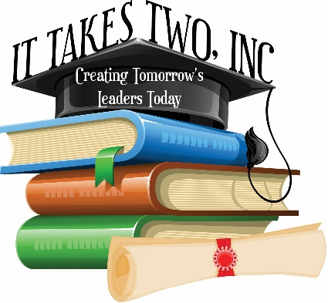

P4GYP SCOPE

OBJECTIVE
To help students successfully handle their transformative years – middle and high school– as it sets the tone for life after high school.

PURPOSE
P4GYP is a co-ed life skills program focused on IT TAKES TWO, INC’s six pillars: anti-bullying, financial literacy, college and career readiness, youth entrepreneurship, leadership, and community service. It is mainly geared toward 5th – 9th grade students; however, older students benefit from participating as well.

COMMUNITY SERVICE & LEADERSHIP
Good stewardship is the foundation of a leader. Community service and leadership are the foundation of this program. College admissions officers are looking for youth who are leaders and believe in giving back, so we will depend on these concepts heavily in the program.

PARENTS CAN EXPECT
Fun, engaging, thought-provoking activities that will help you and your child grow and make middle school and high school a great experience. We have guest speakers lined up who will encourage your child while tapping into their gifts, passions, and talents. Through P4GYP we plan to open their eyes to the possibilities while making sure they are socially and academically prepared.

YOUTH WILL ENGAGE IN:

GROUP & GRADE LEVEL INSTRUCTION

COMMUNITY SERVICE & LEADERSHIP ACTIVITIES

*LOCAL FIELD TRIPS
*ADDITIONAL COSTS MAY APPLY for some trips

SCHEDULE

- College Readiness Workshop (Saturday, April 6, 2019)
- College Access Tour (Monday, April 22, 2019)
- Financial literacy discussion (May – TBD)
- June: start the service project
- USNA Tour (Saturday, July 13, 2019)
- Pentagon tour [TBD]
- Supply Drive Book Bag Stuffing event (August 17, 2019)
- No Bullying Zone: Create & Learn (October)
- Distribute coats, hats, gloves in Baltimore (November)
- Distribute coats, hats, gloves in DC (November)
PAST ACTIVITIES
- Stuffed book bags for 15 adopted families through our Supply Drive;
- Collected new blankets and gently used coats for the homeless;
- Fed the homeless in DC and distributed coats and blankets;
- Attended program workshops discussing bullying, the college admissions process, and financial literacy

Your sponsorship will help assure the success of this program, but more importantly, it will show our young people that the community – residents, businesses, leaders, parents, and educators – believe in them enough to show their support. With your contribution, we can continue to do more. Every success, every accomplishment, every talent, and skill counts.

Please find enclosed more information about the P4GYP sponsorship opportunity.

Please do not hesitate to contact me with any questions or concerns. I look forward to speaking with you at your earliest convenience.

Sincerely,

Jaemellah Kemp, Founder & CEO
443.302.9799
jkemp@ittakestwoinc.org
www.ittakestwoinc.org

sponsorship opportunity

Your sponsorship/donation will support specific P4GYP activities.

Please submit logo via email to Jaemellah Kemp at jkemp@ittakestwoinc.org.

NEXT PAGE: P4GYP SPONSORSHIP LEVELS
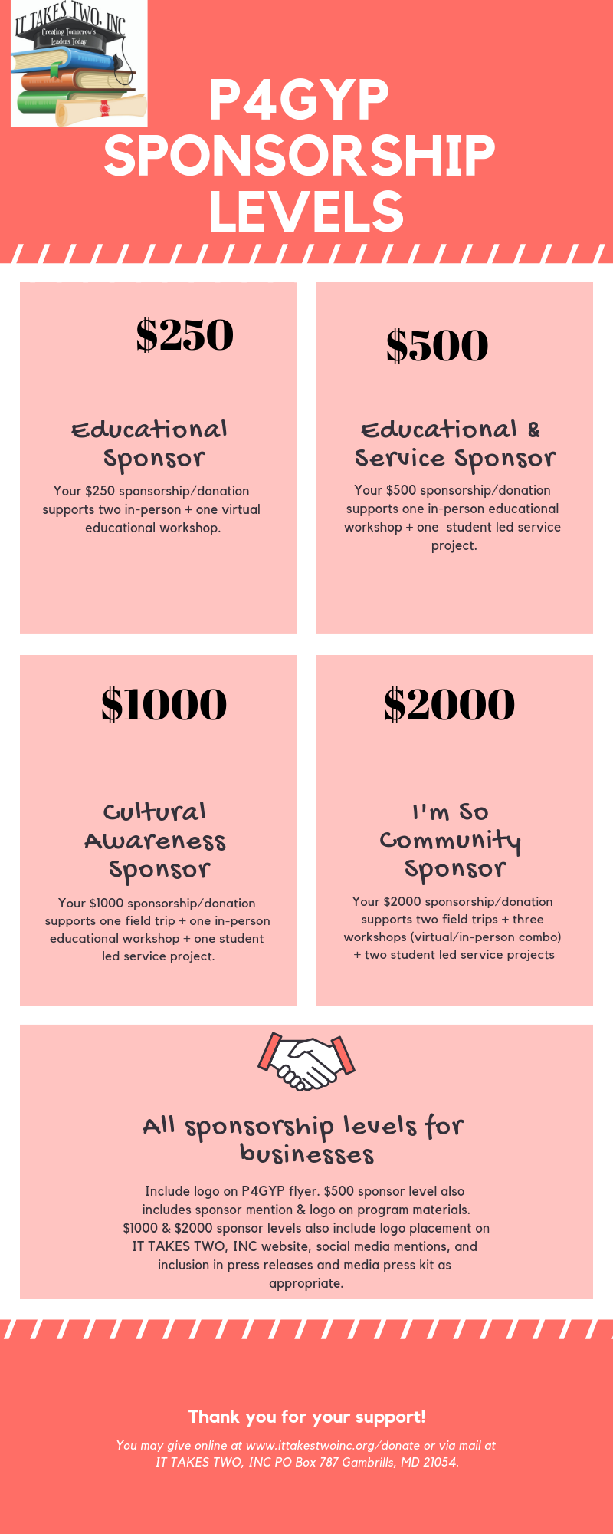
1,100

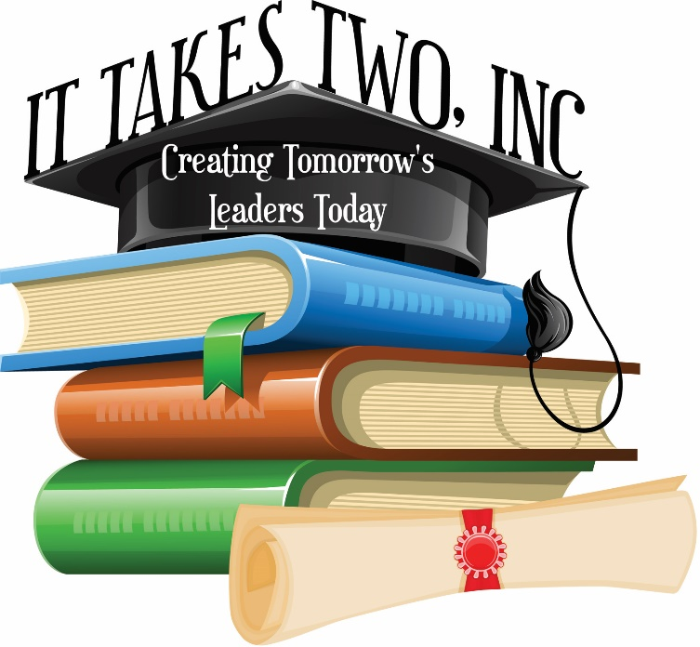

sponsorship AGREEMENT
Positioned for Greatness Youth Program
Jaemellah Kemp, IT TAKES TWO, INC | 443.302.9799 | jkemp@ittakestwoinc.org

Your Name: Click here to enter text.
Business Name: Click here to enter text.
Address: Click here to enter text.
City: Click here to enter text. State: Click here to enter text. Zip Code: Click here to enter text.
Phone Number: Click here to enter text.
Email address:Click here to enter text.
Website: Click here to enter text.

Enter sponsorship/donation amount: $ __________

I ________________ agree to submit the sponsorship fee/donation amount listed above online at www.ittakestwoinc.org/donate.

Social Media

Facebook Fan page (provide link): Click here to enter text.
Instagram (provide link): Click here to enter text.

