  - Press Release

#LawsforPaws campaign launched in the fight to achieve Pet Theft Reform

Nantwich based Clinical Animal Behaviourist, Nose To Trail is joining forces with K9 Nation, a community for dogs owners and dog friendly businesses, in a new #LawsforPaws Dogs Deserve Justice campaign. The campaign aims to bring together dog businesses from all over the UK, in a bid to achieve Pet Theft Reform.

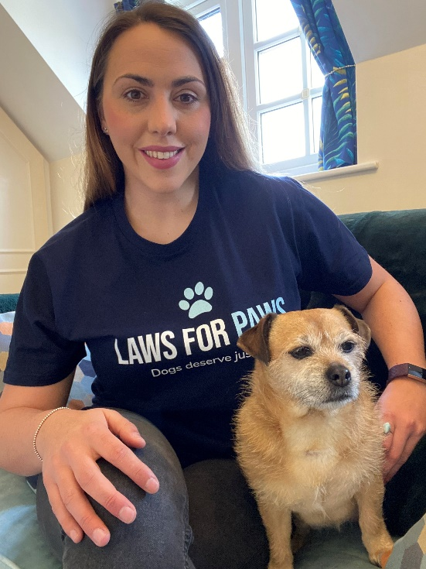

The theft of a pet dog is an incredibly difficult and traumatic experience for the owners. But under current law, it is covered under the Theft Act, and is treated in the same way as the theft of a laptop or television.

The proposed Pet Theft Reform would give courts access to appropriate custodial sentences to act as a deterrent, provide punishment, and protect the public.

Nose to Trail owner Rachel Rodgers said: “We are incredibly proud to take part in his campaign to help raise awareness of the issue. The whole dog business community really cares and are all so desperate to lend their support to help tackle this problem.”

Becky Baker the founder of K9 Nation said “There is some great work already being done in the form of The Theft Reform Campaign and the organisations behind it, including Dog Lost and the Stolen and Missing Pets Alliance. We don’t want to dilute the focus on what’s already being done, but we do want to help harness the energy of the dog business community so they can educate their customers and amplify the message.”

Nose to Trail as well as dog businesses all over the UK will be encouraging their customers to get involved to help support the campaign by writing to their local MP, helping to raise money for the great work that Dog Lost does, and signing the latest Government petition. More information can be found on the campaign homepage https://k9nation.dog/lawsforpaws/

The number of dogs reported stolen in the UK increased by 170%, from 172 in 2019 to 465 in 2020 – and that figure is rising.

Ends.

Notes to editor:
Nose to Trail is a pet behaviour service run by double award winning clinical animal behaviourist Rachel Rodgers.
Rachel has a Master’s degree in Applied Animal Behaviour and Training. She is a full member of the APBC – Association of Pet Behaviour Councillors and APDT – Association of Pet Dog Trainers.
She lives on the outskirts of Nantwich with her two small dogs, Rico – a rescue from Portugal, and Maisy a Jack Russell cross Pug.
www.nosetotrail.co.uk
info@nosetotrail.co.uk
07506059019

