Local dog trainer comes to the rescue in search for missing dog.
For immediate release – March 27th 2021

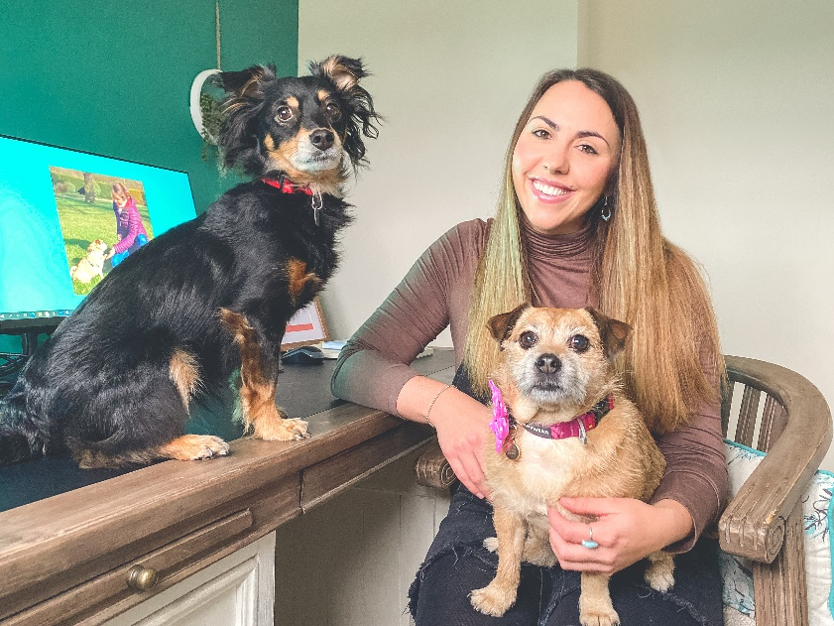
Photo shows Rachel Rodgers CAB with her dogs Maisy and Rico (the rescuer!)
On Friday 26th March 2021, local Dog Trainer, Rachel Rodgers (age 31) was attending some professional development training with Conservation K9 consultancy at Erddig National Trust, in nearby Wrexham with her dog Rico (6-year-old rescued Kokoni X from Portugal).
The course was going well, then during one of Rico’s trials to find some missing scent (truffle oil) all of the course attendees could hear the panicked cries of “HENRY” “HENRY”.
Rushing out into the carpark at the Felin Puleston Outdoor centre the course attendees found local family, The Jones. Their recently rescued Tibetan Terrier, Henry, had run off on his walk around Erddig 3 hours earlier. More family members had turned up to join the search, but poor, shy Henry was nowhere to be found.

The family had already contacted Missing Dogs Team Wales (see poster above) and Henry’s photo and information was all over social media and local networking groups. Unfortunately, with Henry being rescued during lockdown the family hadn’t managed to get his microchip details updated, which was adding to their distress. If he was found, would anyone know he belonged to them?
Rachel who works as a professional dog trainer, and clinical animal behaviourist has for the last 18 months been training her pet dog Rico in the fun dog activity of pet trailing with Becky Smith, at Pet Trailer U.K. This giant game of hide and seek teaches dogs to search for missing pets using their nose. However due to Covid-19 restrictions, the pair have not done any fun scent trails for months, and they have certainly never helped in the case of a genuinely missing dog before.

Rachel was watching the situation in front of her unfold, wondering if having never done a search for a real missing dog before, and with 6 year old Kokoni X, Rico being tired from 2 days training, could they help at all?! Was it worth trying?

Deciding that she couldn’t possibly just stay quiet and not help, the next hurdle to overcome was finding a scent article of missing dog Henry. A scent article is what the trailing dog, in this case Rico, uses to establish who or what they are trying to find. With limited options available, Rachel picked Rico up and popped him in the boot of the family’s car. The car doesn’t just smell of Henry though, it smells of the whole family and their other dog, a beautiful Golden Retriever. To try and reduce this problem, Rachel then let Rico sniff each of the 3 family members at the scene where Henry last was sighted, and their other dog, so that Rico could eliminate them from his search.

Off the pair went – on the search for Henry, accompanied by one of his family members to approach Henry if he was spotted, as he is nervous and would likely flee if approached by a stranger.

Rachel tells us more:

“Pretty early on Rico indicated across a river twice but I couldn’t get across. It was too deep and the other side of the riverbank was rocks enclosed in metal mesh which I could never scale. So we had to go the long way round, we went back over a bridge and then Rico rejoined the trail at the point he had indicated to. He walked straight passed a food bank where Rico literally ignored all the food, as he was focused on the task in hand.”

“He kept telling me to go through a broken down, discarded lorry with the back down, but I couldn’t get down there. Instead, I picked him up onto a 5ft wall. He walked along the top to the end. Indicating again under a tunnel but there was no path, no safe way for us to go.”

Rachel had to come up with another solution, so she took him off working and walked round to original search point. Again Rico had to rejoin the trail.

“This time he took us through some hellish undergrowth to the other side of where he indicated before. Again, we couldn’t get through 6ft high green metal fencing. No way under, over or round.”

Rico tried every route the group could find but sadly as the evening started to draw in, Henry still wasn’t found.

Rachel said “I was disappointed but I also trust Rico implicitly and knew he was on to something. We just couldn’t find a point to rejoin the trail.”
As there was nothing more the trailing duo could do, they headed home where Rachel shared the story on her Instagram account (@NosetotrailUK) urging owners to get a decent scent article for their pets by following @PettrailerUK’s step by step guide. You never know when your dog may go missing, and if Rico is going to help your pet be found – he needs something to work from!

Hours later, the Jones family decided to go and have one more look for Henry. Exactly where Rico had taken them, the family found their dog!
The owners contacted Rachel on her Facebook page @Nosetotrailpetservices saying “Thank you so so so much for today!!! Please thank Rico for us!! We found him exactly where Rico was taking us!!! He was spot on!!! xxxx”.

Rachel then shared the story across her social media pages as she was such a proud dog mum!
Quite right too don’t you think?
Rico, originally a rescue dog himself who was due to be put to sleep in Portugal due to being without a home has saved the day. Getting shy Henry home and out of the horrible weather!

Ends

Notes to editor:
Nose to Trail is a pet behaviour service run by double award winning clinical animal behaviourist Rachel Rodgers.
Rachel has a Master’s degree in Applied Animal Behaviour and Training. She is a full member of the APBC – Association of Pet Behaviour Councillors and APDT – Association of Pet Dog Trainers.
She lives on the outskirts of Nantwich with her two small dogs, Rico – a rescue from Portugal, and Maisy a Jack Russell cross Pug.
www.nosetotrail.co.uk
info@nosetotrail.co.uk
07506059019

