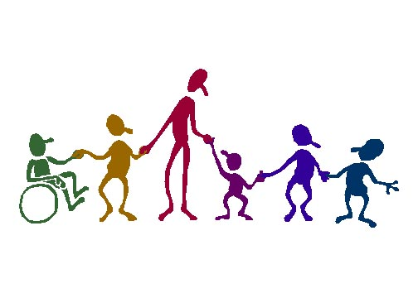

**EXECUTIVE MEETINGS**

**October 1, 2025**

**November 5, 2025**

**December 3, 2025**

**January 7, 2026**

**February 4, 2026**

**March 4, 2026**

**April 8, 2026**

**May 6, 2026**

**June 3, 2026**

**General Meetings**

**Bernie Wolfe School**

**September 24, 2025**

**November 26, 2025**

**January 28, 2026**

**March 25, 2026**

**May 27, 2026**