3300 Irvine Ave. Ste. 307
Newport Beach, CA 92660-3108
T: 949.724.1800 F: 949.724.1811
www.CompleteSpine.com

WELCOME TO OUR OFFICE!

Please print clearly

Patient's Name: __________________________________ Date:________________
Marital Status: Single___ Married___ Separated___Widowed___ Divorced___
Name of Spouse (or parents of child): ____________ No. of Children ______________
Date of Birth______/______/______ Age: _________ SS #__________________
Sex: Male ____ Female ____ Are you or could you be pregnant? Yes ___ No____
Home Address: __________________________________________________________
City: _____________________________________ Zip : ________________________
Home Phone: (_____)_____________Work Phone: (_____)_______________________
Cell Phone: (_____)_____________ Email address: ____________________________
Emergency contact:
Name:____________________________Tele contact:__________________________
Was this an injury? No____ Yes____ Date of Injury: __________________________
Where did injury occur? Auto____ Home ____ Work/Job_____ Other: _____________

Employer: ______________________________________________________________
Occupation: ____________________________________ How Long: _______________

Primary Insurance Company:______________________ Policy #:__________________
Customer service number on the back of card:__________________________________

Relationship to Patient: Spouse / Student / Child Employer: ______________________

Whom may we thank for referring you to our office? _____________________________
How did you hear about us? Doctor Patient Attorney Website Google Insurance

1

PLEASE PRINT - COMPLETE ALL INFORMATION

1111
MEDICAL INTAKE FORM

MEDICAL INFORMATION: TO THE BEST OF YOUR KNOWLEDGE, DO YOU HAVE / HAVE HAD :

- High Blood Pressure yes no 28. Prostate Problems yes no
- Heart Disease Heart Attack yes no 29. Abdominal Pain yes no
- Chest Pains / Angina yes no 30. Thyroid Problems yes no
- High Cholesterol yes no 31. Polio / Muscle Disease yes no
- Pace maker yes no 32. Seizures yes no
- Shortness of Breath yes no 33. Migraine/Cluster Headaches yes no
- Asthma yes no 34. TMJ Disorders yes no
- Allergies yes no 35. Chills/Fever/Sweats yes no
- Chronic Bronchitis yes no 36. Chronic Headaches yes no
- Blood Disorders yes no 37. Swelling of Extremities yes no
- Emphysema yes no 38. Sleep Disorders yes no
- Bleeding/Bruising yes no 39. Depression yes no
- Anemia yes no 40. Fibromyalgia yes no
- Diabetes yes no 41. Chronic Fatigue Syndrome yes no
- Hypoglycemia yes no 42. Lyme’s Disease yes no
- Lightheadedness yes no 43. Chronic Pain yes no
- Dizziness yes no 44. Night Pain yes no
- Concussions yes no 45. Unexplained Pain yes no
- Fainting Disorders yes no 46. Unexplained Weight Loss yes no
- Anxiety/Panic Attacks yes no 47. Cancer/Tumors/Growths yes no
- Arthritis/Joint Pain yes no 48. History of Smoking yes no
- Artificial Joints yes no 49. Are you pregnant? yes no
- Kidney Disease/Stones yes no 50. Gynecological Disorders yes no
- Hepatitis yes no 51. Bladder Incontinence yes no
- Spinal Cord Injury yes no 52. Bowel Incontinence yes no
- Traumatic Brain Injury yes no 53. Fractures yes no
- Ulcers/Blood in Stool yes no Date:__________Area:____________
Date:__________Area:____________

CURRENT MEDICATIONS:
ALLERGIES:
- To Medications:
- To Other Substances:
SURGERY (S) Include Dates:
X-RAYS, MRI, CAT SCANS (Include Area & Dates):

HABITS: (please circle one)
Tobacco: none light moderate heavy How many cigarettes/cigars a day? _________________
Alcohol: none light moderate heavy How many a drinks a day?_________________________
Drugs: none light moderate heavy Type: ______________________________________________
Exercise: none light moderate heavy How many days a week? _________________________
Work: none light moderate heavy How many hours a week? __________________________
Sleep: none light moderate heavy How many hours a night? __________________________
Coffee: none light moderate heavy How many cups a day? ____________________________

2

In your own words, what is your chief complaint? ______________________________________________________________________________________________________________________________________________________________________________________________________________________________________________________________________________

Have you had more than one episode of pain/symptoms? Yes/no If yes, how many? __________________
How long does an episode last? _________________ How much time between episodes? ____________
Are the episodes increasing/decreasing/the same in intensity? (circle one)

Current Episode:
What caused the pain to start? _________________________________________________________________
When did it start? (date or month) ______________________________________________________________
Where do you feel the pain? __________________________________________________________________
Did the pain/symptoms spread? ________________________________________________________________
What makes the symptoms worse? AM/PM sitting standing walking rising lying rest movement
Other: ______________________________________________________
What makes the symptoms better? AM/PM sitting standing walking rising lying rest movement
Other: ______________________________________________________
How would you describe your pain?
___ cramping, dull, aching ___ sharp, shooting ___ constant
___ burning, pressurelike, stinging, aching ___ deep, nagging, dull ___ intermittent
___ throbbing, diffuse ___ sharp, bright, lightninglike ___ occasional

How would you rate your pain on a scale of 1-10 (10 being severe)? __________________________________

Do you experience any of the following symptoms, and where? Numbness: ____________________________
Tingling: ______________________________
Weakness: _____________________________
Did you receive any treatment? Yes/no What treatment? _______________________________________
Did it help? For how long? ________________________________

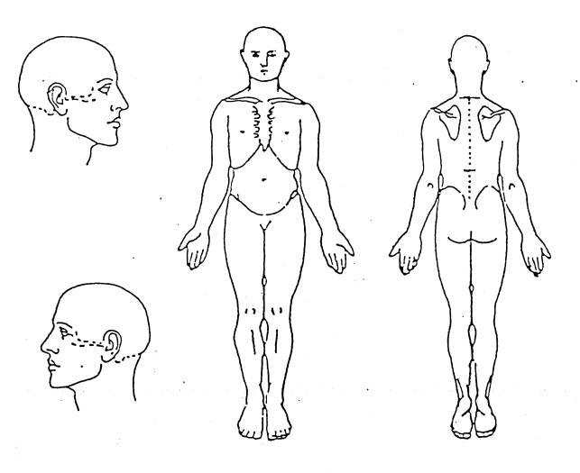
Mark the areas on your body where
you feel the described sensations.
Use the appropriate symbol.
Include all affected areas.

Aching: + + +
Burning: x x x
Numbness: - - -
Pins and needles: o o o
Stabbing: / / /

3

FINANCIAL POLICY

WE ACCEPT CASH, CHECKS, VISA, MASTERCARD, DISCOVER AND AMERICAN EXPRESS.

HMO Plans (with which we are contracted): All co-pays must be satisfied at every visit. Due to contractual and
uniform compliance issues with your insurance company, there are no exceptions to the policy of collecting. Per Greater Newport Physicians and your respective insurance company, coverage of chiropractic services is specifically limited to manual manipulation of the original diagnosis to which you were approved.

PPO Plans (with which we are contracted): We have negotiated rates with your insurance company. Your co-pay Insurance and unmet deductible is your responsibility and payment is due at time of treatment. In the event your insurance coverage changes to a plan where we are not a participating provider, you will be responsible for any out of network deductible or coinsurance amounts.

Medicare:
Medicare requires that we provide only those services approved by Medicare as deemed medically necessary. We will bill your secondary insurance for you as a courtesy: In the event the service is not covered by Medicare, you are responsible for any remaining balance regardless of payment from a secondary insurance.

Cash patients
All services must be paid in full at time of treatment. Our office can provide you with an estimate of the cost of treatment prior to your visit

Cancellation Policy
In an effort to honor our commitments, we require a minimum of 24-hour notice of cancellation. Failure to provide this notice will result in a charge of $25

Returned checks/ Administrative Fee
A $25.00 fee will be charged for any returned checks. We will be unable to accept your check for any services thereafter. All co-pays will be collected at the time of service. If a patient does not submit payment at the time of service or the patient will be billed for the co-pay and a $15 Administrative Fee will be added to cover the cost of billing and collections. Balances over 120 days will be subject to an 18% monthly finance charge.

Date: ________ Responsbile Party: ____________________________________________________

I have read the Financial Policy. I understand and agree to this Financial Policy.

4

Notice of Privacy Practices

We understand that medical information about you and your health is personal. As the custodians of the information in your medical record, we are committed to protecting the privacy of your information as required by law, professional accreditation standards and our internal policies and procedures.

The Notice of Privacy Practices explains your rights, our legal duties and our privacy practices. It also describes how medical information about you may be used and disclosed and how you can get access to this information. The policy in its entirety can be requested from the receptionist or found on our website.

Complete Spine and Wellness Group, Inc will limit the use of patient protected health information for treatment, payment and business operations. Examples of such use are:
- Your protected health information will be shared with your referring MD and other MD’s involved in your treatment.
- Your protected heath information will be shared with your insurance carrier and/or Medicare and other entity involved in reimbursement.
- Your protected health information will be shared with a collection agency if it become necessary to use their services to collect your delinquent account.

Complete Spine and Wellness Group, Inc will not release your health information to other people unless you have given us written authorization to do so. You may revoke the authorization at any time.

You have the right to place restrictions on your protected health information; however, we do not have to honor your request if it involves treatment, payment or business operations.

You have the right to request amendments to your medical records and the right to receive communication somewhere other than your primary address.

Complete Spine and Wellness Group, Inc on occasion will call you for appointment reminders and may leave that reminder message on your answering machine.

This Notice of Privacy Practices may change from time to time and will be re-posted in the reception/lobby area when such changes occur.

I hereby acknowledge the receipt of the Notice of Privacy Practices. A personal copy of the Privacy Practices will be available per my request.

_________________________________________________________________________________________
Signature of Patient or Responsible Party Printed Name Date

5

