THE NEW PEACHWOOD
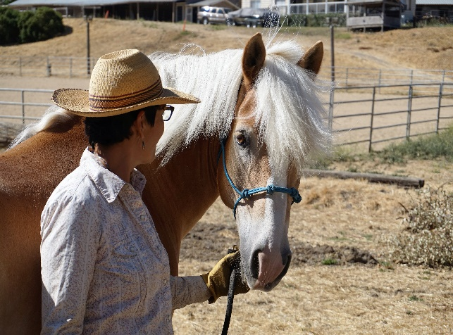
Horse boarding in ceres, 95307 ph:510-789-3196
Services we provide for your horses
- Full service barn includes:
- Large dry lot pens with shelter
- Feeding alfalfa, hay, or stable mix pellets
- Cleaning, water daily top off
- 2 Riding arenas & turnouts
Grooming, Training, and Riding Instruction Available
$250.00/Month
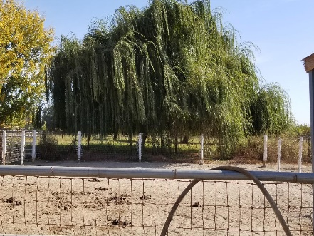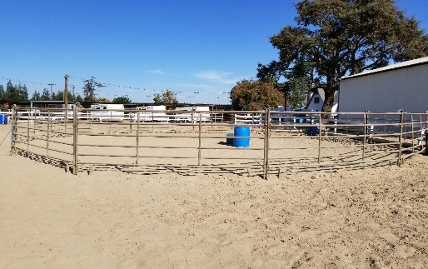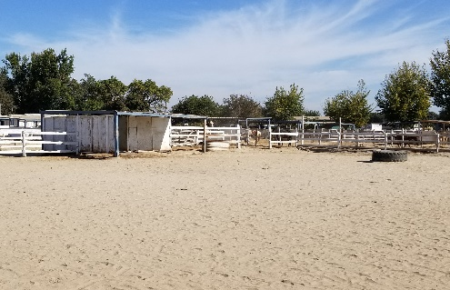
Call Sissy Cortez On Site Owner Operator
510-789-3196
The New Peachwood Horse Boarding Facility
4000 E Service Rd. Ceres, CA 95307

