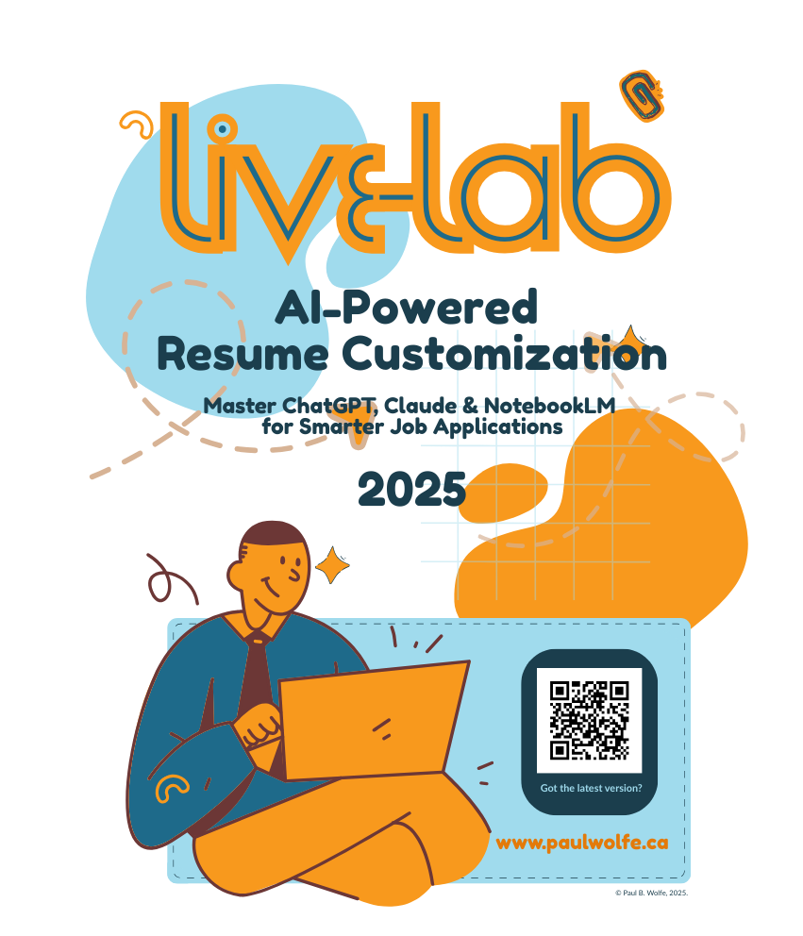

**Job Search & Interview Prep Workbook**

**Table of Contents**

**Live-Labs Related to this Workbook 3**

**The Goal of AI Assisted Job Search 4**

**The Resume Pain Cycle 5**

**What is an Applicant Tracking System? 6**

**Use AI to Optimize Your Resume 8**

**Meet Your Tools: ChatGPT, Claude & NotebookLM 11**

**How to Store Your Prompts in a Prompt Library 13**

**NotebookLM by Google 14**

**ChatGPT by OpenAI 15**

**Claude by Anthropic 16**

**Organize Like a Pro 17**

**Step-by-Step Workflow 18**

**The Prompt Pack 22**

**About Pauly Wolfe 24**

# 



# Live-Labs Related to this Workbook

**Updated: April 11, 2025 v.06**

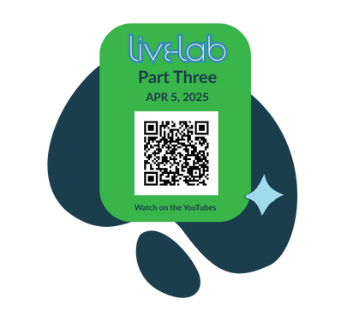

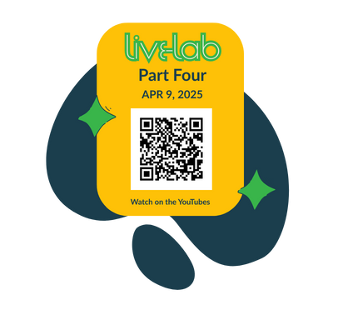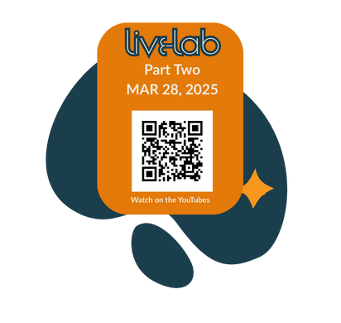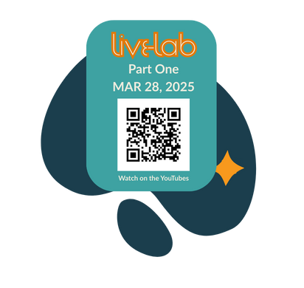

# 

# The Goal of AI Assisted Job Search

An AI-assisted job search is about **quality, not volume**. The goal is to send out applications that reflect your best stories, align with the job posting, and sound like you. **This process helps you stay focused, consistent, and efficient.**

Start with your general resume—your full LinkedIn profile or master version—and the job posting. U**se both to create a tailored resume t**hat highlights your most relevant experience. Then, g**enerate interview questions** based on that resume and the job posting. This helps you prepare and identify the stories you want to share.

Next, record or write your answers in your natural voice. **These responses become source material for a compelling cover letter**. Use the job posting, tailored resume, and your recorded answers to write a letter that feels authentic and focused.

After drafting your cover letter, r**eturn to your resume and revise it so that it aligns in tone, language, and messaging.** The final resume should reinforce what you’ve said in the cover letter.

**Lastly, review everything to ensure consistency and accuracy.** Confirm that it reflects your voice and your value. When done well, this process results in applications that are **thoughtful, personalized,** and ready to stand o

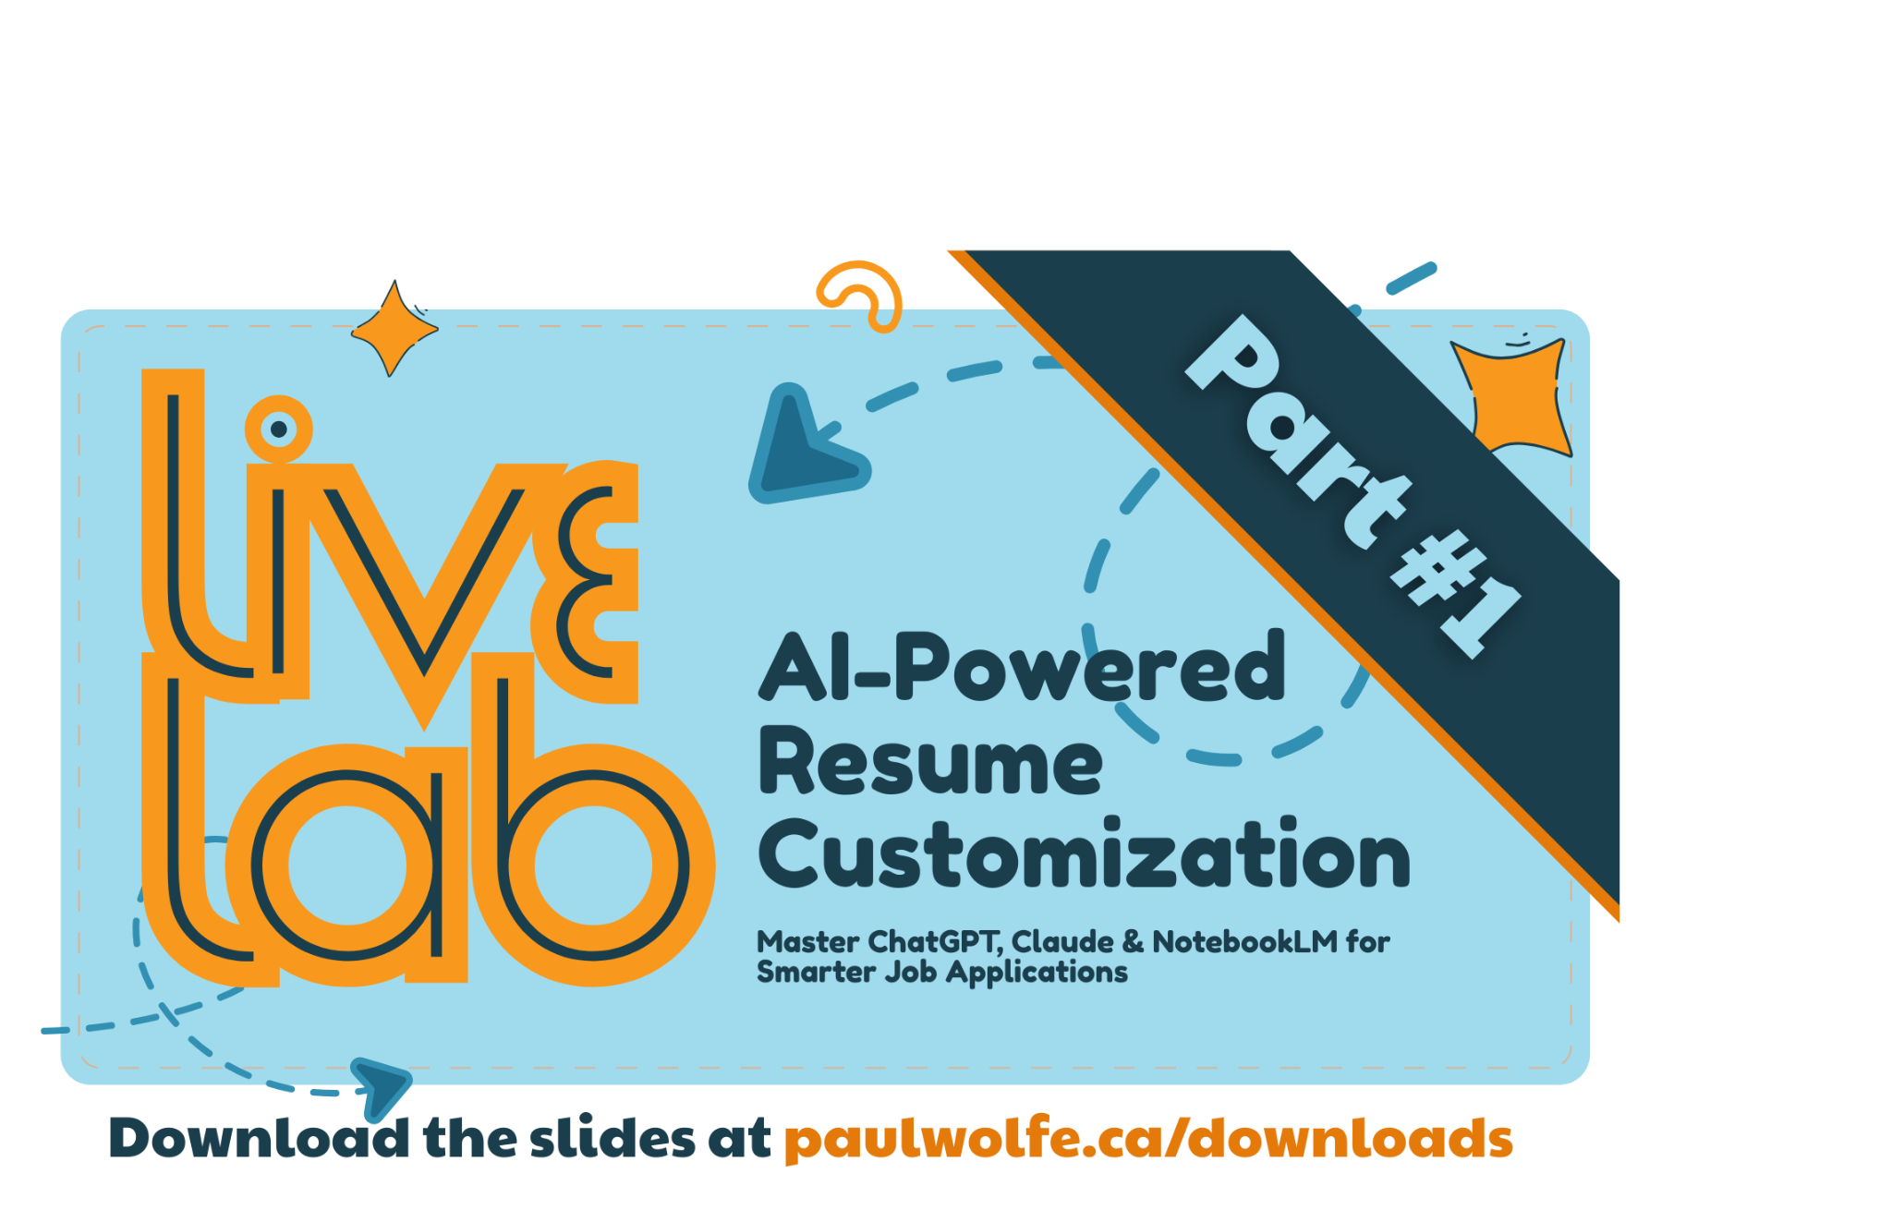

# 

# The Resume Pain Cycle

## Why the Job Search Feels So Hard —And What We Can Do About It

For those of us in our **50s and beyond,** the modern job search can feel like trying to join a conversation that’s already halfway through—fast-paced, full of jargon, and **strangely digital**. We bring **decades of experience** and **hard-earned skill**s, yet the process of applying for jobs often feels like **hitting a wall** again and again.

This frustrating experience is what I call the resume pain cycle—a loop of barriers that turn job searching into an **exhausting chore.** Let’s look at the parts of a modern job search so that we understand what is really happening.

## The Digital Divide: Where the Frustration Begins

**The first hurdle? Technology.** Platforms like LinkedIn, Indeed, Workopolis, and Monster (what happened to Monster!?!) have become essential tools—but they’re not always intuitive, especially if you didn’t grow up with them. Settings are hidden, job **alerts misfire**, and **interfaces change** just when you’ve gotten the hang of them. It's easy to feel behind before you’ve even submitted your first application.

## Repetitive Data Entry:

## The Treadmill You Can’t Get Off

Then comes the never-ending data entry. Every application asks for the **same details**: your name, your work history, your education, your references—even when you’ve already uploaded your resume. It’s like **running in place**: exhausting, time-consuming, and discouraging. For people who **aren’t used to digital workflows**, this step alone can **drain the motivation** to keep going.

## Customization Fatigue:

## Tweaking and Re-Tweaking

You finally get through the forms—only to hit the next wall: customization. **Every job post seems to demand a slightly different version** of your resume and a tailored cover letter. But how do you know which keywords to use? What formatting will work with the **Applicant Tracking System (ATS)**? And how do you make these edits quickly and correctly? For many, this part f**eels like learning a new language** while trying to sell yourself at the same time.

## The ATS Gatekeepers:

## Robots With No Empathy?

Applicant Tracking Systems are the digital bouncers standing between your resume and a real human. If your formatting is off, your keywords aren’t precise, or your file type isn’t right—your application may never even be seen. **These systems reward technical precision more than life experience**, which feels deeply unfair to those who’ve worked hard to build meaningful careers.

## So, What Can We Do?

The good news: the cycle can be broken. Here’s How:

* **Digital literacy training** focused on job search tools can ease the learning curve.
* Resume and cover letter **templates** can reduce customization fatigue.
* **Coaching and peer networks** can offer both encouragement and practical tips for navigating the process.
* **AI-powered tools** are starting to emerge that help tailor your resume to specific job postings—cutting through the ATS wall.

## Conclusion

The resume pain cycle is real—and it’s draining. **But it’s not a personal failing.** The job market has changed rapidly, and many of us weren’t given the tools to adapt. By naming these challenges and seeking out smart, supportive solutions, we can reframe the job search as a chance to showcase our expertise—not just survive a system that wasn’t built with us in mind.

**You’re not starting over.** You’re starting strong—with wisdom, clarity, and a whole lot to offer.



# What is an Applicant Tracking System?

**ATS** (or eh-tee-essess?) are the software tools employers use to manage **the flood of applications** they get online. And here’s the thing: your resume is often being scanned by one of these systems before a real person ever lays eyes on it.

***At this point, I really do want to express empathy for the HR folks who have to sift through piles of digital resumes every day, I’m sure it sucks.***

But, ATS means **your first "interview" isn’t with a hiring manager**—it’s with an algorithm. ATS programs are built to filter, rank, and sort resumes based on specific **criteria**. If your resume doesn’t match what they’re programmed to look for, it can get **filtered out automatically**, even if you’re a perfect fit.

## So what exactly are they scanning for?

**First, keywords.** The ATS is trained to look for specific words pulled from **the job posting**—skills, certifications, job titles, industry terms. If those keywords aren’t in your resume, it might not move forward, even if your experience is solid.

**Next, formatting.** Keep it simple. These systems do best with clean, straightforward layouts. Avoid graphics, text boxes, columns, or anything too decorative. It might look nice to the human eye but could confuse the system.

They’re also scanning for **clear sections** like Work Experience, Education, and Skills. Use standard headings to make your resume easier to read—both for the software and the eventual hiring manager.

And finally, **file type** matters. PDFs (.pdf) and Word documents (.doc or .docx) are the safe bets. Avoid formats like Google Docs links, .pages files, or anything out of the ordinary like WordPerfect (.wpd)—they might not process correctly.

## The Bottom Line About ATS

To give your resume the best chance of getting through the ATS, tailor it with the right keywords, keep your formatting clean, and stick to the basics. The goal isn’t to impress the software—it’s to make it easy for it to recognize your value and get your application in front of a real person.

**You’re not trying to game the system**—you’re just making sure your experience **gets seen.** And that’s **worth the effort.** Here are practical suggestions to help your resume **pass through ATS and into the hands of real decision-makers.**

## 

## So, What Can We Do?

ATS is fairly easy to accommodate once you know what it’s looking for. Use this checklist to review your resume. Take notes in a separate ‘Learnings’ document and then make the changes to your resume you need to in order to be ATS friendly.

* **Use keywords from the job posting.** Think of the job description as your roadmap. ATS software scans for specific words and phrases, especially those tied to required skills, qualifications, and experience. If a posting says they want someone with experience in "grant writing" or "program evaluation," and you’ve done those things, make sure those exact terms show up naturally in your resume.
* **Stick to a simple, clean format.** ATS software reads from top to bottom, left to right—just like English does. But it can easily get confused by complicated layouts, columns, images, or graphics. Stick with a single-column format, standard fonts (like Arial or Times New Roman), and avoid any flashy elements that might not translate properly. The goal is clarity over creativity here.
* **Use standard section headings.** Keep your section titles clear and familiar—like Work Experience, Education, Skills, and Certifications. These are the cues ATS software is looking for when it tries to organize and rank your resume. Unusual headings like "Where I’ve Been" or "My Career Journey" might feel more personal, but they can cause confusion in automated systems. Save the creativity for your cover letter or portfolio.
* **Choose the right file type.** When submitting your resume, stick with either a *.docx* (Word) or .pdf (PDF) file unless the employer specifies otherwise.
* **Avoid headers, footers, and tables.** These design elements can trip up an ATS, making important information unreadable. Keep everything in the main body of the document. If you need to organize details, use basic bullet points instead of tables or text boxes.

## Conclusion

**Tailoring your resume for each application might feel tedious, but it’s one of the most effective ways to move past the automated filters**. A resume that’s friendly to both humans and machines is within your reach—you just need the right tools and a little strategy.



# Use AI to Optimize Your Resume

If you’ve been applying for jobs lately and feel like your resume is disappearing into a black hole, you’re not imagining things. It can be incredibly frustrating, especially if you’ve got years of experience, strong qualifications, and real-world results—but the system never even gives you a chance.

## AI Tools Can Help

ChatGPT and other tools like it (DeepSeek, Claude, Gemini) are smart writing assistants that can take the guesswork out of how to format your resume, what to include in your cover letter, and how to align your language with what the ATS is actually looking for. You don’t need to be a tech expert to use it—you just need to know how to ask the right questions.

Let’s walk through how you can use ChatGPT to get your resume and cover letter into better shape for today’s digital job market.

## Step One: Feed ChatGPT the Job Posting

Start by copying and pasting the job description you’re applying to into Chat. This is your starting point. Every ATS is trained to look for the same kinds of details that are in the job ad itself—skills, experience, education, certifications, and keywords. You can ask ChatGPT something like:

***"Please pull out the most important keywords from this job description and help me tailor my resume to match?"***

What you’ll get back is a clear list of phrases and concepts that need to be present in your resume and cover letter to get past the filters. Things like “stakeholder engagement,” “grant writing,” “nonprofit compliance,” or “data analysis.” You might have all those skills, but if the exact words aren’t there, the system might not pick up on them.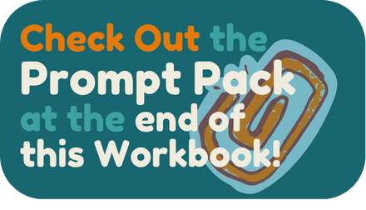

ChatGPT can help you match the language of the job posting while still sounding like yourself. That’s a game-changer.

## Step Two: Rewrite Sections of Your Resume with Those Keywords in Mind

Next, you can paste in a section of your resume—say, your professional summary or a previous job description—and ask ChatGPT to rewrite it using some of the keywords from the job ad. For example:

***"Here’s the description I currently have for my job at ABC Foundation. Can you revise it to better match the job posting I just shared?"***

ChatGPT will take your experience and suggest a version that keeps the meaning but upgrades the wording so it speaks the same language as the ATS. It can even adjust the tone to stay professional and authentic to your voice.

This saves you time and helps your resume get noticed—not because you changed your experience, but because you learned how to present it in a way the system understands.

## Step Three: Clean Up Formatting for ATS Compatibility

Many resumes get tossed by the ATS because they’re just too complex for the system to read. It’s not about style points—it’s about structure. ChatGPT can help here too. You can say:

***"Please format this resume so it’s ATS-friendly?"***

And ChatGPT will guide you through best practices: no tables, no columns, no headers or footers, and a clear, one-column layout. It will help you use standard headings like Work Experience, Education, and Skills—which the ATS is trained to recognize.

It’s a bit like translating your resume into a version both humans and machines can understand.

## Step Four: Customize Your Cover Letter the Smart Way

Cover letters can feel like a chore—

especially if you’re applying to multiple roles. But ChatGPT can make it easier. Once you have the job posting and your resume ready, you can say:

***"Hey, my dude, help me write a cover letter for this job using my resume and the job description?"***

You can even give it a few notes about your tone or style preferences—something warm and professional, or direct and confident. It will generate a full draft that you can then personalize and tweak to make it sound just right.

Instead of starting from scratch every time, you now have a smart shortcut. You still get to tell your story—but without staring at a blank screen for an hour.

## Step Five: Refine and Repeat

The best part? You can keep refining your resume and cover letter as you go. ChatGPT doesn’t get tired. You can ask it to simplify a sentence, add a specific keyword, shorten a paragraph, or reword a clunky phrase.

If you’re applying for multiple roles, you can reuse the same base resume and just ask ChatGPT to make small adjustments for each application. That’s especially helpful when you’re trying to stay motivated and not burn out during the process.

## 

## So, What Can We Do?

Learning to work with ChatGPT is a bit like learning to ride a bike again. It might feel a little strange at first, but once you get the hang of it, it becomes a steady support. You’ve already done the hard part—building a meaningful career. This is just about making sure your experience isn’t lost in translation when it hits a digital wall.

If you’ve been feeling stuck, overlooked, or overwhelmed, don’t let that be the end of the story. Tools like ChatGPT can help you present yourself clearly, confidently, and in a way that both hiring managers and software systems will recognize. And that’s the whole point—to get you seen, heard, and seriously considered

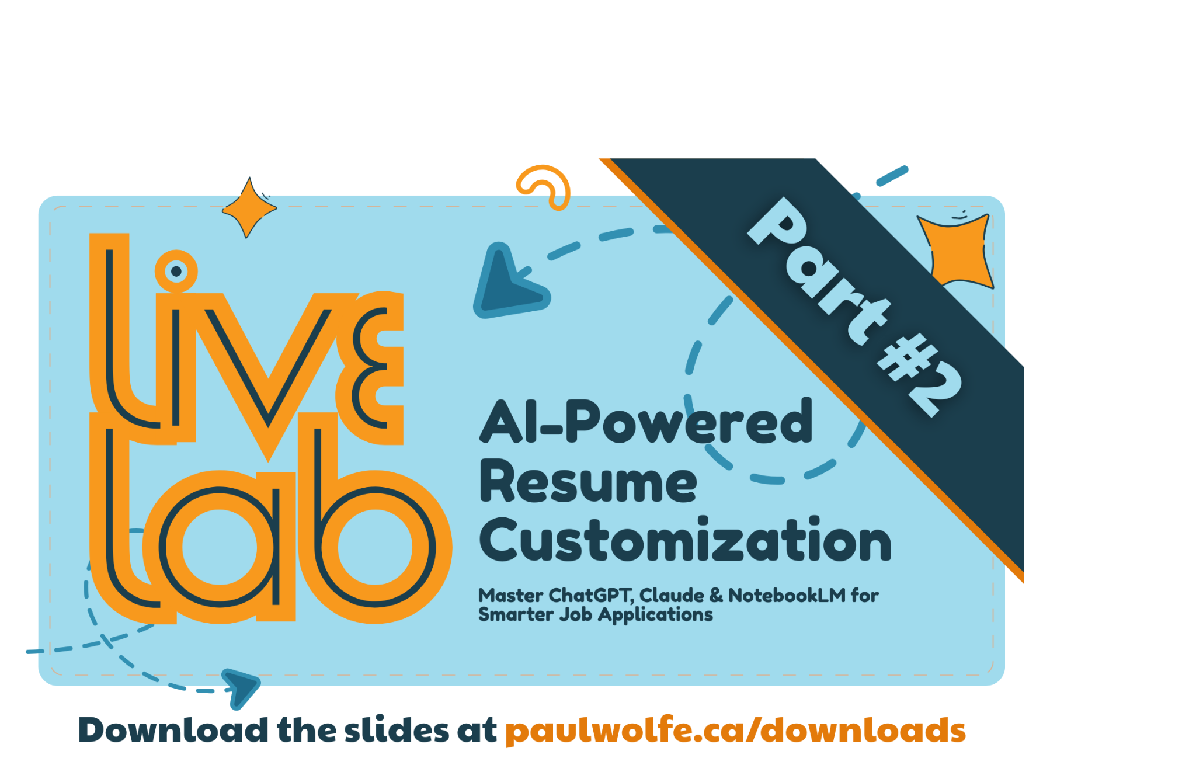

**The information in the next part of this workbook is covered in**

**LiveLab Part Two.**

# Meet Your Tools: ChatGPT, Claude & NotebookLM

Each AI tool has a unique strength — ChatGPT for fast rewrites, Claude for thoughtful context, and NotebookLM for organizing and referencing your job search materials.

**The Basics of Communicating With AI Tools**

**Prompting is simply the act of giving instructions** to ChatGPT or any other AI tool. The more specific and structured you are, the better the results. It’s no different than communicating with colleagues, friends and family. But here’s the trick: **You don’t need to get it perfect the first time.** Start simple. Then build. Below are three versions of a resume customization prompt that grow in depth and clarity.

This is an example of how instructions develop as you chat with these tools. This series illustrates how your typed or spoken instructions become more focused and intentional—yielding more useful results each time.

## Level 1: Basic Prompt – “Do These Match?”

This is the simplest way to get started. Perfect if you’re curious or short on time.

**You:** I’m applying for a job. Can you compare this job posting to my resume and tell me how well they match?

Job posting: [paste job description]

Resume: [paste resume]

Let me know what’s missing or if there are important keywords I should add.

**What you’ll get:** A quick analysis with a list of missing keywords or general advice. It’s not perfect, but it’s a good way to warm up to the tool and see how AI reads your content.

## Level 2: Intermediate Coaching Prompt – “Help Me Optimize for ATS”

Now you’re giving ChatGPT a job: help you write smarter. This is the sweet spot for many job seekers.

**You:** I’m customizing my resume for this job and want to make sure it aligns with the job description, especially for applicant tracking systems (ATS).

Can you: Analyze the job description for keywords and responsibilities, compare it to my resume, highlight gaps, recommend keyword additions, suggest rewording where needed. I want to stay true to my experience, but use language that gets through the ATS filter.

Job description: [paste]

Resume: [paste]

**What you’ll get:** More detailed keyword lists, section-specific advice, and ideas for rewording your bullet points.

## Level 3: Active Partnering Prompt – “Let’s Build a High-Performing Version”

This is where you start treating ChatGPT like your resume editor, strategy consultant, and copywriter rolled into one.

**You:** I’m refining my resume for a specific job and would like help building a high-performing, ATS-optimized version. Please:

* Extract the top 10–15 keywords or phrases from the job description
* Identify where my resume already covers them and where it doesn’t
* Rewrite or suggest new bullet points that highlight accomplishments using the job’s language
* Rewrite my professional summary for better alignment
* Flag anything unclear or awkward in tone or structure

Job post: [paste job post]

Resume: [paste resume]

Please maintain a clear, professional tone and keep everything true to my experience.

**What you’ll get:** Full rewrites of your summary and bullet points, tailored keyword recommendations, and a more strategic perspective. Ideal when applying for high-stakes roles.

## Iteration Is the Secret Sauce

Even when using the most detailed prompt, don’t expect the AI to be perfect on the first go. Prompting is a conversation, not a command. You can follow up with things like:

***“Can you make this bullet more concise?”***

***“That wording sounds too formal. Can you rewrite it with a friendlier tone?”***

***“I actually don’t want to highlight that skill. Can we remove it?”***

Use each response as a starting point, not a final answer. You’re still the editor-in-chief of your resume.

# How to Store Your Prompts in a Prompt Library

Once you find a prompt that works, save it. Don’t reinvent the wheel every time.

Here’s how you can start your own Prompt Library like the Prompt Pack included with this workbook.

## Create a Doc, Folder, or Notebook

Use Google Docs, Notion, Obsidian, or even a simple Notes app. Make it easy to copy and paste.

## Organize by Use Case

* Resume Customization
* Cover Letter Drafting
* Interview Question Generator
* LinkedIn Summary Rewriter

## Label the Level of Complexity

Give each prompt a title that explains what it does, and if you make more than one prompt of that kind, document the results. For example, ***Resume and Job Posting Comparison Prompt Complex with KeyWord Analysis.*** This way you can come back to your prompts and select them based on how much time or energy you have that day.

## Store Examples and Results

Include past prompts and some good outputs you’ve gotten from GPT, so you remember what worked.

## Prompt Like a Pro, One Step at a Time

You don’t need to be an AI expert to benefit from “prompt engineering”. You just need to be curious, willing to experiment, and open to refining your process. As with any new tool, the key is starting small and building your skill with each use.

By prompting GPT to review your resume and job postings together, you’re not just saving time—you’re learning to think more strategically about how you present yourself. And in a crowded job market, that’s a huge win.

# NotebookLM by Google

When managing a job search, especially across multiple applications, things can get messy fast. Job descriptions, resume versions, company research, and interview prep notes often live in separate folders, documents, or tabs. NotebookLM offers a centralized, searchable workspace where you can collect, store, and analyze all your job search materials — and then ask questions about them directly using AI. NotebookLM is ideal when you need to:

* **Summarize job descriptions** and extract key responsibilities, qualifications, and keywords
* **Compare multiple job postings** to spot patterns in what employers are asking for
* **Generate tailored content** for cover letters or interview prep using your own resume and research
* **Track company-specific notes**, mission statements, or culture insights from websites or articles
* **Revisit past applications**, questions asked in interviews, or feedback you’ve received

## Process and starting prompts

To get started, follow these steps to build a dedicated workspace for each opportunity:

1. Create a New Notebook and give it a specific title, such as **Resume + Cover Letter Toolkit.**
2. **Upload source materials** such as the job posting, your master resume, answers you may have given to previous similar interview questions or applications. You can also add notes from the company’s website, or other research you’ve done. In NotebookLM you can add these elements to individual documents named: Job Description, Resume, Company Research, Interview Q&A, and Cover Letter Drafts. This structure allows NotebookLM’s AI to respond to your questions using only the relevant information—helping you stay focused and accurate in your application process.
3. With everything in one place, you can start using prompts like, **“What are the top five qualifications in this job post that I haven’t clearly addressed in my resume?”** or **“Summarize the job description in five bullet points.”** The AI will quickly give you tailored insights that can guide your edits.
4. To streamline your workflow, **create reusable base notes with your core achievements, resume templates, and metrics**. Then simply copy and adapt them for each application. With NotebookLM, resume customization becomes faster, smarter, and more consistent—giving you an edge with every submission.

# ChatGPT by OpenAI

ChatGPT by OpenAI is your personal AI job search companion. Instantly generate tailored resumes and engaging cover letters, optimize LinkedIn profiles, and practice answering common interview questions. Simply describe your experience or upload job postings, and ChatGPT identifies critical skills and keywords to match your applications precisely to each opportunity. This intuitive, easy-to-use assistant helps you stay organized, providing helpful summaries, career advice, and feedback on your responses. Ideal for job seekers at any level, ChatGPT makes your search more efficient and less stressful. Scan the QR code now, log in, and let ChatGPT power your journey toward career success!

## When to use ChatGPT in your job search:

* Refine and polish resumes, cover letters, and LinkedIn profiles.
* Practice and improve your responses to common interview questions.
* Gain personalized, actionable career advice to target specific job opportunities.

# 

# 

# Claude by Anthropic

Claude by Anthropic is an easy-to-use AI assistant designed to support your job search. Instantly craft personalized resumes and compelling cover letters, discover keywords from job postings, and prepare confident responses for interviews. Simply input job descriptions, notes, or career goals, and Claude provides clear summaries, tailored application materials, and thoughtful career advice. Whether you're just starting out or advancing your career, Claude helps keep you organized, informed, and competitive throughout your job hunt. Scan the QR code to quickly log in and experience how Claude makes landing your next opportunity simpler, faster, and stress-free!

## When to use Claude in your job search:

* Develop thoughtful, professional cover letters personalized to your experience.
* Clarify your career goals and strategize your job search approach.
* Receive concise summaries and actionable insights from complex job postings.



# Organize Like a Pro

When applying for a job, you will create five files that streamline your process and keep you organized.

* First, save the **job posting** in a separate document for easy reference, ensuring you have all details even if the posting is removed. 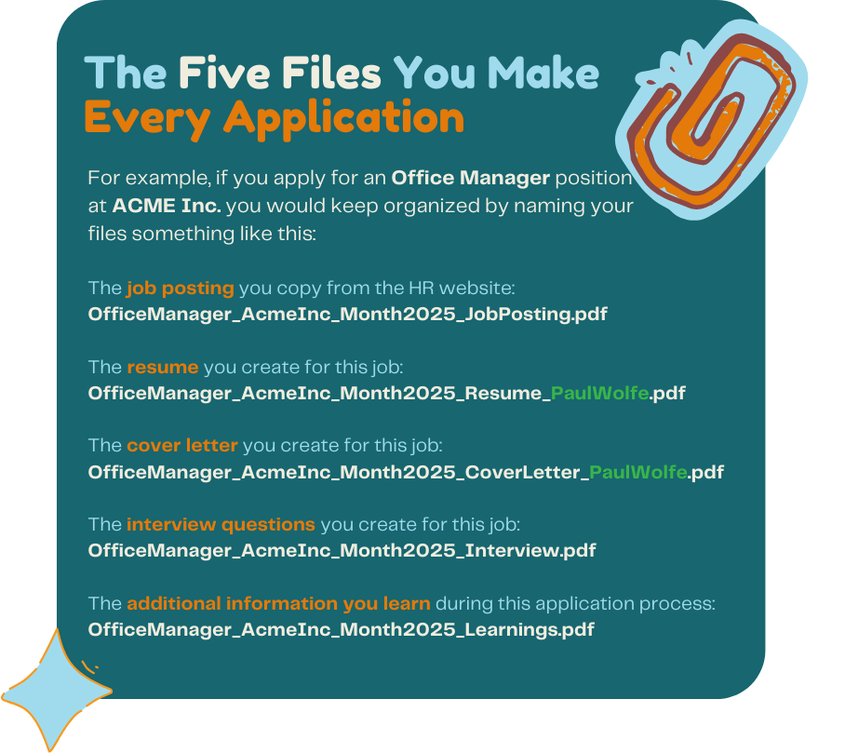
* Second, tailor a **new** **resume** specifically for this job.
* Third, draft a customized **cover letter.**
* Fourth, prepare potential interview **questions** and answers to practice.
* Finally, document your **learnings** throughout the process, noting insights gained for future applications

## 

## Consistent Naming Conventions

Clear file naming makes it easier to locate documents quickly and allows NotebookLM to process information efficiently. **The file name is not magical,** but the structure does matter. Put the position and company first, because this will help the hiring manager identify it quickly. They may be hiring for dozens of jobs so they want to see the position first. They also may have several rounds of hiring happening at the same time, so add the date. This also helps you if you apply to the same company two or more times. **Finally, append your name to the end of the resume and cover letter.** This will help the hiring manager begin their “finding phase”—no name means you may have missed your first opportunity to introduce yourself. Never send a file named **resumecoverletter.pdf**

—this means nothing to the computers and people looking for good candidates. This method also ensures files stay organized chronologically and by job, making retrieval simple and quick.

## Efficient Notebook Structure

For optimal effectiveness with NotebookLM, create a separate notebook for each job opportunity. Each notebook should clearly contain four distinct types of content: the original job posting, your tailored resume, a customized cover letter, and interview preparation notes. Keeping these categories separate within the notebook allows NotebookLM to summarize and respond to prompts accurately and quickly. Each notebook becomes a self-contained resource for that specific job, ensuring clarity and avoiding confusion between different applications.

# Step-by-Step Workflow

## Familiarize Yourself With the Job Site

When beginning your job application process, it's crucial to familiarize yourself with the job site you'll be using. Start by exploring the site's requirements, such as whether you need to upload a PDF or enter information manually. Pay attention to the format, including how sections like personal information, job history, and skills are divided. Look for specific headings, such as 'Experience' or 'Education,' and note if they require details like dates, job titles, and company names in a specific format. Understanding these variations will help you structure your resume accordingly, ensuring a smooth application process. By beginning with the end in mind, you'll be better prepared to present your information in a way that meets the site's expectations, saving time and reducing potential errors.

## Create a Notebook and Add These Three Files

**Begin** your workflow by creating a new notebook for the new job posting you’ve decided to pursue. The notebook should have these files in it when you start:

* The **job posting**
* A **general resume** that contains all of the base information you publicly display on your LinkedIn and public sites.
* The ‘**Learnings Document’** that you’ve updated from your last search. This document will develop over time.

## Give NotebookLM Instructions

Once this is completed, prompt NotebookLM to summarize the key qualifications and skills outlined in the job posting. Do this promptly to ensure accuracy and clarity in future steps.



Ask NotebookLM explicitly to suggest revisions that align your resume more closely with the previously identified keywords and qualifications from the job posting.

## Create a Job-Specific Version of your Resume and Cover Letter

After incorporating NotebookLM's recommendations into a new job-specific version of your resume, finalize and save this customized doc using the naming convention.

Immediately following your resume customization, proceed to create your tailored cover letter. Start by pasting either your general cover letter template or a previous version of a cover letter into NotebookLM, labeling it appropriately. Use a clear prompt such as:

***“Generate a tailored cover letter using my customized resume and the job posting.”***

Review the generated content, adjust slightly as necessary to personalize it, and finalize this letter. Once you’re done, you’ll have a resume and cover letter for this specific posting.

## Submit Your Resume and Cover Letter

Now you’re ready to apply for the job. And, you’ll be free from surprises because you checked the requirements of the job site before you began writing.

* Double-check your documents for spelling, grammar, and formatting consistency.
* Fill in your personal details accurately.
* Upload your resume and cover letter, or copy-paste if required.
* Review all entered information for accuracy.
* Submit the application.
* Save a copy of the submitted application and confirmation email in a designated folder for future reference.

## Start Interviewing as You Write

Even before you have submitted your application, It’s wise (and efficient) to start preparing for potential interviews. Prompt NotebookLM to generate likely interview questions based on the pasted job posting. You can also use NotebookLM’s generated responses to form your initial answers, which you can refine later as needed.



## Use ChatGPT to interview You!

You can enter the interview questions you’ve created in NotebookLM into GPT and ask it to take on the role of a hiring manager and ask the questions one at a time. Paste the questions in and then use voice mode!

## Maintaining Organized Content with Files on your Desktop or Computer

**For those who feel more comfortable with physical file management, you can mirror your NotebookLM setup on your computer.** Create a dedicated folder for each job application on your Desktop or in your Documents folder. Inside each folder, store copies of the job posting, your tailored resume, customized cover letter, and any additional materials like potential interview questions. This approach offers a manual, tactile method of organizing your application materials, providing a sense of familiarity and comfort.

To keep everything organized and manageable, spend about five to ten minutes daily reviewing each folder related to active applications. Quickly skim each section, updating notes such as dates when you submitted applications, any follow-up interactions, or received responses.

Remember, it's about what works best for you; this method isn't necessary for accuracy but can help keep you organized. **NotebookLM can help by quickly summarizing information for daily reviews**—prompt it clearly whenever a summary is needed.

## Maximizing NotebookLM Efficiency

NotebookLM excels at handling clearly structured and categorized content. Ensure job postings pasted into NotebookLM are complete and clearly formatted exactly as provided by employers. The clearer and more specific your prompts are, the better NotebookLM can respond.

For instance, rather than broadly asking for a job summary, ask NotebookLM specifically to identify **"the five most important qualifications and keywords from the job posting."** This precision will improve the accuracy of generated suggestions and insights.

Regularly prompt NotebookLM to create concise summaries to remind yourself of key details, especially after time has passed between activities. For example, asking NotebookLM to "provide a brief summary of the main points from my InterviewPrep document" can quickly refresh your memory and prepare you effectively for interviews.

## Final Checklist and Weekly Reviews

After completing each application, briefly verify that your notebook contains clearly labeled documents including the full pasted Job Posting, Keyword summaries generated by NotebookLM, the optimized Resume and Cover Letter, and your Interview Prep notes. Confirming these steps have been completed ensures you're fully prepared and organized.

Additionally, perform a weekly review, ideally every Friday afternoon, to assess progress across all active notebooks. Prompt NotebookLM clearly for an overall summary, such as: "Give me a quick summary of my job search progress this week across all notebooks." Use this information to decide whether additional follow-ups or strategic adjustments are necessary.

## Why This Methodology Works for You

This structured approach was specifically designed considering your comfort level with technology and the goal of minimizing stress while maximizing efficiency. Consistent naming conventions, clearly organized notebooks, straightforward workflows, and strategic use of NotebookLM's strengths ensure clarity at every step. The methodology balances simplicity and functionality, providing a clear roadmap through your job search.

By following this method consistently, you will significantly enhance the organization and effectiveness of your job search process, allowing you to confidently leverage NotebookLM’s powerful capabilities without becoming overwhelmed.

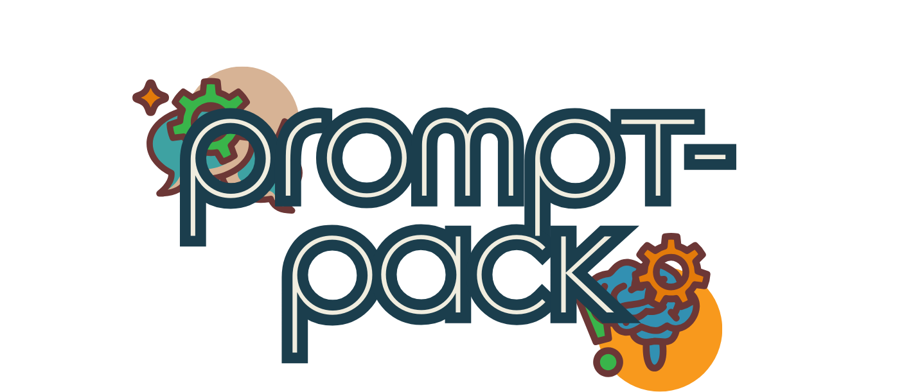

# The Prompt Pack

These prompts are updated after each live-lab.

## What is an Applicant Tracking System?

**Objective:** Create an ATS-readiness checklist

**Prompt:** “Give me a checklist to review my resume for ATS compatibility.”

**Expected Outcome:** You’ll receive a personalized checklist to assess formatting, keywords, and structure, making it easier to revise your resume. It will also suggest a next-step for your job search process.

## Use AI to Optimize Your Resume

**Objective:** Extract keywords from a job posting

**Prompt:** “Here’s a job description. Pull out the 10 most important keywords and required qualifications.”

**Expected Outcome:** You'll receive a targeted list of terms to include in your resume and cover letter to ensure they align with the job ad. You may need to upload Posting or remind the program to review the files it’s been given.

**Objective:** Format your resume for ATS

**Prompt:** “Review this resume formatting and suggest changes to improve ATS compatibility.”

**Expected Outcome:** You’ll get concrete tips: remove tables, use standard headers, ensure readability—all to increase your chances of getting past the digital filter. GPT will also offer next steps.

**Objective:** Draft a job-specific cover letter

**Prompt:** “Write a customized cover letter using this job description and my resume. Make it warm and confident.”

**Expected Outcome:** A first draft of a tailored cover letter that you can personalize further. This reduces the blank-page anxiety and saves time.

**Objective:** Summarize the job posting

**Prompt:** “Summarize this job posting in 5 bullet points that highlight the key qualifications and duties.”

**Expected Outcome:** You’ll get a distilled version of the job ad that helps you focus your resume and interview prep.

**Objective:** Draft interview questions

**Prompt:** “Based on this job description, what are 5 questions they’re likely to ask me in an interview?”

**Expected Outcome:** You’ll get customized interview questions based on your target role—perfect for practicing your responses.

**Objective:** Practice interviewing

**Prompt:** “Act as a hiring manager. Ask me these questions one at a time and wait for my response before asking the next.” **Expected Outcome:** An interactive mock interview experience where you can practice your answers aloud or in writing.

## Maximizing NotebookLM Efficiency

**Objective:** Revisit progress

**Prompt:** “Summarize all the activity in this notebook so I can see what I’ve completed and what’s left to do.”

**Expected Outcome:** NotebookLM will provide a status report of your job application process—great for motivation and accountability.

**Objective:** Get a refresher before an interview

**Prompt:** “Summarize my InterviewPrep notes for this job in 3 sentences so I can review before the interview.”

**Expected Outcome:** A quick snapshot of your prep work to help you walk in with confidence.

## Final Checklist and Weekly Reviews

**Objective:** Create a weekly job search review prompt

**Prompt:** “Give me a summary of my job search progress this week across all active notebooks.”

**Expected Outcome:** A weekly dashboard-style summary to help you reflect, follow up, or pivot strategies.

**Objective:** Evaluate strategy and momentum

**Prompt:** “Based on my weekly activity, what are 3 things I should focus on next week to improve my job search results?”

**Expected Outcome:** You’ll get tailored advice to boost productivity, improve your materials, or re-align with your goals.

# About Pauly Wolfe

**Hi, I'm Paul Wolfe, your friendly**

**neighbourhood knowledge manager.**

If you’re reading this, then I’m ***still actively looking for a remote position*** that helps me support my family, keep learning, and stay in my hometown of Thunder Bay.   
  
**I love everything about communication, and have invested my career in helping people make connections and build relationships.** For the past decade I’ve focused on technical communication and more recently developed a passion for AI tools and automated workflows.

This project is a practical **way to show you what I can do and how I do it.** I started this project on **Monday, March 24, 2025** and I’ve been working regular hours since then. **I’m not rushing or working overtime, I’m just using the tools and skills that I already have**. So, a quick review of this document, my personal website, and my YouTube channel will give you an accurate view of my **work quality, style and pace**. Think of this whole series as an ongoing answer to the interview questions you may want to ask me.

**I’m a pretty self contained unit.** I bring my own fully-equipped home studio, a big bag of skills, a pantry full of experience, and **it’s all powered by a blue-collar, self-driven, work ethic that’s all been polished up with some formal education.** I work within the **lands of the Anishinaabeg peoples** and I serve the communities that have gathered here to create a life for ourselves that is meaningful, healthy and full. So far it’s been a good ride.  
  
**For the job-seekers:** If you find this series helpful and are enjoying what you're learning, I'd be grateful for referrals and some kind words in the comments of my videos.

Thanks for being part of this journey!

Be well,

**Paul B. Wolfe**

Gorham-Ware Township, Ontario, Canada