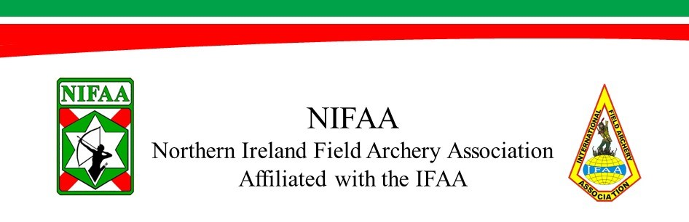
Application for Membership of the NIFAA
Please complete in full (BLOCK CAPITALS) and return via your club Secretary or by post to:
Miss C. McArthur, 35 Island Village, Islandmagee, Larne, Co Antrim, BT40 3AL.
First Name |  |  |  |  |  | Surname
Address
County |  |  |  |  |  | Postcode
E-mail
Tel:
Membership type (Please tick box) |  |  | New |  | Re-joining |  |  | Renewal |  |  | NIFAA No.
Please enter the amount you pay in boxes below.
Family Subscriptions
Family | £ | £80 | For all direct family
Senior | £ | £45 | 65yrs and over
Veteran | £ | £45 | 55-64yrs
Adult | £ | £45 | 21-54yrs
Young Adult | £ | £20 | 17-20yrs
Junior | £ | £20 | 13-16yrs
Cub | £ | £20 | 8-12yrs
Student | £ | £20 | Full time education
All age groups are inclusive of years stated above
Any direct family members living at the same address, up to a maximum of four persons, two of which may be adult, their total subscription shall not exceed £80.00 per annum.
Additional adults shall pay the full adult fee and any additional young adults, juniors or cubs shall pay £10.00 each.

Senior |  | Male |  | Freestyle Limited |  | Compound |  | Classification
Veteran |  | Female |  | Freestyle Unlimited |  | Recurve |  | A
Adult |  |  |  | Freestyle |  | Longbow |  | B
Young Adult |  |  |  | Bowhunter limited |  | Historical |  | C
Junior |  |  |  | Bowhunter Unlimited |  |  |  | U/C
Cub |  |  |  | Bowhunter |  |  |  | N/ A
Professional |  |  |  | Barebow |  | (Senior/Veteran/Cub/Traditional - N/A)
 |  |  |  | Traditional
Please enter Club Name or Independent
Archery Details – Please tick all boxes that apply.

Please enter contact details of two current NIFAA members who are willing to act as sponsors for your membership application if you are a new or re-joining member of the association.
Sponsor 1 |  | Sponsor 2
Name |  | Name
Club |  | Club
NIFAA no. |  | NIFAA no.
E-mail |  | E-mail

Please note – On signing this application form you are entering into a binding agreement for the duration of your annual membership to abide by the Rules, Constitution, and all other Policies of the NIFAA including the IFAA rules that govern or control field archery as an overreaching authority to the country associations.
Failure to abide by these rules will result in you not being covered by the NIFAA Limited Liability Insurance.

- Only equipment that is legally permitted to be used under NIFAA/IFAA rules or the law of the country you are shooting in is permitted to be carried on or at a NIFAA site, course, or tournament, including practice sessions either formally or informally attended.
- Adherence to the IFAA Code of Conduct is mandatory at any or all NIFAA organised, managed, or owned tournaments or organised shoots on any course.
- All archery equipment will conform to any or all IFAA limitations by way of speed, configuration, manufacture, or material. The NIFAA reserves the right to check this at any time an archer is present at a NIFAA event.
- No member is permitted to bring a non-member onto any NIFAA course to shoot unless that person has completed a temporary membership form in advance, and it has been approved by the requisite committee members.

Please note - The above rules relate to NIFAA membership, the NIFAA insurance clearly requires all archers to abide by the rules at any course that has been chartered by the NIFAA, for archery, under the NIFAA banner or risk being uninsured. It is the responsibility of the Club to manage this adherence at their venue when shooting under the NIFAA insurance and to maintain suitable records of all those attending.

- I hereby agree to abide by the Rules, Constitution and Policies of NIFAA and of the IFAA and wish to apply for membership of the Northern Ireland Field Archery Association.
Name (Please print) |  |  |  | Signature
Date of Birth |  |  |  | Date
- Parent or Guardian must sign if applicant is under 18yrs.
Relationship to Junior/Cub |  |  | Signature

- All new members are considered ‘Probationary Members’ for of period twelve months from date of application acceptance. Failure to abide by the rules or constitution after signing will result in your membership being revoked. Subsequently the NIFAA reserves the right to consider a lifetime ban and may notify other archery associations should this occur.
- A classification card and complimentary NIFAA pin badge will be given to all new members.
- For an additional classification card please tick the box below.
- Additional pin badges may be purchased at the cost of £3.00 each (please enclose).
- A 25% reduction is applied to the membership fee each quarter for new applicants only.
- Please make all cheques payable to NIFAA.

Classification Card |  | Free
NIFAA Pin Badge |  | £3.00

For official use only
Amount rec: | A | R/N | R/J | N | O/P
£

Membership enquiries: nifaa.membership@gmail.com

