PINEY POINT VOLUNTEER FIRE DEPARTMENT (PPVFD), INC. BOARD MEETING MINUTES

May 6, 2021 6:30 PM – 8:00 PM
Item | Description | Lead | Notes/Comments
1 | Call meeting to order | VP | 7:13 Meeting Called to order by Steve Wilson and second by Kathy Burris  Members present:  - Steve Wilson President  - Kathy Burris Treasure  - Anita Overbey War Eagle Rep.  - Leah Herron Key Road Rep.  - Debra Sayers Pine Top Rep.  - Liz Mitchell Secretary  - Blake Ballou Fire Chief  - Jim Cantrell Assistant Fire Chief  - Dewy Sayers Area Citizen  Members not present:  - Liz Ledbetter Vice President
2 | Additions and approval of the agenda | President | Introduce New Board Members  Set Goals for the Year  Clarification of Dues
3 | Approval of 3/4/2021 Minutes | Secretary | Sent in email for review – by Liz M.  - Anita Overbey motion to accept  - Leah Herron second  - Unanimous vote to accept
4 | Treasurer's Report | Treasurer | Approve any expenses that need approval  - ER Dues $1857.25  - Weed Killer for $75.00 or Less  - Anita Overbey motioned to accept  - Liz Mitchell second  - Vote was Unanimous  - Reminder any expenditure over $20 dollars needs prior approval.  - If it is a recurring expenditure (Bills and annual Dues) no approval needed.  - Anita Overbey motion to accept  - Debra Sayers second  - Unanimous vote to accept
5 | Chiefs Report | Chief | Review any items that need immediate attention  - Missionary Homes moving into district  - Check Bylaws for Dues for Nonprofits  - James Templin for mowing War Eagle Only  - For summer events that require Firefighters to work a minimal hourly rate of $14 will be charged  - Compensation for Firefighters that answer calls  - Chief will remove himself from compensation  - Jim will present at next meeting compensation plan  - Addressed unanswered calls  - Plan on having coverage during peak times in Summer Months  - New Firefighters  - Paramedic at Station 5  - EMT on call Sat/Sun  - Would like to have an Appreciation Dinner in house only  - Trucks up and running  - Table for next meeting  - Equipment needs  - Water Rescue  - Saws  - Backpack Blowers  - October Fire Show RSVP  - Anita Overbey Motioned to accept  - Leah Herron Seconded
6 | Updates | Board
 | Voting Result | Secretary | - Kathy Denton, Anita Overbey, and Liz Mitchell meet on April 26, 2021  - President, Treasure, Secretary positions 43 votes unanimous  - Key Road Leah Herron 8 votes  - Pine Top Debra Sayers 9 votes  - Approved ByLaws with 32 votes  - Approved AGM Minutes 31 Votes  - Approved Treasure Minutes 31 Votes
7 | New Business | Open
 | Building Committee | Chief | - Gentleman fixing Blake’s deck offered to clear ground for new building for free  - He would like all lumber from original building for the fee  - Break ground in September  - Dirt work by October  - Roll off $700  - Fire Wise
 | Email set up for board members | Secretary | - Gmail set for board members
8 | Next Meeting |  | June 3, 2021 @ Station 2
9 | Adjournment |  | 7:54 Meeting adjourned  - Liz Mitchell motioned  - Steve Wilson second

TREASURER REPORT 5/5/2021

SEE ATTACHED P& L

CHECKING ACCOUNT BALANCE 79569.97
SAVINGS ACCOUNT BALANCE 713.58
MONEY MARKET ACCOUNT 51205.49

EMERGENCY REPORTING IS DUE THIS MONTH 1857.25

8:07 _{PM} Piney Point Volunteer Fire Department
05_{/03/21} Profit & Loss
Cash Basis April 2021
Apr 21
Income
Donations | 60.00
Fire Dues | 320.00
Total Income  Expense | 380.00
Active 911 | 221.00
Computers/Software  Electricity | 83.88
Old Fox Hunter's Property | 16.15
Station 1 | 140.85
Station 3 | 24.43
Station 5 | 18.51
Total Electricity  Insurance | 199.94
Vehicles | 143.00
Total Insurance | 143.00
Postage, Shipping, Mailing | 96.79
Printing Copies | 133.14
Retirement Fund  Supplies | 118.00
Fire Fighting | 82.09
Office | 44.00
Total Supplies | 126.09
Telephone  Truck Maintenance & Supplies | 51.19
Truck 1422 | 231.90
Total Truck Maintenance & Supplies | 231.90
Water | 33.09
Total Expense
1,438.02
-1,058.02
Net Income
Page 1

Chief Report
We are at the lowest COVID numbers since last June for the state, and with the availability of the vaccine to all, we have started to conduct formal in person trainings again. I will briefly touch on future goal considerations for: dedicated standbys, firefighter compensation, and increased coverage.
Need to startup Building Committee soon. Prices continue to increase. Potential options on clearing land and dirt work as well as tree removal.
Station 5: burst water leak was repaired. There is sheet rock damage from the water leak in the bathroom wall.
Station 4: AC/Heater wall unit has been installed.

Specialized Training Updates
Will be requesting a Intro/PPE class from AFA soon. We have 3 FF’s that need these classes.
Currently focusing on tactical considerations for incident command and EMS standards.

Personnel Changes

New prospect Jill Messersams (paramedic) has stated she will be joining soon when she moves to the area. No application has been processed yet due to her being out of state.

April Incident Count: 18 Report #384
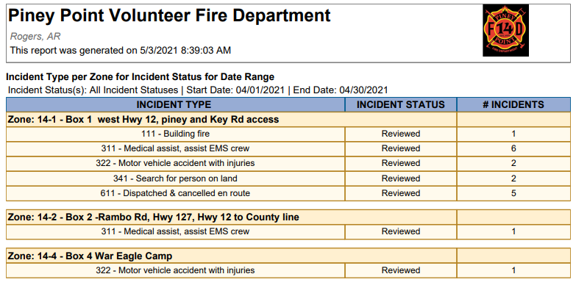

Incident Count YTD: 62 Report #553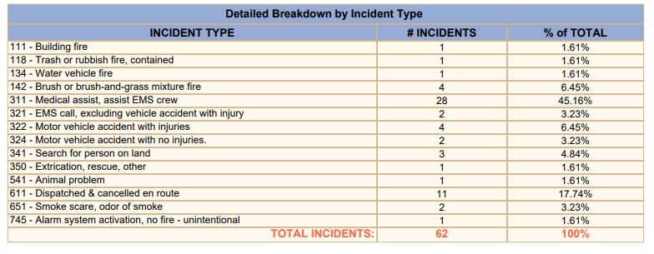

Response & Training Report #1672
Training Points are also for specialized training that occurred throughout the year: Hazmat, Instructor, Etc.
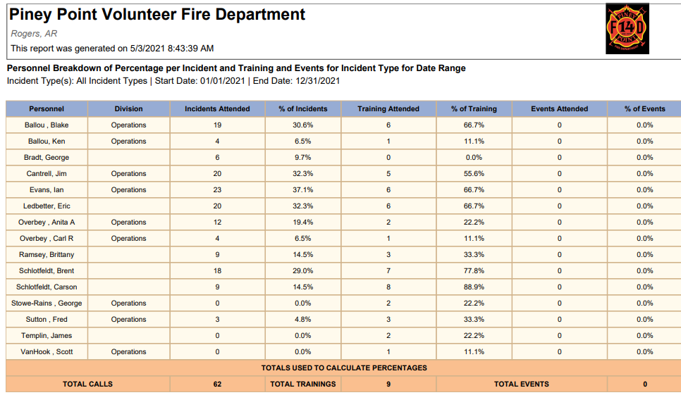

Incidents and Training hours YTD Report #1413
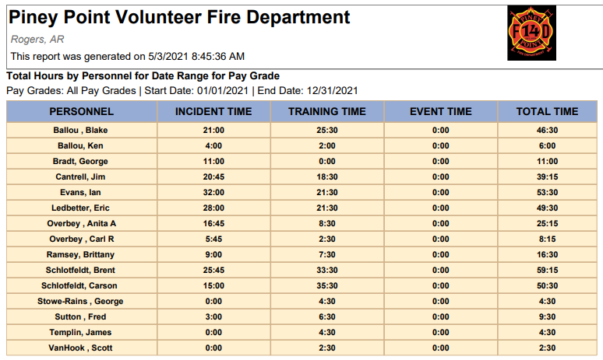

Station Updates
- Station 1, Piney Rd 10594 Piney Road
- No New Updates
  - Needs new facia boards put in place. (need to get estimate of cost)
  - Cleaned inside of station, needs more work with weather compliance
- Current trucks stationed in 2 bays:
  - 1414 –added new accessory lighting, etc.
  - 1422 – truck is out of service, failed pump test. Due to engine overheating while idle and hydraulic leak.

- Station 2, Lookout 22050 E. Hwy 12
- No New Updates
- Current trucks stationed in bays:
  - 1411 – no issues
  - 1423 – no issues
  - 1441 – out of service due to mechanical
  - 1415 – no issues, needs moved to station 5.
  - 1442- no issues

- Station 3, War Eagle 11200 High Sky Inn Rd
- No New Updates
- Current Trucks stationed in bay
  - 1417 – air brakes are locked up and won’t build up air pressure

- Station 4, Camp War Eagle 13552 The Pines Road
- No New Updates
  - Need to install the AC unit on the wall, its sitting in the bay.
  - Need list of supplies together to do wiring to get the AC unit. We can do that ourselves without any issue.
- Current trucks in bay
  - 1421 – no issues, compartments need organized and new mounts put in place for equipment required to make it an Engine
  - 1444 – no issues, Ian has this as a response vehicle from his home on Pullum Place.
  - New truck from Hickory Creek Fire. Testing before mounting pump.

- Station 5, Pinetop 22725 N. Pine Top Rd
- No New Updates
- Current trucks in bay
  - 1413 – air brakes are locked up and will not build up air pressure
  - Trailer with Golf Cart needs moved to make room for 1415 from Station 2. Potentially turn trailer into forestry

- Future Station 1 10400 Piney Road
Building Committee Formed – May 2020 Board Meeting
- Committee on Hold until mid year
- Need to start thinking about building changes at station 2
- Need to begin discussions on Future Station 1
- Will need to get new quotes.
- Multiple building quotes have been requested and submitted for review

Public interactions. It is my recommendation that we continue to limit the exposures of Fire Department hosted events with our immediate community until more states are on the downward Covid trend that the state of Arkansas is. I feel we can safely assume we will have limited interactions that WE host until later in the fall. We will continue to provide support for events in our area, but I feel we should limit what we host. I would like to welcome the new board members and it is my hope we can continue on the path to progression, and continue to grow as a Fire Department in line with the standards of all NWA Fire Departments.

