**PINEY POINT VOLUNTEER FIRE DEPARTMENT (PPVFD), INC. BOARD MEETING MINUTES**

October 7, 2021 7:00 PM – 9:00 PM

|  |  |  |  |
| --- | --- | --- | --- |
| **Item** | **Description** | **Lead** | **Notes/Comments** |
| 1 | Call meeting to order | Pres | * Meeting called to order at 7:00 pm * Steve Wilson President * Liz Ledbetter Vice President * Kathy Burris Treasurer * Anita Overbey War Eagle Rep (Not Present) * Leah Herron Key Road Rep (Not Present) * Debra Sayers Pine Top Rep * Liz Mitchell Secretary * Jim Cantrell Assistant Fire Chief * Brent Schlotfeldt Fireman * Dewy Sayers (community member) * Lisa Wittman (community member) |
| 2 | Additions and approval of the agenda  7:00-7:10 | VP | * Additions: Itemizing the P&L Report * Motion made to add by Liz Mitchell * Second by Liz Ledbetter * Motion to accept agenda made by Liz Mitchell * Second by Liz Ledbetter * Unanimous Vote |
| 3 | Approval of July 8th, 2021 minutes  7:10-7:15 | Secretary | Emailed by Liz Mitchell [ppfd14secretary@gmail.com](mailto:ppfd14secretary@gmail.com)   * Motion to accept made by Kathy Burris * Second by Liz Ledbetter * Unanimous Vote |
| 4 | Treasurers Report  7:15-7:30 | Treasurer | Emailed by Kathy Burris [ppfdtreasurer@gmail.com](mailto:ppfdtreasurer@gmail.com)   * Treasure Reports for 8-2, 9-1, & 10-7 * Motion to accept Treasure Reports by Liz Ledbetter * Second by Liz Mitchell * Unanimous Vote |
| 5 | Chiefs Report  7:30-8:00 | Chief | Emailed by Chief Blake Ballou [1401bcfd@gmail.com](mailto:1401bcfd@gmail.com)   * SCBA * Brand New Air Packs by Scotts $12,000 for 1. * Refurbished Air Packs by Scotts $2575 for a complete set (2 air tanks and Mask) * Buy 10 sets and get 1 free * All testing is covered in the cost * Must be replaced by January * Truck Repairs * Itemized list of repairs to be presented at next meeting. * Fox Hunters demolition and dirt work should start Nov. 1st. |
| 6 | Updates | Board |  |
|  | Fireman Compensation  8:00- 8:10 |  | * Table for further research and discussion |
|  | Piney Road Rep  8:10-8:20 |  | * Lisa Wittman * Motion to accept Lisa Wittman as the Piney Road Rep made by Liz Ledbetter * Second by Liz Mitchell * Unanimous vote |
|  | Fire Dues  8:20-8:30 | Steve | * 2 people with concerns * Steve emailing names to Kathy |
| 7 | New Business | Open |  |
|  | Itemizing P & L |  | * Explained that a detail report can be attained upon request |
| 8 | Next Meeting |  | 11/4/2021 |
| 9 | Adjournment |  | Meeting adjourned at 8:34pm |
|  |  |  |  |

**TREASURER REPORT 8/2/2021**

SEE ATTACHED P& L

CHECKING ACCOUNT BALANCE 77604.55

SAVINGS ACCOUNT BALANCE 713.67

MONEY MARKET ACCOUNT 51209.32

Diesel for the bulk tank at Station 2 was 1441.48. I will pay it

August 10.

ALL RECEIPTS NEED TO BE TURNED IN BEFORE THE LAST DAY OF THE MONTH TO BE PAID BY THE 10TH OF THE NEXT MONTH!!!

PAID BY THE 10TH OF THE NEXT MONTH!!!

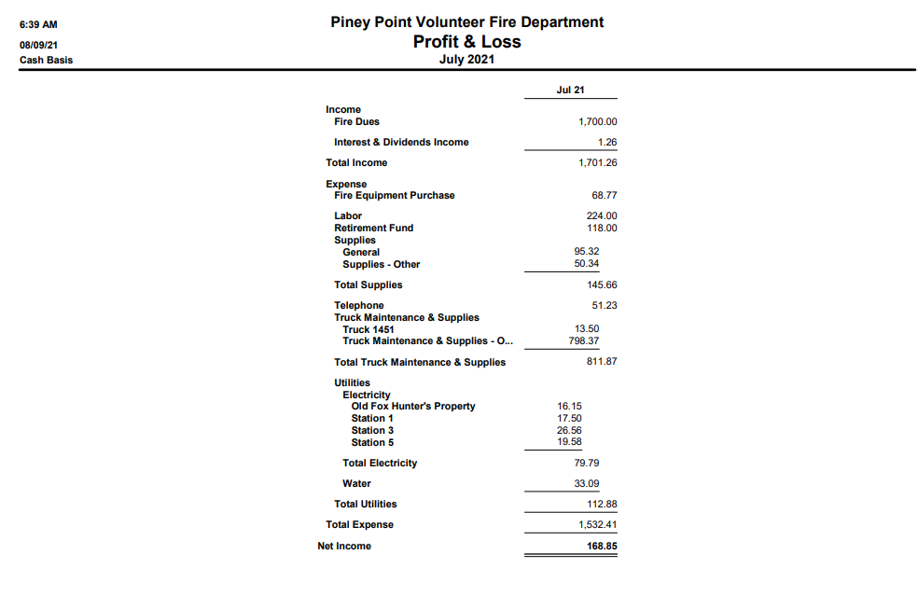

**TREASURER REPORT 9/1/2021**

SEE ATTACHED P& L

CHECKING ACCOUNT BALANCE 94186.33

SAVINGS ACCOUNT BALANCE 713.67

MONEY MARKET ACCOUNT 51210.67

TURN IN BEFORE ALL RECEIPTS BY THE LAST DAY OF THE MONTH TO BE PAID BY THE 10TH OF THE NEXT MONTH!!!

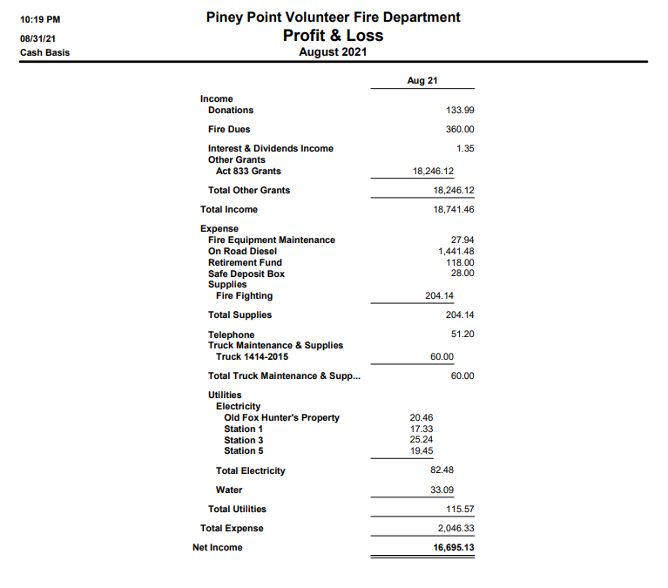

**TREASURER REPORT 10/6/2021**

SEE ATTACHED P& L

CHECKING ACCOUNT BALANCE 94151.62

SAVINGS ACCOUNT BALANCE 713.76

MONEY MARKET ACCOUNT 51211.97

TURN IN BEFORE ALL RECEIPTS BY THE LAST DAY OF THE MONTH TO BE PAID BY THE 10TH OF THE NEXT MONTH!!!

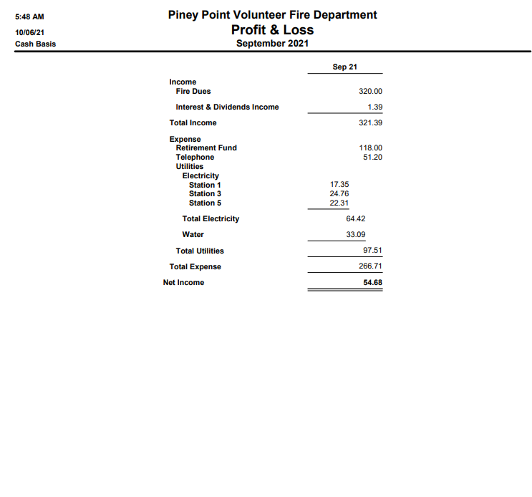

**August Report**

**Chief Report**

As we continue to navigate the COVID-19 pandemic, we find ourselves in this new wave of the Delta Variant. I would like to touch base from a professional outlook and update as to the strain the current health system of NWA is under. Almost around the clock, all the major hospitals remain on Divert, with multiple patients being placed in hallways and waiting room and extended wait times up to 8+ hours being common. It is being highly encouraged that anything not related to loss of life limb or eyesight or requiring surgical interventions be seen at urgent cares, PCP’s or the stand alone ER’s. I encourage everyone to remain vigilant and stay as safe as possible as it is an unprecedented time for healthcare in our area. Due to the extreme level of illness in the communities it is still my professional opinion to avoid hosting public events at this time.

**Specialized Training Updates**

Intro/PPE class for 3 of our firefighters was completed. Should have received certifications from AFA by now in the mail.

A Training burn was conducted with area fire depts at Beaver Lake. This will count towards quarterly Mutual Aid training. Beaver Lake fire Dept was able to acquire a structure to train on fire dynamics and give hands on to real working fire ground operations to our newer volunteers.

**Personnel Changes**

Zach Rogers and Ajay Schinnerer are removed from Wildland SAR team due to scheduling conflicts

**Strategic Planning**

The fire suppression unit on 1442 will be transferred to the new brush unit acquired from HCFD. The needs to update the new brush unit to responding status includes: R Driver side alternator (tested and dead) 4 tires, Left body fender, and some various bulbs and re-wiring.

1442 well then be 1452 and be a light rescue unit.

1414,1421, Rescue 1452 (1442) need inverters purchased and installed for onboard power

Some technical needs are 2 sets of dynamic rope, life safety carabiners, 2 rescue 8’s, 4 pulleys, 2 harnesses.

Additional extrication tools needed for 1414 and the future 1452 Rescue.

Refer to needed tools list

A small aluminum flat bottom boat for flooding, river and lake incidents to be added into strategic future planning. Will discuss at meeting.

**July Incident Count:** **20 Report #384**

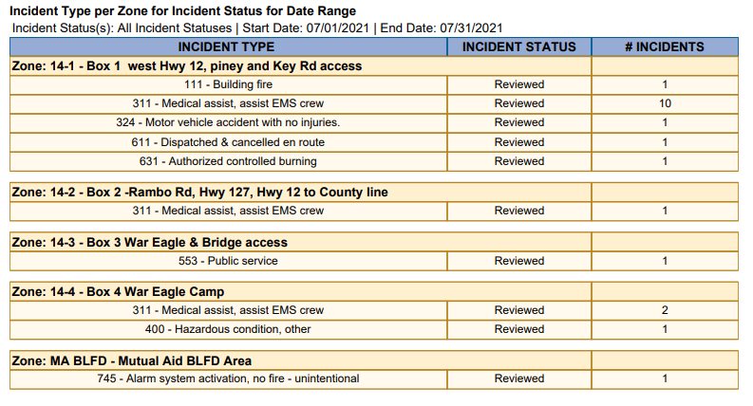

**August Incident Count:** **18 Report #384**

**Incident Count YTD: 138 Report #553**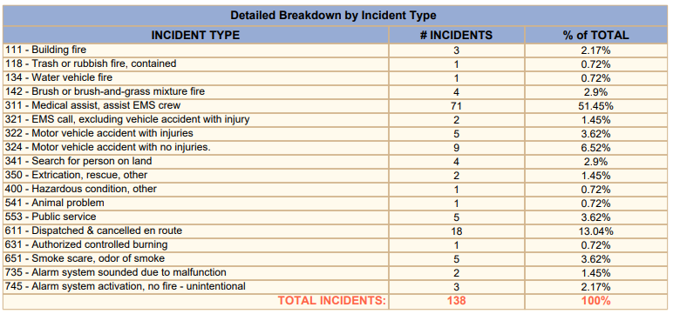

1. *2020 Total Run Count: 172*
2. *2019 Total Run Count: 150*
3. *2018 Total Run Count: 161*

**Response & Training Report #1672**

Training Points are also for specialized training that occurred throughout the year: Hazmat, Instructor, Etc.

**Station Updates**

* **Station 1, Piney Rd 10594 Piney Road**
* Updates
  + Needs new facia boards put in place.
  + Awning added over door
* Current trucks stationed in 2 bays:
  + 1414 – Tire needs evaluated by tire shop
  + 1422 – Needs pump work by Certified Mechanic
* **Station 2, Lookout 22050 E. Hwy 12**
* Need bigger fan
* Need exhaust vent for fumes
* Start thinking about building changes at station 2
* Current trucks stationed in bays:
  + 1411 – In Service
  + 1423 – In Service
  + 1441- Needs Engine looked at
* **Station 3, War Eagle 11200 High Sky Inn Rd**
* No New Updates
* Current Trucks stationed in bay
  + 1417 – In service
* **Station 4, Camp War Eagle 13552 The Pines Road**
* No New Updates
* Current trucks in bay
  + 1421 – In service
  + 1443 (HCFD Truck) refer to list for needs
  + 1444 – No issues, Ian has this as a response vehicle from his home on Pullum Place.
* **Station 5, Pinetop 22725 N. Pine Top Rd**
* No New Updates
* Current trucks in bay
  + 1416 – Needs maintenance
  + 1415 – Needs maintenance
* **Future Station 1 10400 Piney Road**

Building Committee Formed – May 2020 Board Meeting

* Committee on Hold
* Need to begin discussions on Future Station 1
* Free demolition and dirt work tentative to begin in Fall 2021 upon approval
* Will need to get new quotes.

**September Report**

**Chief Report**

The main focus of this months report will be a development from the county for a few select departments. The county has extra funds from the federal government in relation to an act passed for COVID relief. In summary, the departments who represent a large area but do not have a municipality and therefor no way to raise taxes are going to have their act 833 doubled for a limited time. Our last installment will be doubled for 2021, and we will have it doubled in 2022. 2023 and 2024 are hopeful but still has to be voted on as time comes. 2021 we will just see what our last act 833 was in an extra installment. 2022 will be the doubled lump sum.

It was made clear that these funds are to be used to catch up with equipment needs and repairs and to get ahead while we can since it will be temporary. Our most immediate life safety need is airpacks. It is my strong recommendation that we address this need before any other. I will be providing the best option in regards to airpacks at this upcoming meeting.

**Specialized Training Updates**

Narcan Training provided to fire dept. Each participate received free Narcan product that our responders can use for suspected opioid overdose calls.

**Personnel Changes**

Ajay Schinnerer and Zach Rogers to be removed from Roster.

**September Incident Count:** **10 Report #384**

**

1. *2020 Total Run Count: 172*
2. *2019 Total Run Count: 150*
3. *2018 Total Run Count: 161*

**Response & Training Report #1672**

Training Points are also for specialized training that occurred throughout the year: Hazmat, Instructor, Etc.

**Station Updates**

* **Station 1, Piney Rd 10594 Piney Road**
* Updates
  + Needs new facia boards put in place.
  + Needs Landscaping
* Current trucks stationed in 2 bays:
  + 1414 –in service
  + 1422 – waiting on estimate from company for pump rebuild.
* **Station 2, Lookout 22050 E. Hwy 12**
* Current trucks stationed in bays:
  + 1411 – in service
  + 1423 – in service
  + 1441– acceleration issue
  + 1442- in service
* **Station 3, War Eagle 11200 High Sky Inn Rd**
* No New Updates
* Current Trucks stationed in bay
  + 1417 – no issues
* **Station 4, Camp War Eagle 13552 The Pines Road**
* No New Updates
* Current trucks in bay
  + 1421 – no issues
  + HCFD brush unit (future 1442) needs right alternator, fender, tires, pump mounted.
  + 1444 – no issues, Ian has this as a response vehicle from his home on Pullum Place.
* **Station 5, Pinetop 22725 N. Pine Top Rd**
* No New Updates
* Current trucks in bay
  + 1416 – need to allow air brakes build up air pressure
  + 1415 – power steering needs fixed
* **Future Station 1 10400 Piney Road**

Building Committee Formed – May 2020 Board Meeting

* Committee on Hold
* Need to begin discussions on Future Station 1
* Free demolition and dirt work tentative to begin in Fall 2021
* Will need to get new quotes.