**PINEY POINT VOLUNTEER FIRE DEPARTMENT (PPVFD), INC. BOARD MEETING MINUTES**

June 3rd, 2021 7:00 PM – 9:00 PM

|  |  |  |  |
| --- | --- | --- | --- |
| **Item** | **Description** | **Lead** | **Notes/Comments** |
| 1 | Call meeting to order | VP | 7:08 meeting called to Order by Liz Ledbetter  Members present:   * Steve Wilson President (Joined at 7:35) * Liz Ledbetter Vice President * Kathy Burris Treasurer * Anita Overbey War Eagle Rep * Leah Herron Key Road Rep * Debra Sayers Pine Top Rep * Liz Mitchell Secretary   Members Not present   * Blake Ballou Fire Chief * Jim Cantrell Assistant Fire Chief   Area Citizen   * Dewy Sayers Area Citizen |
| 2 | Additions and approval of the agenda | VP | Steve Wilson, Liz Ledbetter, and Liz Mitchell will meet the week before to develop the agenda for up coming meeting. All reports Chief and Treasurer report will need to be submitted the Friday before meeting for review. The Agenda will need to be sent out 48hrs before the meeting date. |
| 3 | Approval of May 6th, 2021 minutes | Secretary | **Sent in email for review – by Liz M.**   * Motion made by Anita Overbey to accept the minutes. * Seconded by Leah Herron * Vote was Unanimous to accept the minutes |
| 4 | Treasurers Report | Treasurer | **Approve any expenses that need approval**   * Motion made by Liz Mitchell to shut off electricity at Fox Hunter’s * Second by Leah Herron * Unanimous vote to shut off electricity * Motion made by Anita Overbey to approve Propane Prepay for $1850.00 for 1000 gallons * Have a $200 credit from Last Year * Leah Herron second * Unanimous vote for purchase * Motion made by Anita Overbey to accept Treasurers report * Debra Sayers second * Unanimous Vote to accept |
| 5 | Chiefs Report | Chief | **Review any items that need immediate attention**   * Chief will submit report the Friday before the meeting so Board members will have time to review the report and develop questions to present at the meeting. * Compensation for Fire Fighters * A comprehensive plan needs to be presented * Board will be reviewing previous minutes to find why compensation ended for Fire Fighters * Tabled till next meeting * Truck Repair Completed by Dewy Sayers * $71.48 for parts and labor for work completed on Truck #1416 * Anita made the motion to pay Dewy for parts and labor * Kathy Burris second * Unanimous Vote for the payment * Trailer full of items from clean out * Correct line of Disposal * Can anything be donated or sold * Google Benton County for Clean Up * Notify community on Facebook and Web Page of the clean up * Motion made by Anita Overbey in the amount of $150 to dispose of tires properly * Leah Herron second * Vote was Unanimous for the disposal amount * Motion made by Anita Overbey in the amount of $275 for the purchase of Throw Rope Bags and Flotation devices for water rescue. * Liz Ledbetter second * Vote was Unanimous for the purchase * Further Truck Repair discussion tabled until next meeting. |
| 6 | Updates | Board |  |
|  | Items from Previous Board Members | Board | * Contact Craig for safe deposit key * Collect secretary computer and paper work from Kathy Denton * Move contents from old computer to flash drive due to computer being outdated * Steve Wilson asked Kathy Denton to keep paper work until he is able to find proper storage. * Board agreed that was acceptable |
|  | Email Address | Secretary | * Confirmed what email addresses needed to say * [PPFD14President@gmail.com](mailto:PPFD14President@gmail.com) …Etc. * Emails will be set up in the next 24hrs |
| 7 | New Business | Open |  |
|  | Streamline Meetings | Leah | * Give each topic a time limit * If time limit is breeched topic will be table for next meeting * Time keeper will be needed (Leah volunteered) |
|  | Items needed for Fire Dept. | Board | * Make a Facebook post with a list of items that are needed * Tabled until next meeting to review with Chief * Reach out for donations |
| 8 | Next Meeting |  | July 8th, 2021 at 7:00pm |
| 9 | Adjournment |  | 8:55 meeting adjourned   * Motioned by Anita Overbey * Second by Liz Mitchell |

**TREASURER REPORT 6/3/2021**

SEE ATTACHED P& L

CHECKING ACCOUNT BALANCE 79330.57

SAVINGS ACCOUNT BALANCE 713.58

MONEY MARKET ACCOUNT 51206.67

PAID 5/24 EMERGENCY REPORTING 1857.25

Attached is the flyer from Andersons for prepay propane.

There is a credit of 242.12 from last year prepay.

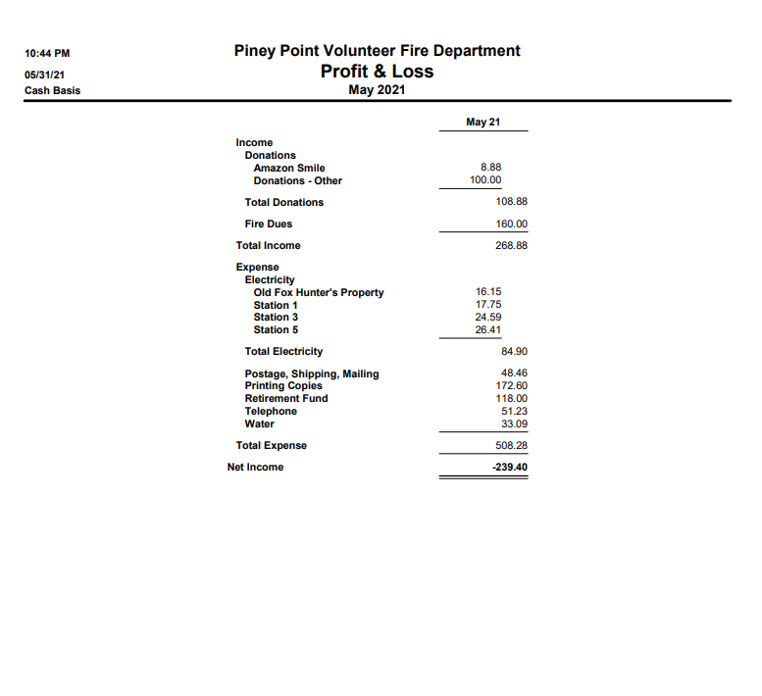

**Chief Report**

All, as Covid numbers drop and the state has ended the emergency declaration, the FD will be focusing on re-organizing and training. There are a few goals I have been working on in phases, starting with station 4 clean up and organization we now have a station we can host classes in during summer weather.

Act833 has been signed and forwarded per fire marshal

Station 2 red building re-organized to serve the purpose of logistics and physical resource work. This will be the storage of our equipment, a work area for us to work on our tools and equipment, and general maintenance.

1415 moved from station 2 out to station 5, trucks will be re-organized for tactics of that area.

Trailer in main building of station 2 has the outgoing clutter from the cleanup. I would like that gone no later than June 21st as I have used some of my vacation days from work to finish up these projects. Plus we need the bay freed up.

**Specialized Training Updates**

Will be requesting an Intro/PPE class from AFA soon. We have 3 EMT’s at a very rare medical training in Little Rock 6/3/2021. It is very rare for EMT’s to be able to be in this class as generally all slots go to paramedics. The local city departments were unable to secure seats so we are very fortunate to be able to have our EMT’s there, learning and gaining the hours needed for their recertification (funds for registration of class and travel expenses came from donation from 1401, no FD funds used)

We are developing a strategy for Rescue training and are set to have a SAR certification class on a date that is to be determined.

**Personnel Changes**

I have brought in Elijah Ballou (1488) who is an EMT, and is covering our area on the days we have people out of area. He started his first official day this past Monday, and ran 2 calls that day. Our Pine Top Paramedic will be in area full time this month I will be getting her squared away as soon as possible. I am working the Wildland/Rescue team roster and will have 2 personnel changes by July time frame. This will be a positive resource that I will go into more detail at a later date after finalization this month. The Wildland/Rescue team will be regularly meeting now that the state dropped the emergency status and will be helping with general tasks as well. I’ve already had help with my projects from them and help with events in our area to come.

**May Incident Count:** **23 Report #384**

**

**Response & Training Report #1672**

Training Points are also for specialized training that occurred throughout the year: Hazmat, Instructor, Etc.

**Incidents and Training hours YTD Report #1413**

**Station Updates**

**Stations 1,2,4 have new locks installed**

* **Station 1, Piney Rd 10594 Piney Road**
* Updates
  + Needs new facia boards put in place. The materials will be in the ballpark of $60 plus hardware.
* Current trucks stationed in 2 bays:
  + 1414 –In service
  + 1422 – truck is out of service, failed pump test. Due to engine overheating while idle and hydraulic leak.
* **Station 2, Lookout 22050 E. Hwy 12**
* Station ongoing cleaning and organization, need medical oxygen company to come fill medical oxygen tanks in smaller building.
* Current trucks stationed in bays:
  + 1411 – no issues
  + 1423 – no issues
  + 1441 – repaired- in service
  + 1442- will be re-organized. Needs new batteries, possibly having batteries donated form Wildland/Rescue Team Supervisor
* **Station 3, War Eagle 11200 High Sky Inn Rd**
* Interior station cleaning needed. Will add to my agenda
* Current Trucks stationed in bay
  + 1417 – no issues
* **Station 4, Camp War Eagle 13552 The Pines Road**
* No New Updates
* Current trucks in bay
  + 1421 – no issues- will be re-organized
  + 14(unit number not assigned) – hickory creek brush truck turn in. Needs front driver side fender panel replaced ($100 neighborhood) and to be outfitted with gear and some electrical work as well as tires in the near future. Will have updated needs list on it.
  + 1444 – no issues, Ian has this as a response vehicle from his home on Pullum Place.
* **Station 5, Pinetop 22725 N. Pine Top Rd**
* Station needs minor cleaning. Water damage is confined to the bathroom area.
* Current trucks in bay
  + 1416 – truck organization needed, pump work
  + 1415 – truck organization needed, power steering needs looked at
* **Future Station 1 10400 Piney Road**

Building Committee Formed – May 2020 Board Meeting

* Committee on Hold until mid year
* Need to start thinking about building changes at station 2
* Need to begin discussions on Future Station 1
* Will need to get new quotes.
* Multiple building quotes have been requested and submitted for review
* Have possible plan for clearing work and dirt work. Contractor willing to meet with committee as well as advise on the metal building he just constructed

**Chief Projects**

I keep a list of projects for my department goals. I set aside days based on my work schedule, military requirements and still allowing some time for family and work on my own home. Generally, these projects are on a strict and planned time frame according to my availability, several weeks in advance, because if I cannot accomplish them in that time frame, it takes a while to set aside another free block of time to dedicate solely to those projects. So If I ever come across as something appearing to be rushed or urgent, this is the reasoning behind it and in no one is meant to come across in any negative light. I will lay out my own personal goals and vision. This is not any sort of “official” checklist that I will be reporting every month on progress, it is more of sharing of my own personal goals/chores with you so you can see where my vision for this year is in regards to station organization.

Station 1 – I view this as a historic landmark for our area. Everyone knows the directions “by the fire station by the church.” The apron in front of the station has been power washed and the area cleaned up of debris in general. I plan on doing a heavy cleaning of the bay, removing any excess items, and doing minor landscaping to the exterior and around the property. I am looking at signage, and would very much like a small library box as well as either a picnic table or sitting bench.

Station 2- the main building of station 2 will be cleared of all equipment and tools. Apparatus, chairs and tables will remain. This will ensure a less intensive set up process for public events. The smaller building at station 2 will be our “workshop” where we house the tools, equipment and other items. This will also be a space where we can work on equipment as well as house resupply items. The other thought behind this is during public events, we do not make ourselves a target by having excess items in view. Will be setting up memorial bench with weather permitting.

Station 3- My goal here is to house swift water supplies. A few extra throw ropes, some PFD’s and a few other items needed for consideration of river safety that can be grabbed quickly in close proximity to the river, ultimately having 6 water rescue sets with 2 being kept at station 3, and the others kept on the most utilized apparatus. (a set is a throw bag, a PFD and a helmet but we can do with just throw bag and PFD for now.)

Station 4- This station is to be the “firefighters” station. We will have our classroom trainings done here since it is our only climate controlled station. This is where the firefighters can meet for their dinners or cookouts, group fitness, etc. this station is more private than our other stations and the risk of shady characters pulling up is much lower than some of the other stations. In short we can use this station for our own functions and utilize station 2 for public functions

Station 5- keep simple and minimal at this time.

As we navigate back to what “normal” life is, we will continue to strategize how best to provide services and coverage to our residents. I am proud of every firefighter on this department and the professional attributes they project. I will be using the month of June to start on my goals list as time and weather permits, and if there are any further questions I will be more than happy to meet with board members as a whole or individually as needed. I would like to extend our deepest gratitude to Dewey as he has already gone above and beyond in serving the department. His talents have shown immediately and his knowledge base is something I will find myself relying on for guidance regularly.

I will also add a checklist of items needed to this report that can be printed out and checked off as obtained. Some may be donated, some may be used, and some need to be purchased as new, and I will annotate that with each item.

Physical Resource needs for Department

* Pressure Washer, electric, Lowes $80, new*
* Dolly, new used or donated
* Hammer, new used or donated
* Socket Set, new used or donated*
* Screw Driver Set, new used or donated
* Wrenches, new used or donated*
* Wire Snips, new used or donated
* Work table vice, new used or donated
* Work table grinder, new used or donated
* Circular saw, new used or donated
* 5 bags concrete* for bench at station 2

Equipment Needs for Emergency calls

* Battery powered chain saw x2 approx. cost under $150 each and 1 plug in chain saw for 1411 approx. cost under $100. Had great results with these and will cut costs of fuel and maintenance long term. We can do 1 battery saw and 1 plug in now and go from there later. We will keep all gas saws on a truck for request as needed, but the electric are easier to use, much lighter and can handle most of what we do. Inverters will be wired to keep battery banks charged.
* Stokes basket $273.00 Fire Safety USA. We need an additional stokes basket for the station 1 area.
* Throw ropes bags for water rescue, $20-$40 each. 6 needed can do 2 now 4 later
* PFD (personal flotation devices) per standard we aren’t supposed to be close to a water’s edge without a PFD on. 6 needed, can do 2 now 4 later. Best deal found is mustang survival USCG approved $88 each
* Backpack blowers- will be filing for grant in fall for these

The * next to items on the physical resources list indicates needs we have now for them. The others are as we can acquire them.

The equipment needs list for the FD must be new. My goal is to move as much as we can to electric on tools and fans (a lot of departments are going this route) because how far they have come and they require less maintenance, less fuel and less issues with starting on scene. We will keep our gas tools on a secondary vehicle. I would also like to slowly transition station lights to LED over time to save on power and longevity. The stokes is needed so we don’t have to bypass a call to get the stokes from station 2 in the event no one is near 2 to grab it. We have other needs but these I have identified as needs for the summer at this time.