**PINEY POINT VOLUNTEER FIRE DEPARTMENT (PPVFD), INC. BOARD MEETING MINUTES**

July 8th, 2021 7:00 PM – 9:00 PM

|  |  |  |  |
| --- | --- | --- | --- |
| **Item** | **Description** | **Lead** | **Notes/Comments** |
| 1 | Call meeting to order | VP | Meeting Called to Order 7:01   * Steve Wilson President (Joined at 8:00) * Liz Ledbetter Vice President * Kathy Burris Treasurer * Anita Overbey War Eagle Rep * Leah Herron Key Road Rep * Debra Sayers Pine Top Rep (Not Present) * Liz Mitchell Secretary * Jim Cantrell Assistant Fire Chief * Brent Schlotfeldt Fireman |
| 2 | Additions and approval of the agenda  7:00-7:10 | VP | * Mowing for Station 3 * Fan for Station 2 * Road at Station 2 * Motion made to add by Anita Overbey * Second by Leah Herron |
| 3 | Approval of June 3rd, 2021 minutes  7:10-7:15 | Secretary | Emailed by Liz Mitchell [ppfd14secretary@gmail.com](mailto:ppfd14secretary@gmail.com)   * Motion to accept made by Anita Overbey * Second by Leah Herron * Unanimous vote |
| 4 | Treasurers Report  7:15-7:30 | Treasurer | Emailed by Kathy Burris [ppfdtreasurer@gmail.com](mailto:ppfdtreasurer@gmail.com)   * Request made to Itemize the P & L to match budget categories * Items will categorize purchase per building and truck * Motion made to accept the Treasure’s Report by Liz Mitchell * Second by Anita Overbey * Vote was Unanimous to accept |
| 5 | Chiefs Report  7:30-8:00 | Chief | Emailed by Chief Blake Ballou [1401bcfd@gmail.com](mailto:1401bcfd@gmail.com)   * Compensation for Firemen * Presentation made by Jim Cantrell * Presentation attached * Tabled for next Meeting time limit of 30 minutes * Motion made by Anita Overbey * Second by Kathy Burris * Truck Repair * No update on Inspection Time * Station 5 trucks are left to be serviced * Lights in stations are being changed to LED * SCBAs will need to be replaced * Replace per bottle expiration * Obtaining Quotes * Grant Possibilities * Possible renting * Ship to Company * $300 per bottle to bring to code * EVS Mechanic for Pump Work * Electrician need to repair light at Station 1 * Need of someone to dig in front of Station 3 for gravel to be placed * ½ yard $15 * Full yard $30 * ACT 833 * Little Rock has received * Blake or Jim will call Lewis * Department Phone Topic Communication * Message on Website and Facebook contact email * Phone used for Day to Day business * Will be creating a message for voicemail directing callers * Anita made motion to Accept Report * Liz Ledbetter Second * Unanimous Vote |
| 6 | Updates | Board |  |
|  | Fox Hunters Club  8:00- 8:10 |  | * Inspected for asbestos and lead to prepare for burn training fire wise * Does not meet NPF Standards * Free Demolition and Dirt Work to start in the Fall * Gentleman requests lumber in return for payment * Liz Ledbetter made motion to accept * Leah Herron second * Unanimous Vote * Camp ground for Bikes Blues Barbeque * Denied * Steve will mow Fox Hunters |
|  | Approval for Items  8:10-8:20 |  | * During monthly meeting * Group Me is not to be used to approve items * Approval only during meetings * If emergency a special meeting will be called |
| 7 | New Business | Open |  |
|  | Fireman Attendance  8:20-8:30 |  | * Fireman represented at every meeting. Anita can’t represent both positions |
|  | Mowing Station 3 |  | * Fred Sutton’s Grandson ( * Early Season Weekly * Late Season Bi Monthly (as needed) * $60 monthly per season April- October * $360 for 6 months * Owners will take care of personal property and person * Motion made to try for a month by Liz Mitchell * Second by Anita Overbey * Vote was Unanimous |
|  | Fan for Station 2 |  | * 72” inch Commercial Fan at $330 at Lowes * Motion made to get donations for fan (Speak to manager at Lowes) * Liz Mitchell made motion * Liz Ledbetter second * Unanimous Vote |
|  | Road Station 2 |  | * Neighbor using Carroll Electric access for personal usage/safety concern * Carroll Electric will be calling Liz Mitchell back about right away * Steve & Blake will visit with owner about access * Motion made by Anita Overbey * Second by Liz Mitchell * Unanimous Vote |
|  | Piney Point Rep  8:30-9:00 |  | * Visiting with members in the neighborhood |
| 8 | Next Meeting |  | 8/5/2021 @7:00 pm |
| 9 | Adjournment |  | Meeting was adjourned at 8:48pm |

**TREASURER REPORT 7/1/2021**

SEE ATTACHED P& L

CHECKING ACCOUNT BALANCE 77324.96

SAVINGS ACCOUNT BALANCE 713.67

MONEY MARKET ACCOUNT 51208.06

O’REILLY BILL IS CURRENTLY $874 TO BE PAID BY 7/10

ALL RECEIPTS NEED TO BE TURNED IN BEFORE THE LAST DAY OF THE MONTH TO BE PAID BY THE 10TH OF THE NEXT MONTH!!!

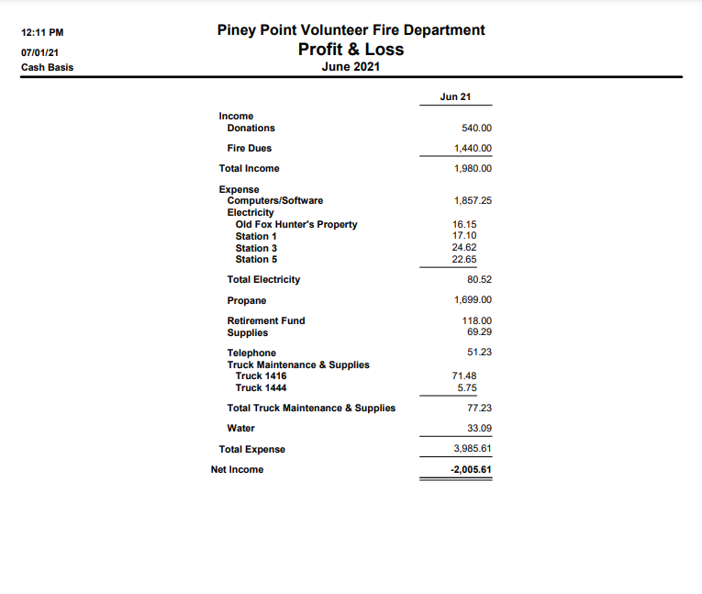

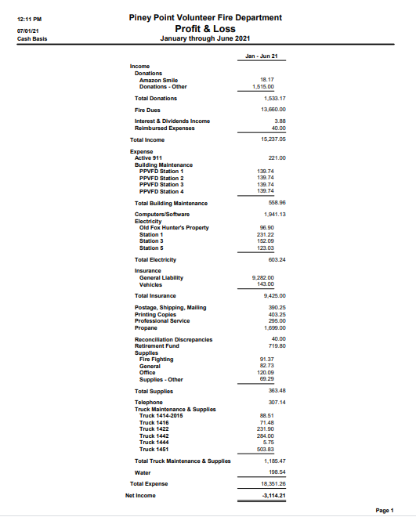

**Chief Report**

A huge thanks to all the FF’s that have helped with the truck maintenance. An even bigger thanks to Carl and Anita for the hard work and dedication they have given toward the trucks maintenance. The stations continue to be in an ongoing phase of organizing and cleaning, with much progress being made. I have been changing lightbulbs as applicable to LED to help with longevity and lower power usage. I believe we can slowly change most fixtures to be more energy efficient in the facilities over time. As time and weather allows, the stations continue to be decluttered and cleaned. We have affixed our River Kit at station 3 to include needs for water incidents at the War Eagle.

The next major need of the department will be a plan for the replacement of SCBA’s. The in service ones we have are county owned and the county as a whole is nearing the expiration dates on these. There is not a plan set in motion to replace these SCBA’s and will fall onto the individual departments. I am looking into viable options currently.

Will need EVS Mechanic to come out for maintenance unable to be performed by in house personnel.

At this time we continue with truck maintenance and building upkeeps and that is the plan for the month of July.

**Specialized Training Updates**

Intro/PPE class in July for 4 of our firefighters

**Personnel Changes**

**N/A**

**June Incident Count:** **17 Report #384**

**

1. *2020 Total Run Count: 172*
2. *2019 Total Run Count: 150*
3. *2018 Total Run Count: 161*

**Response & Training Report #1672**

Training Points are also for specialized training that occurred throughout the year: Hazmat, Instructor, Etc.

**Incidents and Training hours YTD Report #1413**

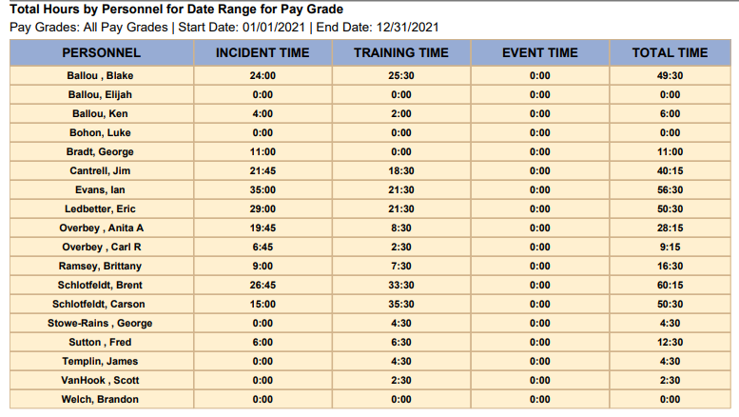

**Station Updates**

* **Station 1, Piney Rd 10594 Piney Road**
* Updates
  + Needs new facia boards put in place.
  + Needs Continued Landscaping (in process)
* Current trucks stationed in 2 bays:
  + 1414 – In service
  + 1422 – Oil Changed, Water Haul only
* **Station 2, Lookout 22050 E. Hwy 12**
* Station Cleaned and organizing still in process.
* Start thinking about building changes at station 2
* Current trucks stationed in bays:
  + 1411 – Oil Changed , In service
  + 1423 – Oil Changed , In Service
  + 1442- Oil Changed , Batteries swapped (donation batteries from FF) In service
  + 1441- Initially issues resolved. Still needs looked at before fully operable
* **Station 3, War Eagle 11200 High Sky Inn Rd**
* Station cleaning started, need minor tractor work to remove earth in front of station to allow standing water to drain properly. Can fill in with gravel
* Current Trucks stationed in bay
  + 1417 – In Service. Low miles since last oil change documented.
* **Station 4, Camp War Eagle 13552 The Pines Road**
* No New Updates
* Current trucks in bay
  + 1421 – In Service
  + 1444 – In Service, Ian has this as a response vehicle from his home on Pullum Place.
* **Station 5, Pinetop 22725 N. Pine Top Rd**
* No New Updates
* Current trucks in bay
  + 1416 - Needs oil change , In service
  + 1415 – Needs power steering fluid. Needs oil change. In service
* **Future Station 1 10400 Piney Road**

Building Committee Formed – May 2020 Board Meeting

* Committee on Hold
* Need to begin discussions on Future Station 1
* Free demolition and dirt work tentative to begin in Fall 2021
* Will need to get new quotes.
* Multiple building quotes have been requested and submitted for review

Need boards purchased for current station 1 siding, current market price. Need electrician to look at outside light as well. It is an electrical issue not bulb issue.

Consideration of new fan for station 2. One that provides more circulation. Need exhaust vent for truck fumes/exhaust. Consideration of station 2 upgrades.

Current list of tools need still apply minus drill, pressure washer. Refer to previous list

Station 5 trucks are the remaining trucks needing oil changes at the time of this report (July 2,2021)

We did have representation in the procession and funeral of fallen Pea Ridge Ofc. Kevin Apple

July plan of action is continued facility cleaning and truck maintenance.

Comparison

|  |  |  |  |  |  |  |  |  |  |  |  |
| --- | --- | --- | --- | --- | --- | --- | --- | --- | --- | --- | --- |
|  |  |  |  |  |  |  |  |  |  |  |  |
|  |  | **Medical** | **Fire/MVC** | **Training** | **Event/Public Relations** | | | |  |  |  |
| **Pea Ridge Fire Dept** | | $12.00 | $ 18.00 | $10.00 | $10.00 | * vendor/sponsor pays per hr, Football is 20.00 per hour | | | | | |
| **Hwy 94 E Fire Dept** | | $ 10.00 | $ 10.00 | $ 10.00 | $ 10.00 |  | | | | | |
| **Little Flock Fire Dept** | | $ 10.00 | $ 10.00 | $ 4.00 | $ 4.00 | * PR/Event anything not a call, but dept sanctioned | | | | | |
| **Nebco Fire Dept** | | $ 7.50 | $ 7.50 | $ 7.50 | $ 7.50 |  | | | | | |
| **Avoca Fire Dept** | | $ 7.00 | $ 7.00 | $ 7.00 | $ 7.00 | *paid dec 1st | | | | | |
| **Hickory Creek Fire Dept** | | $ 5.00 | $ 5.00 | $ 5.00 | $ 5.00 |  | | | | | |
| **Gravette Fire Dept** | | $ 5.00 | $ 5.00 | $ 5.00 | - | * officers get more (10.00), Probation gets less (3.00) | | | | | |
| **Beaver Lake Fire Dept** | | $ 10.00 | $ 10.00 | - | - |  | | | | | |
| **Rocky Branch Fire Dept** | | - | - | - | - | No Pay - strictly volunteer | | | | | |
| **Piney Point Fire Dept** | | - | - | - | - | No Pay - strictly volunteer | | | | | |
|  | |  |  |  |  |  | | | | | |
|  | *PPFD Firefighters would get a 1099 at end of the year* | | |  |  |  |  |  |  |  |  |
|  |  |  |  |  |  |  |  |  |  |  |  |

Proposed

|  |  |  |  |  |  |  |  |  |  |  |  |  |  |
| --- | --- | --- | --- | --- | --- | --- | --- | --- | --- | --- | --- | --- | --- |
| **Name** | **Fire Response $7.00** | | **Medical Response $3.50** | | **MVC Response $7.00** | | **Special Event $10.00** | | **Training $3.50** | | | **Total** | |
|  |  | |  | |  | |  | |  | | |  | |
|  | **Points** | **$** | **Points** | **$** | **Points** | **$** | **Points** | **$** | | **Points** | **$** | |  | |
| Ballou , Blake | 12 | $84.00 | 18 | $63.00 | 6 | $42.00 | 1 | $10.00 | | 7 | $24.50 | | $223.50 | |
| Ballou, Elijah | 0 | $0.00 | 7 | $24.50 | 1 | $7.00 | 0 | $0.00 | | 1 | $3.50 | | $35.00 | |
| Ballou, Ken | 2 | $14.00 | 4 | $14.00 | 0 | $0.00 | 1 | $10.00 | | 2 | $7.00 | | $45.00 | |
| Bohon, Luke | 0 | $0.00 | 0 | $0.00 | 0 | $0.00 | 1 | $10.00 | | 0 | $0.00 | | $10.00 | |
| Bradt, George | 3 | $21.00 | 7 | $24.50 | 2 | $14.00 | 0 | $0.00 | | 0 | $0.00 | | $59.50 | |
| Cantrell, Jim | 8 | $56.00 | 14 | $49.00 | 6 | $42.00 | 0 | $0.00 | | 6 | $21.00 | | $168.00 | |
| Evans, Ian | 10 | $70.00 | 22 | $77.00 | 7 | $49.00 | 1 | $10.00 | | 7 | $24.50 | | $230.50 | |
| Ledbetter, Eric | 10 | $70.00 | 7 | $24.50 | 7 | $49.00 | 0 | $0.00 | | 7 | $24.50 | | $168.00 | |
| Overbey , Anita A | 5 | $35.00 | 8 | $28.00 | 9 | $63.00 | 0 | $0.00 | | 2 | $7.00 | | $133.00 | |
| Overbey , Carl R | 1 | $7.00 | 5 | $17.50 | 3 | $21.00 | 0 | $0.00 | | 1 | $3.50 | | $49.00 | |
| Ramsey, Brittany | 4 | $28.00 | 9 | $31.50 | 1 | $7.00 | 0 | $0.00 | | 4 | $14.00 | | $80.50 | |
| Schlotfeldt, Brent | 9 | $63.00 | 11 | $38.50 | 5 | $35.00 | 0 | $0.00 | | 8 | $28.00 | | $164.50 | |
| Schlotfeldt, Carson | 6 | $42.00 | 5 | $17.50 | 2 | $14.00 | 0 | $0.00 | | 9 | $31.50 | | $105.00 | |
| Stowe-Rains , George | 0 | $0.00 | 0 | $0.00 | 0 | $0.00 | 0 | $0.00 | | 2 | $7.00 | | $7.00 | |
| Sutton , Fred | 2 | $14.00 | 3 | $10.50 | 1 | $7.00 | 0 | $0.00 | | 3 | $10.50 | | $42.00 | |
| Templin, James | 0 | $0.00 | 0 | $0.00 | 0 | $0.00 | 0 | $0.00 | | 2 | $7.00 | | $7.00 | |
| VanHook , Scott | 0 | $0.00 | 0 | $0.00 | 0 | $0.00 | 0 | $0.00 | | 1 | $3.50 | | $3.50 | |
| Welch, Brandon | 0 | $0.00 | 0 | $0.00 | 0 | $0.00 | 1 | $10.00 | | 0 | $0.00 | | $10.00 | |
| **Total** | 72 | $504.00 | 120 | $420.00 | 50 | $350.00 | 5 | $50.00 | | 62 | $217.00 | | $1,541.00 | |
| |  | | --- | |  | |  |  |  |  |  |  |  |  | |  |  | |  | |
|  |  |  |  |  |  |  | **Grade Name** | **Rate** | |  |  | |  | |
|  |  |  |  |  |  |  | [Fire Response](javascript:sendGradeForm('EDIT','19971');) | $7.00 | |  |  | |  | |
|  |  |  |  |  |  |  | [Medical Response](javascript:sendGradeForm('EDIT','19967');) | $3.50 | |  |  | |  | |
|  |  |  |  |  |  |  | [MVC Response](javascript:sendGradeForm('EDIT','35756');) | $7.00 | |  |  | |  | |
|  |  |  |  |  |  |  | [Special Event](javascript:sendGradeForm('EDIT','19972');) | $10.00 | |  |  | |  | |
|  |  |  |  |  |  |  | [Training](javascript:sendGradeForm('EDIT','19970');) | $3.50 | |  |  | |  | |
|  |  |  |  |  |  |  |  |  | |  |  | |  | |
|  |  |  |  |  |  |  |  |  | |  |  | |  | |
|  |  |  |  |  |  |  |  |  | |  |  | |  | |
|  |  |  |  |  |  |  |  |  | |  |  | |  | |
|  |  |  |  |  |  |  |  |  | |  |  | |  | |
|  |  |  |  |  |  |  |  |  | |  |  | |  | |