**PINEY POINT VOLUNTEER FIRE DEPARTMENT (PPVFD), INC. BOARD MEETING AGENDA**

November 4, 2021 7:00 PM – 9:00 PM

|  |  |  |  |
| --- | --- | --- | --- |
| **Item** | **Description** | **Lead** | **Notes/Comments** |
| 1 | Call meeting to order | VP |  |
| 2 | Additions and approval of the agenda  7:00-7:10 | VP |  |
| 3 | Approval of October 7th, 2021 minutes  7:10-7:15 | Secretary | Emailed by Liz Mitchell [ppfd14secretary@gmail.com](mailto:ppfd14secretary@gmail.com) |
| 4 | Treasurers Report  7:15-7:30 | Treasurer | Emailed by Kathy Burris [ppfdtreasurer@gmail.com](mailto:ppfdtreasurer@gmail.com) |
| 5 | Chiefs Report  7:30-8:00 | Chief | Emailed by Chief Blake Ballou [1401bcfd@gmail.com](mailto:1401bcfd@gmail.com)   * SCBA * Truck Repairs |
| 6 | Old Business | Board |  |
|  | 8:00- 8:10 |  | * Vote on the following * SCBA * Truck Repairs * Rescue Basket * Fireman Compensation * Chainsaw |
| 7 | New Business | Open |  |
|  |  |  |  |
| 8 | Next Meeting |  |  |
| 9 | Adjournment |  |  |
|  |  |  |  |
|  |  |  |  |

**TREASURER REPORT 11/2/2021**

SEE ATTACHED P& L

CHECKING ACCOUNT BALANCE 116912.71

SAVINGS ACCOUNT BALANCE 713.76

MONEY MARKET ACCOUNT 51213.15

ELECTRIC BILL AT STATION 5 HAS GONE UP $20 FOR THE LAST

2 MONTHS

TURN IN BEFORE ALL RECEIPTS BY THE LAST DAY OF THE MONTH TO BE PAID BY THE 10TH OF THE NEXT MONTH!!!

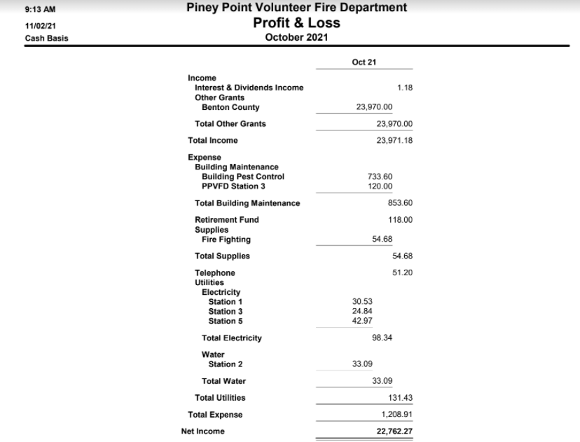

**August Report**

**Chief Report**

As we continue to navigate the COVID-19 pandemic, we find ourselves in this new wave of the Delta Variant. I would like to touch base from a professional outlook and update as to the strain the current health system of NWA is under. Almost around the clock, all the major hospitals remain on Divert, with multiple patients being placed in hallways and waiting room and extended wait times up to 8+ hours being common. It is being highly encouraged that anything not related to loss of life limb or eyesight or requiring surgical interventions be seen at urgent cares, PCP’s or the stand alone ER’s. I encourage everyone to remain vigilant and stay as safe as possible as it is an unprecedented time for healthcare in our area. Due to the extreme level of illness in the communities it is still my professional opinion to avoid hosting public events at this time.

**Specialized Training Updates**

Intro/PPE class for 3 of our firefighters was completed. Should have received certifications from AFA by now in the mail.

A Training burn was conducted with area fire depts at Beaver Lake. This will count towards quarterly Mutual Aid training. Beaver Lake fire Dept was able to acquire a structure to train on fire dynamics and give hands on to real working fire ground operations to our newer volunteers.

**Personnel Changes**

9:15 AM Piney Point Volunteer Fire Department

11/02/21 Profit & Loss

Cash Basis January through October 2021

Jan - Oct 21

|  |  |
| --- | --- |
| Income Donations |  |
| Amazon Smile | 24.66 |
| Donations - Other | 1,642.50 |
| Total Donations | 1,667.16 |
| Fire Dues | 16,040.00 |
| Interest & Dividends Income  Other Grants | 10.54 |
| Act 833 Grants | 18,246.12 |
| Benton County | 23,970.00 |
| Total Other Grants | 42,216.12 |
| Reimbursed Expenses | 40.00 |
| Total Income  Expense | 59,973.82 |
| Active 911 | 221.00 |
| Bounced Check  Building Maintenance | 88.00 |
| Building Pest Control | 733.60 |
| PPVFD Station 1 | 139.74 |
| PPVFD Station 2 | 139.74 |
| PPVFD Station 3 | 259.74 |
| PPVFD Station 4 | 139.74 |
| Total Building Maintenance | 1,412.56 |
| Computers/Software | 1,941.13 |
| Fire Equipment Maintenance | 27.94 |
| Fire Equipment Purchase  Insurance | 68.77 |
| General Liability | 9,282.00 |
| Vehicles | 143.00 |
| Total Insurance | 9,425.00 |
| Labor | 224.00 |
| On Road Diesel | 1,441.48 |
| Postage, Shipping, Mailing | 390.25 |
| Printing Copies | 403.25 |
| Professional Service | 295.00 |
| Propane | 1,699.00 |
| Reconciliation Discrepancies | 40.00 |
| Retirement Fund | 1,191.80 |
| Safe Deposit Box  Supplies | 28.00 |
| Fire Fighting | 350.19 |
| General | 178.05 |
| Office | 120.09 |
| Supplies - Other | 119.63 |
| Total Supplies | 767.96 |
| Telephone | 511.97 |

Page 1

|  |  |
| --- | --- |
| 9:15 AM | Piney Point Volunteer Fire Department |
| 11/02/21 | Profit & Loss |
| Cash Basis | January through October 2021 |

Jan - Oct 21

Truck Maintenance & Supplies

Truck 1414-2015 148.51

Truck 1416 71.48 Truck 1422 231.90

Truck 1442 284.00 Truck 1444 5.75 Truck 1451 517.33

Truck Maintenance & Supplies - O... 798.37

Total Truck Maintenance & Supplies 2,057.34

Utilities

Electricity

Old Fox Hunter's Property 133.51

Station 1 313.93

Station 3 253.49

Station 5 227.34

Total Electricity 928.27

Water

Station 2 330.90

Total Water

330.90

1,259.17

23,493.62

36,480.20

Total Utilities

Total Expense

Net Inco