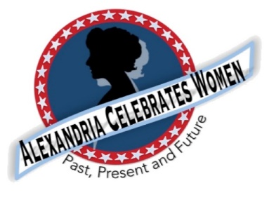

For Immediate Release
February 16, 2021 Contact: Gayle Converse gcprod@bellsouth.net
2021 Celebrate Women Awards
Awards will Honor Women on the Front Lines of Pandemic

Alexandria, VA -- We have been inspired for centuries by women who stepped up and led the way in Alexandria. This past year, many women have worked and volunteered an exceptional number of hours on the front lines – delivering mail and packages, ensuring our food supply, teaching our children, caring for our health and safety, and many other efforts helping the Alexandria community battle COVID-19.

To honor women who have gone above and beyond during this crisis, Alexandria Celebrates Women is proud to host the first Celebrate Women Awards Monday March 29. This Women’s History Month awards ceremony will replace the Alexandria Commission for Women’s annual Salute to Women.

The Celebrate Women Awards will be a FREE online event – highlighting five women through biographical videos.

Event: 2021 Celebrate Women Awards (FREE online event)
Date: Monday March 29, 2021
Time: 7 p.m. ET

Join us to honor extraordinary women who are helping us all through extraordinary times.

Alexandria Celebrates Women (ACW) recognizes the accomplishments and contributions of Alexandria, Virginia’s women of the past, present and future. The volunteer 501(c)(3) charitable non-profit organization acknowledges the distinguished history of Alexandria’s heroines while celebrating the empowerment of Alexandria’s modern woman. https://alexandriacelebrateswomen.com/

