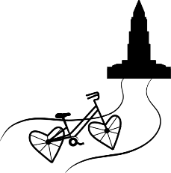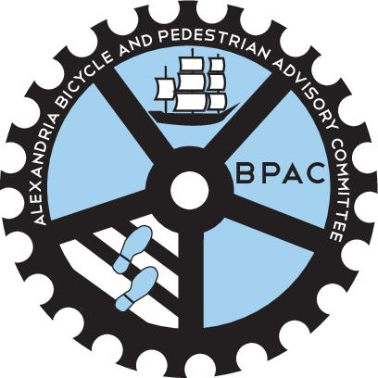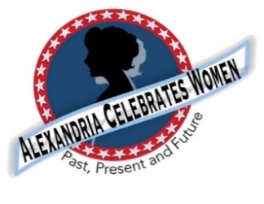

For Immediate Release Contact: Gayle E. Converse gcprod@bellsouth.net 404.989.0534

March 11, 2021

Women’s History Bike Ride March 27
Route will Include Historic Sites and Health and Safety Precautions
Alexandria, VA – Bicycle enthusiasts will have the chance to enjoy another “Women’s History Bike Ride” in and around Alexandria, Virginia Saturday, March 27. The 2021 event – designed to recognize 2021 as “The Year of the Woman” in the United States -- will feature a new route that will take participants to sites associated with many of the area’s heroines of the past. Most of the historic sites will differ from last August’s popular Women’s History Bike Ride.
The free, family-friendly event is sponsored by Alexandria’s Bicycle and Pedestrian Advisory Committee (BPAC), Alexandria Celebrates Women and the Alexandria Spokeswomen. The ride will feature safety-conscious staggered start times (9:00, 9:30, 10:00, and 10:30 a.m. ET) for small groups of ten riders or fewer. The event will begin at Jones Point in Alexandria. The 14-mile route will consist of a mix of trails and neighborhood streets (with a few hills). Participants are welcome to join for all or part of the ride. (https://ridewithgps.com/routes/35176189)
Event: Women’s History Bike Ride
Location: Jones Point Park, Alexandria, VA
Date: Saturday March 27, 2021 (Rain Date: March 28, 2021)
Time: Staggered Ride Starts: 9:00 a.m., 9:30 a.m., 10:00 a.m., 10:30 a.m. ET
"This ride will be a fun and healthy way to celebrate women who worked to improve Alexandria and the country. We'll honor women who fought for the right to vote, and we’ll also learn about some of the parks, schools, and other city facilities named after notable Alexandrian women,” stated BPAC Vice Chair for Bicyclists, Josephine Liu.
For everyone's health and safety, CDC guidelines will be followed: each ride will be limited to eight participants, plus a ride leader and sweep; masks must be worn at the meeting start, during the history stops, and also while riding, if riders can breathe comfortably while doing so; participants will be asked to maintain social distancing at all history stops and while riding (at least 10 feet apart)); and participants will be asked to electronically sign a waiver before the ride.
Participants are required to bring a working bike and helmet, a face covering, hand sanitizer and water and to wear weather-appropriate clothing. There is limited participation for this FREE event (up to eight riders in each tour). Online registration is required and will open March 12, 2021 on Eventbrite: https://www.eventbrite.com/e/womens-history-bike-ride-tickets-144711609319 Links to registration will also be posted on social media.

About BPAC
The Alexandria Bicycle and Pedestrian Advisory Committee (BPAC) is an all-volunteer 501(c)(3) charitable non-profit organization that promotes walking and biking, and infrastructure and policy changes that create a safe, accessible, and livable city for all.

About Alexandria Celebrates Women
Alexandria Celebrates Women (ACW) recognizes the accomplishments and contributions of Alexandria, Virginia’s women of the past, present and future. The volunteer 501(c)(3) charitable non-profit organization acknowledges the distinguished history of Alexandria’s heroines while celebrating the empowerment of Alexandria’s modern woman. https://alexandriacelebrateswomen.com/

About Alexandria Spokeswomen
Alexandria Spokeswomen is a group of women and female-identifying persons who like to bike or use bikes to get around in Alexandria. The group plans events and group rides, such as its annual "Women on a Roll" ride each May; and is especially supportive of newcomers, whether that means new to bike commuting, bike maintenance or gaining confidence to ride with a group. Many members choose to be active in the community, spreading their joy of biking through volunteering and advocating for infrastructure to support biking and safety.

--00--

