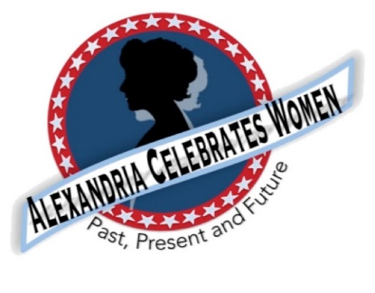
For Immediate Release
October 29, 2020

Alexandria Celebrates Women Celebrates 2020 Alexandria Film Festival Women’s Showcase
Alexandria -- In this centennial year of the American Woman’s vote, please join Alexandria Celebrates Women in celebrating The Alexandria Film Festival 2020 Women’s Showcase.
The Thursday November 12 event begins at 7 p.m. with the first of four films highlighting women: “Lily Meade Valentine: Virginia Suffragist” – a short by 15-year old Julia Hocker.
“9-5: The Story of a Movement” by Oscar-winning filmmakers Steven Bognar and Julia Reichert, is the story of women’s struggle for equality in the workplace and is based in part on the Hollywood comedy “9-5” starring Jane Fonda, Lily Tomlin and Dolly Parton.
The Nov. 12 Showcase will also host a sneak preview of “The Housatonic at Stockbridge” - a story by filmmaker Tim McLoraine and inspired by a Charles Ives’ composition regarding a 1908 honeymoon in Western Massachusetts.
A fourth film, “Roe vs Wade” by filmmaker Ann Hartley, explores the origins of the landmark decision.
Question and answer sessions with filmmakers follow each movie.
Tickets for the Alexandria Film Festival’s all-digital event can be purchased through alexfilmfest2020.eventive.org
The Alexandria Film Festival, a 501 (c)(3) non-profit organization, brings high quality short and feature-length films, documentaries, and filmmaker panels and arts presentations to the historic city of Alexandria, Virginia, via a four-day annual festival. https://alexfilmfest.com/about/
Alexandria Celebrates Women recognizes the accomplishments and contributions of Alexandria, Virginia’s women of the past, present and future. The volunteer 501(c)(3) charitable non-profit organization acknowledges the distinguished history of Alexandria’s heroines while celebrating the empowerment of Alexandria’s modern woman. https://alexandriacelebrateswomen.com/

--00--

