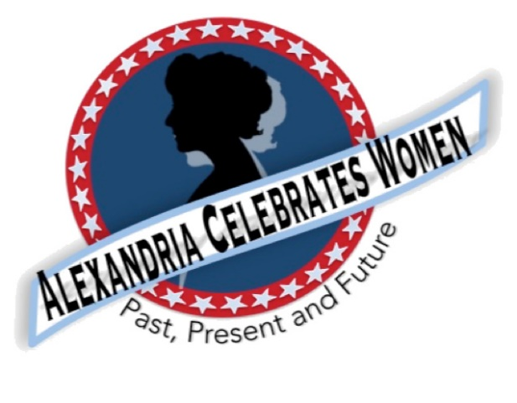

**Alexandria Celebrates Women**

***100 Years of Women’s Right to Vote***

**August 2020 Newsletter**

**Editor:** Gayle Converse

**“The right of citizens of the United States to vote shall not be denied or abridged by the United States or by any State on account of sex.”**

***- 19th Amendment to the United States Constitution***

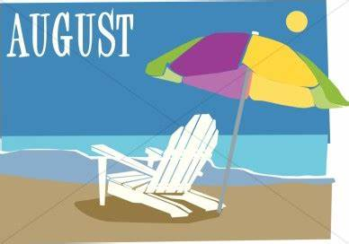 **Welcome** **to the August 2020 newsletter of Alexandria Celebrates Women -- *100 Years of Women’s Right to Vote.***

Break out your purple, white and gold! August marks a century of women’s voting rights in the United States! August 18, 1920 marks the 100-year anniversary of the ratification of the 19th Amendment to the U.S. Constitution (more about what *actually happened* to ensure ratification, below!).

We hope that you, your families and friends are well and safe during this time and we hope the *herstory* and educational links that follow can serve as a part of a plan to encourage your family’s enthusiasm for American **her**story.

**The Basics**

The **19th Amendment to the United States Constitution** (Amendment XIX – often referred to an the “Susan B. Anthony Amendment”) granted American women the right to vote, a right known as women’s suffrage. The Amendment prohibits the states and the federal government from denying the [right to vote](https://en.wikipedia.org/wiki/Suffrage) to citizens of the United States on the basis of sex. When the Amendment was ratified August 18, 1920, it ended almost a century of protest. <https://www.history.com/topics/womens-history/19th-amendment-1>

**Items of Interest**

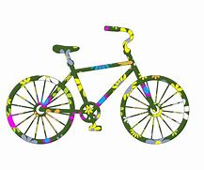

**August 15,** **2020** Alexandria ***Women’s History Bike Ride***is ON!

Sponsored by the Alexandria Pedestrian Bicycle and Safety Committee, the Alexandria Spokeswomen and Alexandria Celebrates Women, this **free** early morning event is geared for safety and fun. The ride will feature socially distanced **staggered start times (7:30 a.m., 8:00 a.m., or 8:30 a.m. EDT)** for small groups of eight riders or fewer. The ride will begin near the Alexandria Office of Voter Registration and Elections on North Royal Street in Old Town. The 14-mile route will consist of a mix of trails and neighborhood streets (with a few hills). Participants are welcome to join for all or part of the ride. <https://ridewithgps.com/routes/31837986>.

For everyone's health and safety, the following precautions will be taken: breaking into small groups of 10 riders (one ride leader, one sweep, and eight participants); requiring registrants to sign up in advance for specific time slots; asking everyone to self-screen and not ride if they've experienced symptoms of COVID-19 (fever, cough, shortness of breath, chills, sore throat, muscle aches) or if they have been exposed to a known COVID-19 case within the last 14 days; asking participants to wear masks at the meeting start and during the history stops, and also while riding, if they can breathe comfortably while doing so; asking people to give each other social distancing space at history stops and while riding (at least 10 feet, and preferably 20 feet); keeping an eye on local COVID-19 conditions; and cancelling the ride if needed. Participants will be asked to sign a waiver before the ride.

Participants are required to bring a working bike and helmet, a face covering, hand sanitizer and water and to wear weather-appropriate clothing. Riders are encouraged to wear women’s suffrage-era (early 1900’s) costumes or American suffrage colors of purple, white and gold and/or decorate their bicycles with suffrage colors.

Registration is **FREE** at <https://www.eventbrite.com/e/womens-history-bike-ride-tickets-113229135392>

**Event: Women’s History Bike Ride**

**Location: Ride start – Outdoor brick courtyard on N. Royal St. between Alexandria Office of Voter Registration and Elections and Weichert Realtors, 132 North Royal Street Alexandria, VA 22314 (*across* N. Royal St. from Alexandria’s Market Square)**

**Date: Saturday August 15, 2020**

**Time: Staggered Ride Starts: 7:30 a.m., 8:00 a.m., or 8:30 a.m. EDT**

Torpedo Factory Artists Mark 19th Amendment Ratification Centennial

Artists in Studio 311 (the third floor) at Alexandria’s Torpedo Factory Arts Center are designing a special exhibit to commemorate 100 years of the women’s vote! The artists will exhibit paintings and other art to celebrate the historic women’s movement. Along with the special presentation, Alexandria Celebrates Women will sponsor a life-size historic photograph of suffragists – a photo large enough for a selfie – you can pose as an early 20th century suffragist! The photo and art display are scheduled for exhibition, soon!

**Two Alexandria Celebrates Women Events to Look For!**

**Historic Marker**

The Office of Historic Alexandria is working with Alexandria Celebrates Women to install an historic marker to commemorate the location of an important American suffrage movement federal court case in Alexandria. Alexandria Celebrates Women will raise funds for the marker. Please watch your email for our letter asking for your help with this important history project.

**Mayoral Proclamation**

Alexandria Mayor Justin Wilson will issue a proclamation to commemorate the women’s vote and to honor Alexandria’s women of the past, present and future! Date and time to be announced.

**Alexandria Public Library Virtual Kate Waller Barrett Event August 19**

Learn about the notable namesake of the Queen Street Library: humanitarian, reformer and suffragette Kate Waller Barrett. Presented by Patricia Walker of Local History/Special Collections.

<https://socialwelfare.library.vcu.edu/people/barrett-kate-waller/>

**Wednesday, August 19  
7 p.m. – 8 p.m.**



***Alexandria Times* -- July 23, 2020 – “The women’s suffrage movement – a template for modern protests” (page 15)** <https://alextimes.com/wp-content/uploads/2020/07/07_23_2020-Alex_Times_WEB.pdf>

***Wall Street Journal* – August 2, 2020 --** <https://www.wsj.com/articles/how-womens-suffrage-changed-america-far-beyond-the-ballot-box-11596207771>

**Herstory**



The Story behind the Ratification of the 19th Amendment

As the Tennessee Legislature argued the 19th Amendment, an incredibly young legislator ended up playing an incredible role in the heat of that August special session. The Representatives had adopted the wearing of red roses in their lapels if they were against women’s voting rights – and yellow roses if they were pro ratification. The yellow rose symbolized one of the three colors of the women’s movement (gold, purple and white).

On the House floor -- after several tie-votes to table the legislation -- Tennessee junior statesman -- twenty-four-year-old Harry T. Burn -- wore the red rose on his lapel – however, hidden from sight in his jacket pocket – was a letter from his mother.

On page two of the seven-page note, she had written, “Hurrah and vote for Suffrage.” On page six, she instructed Harry to “Be a good boy” in advocating for women.

…Young Harry Burn shouted “aye” to the vote that changed history – enabling Tennessee to become the 36th state needed for ratification of the 19th Amendment.

<https://www.history.com/news/american-womens-suffrage-19th-amendment-one-mans-vote>

**Alexandria Celebrates Women Encourages Area Florists to promote the Yellow Rose during August**

As part of this month’s centennial observance, many Alexandria flower shops plan to feature the yellow rose. Ask your local florist if they are participating!

**Lucy Burns Museum Lorton, Virginia** <https://www.aam-us.org/2020/03/02/silent-no-more-the-new-lucy-burns-museum-speaks-to-the-centennial-of-suffrage/>

**“We Demand” Coloring Book** <https://www.workhousearts.org/lucyburnsmuseum/>

The Library of Virginia’s current exhibition, *We Demand: Women’s Suffrage in Virginia* commemorates the centennial of the ratification of the 19th Amendment to the U.S. Constitution guaranteeing women the right to vote.  As part of this exhibit they have created a Suffrage Coloring Book!  Color your favorite pages and then share photos of them with the Lucy Burns Museum on social media! Use the hashtags #LucyBurnsMuseum #SuffrageColoringBook #ColorOurCollections and tag @LibraryofVA and @WorkhouseArts. Thank you to the Library of Virginia for creating this fun activity to learn about the Suffragist Movement!

**100 Years of Working Women** <https://www.dol.gov/agencies/wb/data> <https://www.bls.gov/bls/cpswomendata.htm>

Women have been in the work force for more than 100 years, but in honor of the 100th Anniversary of the Women’s Bureau, find the top 10 occupations women have held in each decade since 1920. This data also includes the number of women in the labor force in each decade, and the percentage of women in the top 10 occupations. [https://usafacts.org/data/topics/economy/jobs-and income/?utm_source=bing&utm_medium=cpc&utm_campaign=NDCompetitors&msclkid=299f041fb9171cada4d35af017830d50](https://usafacts.org/data/topics/economy/jobs-and%20income/?utm_source=bing&utm_medium=cpc&utm_campaign=NDCompetitors&msclkid=299f041fb9171cada4d35af017830d50) <https://www.bls.gov/opub/mlr/2007/06/art2full.pdf>

**Women’s Suffrage Centennial Commission Webinar – “An Inside Look at Washington, D.C. Exhibits”** <https://www.youtube.com/watch?v=J089IhzkTkA&t=347s>

**The National Women’s History Museum reminds us of the free resources it offers on the NWHM website** www.womenshistory.org! **The virtual museum is open 24/7.** NWHM resources include online exhibits, digital classroom resources, electronic field trips, and biographies.

The **Virginia Museum of History & Culture’s “Share Your Story”** is seeking to document the COVID-19 impact in the Commonwealth through your stories. <https://www.virginiahistory.org/node/2852?promo=821>

**Voting**

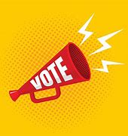

**Alexandria** **Office of Voter Registration and Elections**

Registration is open online <https://www.alexandriava.gov/Elections> for absentee ballots For the **November 2020 Election.** As of July 1, 2020, “no-excuse” absentee ballots are available.

To promote social distancing, the Office of Voter Registration and Elections is open by appointment only. Voters are encouraged to request absentee ballots online and to register to vote online through the Virginia Department of Elections. For questions regarding registration, absentee voting or to request and appointment, email [voters@alexandriava.gov](mailto:voters@alexandriava.gov) or call **703.746.4050**.

**FACT:** Women, who constitute more than half the population, have cast almost ten million more votes than men in recent elections. <http://www.cawp.rutgers.edu/sites/default/files/resources/genderdiff.pdf>

**Career**

Most essential workers in the United States are *women*. If you are experiencing changes in your routine – whether currently working from home or being asked to return to your workplace, you might be worrying about finances and quarantine fatigue. Additional worry about mental health and risk of exposure to COVID-19 are affecting most of us.

We salute those of you who work in essential industries, including cleaning services, grocery and drug stores, farmer’s markets, transportation, federal, state and local government, active duty U.S. Military and Reserves, teaching, U.S. Post Office, and other delivery businesses. We thank the region’s brave first responders and their equally brave families: medical personnel, firefighters, law enforcement, and City and County maintenance crews and volunteers.

**Fairygodboss** offers a women’s career community, expert career advice, job openings and company reviews to help you advance your career. https://fairygodboss.com

|  |
| --- |
|  |

***National* Key Dates:**

**1848:** **Seneca Falls Convention – National-level launch of the movement for women’s rights**

Following the Convention, the demand for the vote became a centerpiece of the women’s rights movement. Elizabeth Cady Stanton and Lucretia Mott, along with Susan B. Anthony and other activists, raised public awareness and lobbied the government to grant voting rights to women.

**August 18, 1920: Tennessee legislature ratifies 19th Amendment**

Tennessee becomes the last of the necessary 36 states to secure ratification.

**August 26, 1920: 19th Amendment officially certified by the U.S. Secretary of State**

U.S. Secretary of State Bainbridge Colby **certified** the 19th Amendment and made the adoption of the Amendment official. Every year on this date, we celebrate ***Women’s Equality Day*** in commemoration.

***Virginia* Key Dates**

**November 27, 1909** - A group of women, including Ellen Glasgow, Mary Johnston, Kate Langley Bosher, Adèle Clark, Nora Houston, Kate Waller Barrett, and Lila Meade Valentine, found the Equal Suffrage League of Virginia.

**1917-- Women suffragists force fed at the “Occoquan” Workhouse**

**November 23, 1917 -- Suffragist prisoners released from Workhouse to attend hearing in Federal Court in Alexandria, VA** Judge ruled that women protesters had been unlawfully imprisoned at Workhouse

**August 1920** - Virginia women gain the right to vote after the Nineteenth Amendment to the U.S. Constitution becomes law.

**1924** - Kate Waller Barrett of Alexandria serves as a delegate to the Democratic National Convention.

**February 21, 1952** - The Virginia General Assembly ratifies the Nineteenth Amendment to the U.S. Constitution, thirty-two years after it became law.

**Resources**

**Virginia Museum of History and Culture** <https://www.virginiahistory.org/what-you-can-see/story-virginia/explore-story-virginia/1876-1924/virginia-and-women’s-suffrage>

**Turning Point Suffragist Memorial Association** <https://suffragistmemorial.org/suffragist-memorial-site-surroundings/>

**Women’s Suffrage Museum (Lucy Burns Museum)** **“From the White House to the Workhouse to the Franchise”** <https://workhousemuseums.org/history/importance-of-womens-suffrage/>

**Encyclopedia Virginia** “**Woman Suffrage in Virginia”** <https://www.encyclopediavirginia.org/Woman_Suffrage_in_Virginia>

**William & Mary (W&M) Women's Law Society “**[**Women's Suffrage in Virginia”**](http://wmpeople.wm.edu/site/page/wmws/womenssuffrageinvirginia) <http://wmpeople.wm.edu/site/page/wmws/womenssuffrageinvirginia>

**League of Women Voters of Fairfax Area (LWVFA)** <https://www.lwv-fairfax.org/>

**League of Women Voters Centennial** <http://www.lwvnca.org/Centennial.html>

**The National Women’s History Museum** “**Crusade for the Vote: Suffrage Resource Center”**

[www.crusadeforthevote.org/educational-resources](http://www.crusadeforthevote.org/educational-resources)

[www.crusadeforthevote.org/partners](http://www.crusadeforthevote.org/partners)

<https://www.womenshistory.org/womens-history/online-exhibits>

<https://www.womenshistory.org/exhibits/creating-female-political-culture>

**Women's Suffrage Centennial Commission** <https://www.womensvote100.org/about>

**Suffrage Sisters**[*media@womensvote100.org*](mailto:media@womensvote100.org)

**General inquiries** | [staff@womensvote100.org](mailto:staff@womensvote100.org)

**Virginia History** <https://wmpeople.wm.edu/site/page/wmws/womenssuffrageinvirginia>

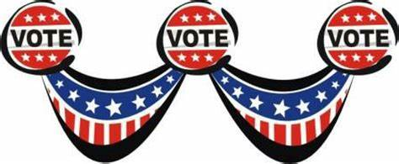

For more information contact Pat Miller at [AlexandriaCelebratesWomen@gmail.com](mailto:AlexandriaCelebratesWomen@gmail.com)